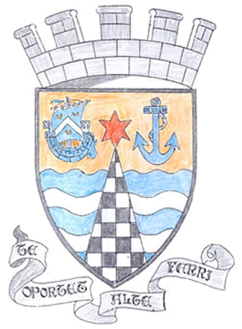
Tayport Ferryport –On-Craig

Community Council

MINUTES OF THE MEETING OF
THE TAYPORT FERRYPORT ON CRAIG COMMUNITY COUNCIL
HELD IN THE BURGH CHAMBERS ON MONDAY 7th OCTOBER 2019 AT 19:00 HRS

Present: Chair: Mr D Gray:.Secretary: Mr G M Beat: Treasurer: Mr J Kinnear
Mrs L White, Mrs M Taylor, Mrs S Walker, Ms N Walker, Mr D Myles

In Attendance: Councillor Bill Connor , Cllr Jonny Tepp

Apologies: Mrs H Lowe , Mr M Mitcham , Cllr Tim Brett

Declarations of Interest: Mr D Myles – Foodbank , Messrs J Kinnear , D Gray and Cllr Connor – Auld Kirk

The Minutes of the previous meeting on 2nd September were agreed .

Guest Speakers : Ms Yvonne Wynia , Project Co-ordinator for the Larick Centre gave an outline of her work
getting things organised for a wide variety of uses for the new centre when it opens .

Mr Jason West of the Tayport Breakers Baseball Club gave some background of
himself and spoke of his hopes to develop the game in Tayport and play in the Scottish
League . 41 people have so far expressed an interest , training begins Saturday 13th Oct

Matters arising from previous minute :

1. Christmas Lights Switch On set for 1st December , Instrumental Band will Play , Choirs will sing ,
Santa will be there , Mulled wine and mince pies and tea and cakes .
2 Hope for a Santa run this year .
3. Citizen of the Year Awards Day was well attended , our Congratulations to Robert Bates and to the
Charity Shop Ladies for their commendation for their exceptional fund raising efforts .
4. Problems with appointments at Tayport Surgery as it is to be closed in the afternoon on a permanent
basis . This matter to be taken up with the NHS .
5 Thanks from Scotscraig Golf Club for the use of a Marquee , Donation to follow .
.
.

Agenda Items/Discussion | Action
Police:
No report as yet .

Foodbanks Report:

Average of 7 Clients per week at present. 15 foodbags being delivered to
Wormit School during School Holidays and 18 bags to Tayport School .
Thanks to all Churches in Tayport , the Primary School and the Co-op for
their donations to the foodbank.

Treasurer’s Report:

Full report of last year’s Accounts distributed and an update of our present
Accounts given .
Action Plan:

No Report

Fife Council and Other Correspondence:

1. BT Phone boxes , suggested we take on one at Banknowe for use as a base
for a defibrillator .
2. Beautiful Fife Report – Special Comment for the Community Garden and War
Memorial . Letter of Congratulations from Willie Rennie MSP for our efforts .
Awards for the Caravan Park – Gold Award from David Bellamy for the 3rd
Year , also the Going Green Together Award ., well done .
3. Auld Kirk Charitable Trust asking for assistance with lighting of the Church
over the Christmas period .Moved by David Myles – agreed .
4. Replacement of waste bins at lay by – funding received .
5. Community Council Education – further seminars to take place .
6. Application to British Legion Scotland for funding for the Green Flag for the
Common agreed .

Planning:

Ferryport Cemetery application for repairs and maintenance of walls (proposed) - Approved

Fife Councillors Reports:

Written Reports attached , Report on the condition of the School building also given .

Questions for Fife Council:

1. Length of time and mess made during drainage work at Q1 and B945 junction
2. Rock armour at outlet of at the East Common breaking away due to erosion
3. Flooding at bottom of Banknowe Drive needs immediate attention
4. Work repairs to Sea Wall were well done
5. Complaints about dog poo – asking for Safer Communities to take some action

A,O,C,B,

1. Walking Football available in Newport on Tay
2. Skate Park to be opened on Saturday 19th October at 1pm
3. Letter of Thanks to be sent to Rev Brian Oxburgh on his retiral
4. Arrange for tree planting to be done to celebrate Mrs Park’s 100th Birthday

Next meeting on 4th November 2019 at 7pm in the Burgh Chambers

The meeting closed at 9.15 pm

