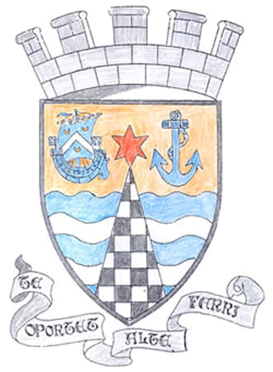
Tayport Ferryport –On-Craig

Community Council

MINUTES OF THE MEETING OF
THE TAYPORT FERRYPORT ON CRAIG COMMUNITY COUNCIL
HELD IN THE BURGH CHAMBERS ON MONDAY 7th OCTOBER 2024 AT 19:00 HRS

Present: Chair::Mrs S Walker:. Secretary: Mr G M Beat: Treasurer:Miss R McCallum
Messrs D Myles , N Sneddon , B de Smid , J Kinnear

Attending: Councillor J Tepp

Apologies: Mrs R Dawson

Declarations of Interest: Mr D Myles - Foodbank

Minutes: The Minutes of the meetings held on 1st July and 2nd September were agreed

Matters Arising from Previous Minutes:

1. Craig Road , 3 areas closed off by cones and barriers for some weeks now for no reason as work has been completed at this road .
2. Castle Road sign is still damaged/askew
3 Primary School Crossing , Markings still not repainted , nearby drain on Queen Street is blocked .
4. At Queen Street Recycling point , yellow skip has been reported for excessive noise and does it
meet accessibility requirements for height
5 The Community Garden foot bridge requires repair , reported . Fife Council are looking into repair/
replacement
6. Sea Wall erosion (close to Caravan Park entrance) – getting worse as erosion is undercutting the
grassy area.
7 Tayport Cemetery – needs attention – Lead officer from Fife Council is coming to discuss.
.

Police Matters – Report issued to Members - Questions raised on Speeding on B945 and B946

Foodbanks Report - Consistent usage . Weekly/fortnightly deliveries to 7 – 13 families , total of 395 food
parcels handed out since January. Finance is good with Donations from St Andrews
University , schools and local church . £200 from choir .

Treasurer’s Report – Annual Grant applied for . Accounts needed agreed , but could not be signed off at
AGM as an auditor was not available at that time . Lynne Borland has agreed to audit
Applied for ICO , data protection number .Bank balance as stated to Members .
:

Agenda Items/Discussion | Action
.
Fife Council Correspondence
:
1. Meeting with Fife Council Senior Executives (16/10/24) to discuss areas of
concern in town .
.

2. Tay Bridgehead Forum – Attended by S Walker and B de Smid (28/8/24)
3. Out of Hours Service at St Andrews Hospital – Chairperson of out of hours
Group has agreed to meeting Community Councils to discuss Services /cuts
(£12M projected cuts )
4. Changes to Waste Collections - Online bin calendar has new dates (Fife
Council Site)
5. Local transport for Fife – Strategy for next 10 years published by Fife Council
6. Christmas Lights Night – Raffle prizes needed , tents/gazebos to be organised
Tree , Santa and bouncy castle booked for 24th November
7.. Citizen of the Year /Commendation Ceremony – Well attended , a good day
had by all . Letters of thanks to be sent out.
8. Accounts 2023/2024 – Lynne Borland has audited these Accounts and they
have been approved by Community Council at this Meeting

Planning Applications

1. 24/02175/FULL Installation of Ground mounted Solar Arrays at the Lariick
Centre Shanwell Road DD6 9EA
Fife Councillors Report  Castle Street – Brown Bins removed  Glebe Gardens – Speed survey carried out  Castle Street – Broken kerbstone has been removed – needs replacing  William Street - speed survey near Nursery requested  Housing Services – Willie Rennie had a meeting with residents regarding anti – social behaviour .  Disabled Parking Bays – Require eligibility check through Fife Council  Scottish Power – Major Works planned to upgrade network between Cupar to  Guardbridge  Playpark – Councillor Tepp requested a meeting with the Parks Department . | .
Questions for Fife Council:

1. Auld Kirk Clock – As Fife Council adjust times when clocks change , chime
needs resetting too as it runs fast
2. Road Repairs on B945 – Potholes are marked but not repaired
3 Maitland Street – Roundabout markings have completely faded , need
repainting
A.O.C.B.

Dolphin Centre AGM on 9/10/2024
Remembrance Service on 10/11/2024 – Wreath ordered
Note - Request to hold meetings in accessible rooms when disabled persons are expected to attend . Discuss
.

Meeting closed at 9.pm

Next meeting in the Burgh Chambers at 7pm on Monday 4th November 2024

