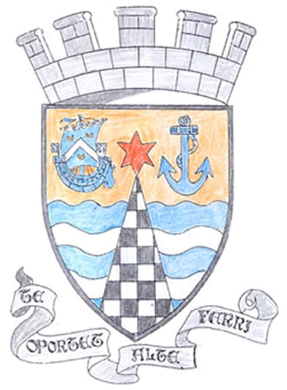
Tayport Ferryport –On-Craig

Community Council

MINUTES OF THE MEETING OF
THE TAYPORT FERRYPORT ON CRAIG COMMUNITY COUNCIL
HELD IN THE BURGH CHAMBERS ON MONDAY 1ST JULY 2024 AT 19:00 HRS

Present: Chair: Mrs S. Walker , Secretary: Mr G M Beat ,Treasurer; Miss R MacCallum
Messrs J Kinnear , B de Smid ,N Sneddon, E MacDonald

Attending: Councillor L Kennedy – Dalby , Councillor J Tepp

Apologies: Mr D Myles , Mrs R Dawson:

Minutes: The Minutes of the meeting held on 3rd June were agreed

Matters Arising from Previous Minutes

1. Paths and Trees at East Common – Fife Council’s reply was that the areas concerned e being left to
left to encourage wildlife .We are happy with rewilding but these new areas were not on the
re wilding Map , to take up with the grounds maintenance team .

2. King Street potholes , Fife Council inspected and decided no immediate repairs were necessary , but
to be revisited when the budget allows

3. Promenade Coastal Erosion – Fife Council approached the Caravan Site , but the erosion is outwith
their Grounds . Can Grounds Maintenance investigate as it appears to be dangerous .

Police Matters : Issued to Members – No questions

Foodbanks Report: N/A

Treasurer’s Report Bank Balance noted and Locality Budget is providing a sum towards Heritage Signs The address for Bank Statements has to be changed with a visit to the bank.
.Agenda Items/Discussion | Action
Fife Council and General Correspondence.

1. Tayport Cemetery Maintenance- while road entrances and taps have been
repaired well , grass has been cut but weeds are everywhere on paths and
around Graves , there are large bushes throughout the Cemetery which were
kept trimmed up until a year or two ago which are now encroaching on and
pressing on gravestones , in some cases hiding the stones from view .Could
some work be done before stones are pushed over .Request to Council .
2. Christmas Lights – Discussed a letter from Bill Liddle of Fife Council on this
topic. So far 2 groups have indicated that they would help with Funding.
The Switch on date for this year is Sunday 24th November .
3. Citizen of the year , 12 nominations. Ceremony on 21/9/24 . Gregory Hall to be
booked for 2-4 pm .
4. Auld Kirk wall repairs – wall at No 1 Whitenhill requires Inspection . Councillor
Tepp has spoken with Cemeteries department who have agreed to inspect.
5. Fife Events – 450 Events take place in Fife each year , with 350 Event
Applications . Groups must inform Fife Council Planning/Events department if
hosting an Event for insurance purposes .
6. New Heritage Entry Signs , majority of funding in place for 4 signs . .

Planning – None | .
Fife Councillors Report

Covered in Matters Arising Correspondence

Questions for Fife Council:

Could dedicated motorhome only/car only parking bays be set up on East Common
to avoid all spaces being taken by Motorhomes .Other areas have pay systems in place for Motorhomes , Cllr Tepp to speak with Fife Coastal Trust .

All Kerbs in Tayport in real need of weeding , especially Banknowe Avenue , can
something be done

Nelson Street potholes once again requiring attention

Thanks to Building Services for action in Castle Street and to Fife Council for action
In securing H & H site on Nelson Street

A.O.C.B.

Weeds at Larick Centre , Weeding day being organised by the Centre on 25/7/24 from 4- 6 pm

Dolphin Centre - -Plant to Plate held on Fridays . No update on transfer of ownership.

The Meeting closed at 8.40 pm

Next Meeting in the Burgh Chambers at 7.00 pm on Monday 2nd September 2024

