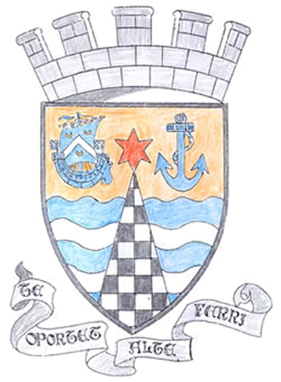
Tayport Ferryport –On-Craig

Community Council

MINUTES OF THE MEETING OF
THE TAYPORT FERRYPORT ON CRAIG COMMUNITY COUNCIL
HELD IN THE BURGH CHAMBERS ON MONDAY 1ST APRIL 2024 AT 19:O0 HRS

Present: Chair: Mrs S Walker. Secretary: Mr G M Beat , Messrs J Kinnear , B de Smid , N Sneddon

Attending: Councillor J Tepp

Apologies: Mrs R Dawson , Miss R McCallum , Mr D Myles ,Mr E MacDonald , Cllr L Kennedy- Dalby

Minutes: The Minutes of the meeting held on 4th March were agreed .

Matters Arising from Previous Minutes:

1. Kerb stones in Pond Lane still not repaired
2. Drain at William Street opposite School , completely Blocked
3. Burn edge / Community Garden bridges need repair , previously reported
4. H&H Site at foot of Nelson Street , broken fence in very poor condition .
5. Pond Reeds have been cut back around 1 metre by Colin Davidson , apparently cost of further work
by Contractors at this time would be extortionate , further work will be done after nesting season
6. Shanwell Road Bus Stop , no update yet

Police Matters: No questions – Report issued to Members .

Agenda Items/ Discussion | Action
Treasurer’s and Foodbank Reports were unavailable at this time .
.
Fife Council and General Correspondence :

1 SEPA Consultation on review of flooding risk in Scotland discussed
2. SEPA Scottish Waste from all sources – highlighted the Scottish recycling
rate has reached an all time high and reliance on landfill is only 23% an all
time low .
3. Temporary Traffic Restrictions – some have ended but cones and signs are
not all being removed after work is completed
4.. St Andrews Hospital (Out of Hours Group) meeting on 16th April
5. Tayport/Serpentine Layby landslip , programmed for work in April , Cycle path,
Council Department responsible looking into it .
6. School Crossing Markings , reported and on Fife Council’s to do list
7. Tay Bridgehead Community Council Forum , successful meeting , minutes
provided for discussion .
.
Planning:

24/00399/ADV Display of 4 Welcome signs at Various locations in Tayport . Fife Council ask for more info before approving costs
Fife Councillors Reports:

Roads Dept answer on Top Park Crossing delays , Supply issues , Damage and weather. Crossing Volume adjusted to lowest permitted setting.

EV Charging points cables crossing pavements , to clarify Legal issues that this raises

Objections raised to traffic order on Parking in Shanwell Road , requires a report to be written for consideration by local area committee

Tayport Playgroup looking for a new permanent home , Suggestions given

Street Lighting issues – Scottish Power are responsible for maintaining but can take
28 days to fix outages

Tay Road Bridge merging South , not long enough for safe connection

Councillor Kennedy Dalby also asks if all Sporting groups could contact herself or the Larick as they are looking into a Sporting Memories Group to see if ther would be interest and volunteers for this Club ,
Questions for Fife Council

1. Waterlogged area needs attention (between Links Road North and BMX Track where new trees planted)
2. Very large pothole on Cupar Road on left hand side within sight of St Michaels Inn , it is dangerous
3. At rear of 49 Ogilvy Street on Cross Street , Tayport , ivy is growing over the wall onto the pavement causing difficulty in getting passed .
4. Cemetery water tap in Central Area now completely broken off and water spouting out
5. Path at rear of Harbour Road choked with silt and seaweed
6. More detail requested on Asset transfer details on Burgh Chambers and Gregory Hall

A.O.C.B.

TCC assets at Jim Kinnear’s property needing disposed of (Marquees etc) for discussion

New signs for entry into Tayport , both ways , also to the Harbour and Library have been erected by Fife Council .
Manufacture of Frames for Heritage Trail are progressing

The Meeting closed at 8.40 pm

Next Meeting in the Burgh Chambers on Monday 6th May at 7 pm

