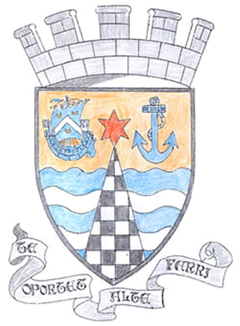
Tayport Ferryport –On-Craig

Community Council

MINUTES OF THE ANNUAL GENERAL MEETING OF
THE TAYPORT FERRYPORT ON CRAIG COMMUNITY COUNCIL
HELD IN THE BURGH CHAMBERS ON MONDAY 6TH MAY 2024 AT 19:O0 HRS

Present: Chair: Mrs S Walker , Secretary: Mr G M Beat , Treasurer: Miss R McCallum
Mrs R Dawson , Messrs J Kinnear , B de Smid , N Sneddon , D Myles ,
E MacDonald

Attending: Councillor J Tepp

Apologies: Councillor L Kennedy-Dalby

Minutes: The Minutes of the meeting held on 1st April were agreed

Declarations of Interest: D Myles ( Foodbank )

Matters arising from Previous Minutes:

1 Seaweed and silt on Harbour Road path cleared naturally by sea and weather
2. BMX Track flooding has receded
3. H & H site fencing still in poor/dangerous condition , lamppost down – reported
4. Zebra Crossing at School reported for indistinct marking and choked drain
5. Pond Lane kerb stone repair on Fife Council List

Report from the Chair: Thanks given to Fife Councillors , Treasurers and Secretary
and for the help of all Community Councillors . Noted that the Crossing to the Top Park has been completed at last , a
successful Christmas Lights Switch on and Minutes to be
widely available .

Treasurer’s Report; Report submitted to Community Council Members

Police Report: Submitted – No Questions

Agenda Items/Discussion
Foodbanks Report.- Still busy , support from Rotary and Newport Trust , Good Group of Volunteers , to advertise for
Donations.
Fife Council and Other Correspondence

1. Christmas lights for 2024 , Good Discussion on gaining help
and ideas from other residents , costs of Blachere and Fife
Council installation and connection rising , looking at further
Consultation with both parties , Keep on Agenda
2. Fire Brigade Consultation - on Website
3. Traffic Restrictions , Nelson Street/Pond Lane , concerns over
Queen Street diversions , Councillor Tepp asking relevant
Department if they can be removed
4. Tayport Instrumental Band closing down
5. Banknowe Kiosk , panes to be repaired
6. Tayport in Bloom Grant paid , new format for Grant
7. Solar Farm installation at Larick asking for TCC support which
we have agreed to .
8. Welcome to Tayport signs , locations agreed and funding
applied for .
Planning.

1 24/00647 Change of use of flat to short term holiday let at 2b
Castle Street DD6 9AF
Fife Councillors Report.  Report issued to all Community Councillors  Notes . Some playground Equipment at East Common removed for replacement  Burn edge resurfacing work and inspection at Burn edge Bridge  Cycle path/Embankment work still to commence  West Lights unadopted road will be periodically maintained when monies  are available  Shanwell Road traffic restrictions to go ahead , with clearer parking signs at  Shanwell Road South  At present in Fife no Dental practices are accepting new NHS patients | .
Questions for Fife Council.

1. Kerbstones in Castle Street (outside old Coloured Soul) and
Queen Street (outside Gregory Hall) need repair
2. King Street road surface in dire need of repair
3. Disabled access on Castle Street (dropped access) being
blocked by drivers

A.O.C.B.

Transfer of Dolphin Centre is not going ahead at this time

The Meeting closed at 9.00 pm

Next Meeting in the Burgh Chambers at 7.00 pm on 3rd June 2024

