RESEARCH ARTICLE



**{description}: Computational Analysis of Sequence Homology**

**{first_name} {last_name}1, Seyed Ahmad Mohajeri2,3, Bamdad Riahi-Zanjani1, Sona Sepahi4, Samaneh Sepahi3 ⃰**

1 Medical Toxicology Research Center, School of Medicine, Mashhad University of Medical Sciences, Mashhad, Iran.

2 Pharmaceutical Research Center, School of Pharmacy, Mashhad University of Medical Sciences, Mashhad, Iran.

3 Targeted Drug Delivery Research Center, School of Pharmacy, Mashhad University of Medical Sciences, Mashhad, Iran.

4 Mashhad University of Medical Sciences, Mashhad, Iran.

5 Iranian Academic Center for Education, Culture and Research, Mashhad, Iran

**ABSTRACT**

Amylase is an enzyme with broad hydrolysis activities that catalyzes the hydrolysis of starch into glucose and other small molecules such as maltose. It is an enzyme of glycoside family with surface layer homology (SLH) domain. SLH, which is known as cell wall binding domain is essential for binding to peptidoglycan of cell membranes. Since designing and producing enzymes with strong catalytic activity is essential in future food industry, investigating the similarities of amylases of different species can be helpful in protein engineering of these enzymes. Homology alignment of bacterial and human amylase sequences shows that both sequences contain 511 amino acid that are highly conserved with several repeated sequences that seems to be necessary for catalysis activity and structural conformation of the protein. In this study, we aimed to characterize the most critical structural and catalytic domains of amylase using bioinformatics tools. In this study, it was shown that SLH and starch binding domain (SBD) are extremely conserved in both human and bacterial amylase. In addition, it was shown that similar domain with several repeated di- or tri-peptide sequences existed in almost all amylases indicating that these residues may have valuable functional, structural and evolutional information. The results of this study may provide new insights into biological aspects of proteins that have not yet been elucidated.

**Keywords:** Amylase, SBD, SLH, Secondary structure

**A**mylase is a hydrolysis enzyme of glycoside hydrolase family that catalyzes the hydrolysis of starch into maltose and glucose (1). As an exocrine enzyme, it is mainly produced in the pancreas and parotid glands. Hence, two isoenzymes of this enzyme have been recognized in human, which is known as alpha-amylase and beta-amylase. Alpha-amylase is produced in salivary glands, but beta-amylase is produced and secreted from pancreas (2). Beta-amylase and bacterial amylases are mainly involved in hydrolysis of polysaccharide chains such as starch and glycogen from their reducing end and produce maltose and glucose. But, alpha-amylase can nonspecifically break down polysaccharide chains with no regular pattern (3, 4).

Enzymes that are derived from microbial sources can be used in industrial applications such as food and detergents. Amylase is an important enzyme that is widely used in pharmaceutical industries as well as in analytical chemistry, detergents, and paper industries (5, 6). Alpha-amylases that are used in industry have mostly fungi and bacterial origin. Bacterial and fungal species such as *Bacillus* and *Actinomycetes* that are stable in various conditions such as high temperatures and acidic environment are suitable for amylase production (7).

The basic structure and homology of starch-degrading enzymes have been studied (8, 9). Some homolog sequences including multiple domains and starch binding domain have been recognized in this group of enzymes. These domains are also found in 10% of microbial amylase (10, 11). Since many bacteria in addition to *Eukaryotes* can produce amylase, finding possible similarities in different isozymes of amylase can be interesting (12, 13). Determination of similar sequences of amylase is helpful in recombinant protein engineering of this enzyme. Studies show that although sequences are more similar in species with close phylogeny, but some consensus sequences are also found in species with relatively far phylogeny. Therefore, identification of similarities and differences in the consensus sequences can help to understand the evolutionary origins of these proteins (5).

The aim of this study is to identify the consensus sequences, and to recognize the evolutionary origins of amylase in bacteria and human in addition to finding specific and similar functional motifs of these enzymes.

**Methods**

***Homology and sequences analysis with CLC software***

The sequences of 100 different bacterial and human amylases were searched within the UniProt (<http://www.uniprot.org/blast/>). The sequences were then blasted using CLC workbench software V 5.1 separately to determine the similarities or differences between human and bacterial amylase. The putative sequences of human and bacterial amylases that had been obtained by sequence blasting were then analyzed.

***Structural analysis of amylase***

Structural analysis of amylase was performed using sequence homology as well as CLC workbench 5.1 and VMD (v 1.8.7) software. Structural prediction of the putative sequences was performed and confirmed using SWISS-MODEL server, CLC workbench and VMD (14, 15). Statistical data were also collected by comparing the sequences.

**Results**

***Sequence analysis***

Bacterial and human amylase consensus sequences were obtained using blast programs. Hence, putative sequences of both species were designed based on consensus sequences. Sequence analyses of 100 thermophile bacterial amylase showed that majority of amylases contain 354 amino acid residues in their structure that is partly conserved in some species. Isoelectric point and molecular weight of the consensus sequence was estimated 5.5 and 41.016 KDa, respectively. The putative sequence of bacterial amylase that had been obtained using blast programs contained 40% hydrophobic, and 20% hydrophilic amino acid residues. Leucine and glycine were the most frequent amino acids in bacterial amylase. Lue-Asp, Lys-Glu and Gly-Asp were also shown to be the most frequent repeated dipeptide sequence (**Table 1**).

Consensus sequence of human amylase contained 511 amino acid residues with estimated isoelectric point and molecular weight of 6.73 and 57.76 KDa, respectively. Forty eight percent of all amino acid residues were hydrophobic and 27% were hydrophilic. Similar to bacterial amylase, glycine was the most frequent amino acid of human amylase.

C-terminal region of bacterial consensus sequence was rich of lysine (positive charge) and N-terminal region contained aromatic amino acids as well as aspartic acid (negative charge). The C-terminal of human and bacterial amylase had amino acid with positive and negative and dominant second structure is in N-terminal region with aromatic amino acid and amino acid with positive charge. Asn-Asp and Thr-Gly dipeptides were the most frequent sequences with sixteen repeats (**Table 1**). GFRI and VINH tetrapeptide was observed in both human and bacterial amylase sequences. But the GFRD tetrapeptide was the most frequent repeated sequence in both bacterial and human amylase. His-Asp dipeptide was observed in all bacterial amylases, so it was deduced that this dipeptide may have major role in structure or function of these proteins.

**Table 1.** Motifs found in human and bacterial amylase sequences.

|  |  |  |
| --- | --- | --- |
| **Name** | **Motif** | **Peptide** |
|  | IVHLFEW400 | Heptapeptide |
| I412(x6)YL(X3)G(X3)V(X3)P |  |
| Y457(X4)Y(X1)L(X4)G(X3)E |
| V492(X6)G499(X)I(X)I(X2)D507(X) |
| V509 I 510 N511 H512  Human and Bacterial amylase | Tetrapeptide |
| G671F672R673I674 | Tetrapeptide |
| D713 A714 |  |
| E(D)806 |
| L846 |
| N853H854D855 | Tripeptide |
| L919 |  |

***SLH and SBD domain***

Surface layer homology (SLH) domain is composed of one to three repeats of 50 amino acids, wherein 10 to 15 amino acids are highly conserved. Sequence analysis of this domain showed that Lue-Ala dipeptide was the most frequent dipeptide sequence in SLH domain of bacterial amylase, especially in *Thermoanaerobacterium thermosulfurigenes, Bacillus stearothermophilus TS-23,* and *Bacillus sp. XAL601*. Comparison of bacterial and human SLH domain showed that there is 30% homology between the sequences of both species. The results also showed that Asp-Ile, Thr-Arg and Ala-Glu dipeptides were the most frequent dipeptides in SLH domain of two sequences (**Table 2**).

**Table 2**. Comparison of SLH domain in three bacterial species (*Thermoanaerobacterium thermosulfurigenes, Bacillus stearothermophilus TS-23,* and *Bacillus sp. XAL601*) with putative human and bacterial amylase sequences.

|  |  |
| --- | --- |
| **Similar sequences** | **SLH domains** |
| Asp 162-Ile 163  Lys 187-(X2)-Ile  Ala 213-(x)-lys 215  Phe 244-(x3)-Asp 248-val 249  Lys 276-(x)-Gly 278-(X)-Ile 280-(x5)-Gly 286  Thr 351-Arg 352  Phe 451-(x9)-Pro 460-(x)-Gly 462  Ala 507-Glu 508 (C-terminal) | Putative human amylase |
| Asp 3-(x4)-Trp8-(x)-Lys (N-terminal)  Lue 27-Ala 28-(x6)-Glys 35 (N-terminal)  Phe 73-(X3)-Asp 77-(x)-Lys 79  Glu 124-Trp 125  Gly 233-(x3)-Gly 237  Gly 327-Lue 328 (C-terminal) | Putative bacteria amylase |

The sequence of starch binding domain (SBD) is almost similar among microbial amylolytic enzymes. There is also 28% similarity between human genethonin and cyclodextrin glycosiltransferase (CGTase) of Bacillus species with bacterial and human SBD (**Table 3**). V104XVDR, L277G, and W284, repeats were also found within the studied sequences. In addition, Phe 350, Gly 366 and Thr 357 were highly conserved in these sequences. These results may explain similar mechanism of action, despite wide difference between the origins of amylase.

***Table 3.*** SBD motif in human genethonin, and bacteria CGTase compared with conserved sequence in bacterial and human amylase.

|  |  |
| --- | --- |
| Ser (Thr)21-Gln  Glu 364-Asn 365  Val 381-Thr 382  Ile 505-His 506 | **Genethonin and human amylase** |
| Val 104-(x)-Val-Arg  Lue 277- Gly  Ile 311-(x4)-Asn-Gln  Trp331-(x6)-Ala | **Genethonin and bacteria CGTase compared with human amylase** |
| Ile 46-Gly 47  Pro 197-Ala 198  Ile 266-(x3)-Gly 270 | **Bacterial CGTase and human genethonin compared with bacteria amylase** |

***Structural studies***

As expected by primary structure of the putative sequences, modeling and structural studies of the human and bacterial amylase showed that various types of this enzyme have similar structure. Secondary structure of the bacterial and human putative sequences are demonstrated in figure 1 and 2.

C:\Users\adel\AppData\Local\Microsoft\Windows\INetCache\Content.Word\putative bacterial amylase.tif

**Figure 1.** Secondary structure of putative bacterial amylase

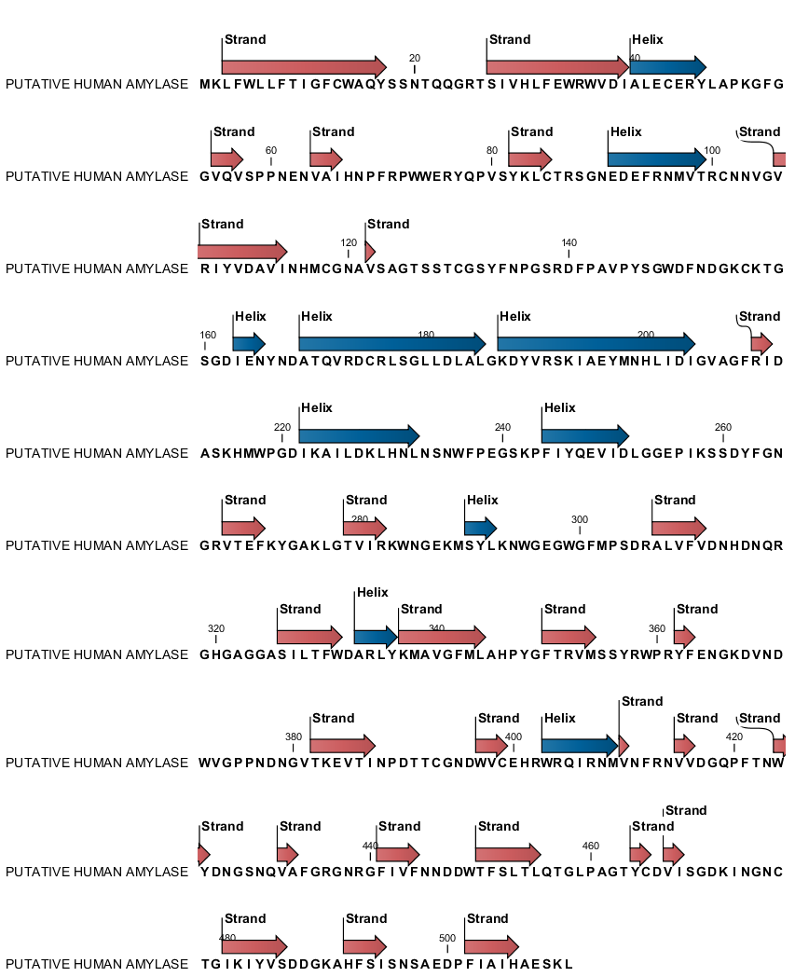

**Figure 2.** Secondary structure of putative human amylase.

**Discussion and conclusion**

Structure and function of starch hydrolyzing enzymes including alpha and beta amylase, cyclodextrin glycosiltransferase and oligo 1, 6 glucosidase have been extensively studied (16-18). Amylase family has 5 conserved regions (substrate banding domains) with α/β barrel structure, wherein the active site of these enzymes is in C-terminal of barrel (19). Findings have shown that α/β barrel catalytic domain is composed of 8 β-strands that are surrounded by 8 α-helix structures. Because this structure was primarily observed in muscle triose phosphate isomerase (TIM), the enzymes with this folding structure are called TIM barrel enzymes (20). Sequence analysis showed that alpha amylase has 10 repeats of α/β barrels, but beta amylase has the lowest structural similarities to alpha amylase subfamily (13, 21).

Investigation on sequence homology of the putative-raw starch binding domain of starch-hydrolyzing enzymes that included starch-degrading enzymes from fungi showed that their structure was rich of glycine. They also showed that tryptophan, isoleucine, lysine, asparagine and threonine had an important role in binding glycoside to enzyme active site. Also, it was shown that amino acids including proline and glycine play critical role in conformation of the polypeptide (8, 22). In agreement with these findings, we showed that glycine and proline were highly conserved in the bacterial amylase, and these amino acids may have important role in poly peptide conformation. In consistent to our findings, the results of studies on SBD of amylase in bacteria, fungi and human showed that this domain exists in almost 10% of amylolytic enzymes. SBD motif was also found in genethonin, cyclodextrin glycosiltransferase and aspergillus glucoamylase. SBD in these sequences contains β-sheet and β-barrel that are mainly responsible for binding to the starch (10, 23, 24).

Since, amylase is an important enzyme with wide industrial applications, study of its structure and functional domains can help to design recombinant enzymes with broad spectrum of catalytic activities (25). In this study, we studied on different isoenzyme of bacterial and human amylase, and the results showed that these proteins with same catalytic activity have similar structure and sequence with similar functional domains. The results of this study suggest that consensus sequence of human and bacterial amylase had a highly conserved sequences including a SLH domain in outer surface of the protein that facilitate the binding of enzyme to cell wall and a SBD domain that is responsible for binding of enzyme to starch. The results of this study may provide new insights into biological aspects of amylase that can help to design new recombinant enzymes with high catalytic activity and with high resistance to pH and temperature variations.

**References**

1. Kumar V. Identification of the sequence motif of glycoside hydrolase 13 family members. Bioinformation. 2011;6(2):61-3.

2. Blesák K, Janeček Š. Two potentially novel amylolytic enzyme specificities in the prokaryotic glycoside hydrolase α-amylase family GH57. Microbiology. 2013;159(12):2584-93.

3. Reddy N, Nimmagadda A, Rao KS. An overview of the microbial α-amylase family. African Journal of Biotechnology. 2004;2(12):645-8.

4. Yamashita K, Tachibana Y, Nakayama T, Kitamura M, Endo Y, Kobata A. Structural studies of the sugar chains of human parotid alpha-amylase. Journal of Biological Chemistry. 1980;255(12):5635-42.

5. Gabriško M. Evolutionary history of eukaryotic α-glucosidases from the α-amylase family. Journal of molecular evolution. 2013;76(3):129-45.

6. Park J-T, Suwanto A, Tan I, Nuryanto T, Lukman R, Wang K, Jane J-l. Molecular cloning and characterization of a thermostable α-amylase exhibiting an unusually high activity. Food Science and Biotechnology. 2014;23(1):125-32.

7. Maity S, Mallik S, Basuthakur R, Gupta S. Optimization of Solid State Fermentation Conditions and Characterization of Thermostable Alpha Amylase from Bacillus subtilis (ATCC 6633). Journal of Bioprocessing & Biotechniques. 2015;2015.

8. Svensson B, Jespersen H, Sierks MR, MacGregor E. Sequence homology between putative raw-starch binding domains from different starch-degrading enzymes. Biochemical Journal. 1989;264(1):309.

9. Tiwari S, Srivastava R, Singh C, Shukla K, Singh R, Singh P, Singh R, Singh N, Sharma R. Amylases: an overview with special reference to alpha amylase. J Global Biosci. 2015;4:1886-901.

10. Janeček Š. A motif of a microbial starch-binding domain found in human genethonin. Bioinformatics. 2002;18(11):1534-7.

11. Zona R, Janecek S. Relationships between SLH motifs from different glycoside hydrolase families. Biologia (Bratisl). 2005;60:115-21.

12. Carpenter D, Dhar S, Mitchell LM, Fu B, Tyson J, Shwan NA, Yang F, Thomas MG, Armour JA. Obesity, starch digestion and amylase: association between copy number variants at human salivary (AMY1) and pancreatic (AMY2) amylase genes. Human molecular genetics. 2015;24(12):3472-80.

13. Janeček Š, Svensson B, MacGregor EA. α-Amylase: an enzyme specificity found in various families of glycoside hydrolases. Cellular and Molecular Life Sciences. 2014;71(7):1149-70.

14. Arnold K, Bordoli L, Kopp J, Schwede T. The SWISS-MODEL workspace: a web-based environment for protein structure homology modelling. Bioinformatics. 2006 Jan 15;22(2):195-201. DOI: 10.1093/bioinformatics/bti770.

15. Schwede T, Kopp J, Guex N, Peitsch MC. SWISS-MODEL: An automated protein homology-modeling server. Nucleic acids research. 2003 Jul 1;31(13):3381-5.

16. Syson K, Stevenson CE, Rashid AM, Saalbach G, Tang M, Tuukkanen A, Svergun DI, Withers SG, Lawson DM, Bornemann S. Structural insight into how Streptomyces coelicolor maltosyl transferase GlgE binds α-maltose 1-phosphate and forms a maltosyl-enzyme intermediate. Biochemistry. 2014;53(15):2494-504.

17. El‐Enshasy HA, FATTAH A, Othman NZ. Amylases: Characteristics, Sources, Production, and Applications. Bioprocessing Technologies in Biorefinery for Sustainable Production of Fuels, Chemicals, and Polymers, Wiley, USA. 2013.

18. A Linares-Pasten J, Andersson M, N Karlsson E. Thermostable glycoside hydrolases in biorefinery technologies. Current Biotechnology. 2014;3(1):26-44.

19. Janeček Š. Parallel β/α‐barrels of α‐amylase, cyclodextrin glycosyltransferase and oligo‐1, 6‐glucosidase versus the barrel of β‐amylase: Evolutionary distance is a reflection of unrelated sequences. FEBS letters. 1994;353(2):119-23.

20. Janeček Š, Ivuchtová A, Petrovičová S. A novel GH13 subfamily of α-amylases with a pair of tryptophans in the helix α3 of the catalytic TIM-barrel, the LPDlx signature in the conserved sequence region V and a conserved aromatic motif at the C-terminus. Biologia. 2015;70(10):1284-94.

21. Froese DS, Michaeli A, McCorvie TJ, Krojer T, Sasi M, Melaev E, Goldblum A, Zatsepin M, Lossos A, Álvarez R. Structural basis of glycogen branching enzyme deficiency and pharmacologic rescue by rational peptide design. Human molecular genetics. 2015:ddv280.

22. Møller MS, Goh YJ, Viborg AH, Andersen JM, Klaenhammer TR, Svensson B, Hachem MA. Recent insight in α-glucan metabolism in probiotic bacteria. Biologia. 2014;69(6):713-21.

23. Meekins DA, Vander Kooi CW, Gentry MS. Structural mechanisms of plant glucan phosphatases in starch metabolism. FEBS Journal. 2016.

24. Peng H, Zheng Y, Chen M, Wang Y, Xiao Y, Gao Y. A starch-binding domain identified in α-amylase (AmyP) represents a new family of carbohydrate-binding modules that contribute to enzymatic hydrolysis of soluble starch. FEBS letters. 2014;588(7):1161-7.

25. Lu Z, Wang Q, Jiang S, Zhang G, Ma Y. Truncation of the unique N-terminal domain improved the thermos-stability and specific activity of alkaline α-amylase Amy703. Scientific reports. 2016;6.