**Title:**

Deleting a non-existent tag from a vulnerability results in message ‘Tag deleted successfully’

**Steps:**

1. Pre-Condition: Knowledge of orgUuid and traceUuid
2. Credentials to form a valid header for making valid API requests to <https://ce.contrastsecurity.com/>
3. Using an API client, make the following request

DELETE

[https://ce.contrastsecurity.com/Contrast/api/ng/{orgUuid}/tags/trace/{traceUuid}](https://ce.contrastsecurity.com/Contrast/api/ng/%7borgUuid%7d/tags/trace/%7btraceUuid%7d)

1. In the body, specify a tag which does not exist for that vulnerability. For example, use a GUID as tag name

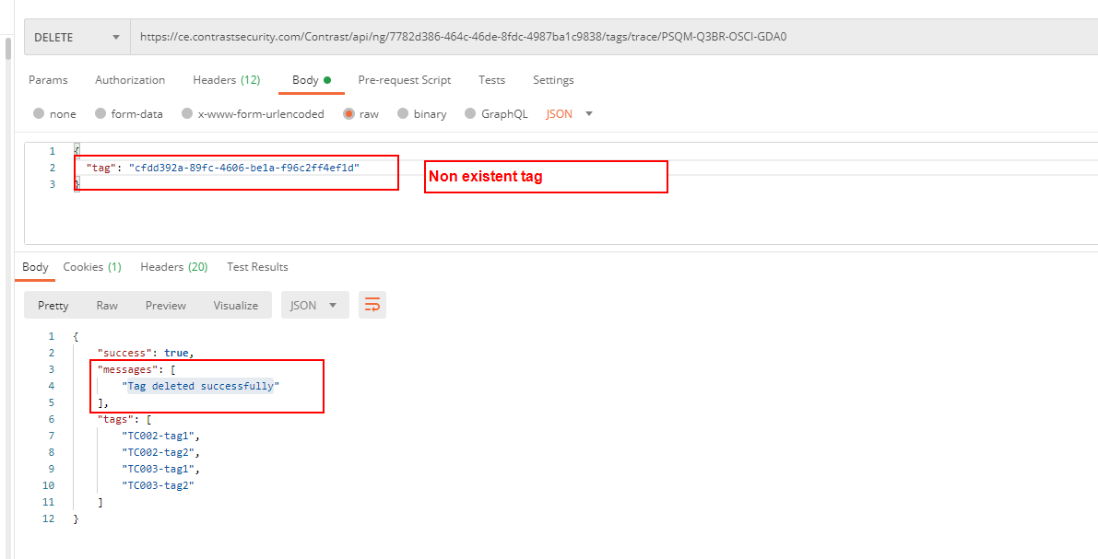

1. As seen, the messages array contains message “Tag deleted successfully”. – BUG. I believe this is incorrect, or at the least, misleading.
2. I suggest the message should read something like “One or more tags specified did not exist”.
3. It appears to me that the above is by conscious design, since adding an existing tag also results in message “Tag added successfully”. But from a user perspective, such messages appear misleading.
4. The steps for this bug report have been automated in TC004() in the UnitTestsAPI project.