**Title:**

Incorrect message in GET /ng/{orgUuid}/tags/traces response body

**Steps:**

1. Pre-Condition: Knowledge of orgUuid
2. Credentials to form a valid header for making valid API requests to <https://ce.contrastsecurity.com/>
3. /ng/{orgUuid}/tags/traces. API documentation. The following description is correct

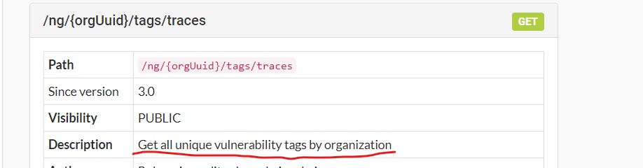

1. Make the above call in an API client
2. The following is the response body

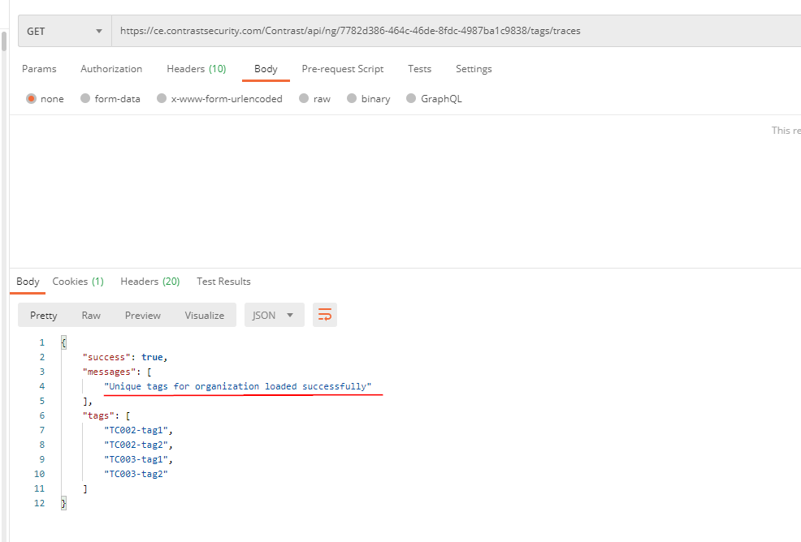

1. The above message is incorrect - BUG. It should read as “Unique vulnerability tags for organization loaded successfully”. Because an organization can have tags for applications, servers, libraries etc. The above call lists *only* vulnerability tags. I have verified the functionality of the above as well by adding tags to applications etc. Also note that the URI includes tags/traces, meaning it is only for vulnerability tags