**Title:**

Get all available filters (/ng/{orgUuid}/traces/filters/listing/new). 500 (server error) for invalid query string values

**Steps:**

1. Pre-Condition: Knowledge of orgUuid.
2. Credentials to form a valid header for making valid API requests to <https://ce.contrastsecurity.com/>
3. /ng/{orgUuid}/traces/filters/listing/new
4. The following is the documentation for it

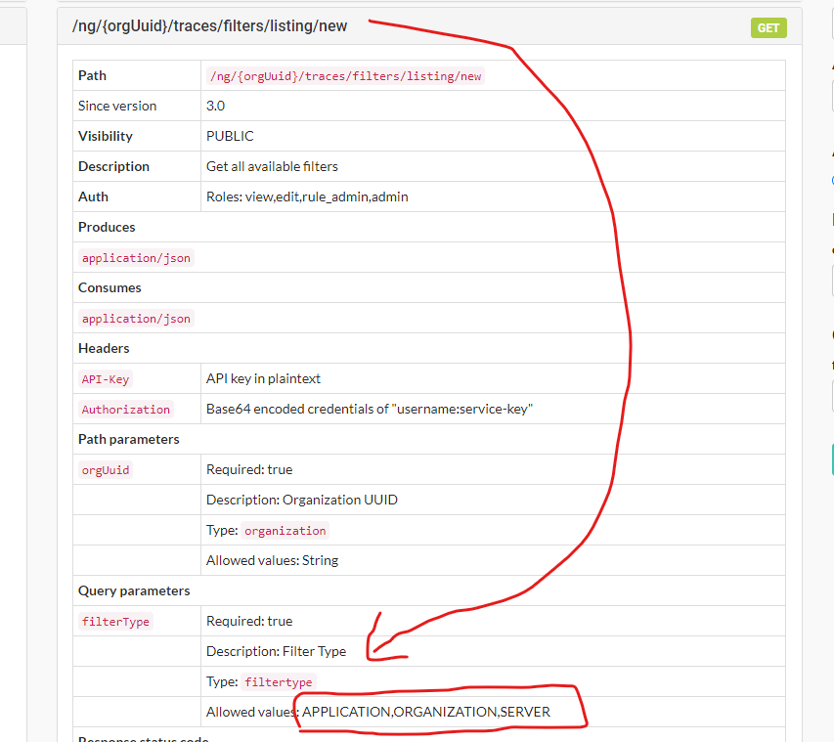

1. Specify any of these query string values in lower case

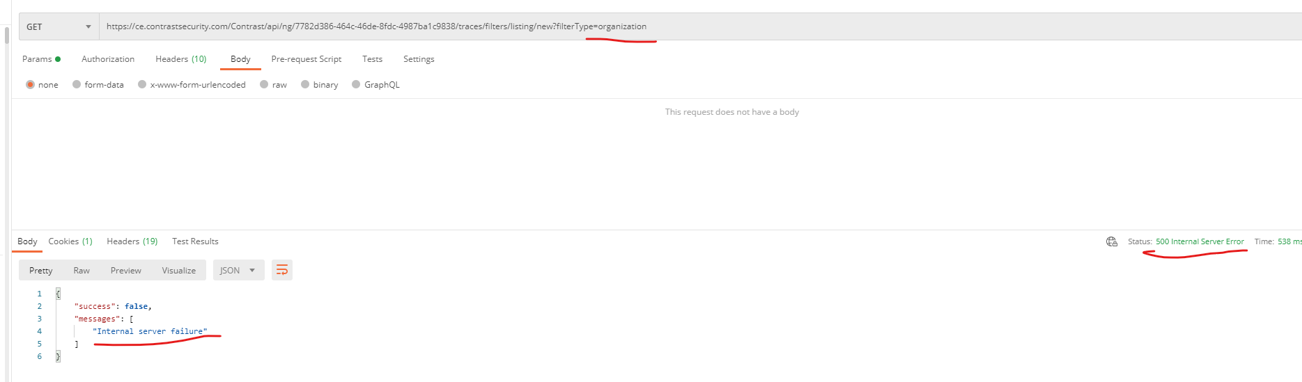

1. As seen this results in 500 - BUG
2. I think the server should be able to handle this and should come back with 400 (Bad Request)
3. Note the same error happens for any invalid query string value e.g. “abc”