**Title:**

For log in, the field label “Username or Email” is misleading / confusing. Not consistent with how this labelling is used in popular web apps (and thus contrary to user expectations).

**Steps:**

**Note:** This bugs stems from the fact that for my API header authorization in the code, I initially used mmdfaisal:{service-key} to encode to base-64 (which obviously did not work) instead of using [mmdfaisal@gmail.com:{service-key}](mailto:mmdfaisal@gmail.com:%7bservice-key%7d)

I knew I needed the username field from the following:

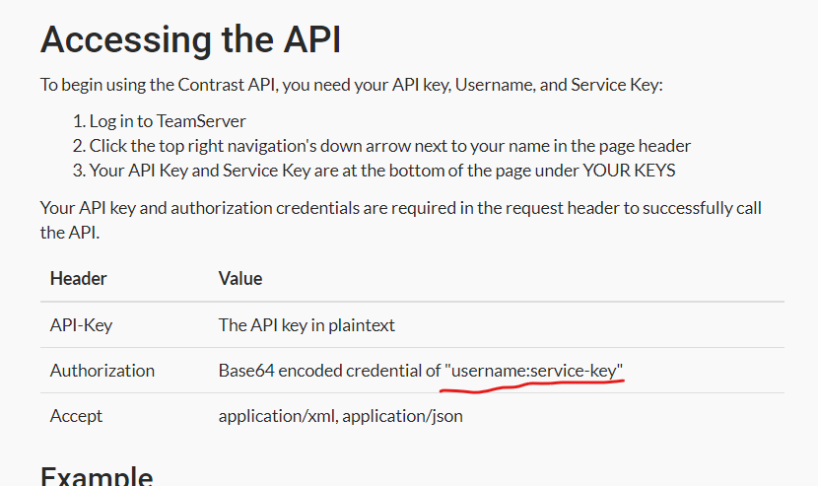

1. Access <https://ce.contrastsecurity.com/>
2. You are presented with the following

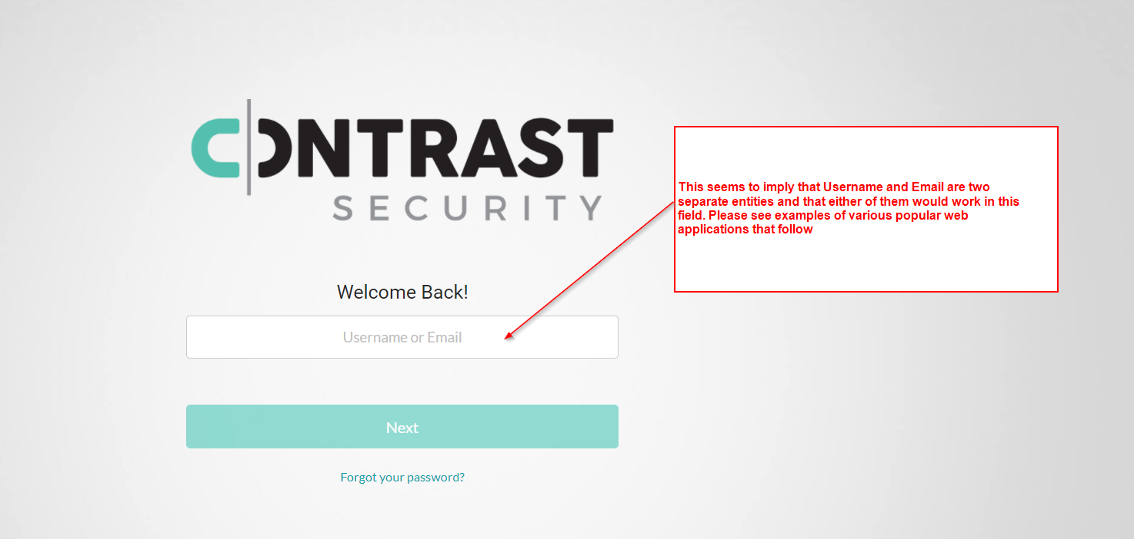

1. The web apps that employ the above kind of dual entity for login have two separate entities that both work.

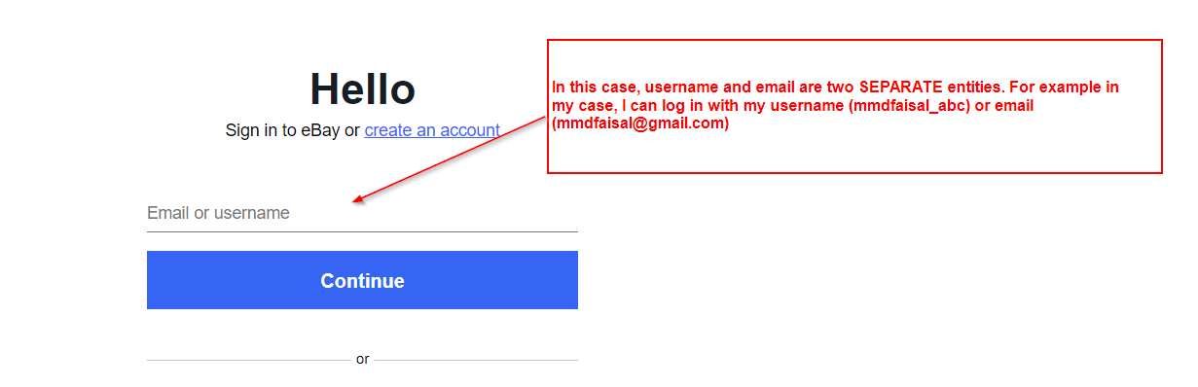

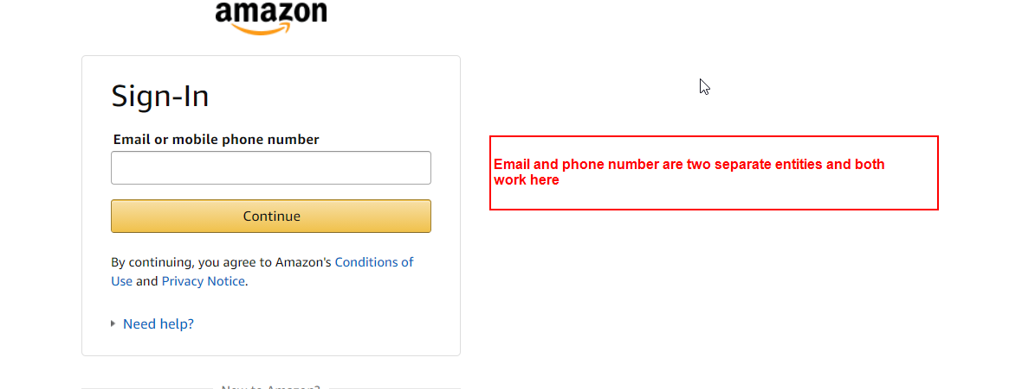

1. Other popular web apps do not use this dual entity login, and their login field clearly defines what exactly does the user have to enter

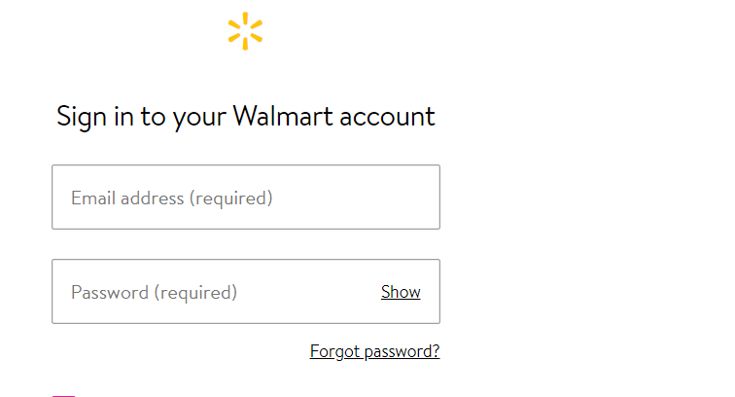

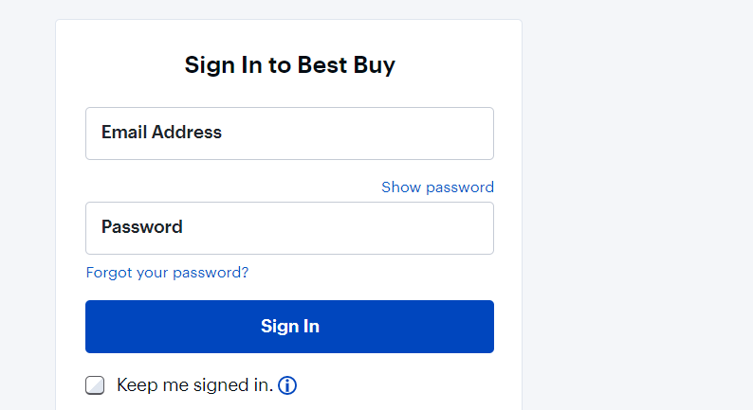

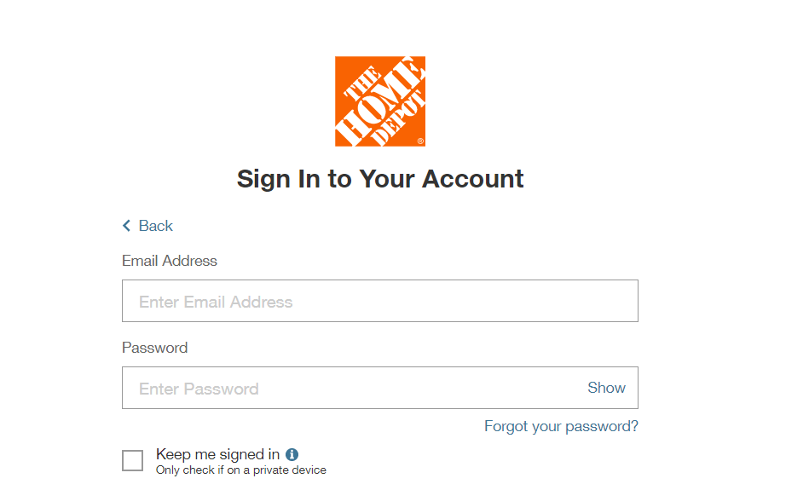

1. This leads me back to the Contrast Security log in screen. As seen, it is not consistent with how the labelling “username or email” is popularly used and it is therefore confusing from a user perspective.
2. Please also note that in the User details screen, there is no such entry as username, so it is hard for me as a user to figure out what is the value for username

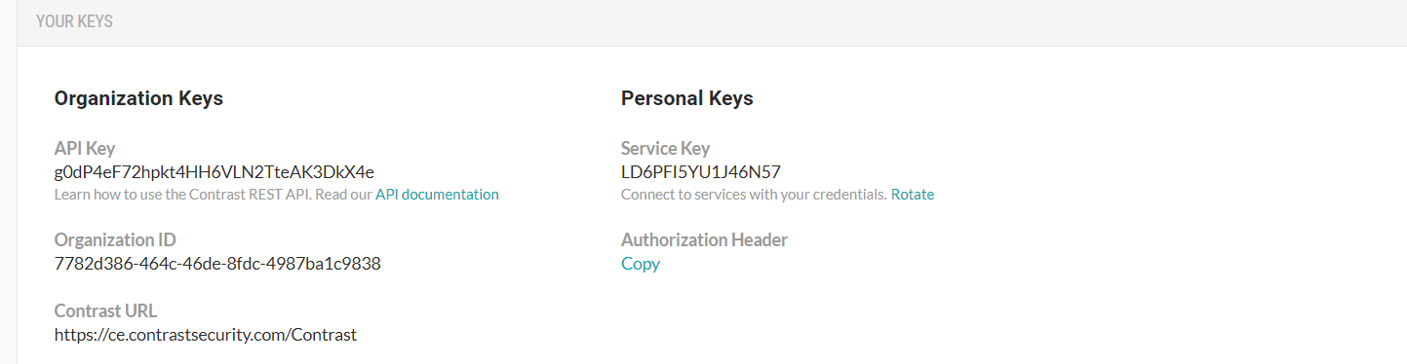

1. GET call to /ng/orgUuid/users also does not list any field named “username”. It lists user_uuid

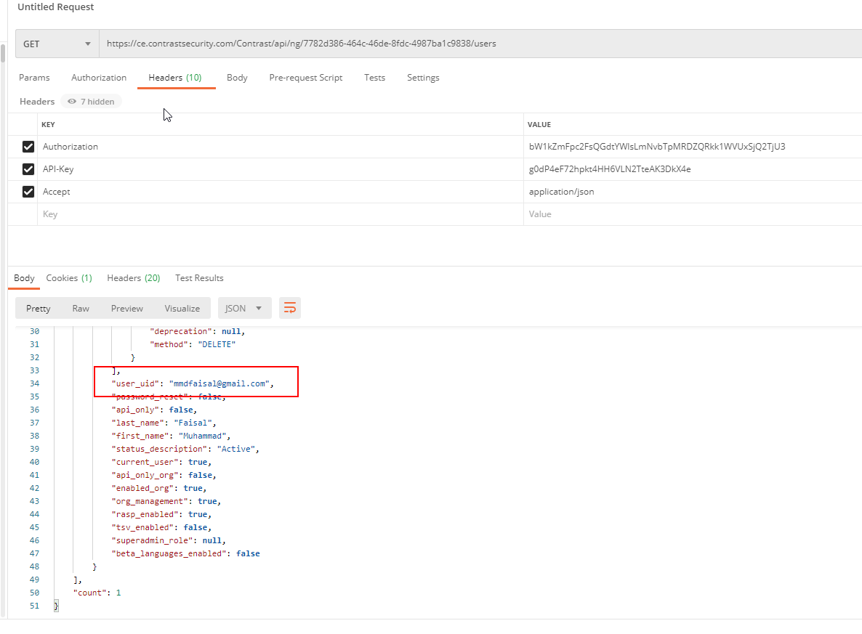

1. I suggest the UI label should be Username(your email address). This will help the user on the UI screen. It will also help the API user when they need the username to generate the auth header.