**Title:**

Inconsistency between Contrast project assignment doc and Contrast UI. The UI button should have label ‘Create Free Account’

**Steps:**

1. Application to QA Test Software Engineer role at Contrast Security.
2. Phone screen.
3. Technical interview.
4. Receive project assignment doc. See screenshot below

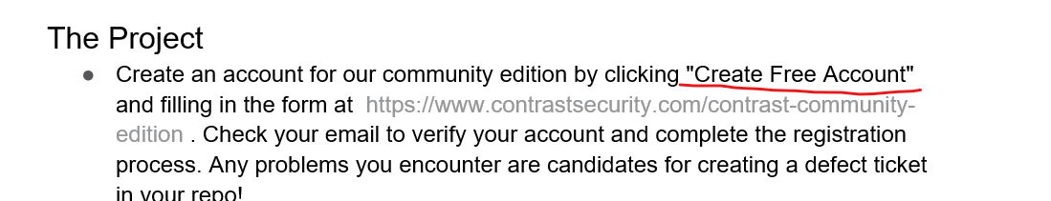

1. Clear the browser cache so any existing sessions / cookies are deleted.
2. Access the URL in the above doc.
3. See screenshot below

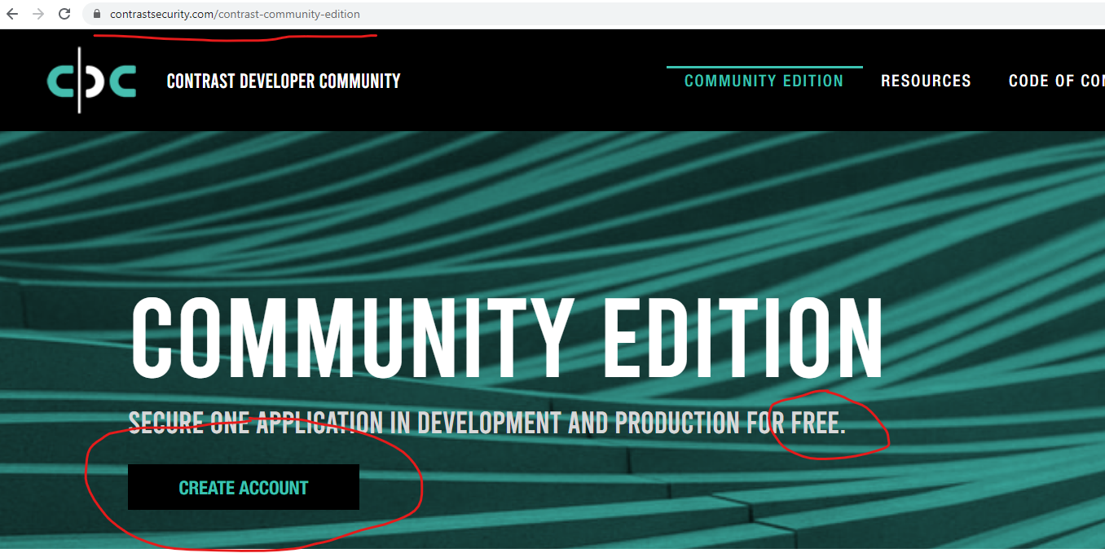

1. It does not say “Create Free Account” as per the project doc – BUG
2. It does say in the text above that it is free.

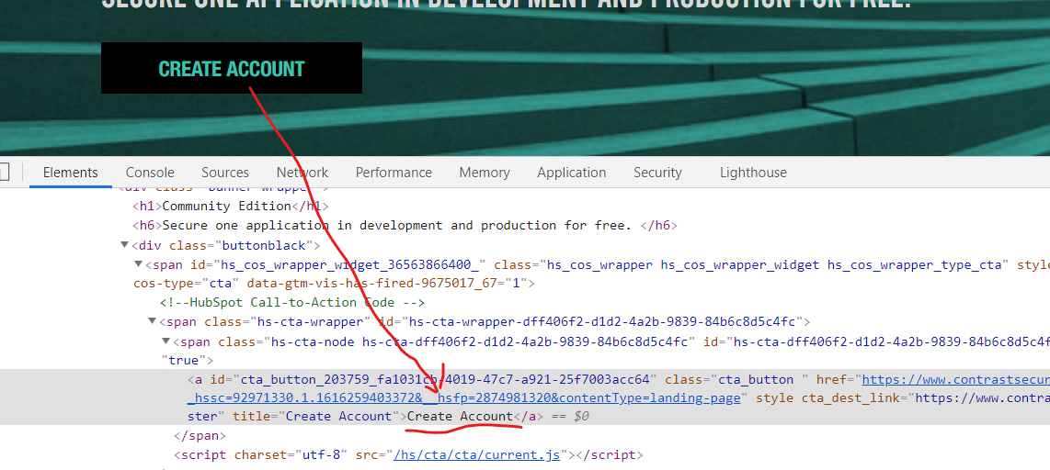

1. But people notice buttons more **quickly** than text. I suggest changing title/innertext property to Create Free Account