**Title:**

Create new Community edition account. Configure credentials. Inconsistency in tooltip for password and confirm password input fields.

**Steps:**

1. Access <https://www.contrastsecurity.com/contrast-community-edition>
2. Create a new account.
3. Click on the confirm link in your email.
4. During this process, you will come to the Configure Credentials screen
5. Enter a new password field has tooltip. But the ‘Confirm your new password’ field does not have tooltip. I believe this one should have tooltip too.

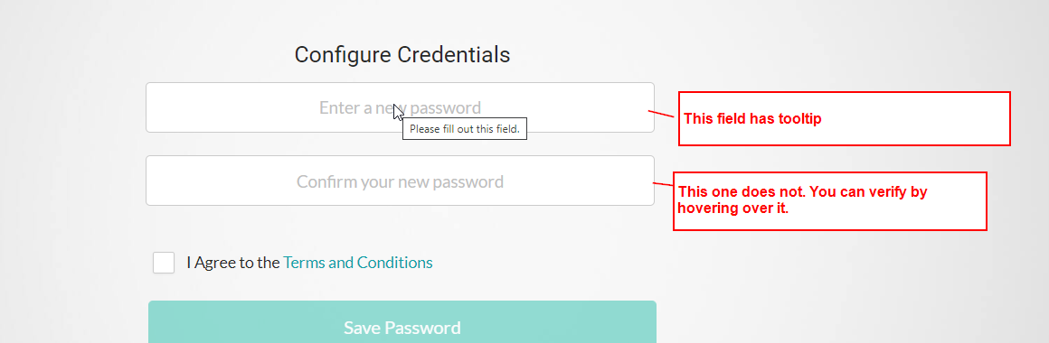

1. At present, I am unable to depict/detect the above (jQuery?) tooltip using the browser DOM. I did some research into it and tried a few things but not successful so far. Will look more into it.
2. Note that on regular login screen, when the user is presented with Username/Email field, that field also does have tooltip