**Title:**

API documentation. Entries in the left bar get misaligned on higher zoom setting of Chrome browser

**Configuration:**

OS: Windows 10

Browser: Chrome Version 89.0.4389.82 (Official Build) (64-bit)

Resolution: 1920 x 1080

Monitor Size: 23 inches

**Steps:**

1. Access <https://api.contrastsecurity.com/>
2. In Chrome browser, set the zoom to 150%
3. The entries in the left bar flow out of their defined zone – BUG

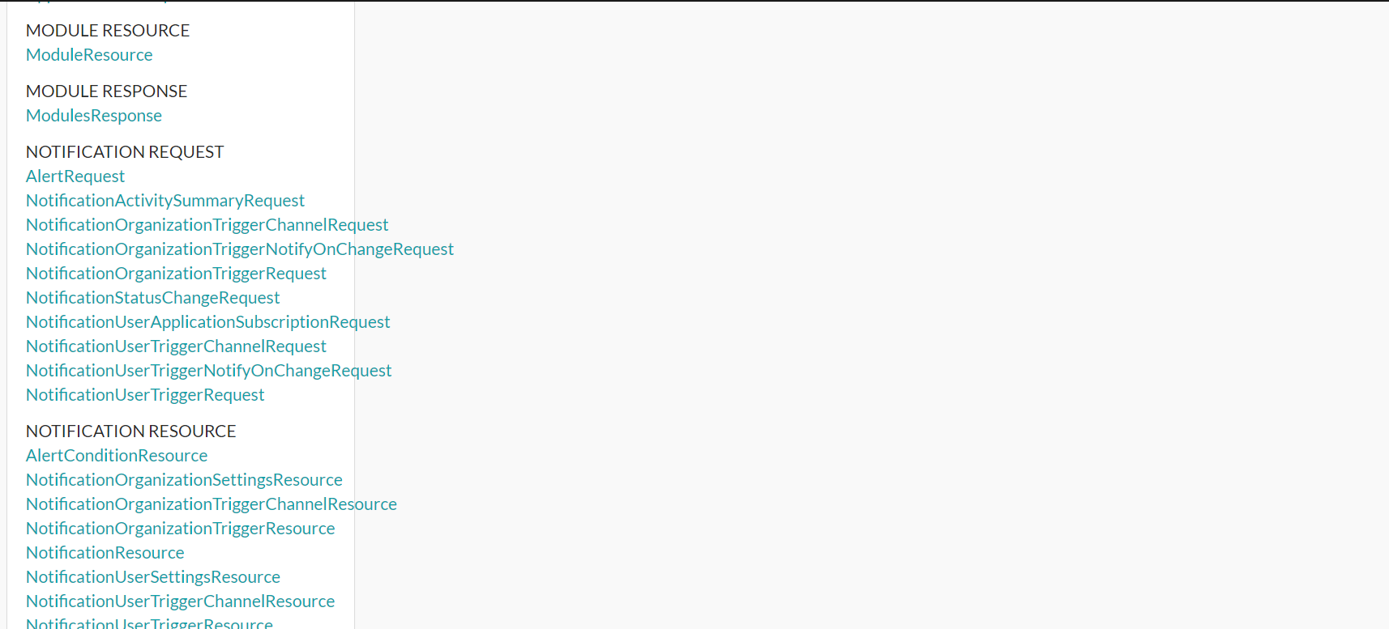

1. I tested similar scenario on other popular web apps. For example, on amazon, on the same config settings as above, this is at 200% zoom.

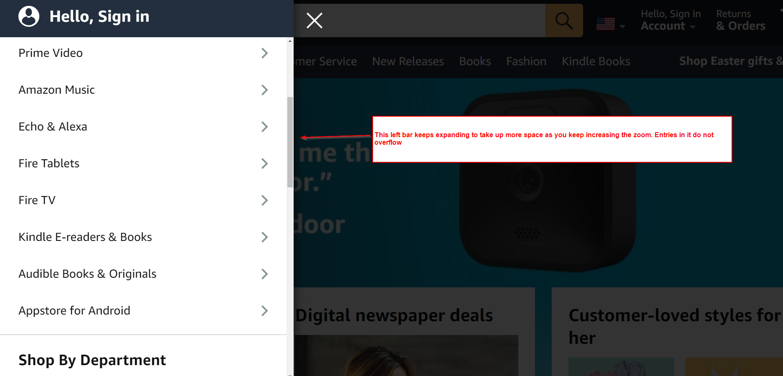

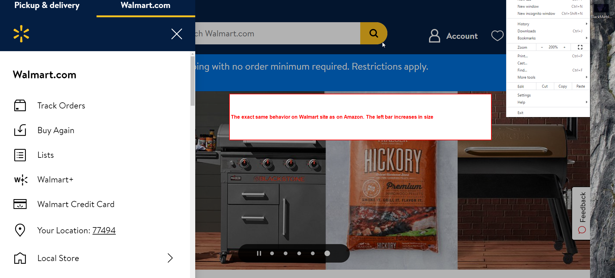

1. On Contrast, the bar width does not increase, but the text does. Leading to overflow