**Title:**

Time Zone for a new user is assumed as EST. The API call does not revert back to EST after it has been changed (or API property values do not change when change is made on the UI)

Note: These can be considered two/multiple bugs but since the second/others appear to be a consequence of the first, I am listing in the same bug report.

**Steps:**

1. Create a new user of Contrast Security Community .
2. Note that in that process, the user is NOT asked about their time zone.
3. In the UI, top right corner, access User Settings.
4. The Time Zone is defaulted to EST. I think this should not happen. It should be possible for the web client to detect the user’s time zone based on their IP and use it accordingly in the account settings. Or ask the user their timezone during registration.
5. Using an API client, do

GET <https://ce.contrastsecurity.com/Contrast/api/ng/profile/organizations>

1. Note that value of timezone property is “EST”

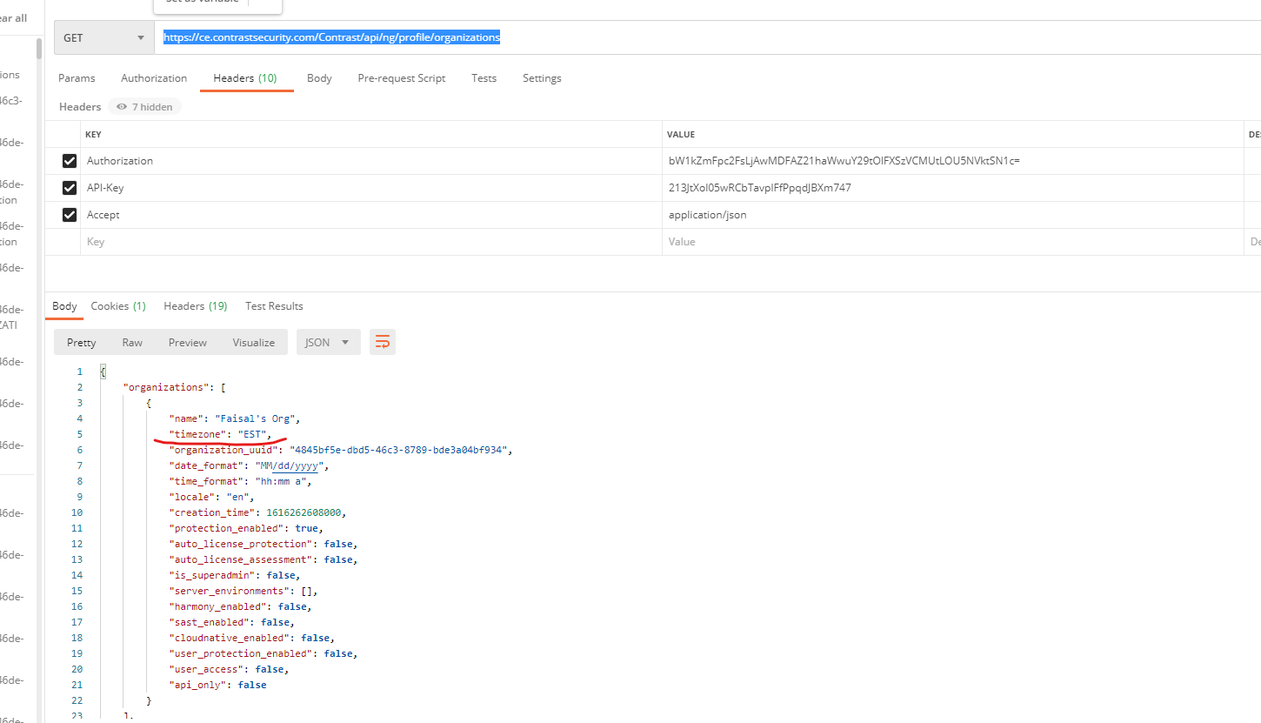

1. Now in the web client, change to the time zone to any other value e.g. Central Time. Save

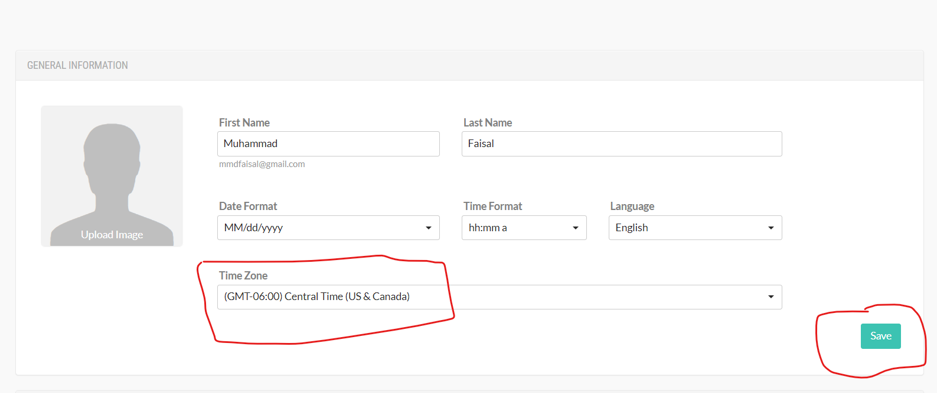

1. Do the same GET call as before

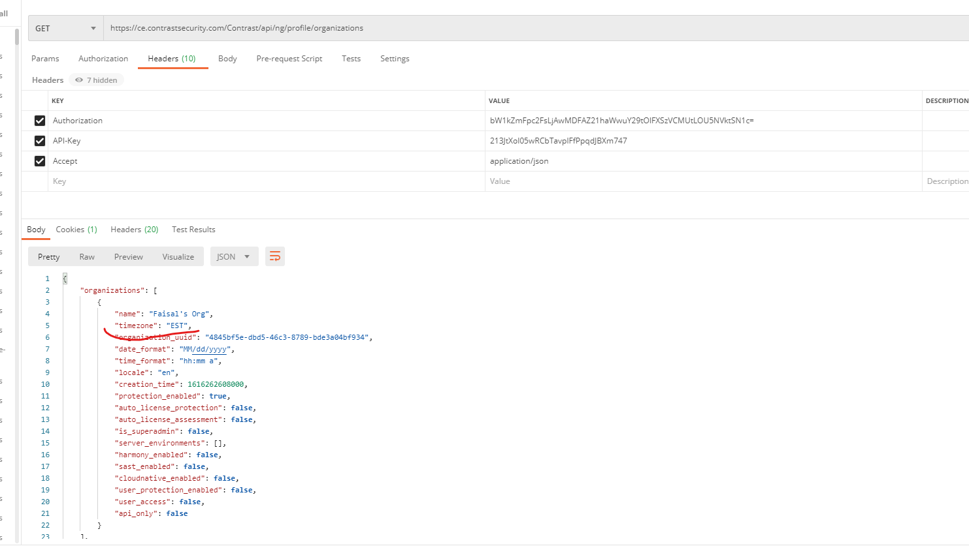

1. The time zone continues to show up as EST – BUG

Note: This appears to be a new bug as of 03/20/21. I had tested the same a few days earlier and the timezone in the API call did change. The bug I wanted to report at that time was that it no longer uses EST/CST etc in the timezone values for the API property. Instead it was using America/NewYork and so on. Which is inconsistent with the initial state, which was EST.

As of now, 03/20/21, changing any of the properties like Language/Locale, TimeFormat etc in the UI are having any effect on the results of the API call. Maybe there is some caching time period. Not sure. Note that on 03/20/21, I created another new account to test this scenario.

Update: Tried again after 15 mins but the API call still does not list any changed property values.