**Title:**

API Documentation. Usability Issue. Object names should be hyperlinked to their definitions.

**Steps:**

1. Using this endpoint as an example.

/ng/{orgUuid}/traces/{appId}/filter

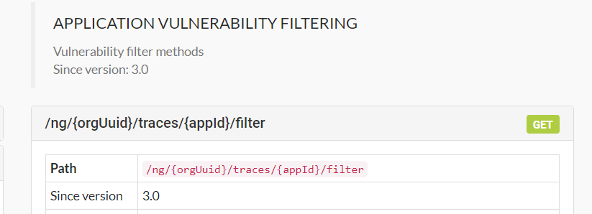

1. Scroll down the list of Query Parameters. Using a parameter which start with “list of….”

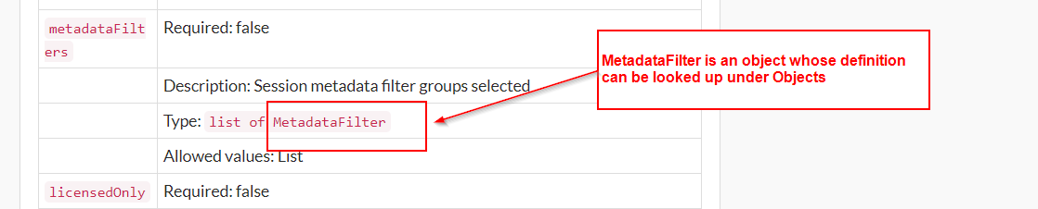

1. Now using an object definition of another object. Here a field description also starts with “list of…” – same as in step 2.

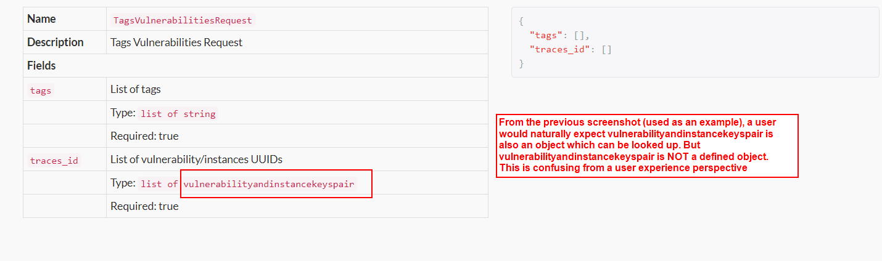

1. To resolve these kind of situations, I suggest whenever an object name is listed, it should be hyperlinked to its definition. It would solve the confusion between what is a Contrast API object and what is not that.
2. The above suggestion(4) would also resolve this usability issue I faced:
3. Any time I encountered a new object (as in Step 2), I would:

* Open a new browser window
* Navigate to <https://api.contrastsecurity.com/>
* Do control F
* Copy/paste the object name to find that object in the documentation
* Click on that object name in the left bar to view its definition

1. The above is quite a convoluted and not user friendly experience. If the object name is hyperlinked, the user can open that link in a new tab. So that they can quickly look it up and also do not lose their current position in the chain of objects which they are researching.