**Title:**

Contrast Careers Page. The six company values may not be perceived by the user as equally important.

**Configuration:**

OS: Windows 10

Browser: Chrome Version 89.0.4389.82 (Official Build) (64-bit)

Resolution: 1920 x 1080

Monitor Size: 23 inches

**Steps:**

1. Access <https://www.contrastsecurity.com/careers>
2. Zoom setting at 100%, so this is the default user experience.
3. Scroll down to where the six company values are described.
4. Under the above config settings, this is how it displays

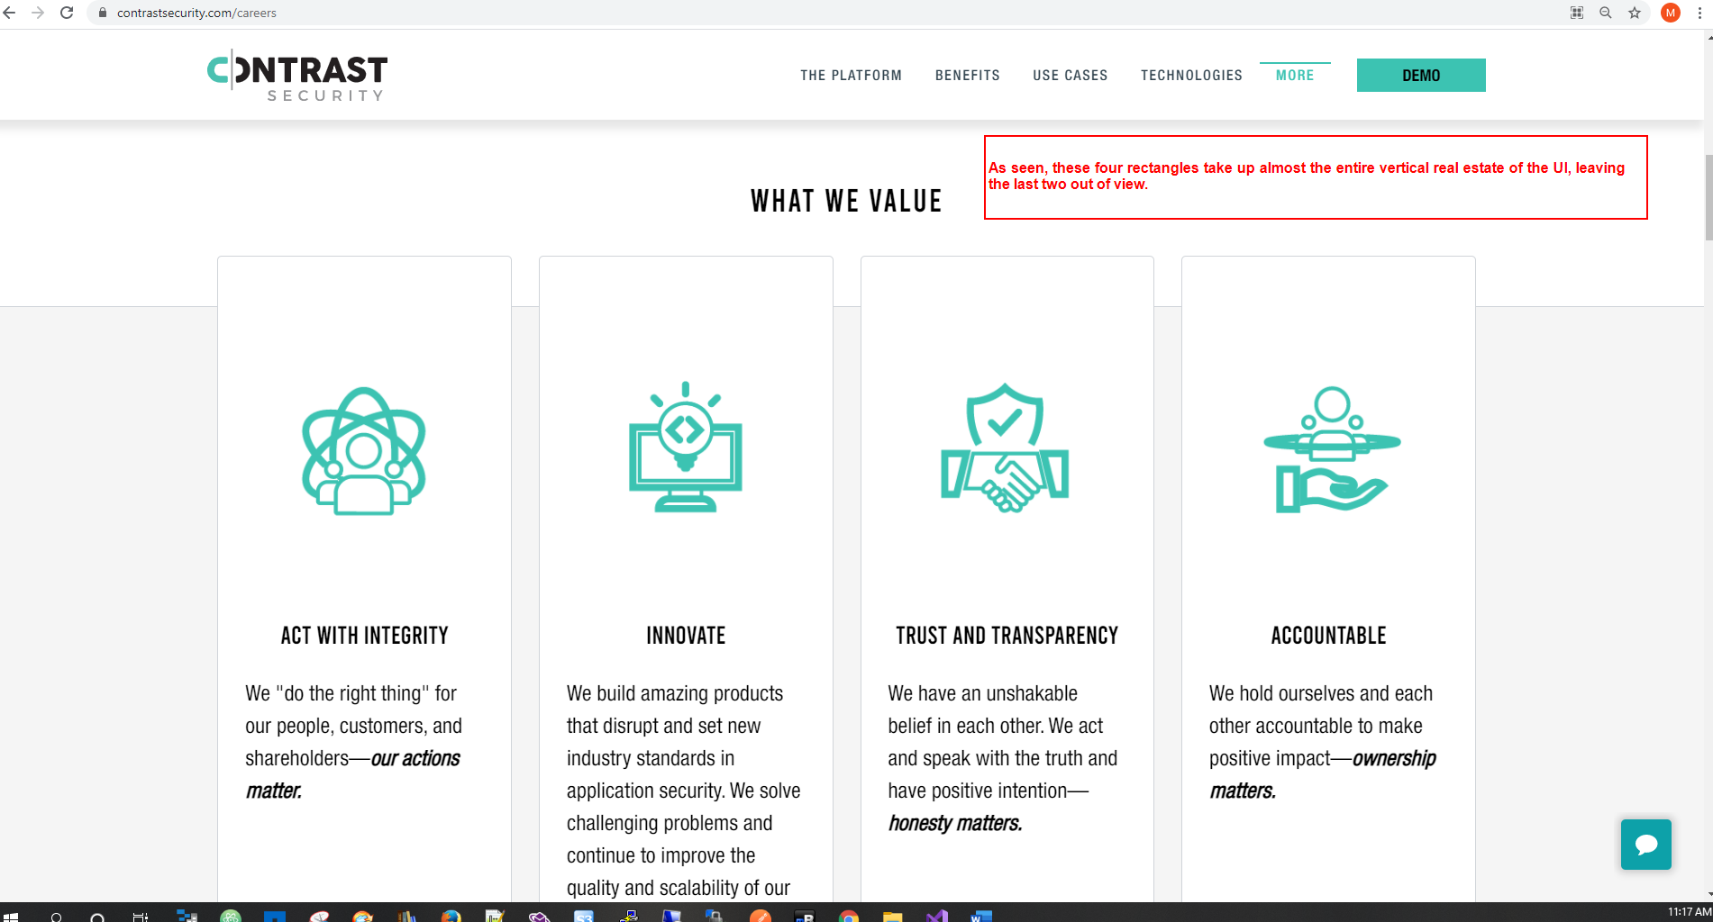

1. The above can lead to at least two issues from a user viewpoint:

* A user (especially a casual one) may not scroll down further
* Even if they do, they may subconsciously perceive the last two values as somewhat less important (please see note about this in this bug report)

1. I have some suggestions

* Make the vertical size of these rectangles smaller. As seen, even with the same size of embedded images and text, there is room at the top of the rectangles that can be reduced.
* Instead of six rectangles, have a circle with six pies, each just naming the six values. With their description following below

1. Note: There is a strong link between UX design and the subconscious mind. One of the reasons that web / mobile apps of Facebook, Instagram etc. are so popular (addictive?) is because of infinite scrolling. A traditional book has a defined end to each page (e-books have also defined pages), so the user gets the sense that they have completed a task (finished reading a page). With infinite scrolling, that never happens, and there is always more to consume. Subconsciously the user never gets the sense that they are done doing something.