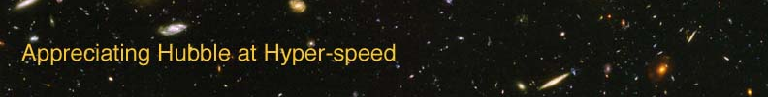

DISTANCE MEASURES – INSTRUCTOR GUIDE

The goal of this exercise is to introduce the student to some common units of distance measure used in astronomy.

APPROPRIATE GRADE LEVEL: Grades 8 and up

ESTIMATED TIME: 30 minutes

EQUIPMENT: Ruler, Calculator, Objects that can be used to mark distances

LEARNING OUTCOMES: By the end of this exercise the students should be able to:
- Utilize different units to express distances
- Visualize the distances to the eight planets in our solar system
- Perform unit conversions

DIRECTIONS:

Each student should have a copy of the lab exercise, a ruler, and a calculator. A box containing objects (dice, weights, anything small that will not roll easily) should be available in the room for students to collaborate on the size-scale of the solar system activity.

To kick off discussion of the goals of the exercise, write down the distance to Alpha Centauri in cm (about 4 000 000 000 000 000 000 cm)on the board. Students should come to the realization that centimeters are not the best units to use for expressing astronomical distances.

If the students have not had much experience with unit conversions, perform a few examples for them.

Ideas for active engagement: Ask your students what units they use to measure distances or lengths. Ask them about the usefulness of using miles to measure one edge of a piece of paper or inches to measure the distance from their homes to school.

To help visualize unit conversions, have them determine how many inches are in a centimeter by looking at the provided ruler.

OPTION FOR LONGER EXERCISE: Combine with the “Parallax” exercise to fill a more traditional lab period.

