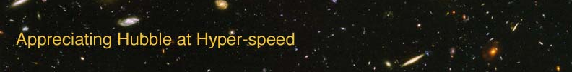

GALAXY EVOLUTION – INSTRUCTOR GUIDE

The goal of this laboratory exercise is to introduce the student the concept of galaxy evolution. The student will venture into the past of the universe to determine if galaxies remain the same or change with time.

APPROPRIATE GRADE LEVEL: Grades 11 and up

ESTIMATED TIME: 30-45 minutes

EQUIPMENT: Computer with AHaH applet installed

LEARNING OUTCOMES: By the end of this exercise, the students should be able to:
- Apply concepts from previous exercises
- Utilize computer software to make observations
- Analyze data and interpret results

DIRECTIONS:

Each student should have a copy of the lab exercise and access to a computer with the AHaH applet installed. Access to the internet would be useful as it would allow the students to reach the “Help” documentation. Working in pairs is fine for this experiment.

Information from the “Look-back Time” and “Hubble Law” exercises is needed to answer the questions, interpreting the changes seen in galaxies going from low to high redshifts. If the students have not performed these exercises, be certain to give them instruction in the following concepts:
- High redshifts correspond to large distances.
- Large distances correspond to greater look-back times.

The students should be prompted on how to use the following aspects of the AHaH applet:
- Info Box
- Jump Box
- Arrow keys for navigation
Ideas for active engagement: Many students now associate the term “evolution” with biological evolution. Ask students what evolution means. Students should eventually come up with “change” and this will help alleviate misconceptions.

OPTION FOR LONGER EXERCISE: Combine with either or both of the “Look-back Time” or “Hubble Law” exercises to fill a more traditional lab period.

