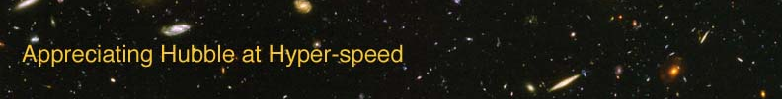

GALAXY MORPHOLOGY – INSTRUCTOR GUIDE

The goal of this exercise is to introduce the student to the different types of galaxies we see in the universe. The study of the shapes and types of galaxies is called galaxy morphology, and it has enabled us to learn much about galaxies.

APPROPRIATE GRADE LEVEL: Grades 10 and up

ESTIMATED TIME: 30 minutes (depends on number of objects assigned to identify)

EQUIPMENT: computer with AHaH applet installed

LEARNING OUTCOMES: By the end of this exercise the students should be able to:
- Identify different galaxies by their appearance.
- Apply the observed colors of a galaxy to the properties of its stars
- Understand the properties of the different Hubble classification types

DIRECTIONS:

Each student should have a copy of the lab exercise and a calculator.

If the students have not completed the “Blackbody Radiation” exercise and its application to stars, either do that exercise as the first part of this as a longer lab or give them the necessary information up front.

A complete list of galaxies and their morphological classifications is provided on the “Appreciating Hubble at Hyper-speed” website. (Elmegreen, et al, 2005) You may either tell your students specific galaxies to look at, or you can allow them to pick galaxies randomly. If you allow them to choose randomly, tell them that you want them to have a mixture of spirals, ellipticals, and irregulars.

Here is a brief suggested list of object IDs to give to your students, if desired:

- Spirals: 1478, 7556, 9834, 5805, 423
- Ellipticals: 6027, 2414, 2322, 9264, 4320
- Irregulars: 3772, 5271, 697, 3060, 6153, 6649

Ideas for active engagement: Show your students images of typical spiral, elliptical, and irregular galaxies. At first, identify the galaxy classification to help familiarize the student with the morphological classes. Then show galaxies and illicit their answers and reasoning for galaxy classification.

OPTION FOR LONGER EXERCISE: Combine with the “Blackbody Radiation” exercise to fill a more traditional lab period.

