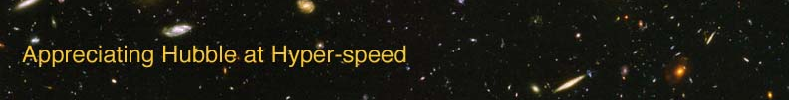

HUBBLE LAW – INSTRUCTOR GUIDE

The goal of this laboratory exercise is to introduce the student to the Hubble Law. The student will deduce the relationship and discover some of the uses and implications of the Hubble Law.

APPROPRIATE GRADE LEVEL: Grades 10 and up

ESTIMATED TIME: 30-45 minutes (depends on number of objects assigned to identify)

EQUIPMENT: Calculator, Ruler, Graph Paper or graphing software, Computer with AHaH applet installed

LEARNING OUTCOMES: By the end of this exercise the students should be able to:
- Gain familiarity with the expansion of the universe
- Obtain data
- Perform mathematical computations of universal properties
- Understand the concept of redshift

DIRECTIONS:

Each student should have a copy of the lab exercise, ruler, graphing materials, calculator, and access to a computer with the AHaH applet.

If the students have not been introduced to the concepts of Doppler shift, redshift, or the Hubble law, it might be useful to have a discussion of these topics at the beginning of the class. Relating the Doppler shift of light to be Doppler shift of sound (i.e., how a siren’s pitch changes) can be useful, although the author finds that fewer students are familiar with this example as time goes by.

Depending on the math prerequisite for your course, you may need to present the mathematical definition of the slope of a line.

Ideas for active engagement: A handy demonstration of the expansion of the universe can be done with two prepared transparencies and an overhead projector. On a sheet of paper, draw multiple dots and squiggles representing galaxies. Make a transparency of this drawing to represent a snapshot of the universe. Then, using a photocopy machine, make a 125% reproduction of your drawing and make a transparency of the magnified drawing. Outline the galaxies on the magnified transparency with red pen. This second transparency represents a snapshot of the universe at a later time. You should be able to overlap the same galaxy on each image and show that each galaxy would see a universe expanding away from it.

OPTION FOR LONGER EXERCISE: Combine with the “Theta-z Relation” or “Cosmological Parameters” exercise to fill a more traditional lab period.

