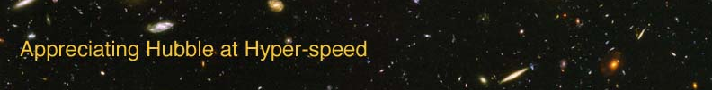

LOOK-BACK TIME – INSTRUCTOR GUIDE

The goal of this laboratory exercise is to introduce the student to the concept of look-back time. Because the speed of light is not infinitely fast, the light from distant objects takes time to reach us here on Earth. At the end of this lab, the students should have greater appreciation of how this allows us to look back in time as we look out in the universe.

APPROPRIATE GRADE LEVEL: Grades 8 and up

ESTIMATED TIME: 30 minutes

EQUIPMENT: Calculator (not necessary, but some students may find one useful)

LEARNING OUTCOMES: By the end of this exercise the students should be able to:
- Understand the definition of a light-year
- Infer the implications of a finite speed of light
- Develop the concept of look-back time
- Incorporate the large distances of space with the large timescales visible in the universe.

DIRECTIONS:

Each student should have a copy of the lab exercise and a calculator.

If the speed of light has not been introduced in lecture, do so before starting this exercise.

If the definition of a light-year has not been previously introduced, do so. It is a common misconception that a light-year is a measure of time. The first question of the exercise is meant to reinforce the definition that a light-year is a measure of length.

Ideas for active engagement: Ask the students about the seeing the lightning and hearing the thunder during a thunderstorm. Many of your students will be aware that the thunder lags the lightning when the strike occurs at a distance.. Explain this difference is due to the speed of light being faster than the speed of sound. Follow-up by asking why the students see your mouth move and hear your voice in synch. Lead the students to the reasoning that your proximity to them allows both signals to reach them “simultaneously”. Ask about distances to celestial objects and then do the example of how long it takes light to reach us from our Moon to demonstrate that space is SO big that there is a lag for light. (average distance to Moon = 384,000 km, speed of light = 3 × 10⁵ km/s)

OPTION FOR LONGER EXERCISE: Combine with the “Distance Measures” exercise to fill a more traditional lab period.

