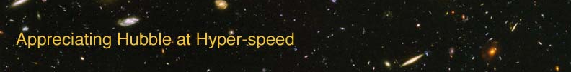

PARALLAX – INSTRUCTOR GUIDE

The goal of this exercise is to introduce the student to the concept of parallax, which is a method used to measure distances here on Earth as well as in space.

APPROPRIATE GRADE LEVEL: Grades 8 and up

ESTIMATED TIME: 20 minutes

EQUIPMENT: Calculator, ruler

LEARNING OUTCOMES: By the end of this exercise the students should be able to:
- Understand the definition of parallax
- Appreciate everyday usage of parallax
- Experience the concept of parallax
- Practice mathematical applications of parallax.

DIRECTIONS:

Each student should have a copy of the lab exercise and a calculator.

Students have likely utilized parallax to estimate distances without understanding that is what they were doing. Perhaps do the “finger” parallax demonstration with the class. Then ask them the following: when traveling on a freeway, how can students estimate which object is closer – plants on the roadside or mountains on the horizon? One answer will be size; students know that plants are smaller than mountains. This is a valid way of estimating distance, but not particularly useful in astronomy, where we may not know in advance the size of a celestial object. The other answer should be that the bushes move more than the mountains do; this is an everyday usage of parallax.

Ideas for active engagement: Go outside and find a place where you have at least ten feet of open space to work with. Using chalk, mark a place for a student to stand.
- You or a student measure with the meter stick the distance to the fixed student.
- Have the class find a distant reference point on the horizon behind the fixed student, such as a building, a tree, or a light. The farther away, the better!
- Facing the fixed student and the reference point, mark a straight line that is several feet in length and at least ten feet away from the fixed student. The line should be oriented perpendicular to the student and aligned so that the student lines up with the distant reference when you stand roughly in the middle of the line. (See figure below.)
α

β
θ = α + β
To a distant reference point
To a distant reference point
Ba
s
e
l
i
n
e

- Have the class stand at one end of the baseline and measure the angle α between the fixed student and the distant reference point.
- Repeat this measurement at the other end of the baseline, measuring the angle β.
- Ask the class what they noticed. They should notice that the fixed student appeared to move.
- Repeat, switching out the fixed student so that he/she can do the experiment and for students to more fully appreciate what they see.

OPTION FOR LONGER EXERCISE: Combine with group measurements of the activity outlined in the “Ideas for active engagement” above. Rulers, chalk, and protractors will be necessary. Have the students measure the data instead of (or in addition to) answering the conceptual questions outlined previously.

The relationship between the distance to an object (R), the baseline (D), and the angular size of the object (θ) is given by the following expression:

where the “57.3” is a constant which allows the angle θ to be measured in units of degrees.

