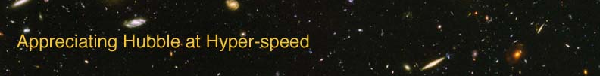

PROPERTIES OF WAVES – INSTRUCTOR GUIDE

The goal of this laboratory exercise is to introduce the student to the properties of waves. Waves are an important tool for understanding astronomy, because light can be described as an electromagnetic wave.

APPROPRIATE GRADE LEVEL: Grades 8 and up

ESTIMATED TIME: 20 minutes

EQUIPMENT: Calculator, Ruler

LEARNING OUTCOMES: By the end of this exercise the students should be able to:
- Measure the amplitude and wavelength of a wave.
- Calculate the frequency of a wave
- Utilize the relationship between speed, wavelength, and frequency of a wave.

DIRECTIONS:

Each student should have a copy of the lab exercise, a ruler, and a calculator.

If the material has not yet been covered in a classroom setting or reading assignment, go over various parts of a wave. Introduce the students to the following relationship: speed of a wave = wavelength × frequency.

Ideas for active engagement: Bring in an object (such as a Slinky or wave demonstrator) that allows you to show a wave in class. Ask students to tell you what to do to increase the frequency, etc…

OPTION FOR LONGER EXERCISE: Combine with the “Blackbody Radiation” exercise to fill a more traditional lab period.

