bamazonCustomer.js

Initial Database “products” (1002.bmp)
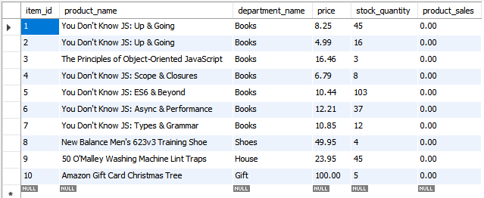

Initial database “departments” (1003.bmp)

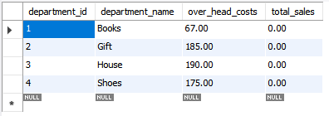

1.) Purchase a product
Verify it informs the user of the total cost. (1004.bmp)
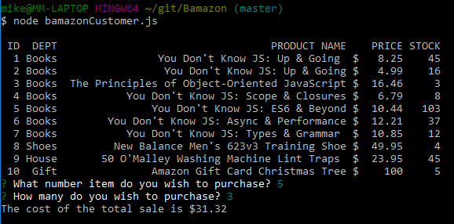

Verify the “products” table after purchase. 3x10.44 = 31.32 (1007.bmp)
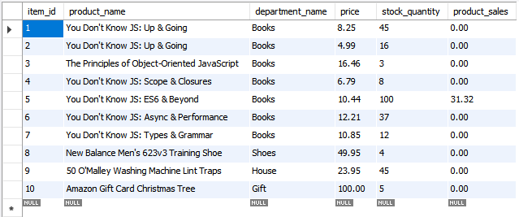

Verify the “departments” table after the purchase (1008.bmp)
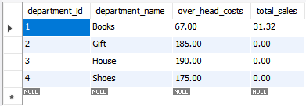

2.) Attempt to purchase more of a product than is in stock. (2001.bmp)
Ensure it is not allowed and returns you to choose again.
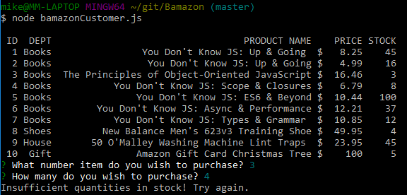

2.) Attempt to purchase a non-existent product id. (2002.bmp)

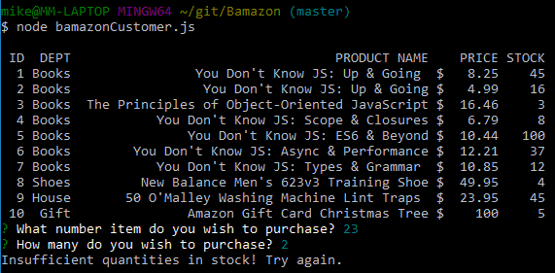

bamazonManager.js
- View Products for Sale (Note Item 7 has 12 in stock) (3001.bmp)
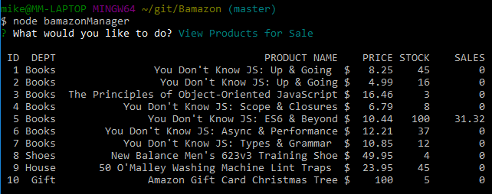

- View Low Inventory (3002.bmp)
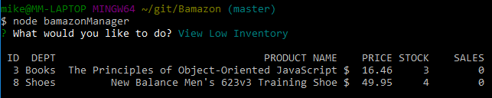

- Add to Inventory (3003.bmp)
Item 7 now has 17 in stock)
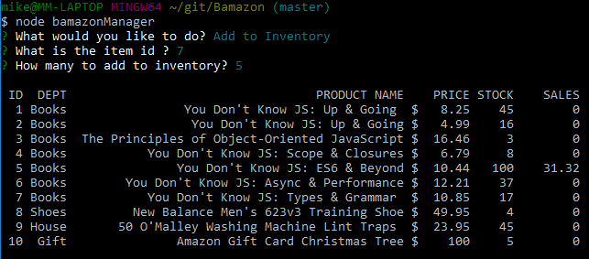

- Add New Product (3004.bmp)
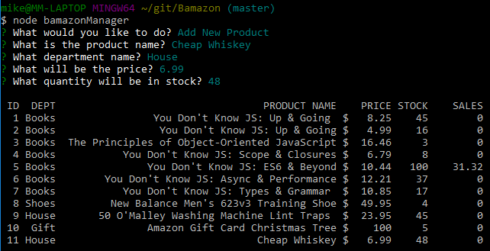

“products” database (3005.bmp)
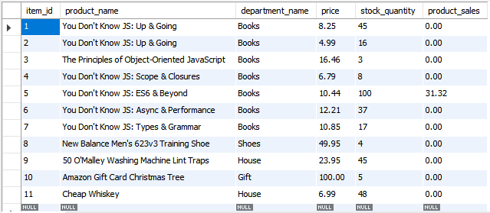

bamazonSupervisor
- The tables (4001.bmp)
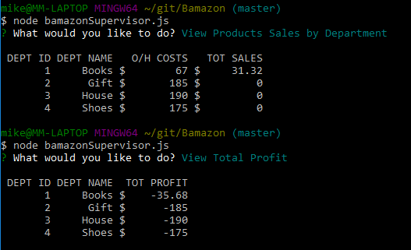

“departments” table (4002.bmp)
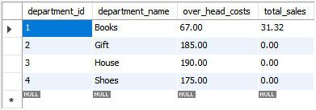

Custom alias query (4003.bmp)
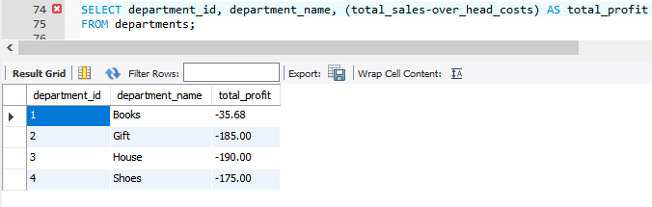

- Adding a new department (5001.bmp)
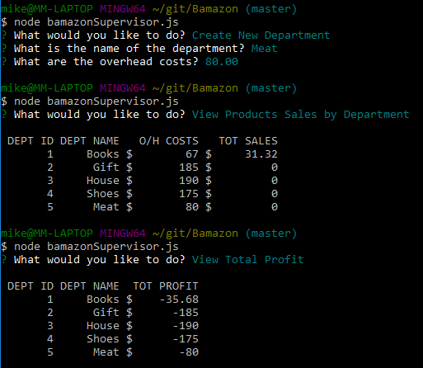

Using it for a while
After playing with making more purchases and adding new products to the Meat department, I now have the below. (6001.bmp)
