* **The requirements for Final Project are as follows:**

```
* Must use ReactJS or Angular in some way (even if minimal)

* Must use a Node and Express Web Server

* Must be backed by a MySQL or MongoDB Database with a Sequelize or Mongoose ORM

* Must have both GET and POST routes for retrieving and adding new data

* Must be deployed using Heroku (with Data)

* Must utilize at least two libraries, packages, or technologies that we haven’t discussed

* Must allow for or involve the authentication of users in some way

* Must have a polished frontend / UI

* Must have folder structure that meets MVC Paradigm

- Must meet good quality coding standards (indentation, scoping, naming)

```

Wyeast
Calculators
http://www.beerformulator.com/

BJCP Styles
http://www.bjcp.org/styles04/

Brewery DB
Email - mmeder2016@gmail.com
Password – Melikumbeer975
BrewApp

http://www.brewerydb.com/

API Key: 9f195bca21d9eb8f1e20cfe7615e3744

Project
Provide a web based application where a beer brewer can get fast and efficient assistance with creating beer recipes. This application will automatically perform all the mathematical calculations as they are entered into the provided forms.

- Required
  - The brewerydb API will be used to acquire all data.
  - A new recipe can be created from scratch and saved to database.
  - A new recipe can be created by cloning one of the users existing recipes, saved as a new one, and then edited as needed.
  - The user can browse his existing recipes.
- Wish list
  - A use can browse all existing recipes from all users, by style, but only edit his own.

Dictionary - https://www.craftbeer.com/beer/beer-glossary

Style – Beer Styles - http://www.brewerydb.com/styles

Process Calculators (Panels)
- Displayed data
  - Blue – user entered data
  - Red – calculated on the fly from the available data
  - Green – selected from the brewerydb API.

Recipe Calculation Panel (All front end)

This panel is for calculations based on the Batch Size(Fermenting Panel), Grains, and hops used. It provides estimates for how the beer will turn out.

- Batch Size - gallons (User Entered)
- Date (User Entered)
- Original Gravity (Calculated)
- Final gravity (Calculated)
- International Bittering Units (Calculated)
- Standard Reference Method (Calculated)
- Alcohol by Volume (Calculated)
- Balance – Not needed

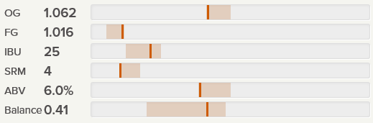

Mashing Panel (Grains)
A list of all the grains by weight
- Name (string) (Selected from API)
- Amount (lbs) (User Entered)
- Amount (ozs) (User Entered)
- Use – not needed

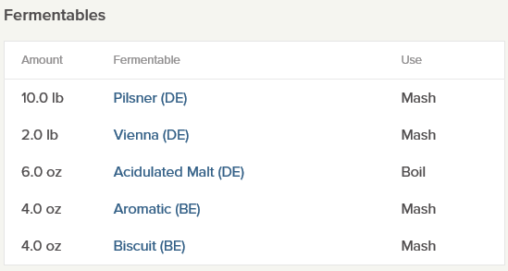

Boiling Panel(Hops)

- Name (string) (Selected from API)
- Amount (lbs) (User Entered)
- Amount (ozs) (User Entered)
- Alpha Acid (User Entered)
- Time - minutes (User Entered)
- Use – not needed
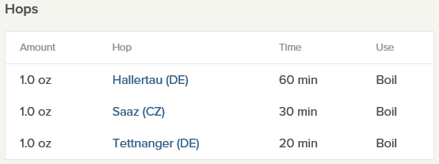

Fermenting and Comment Panel
Yeast (string) (Selected from API)
Temperature – F (number) (User Entered)
OG (number) (User Entered)
FG (number) (User Entered)
Comment (string) (User Entered) - dry hopping, mash pH, etc. One text box editable is sufficient

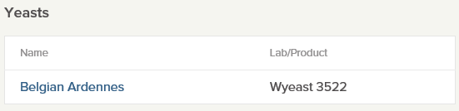

Carbonating (Optional for now)
There are many carbonating calculators on the internet.
Force - There is force carbonating and accompanying charts.
Natural – There are many on the internet.
http://www.northernbrewer.com/priming-sugar-calculator/

Data
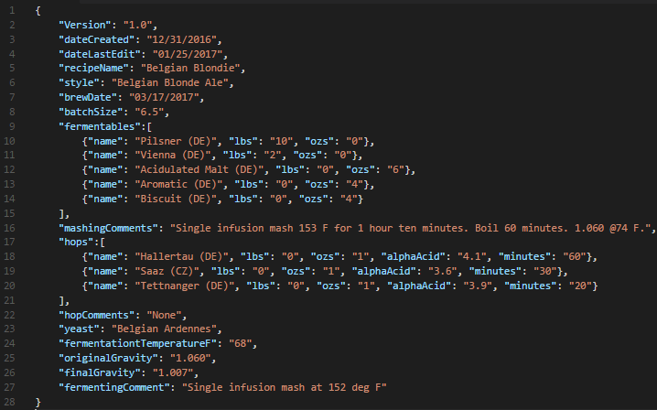

New Recipe
- View Recipes button – view the recipe name for the user

- Create New Recipe button
  - From server populate styles, fermentables, hops, yeasts.

- Save Recipe button

- Recipe Calculation Panel
  - Enter name
  - Date
  - Style
  - Batch Size

- Mashing Panel
  - List of fermentables
    - name - dropdown
    - lbs – defaults to zero
    - ozs – defaults to zero
    - delete button
  - Comment Edit box

- Hop Panel
  - List of hops
    - name - dropdown
    - lbs – defaults to zero
    - ozs – defaults to zero
    - alpha acid
    - time in boil
    - delete button

  - Comment Edit box

- Fermenting Panel
  - name – dropdown
  - fermentation temp F
  - O.G.
  - F.G.
  - Comment Edit box

