Motivation
Last election results are very interesting, and several states have surprising result . Most of the media had the wrong prectication. Moreover, in the last few years, the western countries have had several elections that have unexpected results too. We want to know if the same social values exist among western countries that would influence the election results.

Problem
Can we use the data under following categories: Economics, Political affiliation (also known as political party), and Background or Social Media - to train a model which can use to predict the election results? Does the western world have similar social values that affect the elections? Is there a correlation between the results of elections and economics, background, or social media?
We expect it is complicated project which involves a lot of features, data collecting, and pre-processing. We expect that our model can give us some idea about people’s preferences on the candidates and their raised issues. If our model can also work on other western countries, then we may be able to conclude that the social values are same among some countries.
This problem is a classification problem, where the election results are the target.

Proposed Solution
We want to use our data to see if we can create a model to predict whether or not the republican candidate will win the election. We randomly picked Republican, our choice has nothing to do with our own affiliations. We are separating the election into only Republican and Democratic. A description of all our desired attributes/features is at the end of the document.
We want to use SVM to create our model because the data is not linearly separable. It has more dependent features. We will also be using other classification algorithms to compare.

Methodology
We tested our dataset using different classifiers (i.e. Perceptron, Decision Tree, KNN, Logistic Regression, SVM, and SGD) and compare their results.
We performed our tests without dimension reductions by changing different parameters, followed by the same tests by using dimension reduction techniques through modifying number of components.
For each test, we tested different classifiers on our data. The parameters were changed for the first three tests. We didn't use any dimension reduction techniques for those first three tests.
According to our notes from class,
The Fisher’s propose is used to maximize the distance between the mean of each class and minimize the spreading within the class itself. Thus, we come up with two measures: the within-class and the between-class. However, this formulation is only possible if we assume that the dataset has a Normal distribution.

As you will see in the results section, our results shows a decrease in performance when using LDA. This means that the distribution of our data is primarily non-Gaussian.
To validate our model, we tried to get data from France as its governing system is similar to the United States. However, the data was scarce and we did not find enough of our feature or instances. We settled on just analyzing the United States.

Preprocessing Data
We had to find all our data for the US. We decided on the features before we actually found the data, so we spent much time searching. Our data needed to be for each state, for each election year. They also needed to include the election result for that state. The data was gathered in a separated state, so they had to be combined. This can be seen in transform_data.py, with the original datasets being in datasets/.

Results
Our result data is stored in the directory results/. The file cross_valid_results.docx contains a second set of results used, ran separately, used as cross validation data. You may also refer to that file when analyzing results. The subdirectory `Tests With Parameters/` contains the parameters beside the result.

Our Runtime showed PCA to be the fastest in running time, while LDA was the slowest. KNN also had one of the quickest runtimes. You can see this in `results/runtimes.txt`

Test1

Parameters
per = Perceptron(n_iter=50, eta0=.1, random_state=1)

clf_entropy = DecisionTreeClassifier(criterion="entropy", random_state=1, max\_depth=5, min_samples_leaf=3)

knnn = KNeighborsClassifier(n_neighbors=9, metric='euclidean')#how did i choose

logreg = LogisticRegression(multi_class='auto')

clf1 = svm.SVC(kernel="linear", random_state=1, C=1)

clf2 = svm.SVC(gamma='scale', C = 1.0)

sgd = linear_model.SGDClassifier(max_iter=100, tol=1e-3)

Results

Key
ID | Classifier
1 | Perceptron
2 | Decision Tree
3 | KNN
4 | LR
5 | SVM-L
6 | SCm-NL
7 | SGD
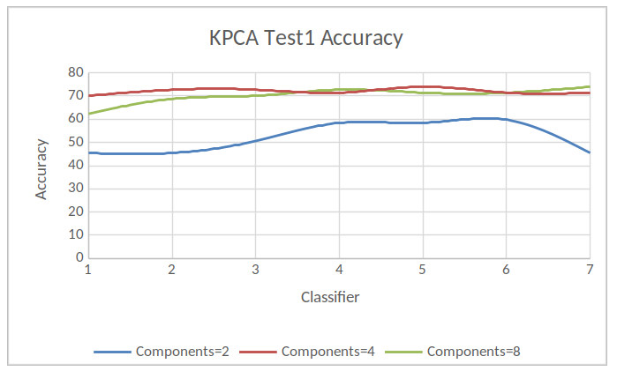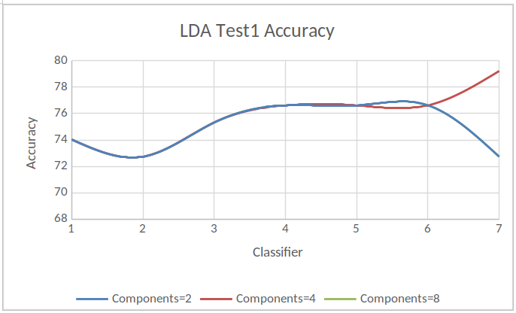
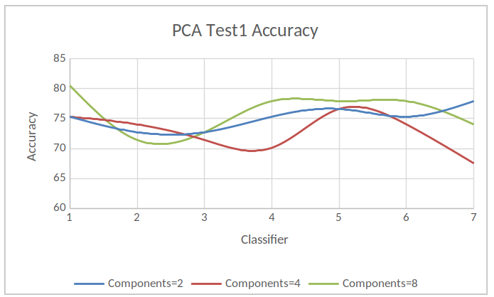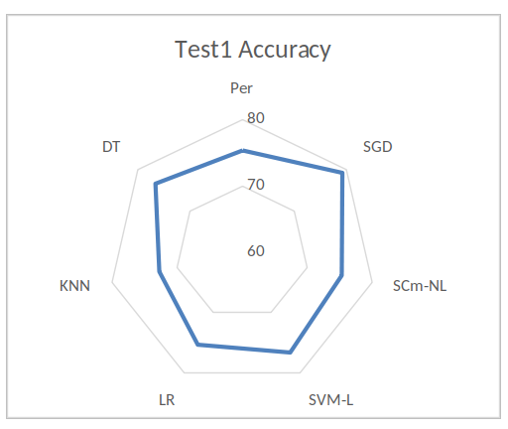

Test2

Parameters
per = Perceptron(n_iter=100, eta0=.1, random_state=1)

clf_entropy = DecisionTreeClassifier(criterion="entropy", random_state=1, max_depth=10, min_samples_leaf=5)

knnn = KNeighborsClassifier(n_neighbors=9, weights='uniform', algorithm='auto', leaf_size=30)

logreg = LogisticRegression(warm_start=True, n_jobs=5, max_iter=100, C=2)

clf1 = svm.SVC(kernel="linear", random_state=1, C=2, degree=3, class_weight='balanced')

clf2 = svm.SVC(gamma='scale', C=2, degree=3, class_weight='balanced')

sgd = linear_model.SGDClassifier(max_iter=100, tol=1e-3, alpha=0.0002, shuffle=True)

Results

Key
ID | Classifier
1 | Perceptron
2 | Decision Tree
3 | KNN
4 | LR
5 | SVM-L
6 | SCm-NL
7 | SGD
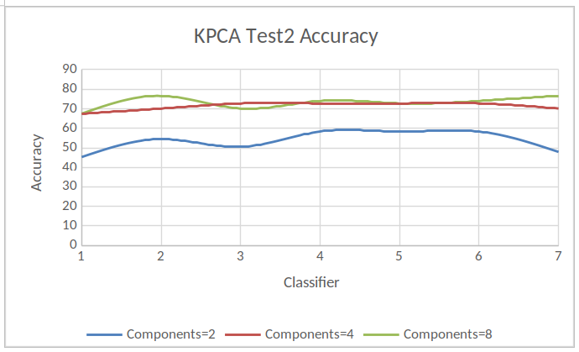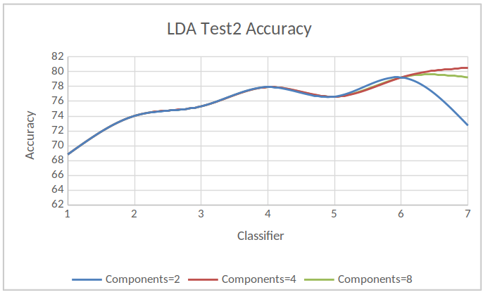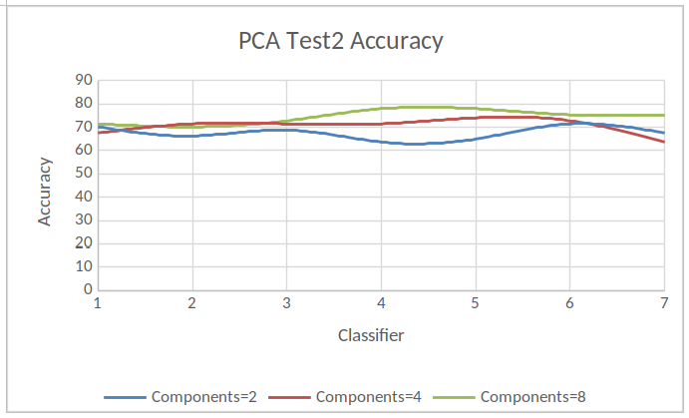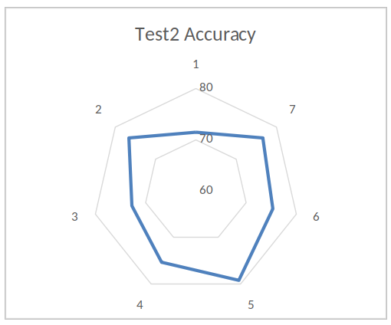

Test3:

Parameters
per = Perceptron(n_iter=100, eta0=.2, random_state=1)

clf_entropy = DecisionTreeClassifier(criterion="entropy", random_state=1, max_depth=15, min_samples_leaf=10)

knnn = KNeighborsClassifier(n_neighbors=9, weights='uniform', algorithm='auto', leaf_size=50)

logreg = LogisticRegression(warm_start=True, n_jobs=10, max_iter=200, C=5)

clf1 = svm.SVC(kernel="linear", random_state=1, C=5, degree=5, class_weight='balanced')

clf2 = svm.SVC(gamma='scale', C=5, degree=5, class_weight='balanced')

sgd = linear_model.SGDClassifier(max_iter=200, tol=1e-3, alpha=0.0004, shuffle=False)

Results

Key
ID | Classifier
1 | Perceptron
2 | Decision Tree
3 | KNN
4 | LR
5 | SVM-L
6 | SCm-NL
7 | SGD
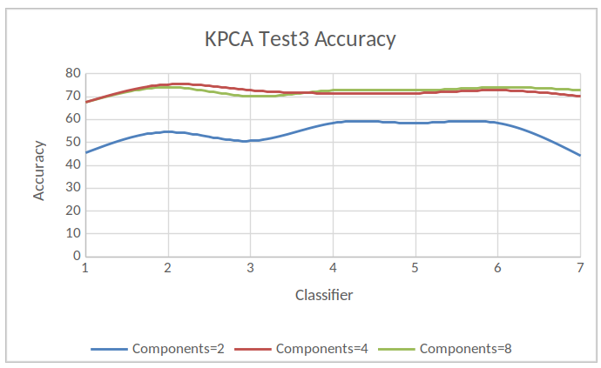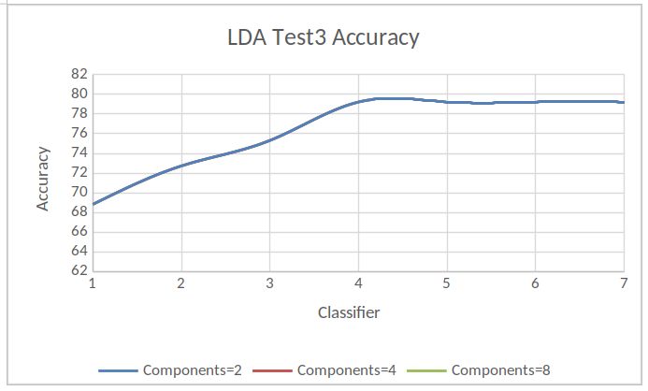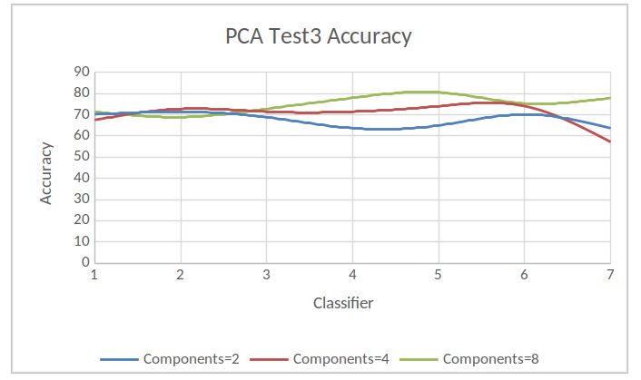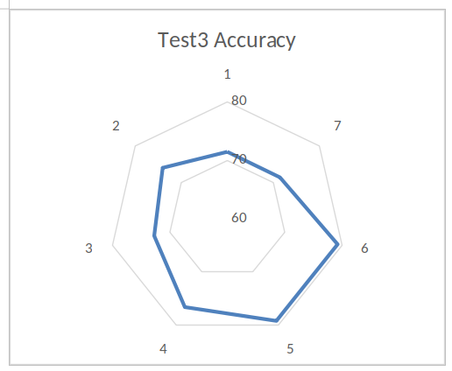

Appendix

USA Dataset Shape and Definitions
Features | Description
year | Election year
state | State name
hs_grad | At least HS graduate (%)
bachelors | At least college graduate (%)
adv_degree | Obtained advanced degree (%)
median_household_income | Median household income
rep_spending | Republican candidate spending
dem_spending | Democrat candidate spending
inflation_rate | Inflation rate that year
poverty_rate | Poverty rate that year
stock_change | NASDAQ Index (end_year - start_year)
unemployment_rate | Unemployment rate that year
perc_urban | Percentage urban population
rep_sen | Percentage senators that are republican
rep_house | Percentage representatives that are republican
campaign_fund | Campaign spending for republican (% from total)
rep_legis | Percentage of republican legislators in the state
stateGDP | Ratio of Average GDP and Average GDP of Country

Analysis
Our highest accuracy was 79.22%, and the minimum accuracy was 71.43%, as seen from our results. We used the PCA method on all three tests; the highest accuracy was 80.52%, and the lowest, 57.14%. We used the LDA method for all three tests, the highest accuracy was 80.52%, and the lowest was 68.83. We then used Kernel PCA (KCPA) and got 76.62% for our highest accuracy, and 44.16% for our lowest.

Datasets
Poverty rate in France from 2000 to 2015
https://www.statista.com/statistics/460446/poverty-rate-france/
Unemployment rate in France from 2005 to 2015
https://www.statista.com/statistics/459862/unemployment-rate-france/
Average annual wages in France from 2000 to 2015
https://www.statista.com/statistics/416204/average-annual-wages-france-y-on-y-in-euros/
inflation rate France
https://knoema.com/atlas/France/Inflation-rate
France Stock Exchange
https://www.macrotrends.net/2596/cac-40-index-france-historical-chart-data
Share of the urban population in France from 2005 to 2015
https://www.statista.com/statistics/466415/share-urban-population-france/
France GDP
https://countryeconomy.com/gdp/france?year=2015
USA Election Campaign Spending
https://www.huffingtonpost.com/entry/56-years-of-presidential-campaign-spending-how-2016_us_5820bf9ce4b0334571e09fc1
USA Inflation Rate
https://www.inflation.eu/inflation-rates/united-states/historic-inflation/cpi-inflation-united-states.aspx
USA Stock Market Performance %
https://www.macrotrends.net/1320/nasdaq-historical-chart
USA Unemployment Rate
https://data.bls.gov/map/MapToolServlet
USA Poverty Rate
https://www.statista.com/search/?q=poverty+rate&language=0&p=1

