DATA STRUCTURES

EXTRA QUESTIONS DATA STRUCTURES
NAME-MEET
ROLL NO-1024030343
BATCH-2C24 
ASSIGNMENT-1 ARRAYS
Ques-1)
Solution-
#include <iostream>
#include <vector>
#include <cmath>
using namespace std;
int countPairsWithDiffK(const vector<int>& arr, int k) {
int count = 0;
int n = arr.size();
// Loop through each pair (i, j) where i < j
for (int i = 0; i < n; ++i) {
for (int j = i + 1; j < n; ++j) {
// Check if the absolute difference is exactly k
if (abs(arr[i] - arr[j]) == k) {
count++;
}
}
}
return count;
}
int main() {
vector<int> arr = {1, 5, 3, 4, 2};
int k = 2;
cout << "Number of pairs with difference " << k << ": "
<< countPairsWithDiffK(arr, k) << endl;
return 0;
}
OUTPUT
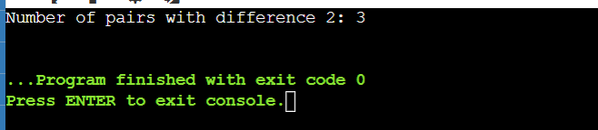
Ques-2)
Solution-
#include <iostream>
#include <string>
using namespace std;
bool isSubstring(const string& sub, const string& full) {
return full.find(sub) != string::npos;
}
bool canSplitWithCommonSubstring(const string& s) {
int n = s.length();
for (int i = 1; i < n - 1; ++i) {
for (int j = i + 1; j < n; ++j) {
string A = s.substr(0, i);
string B = s.substr(i, j - i);
string C = s.substr(j);
if ((isSubstring(A, B) && isSubstring(A, C)) ||
(isSubstring(B, A) && isSubstring(B, C)) ||
(isSubstring(C, A) && isSubstring(C, B))) {
return true;
}
}
}
return false;
}
int main() {
string s;
cout << "Enter the string: ";
cin >> s;
if (canSplitWithCommonSubstring(s)) {
cout << "YES\n";
} else {
cout << "NO\n";
}
return 0;
}
OUTPUT
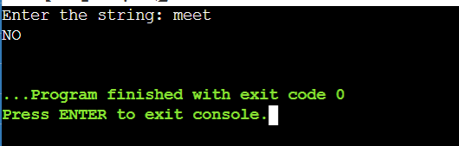
Ques-3)
Solution-
#include <iostream>
#include <string>
#include <algorithm>
using namespace std;
bool areAnagrams(string str1, string str2) {
if (str1.length() != str2.length()) return false;
sort(str1.begin(), str1.end());
sort(str2.begin(), str2.end());
return str1 == str2;
}
int main() {
string str1, str2;
cin >> str1 >> str2;
if (areAnagrams(str1, str2)) {
cout << "Yes, they are anagrams." << endl;
} else {
cout << "No, they are not anagrams." << endl;
}
return 0;
}
OUTPUT
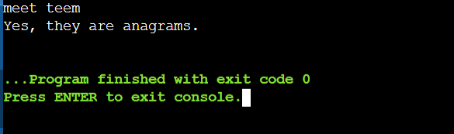
Ques-4)
Solution-
#include <iostream>
#include <vector>
using namespace std;
void sortBruteForce(vector<int>& arr) {
int count0 = 0, count1 = 0, count2 = 0;

for (int num : arr) {
if (num == 0) count0++;
else if (num == 1) count1++;
else count2++;
}
int index = 0;
while (count0--) arr[index++] = 0;
while (count1--) arr[index++] = 1;
while (count2--) arr[index++] = 2;
}
int main() {
vector<int> arr = {2, 0, 2, 1, 1, 0};
sortBruteForce(arr);
for (int num : arr) {
cout << num << " ";
}
cout << endl;
return 0;
}
OUTPUT
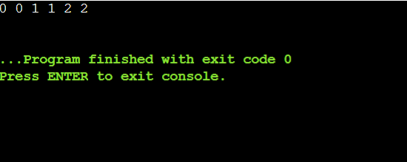
Ques-5)
Solution
#include <iostream>
#include <vector>

using namespace std;
void duplicateTwos(vector<int>& arr) {
int n = arr.size();
int possibleDups = 0;
int last = n - 1;
for (int i = 0; i <= last - possibleDups; ++i) {
if (arr[i] == 2) {
if (i == last - possibleDups) {
arr[last] = 2;
last--;
break;
}
possibleDups++;
}
}
int i = last - possibleDups;
int j = last;
while (i >= 0) {
if (arr[i] == 2) {
arr[j--] = 2;
if (j >= 0) arr[j--] = 2;
} else {
arr[j--] = arr[i];
}
i--;
}
}
int main() {
vector<int> arr = {1, 2, 3, 2, 4, 5, 2};
duplicateTwos(arr);
for (int num : arr) {
cout << num << " ";
}
cout << endl;
return 0;
}
OUTPUT
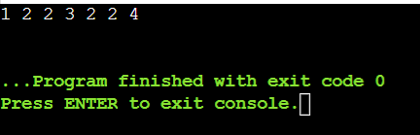
ASSIGNMENT-2 STACK
Ques-1)
Solution#include <iostream>
#include <vector>
#include <stack>
using namespace std;
vector<int> nearestSmallerToLeft(const vector<int>& A) {
int n = A.size();
vector<int> result;
stack<int> s;
for (int i = 0; i < n; ++i) {
while (!s.empty() && s.top() >= A[i]) {
s.pop();
}
if (s.empty()) {
result.push_back(-1); // No smaller element to the left
} else {
result.push_back(s.top());
}
s.push(A[i]);
}
return result;
}
int main() {
vector<int> A = {4, 5, 2, 10, 8};
vector<int> result = nearestSmallerToLeft(A);
for (int val : result) {
cout << val << " ";
}
cout << endl;
return 0;
}
OUTPUT
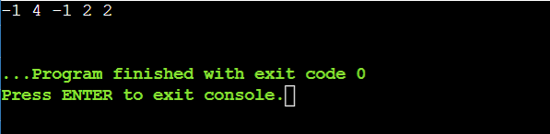
Ques-2)
Solution
#include <iostream>
#include <vector>
#include <climits>
using namespace std;
class MinStack {
private:
vector<int> stack;
public:
void push(int x) {
stack.push_back(x);
}
void pop() {
if (!stack.empty()) {
stack.pop_back();
}
}
int top() {
if (!stack.empty()) {
return stack.back();
}
return -1;
} int getMin() {
int minVal = INT_MAX;
for (int val : stack) {
if (val < minVal) {
minVal = val;
}
}
return minVal;
}
};
int main() {
MinStack st;
st.push(5);
st.push(3);
st.push(7);
st.push(2);
cout << "Minimum: " << st.getMin() << endl; // 2
st.pop();
cout << "Minimum after pop: " << st.getMin() << endl; // 3
cout << "Top: " << st.top() << endl; // 7
return 0;
}
OUTPUT
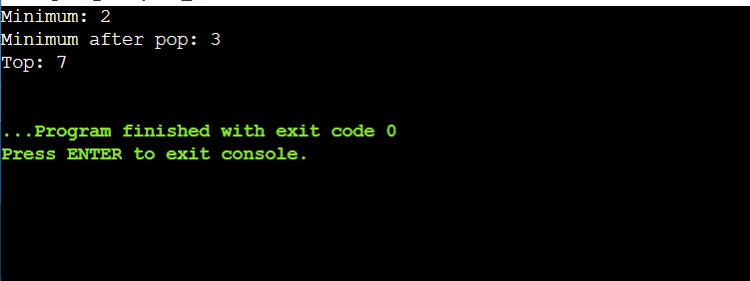
QUES-3)
SOLUTION
#include <iostream>
#include <vector>
#include <stack>
using namespace std;
vector<int> nextGreaterElements(const vector<int>& arr) {
int n = arr.size();
vector<int> result(n, -1);
stack<int> s;
for (int i = n - 1; i >= 0; --i) {
while (!s.empty() && s.top() <= arr[i]) {
s.pop();
}
if (!s.empty()) {
result[i] = s.top();
}
s.push(arr[i]);
}
return result;
}
int main() {
vector<int> arr = {4, 5, 2, 10, 8};
vector<int> result = nextGreaterElements(arr);
for (int val : result) {
cout << val << " ";
}
cout << endl;
return 0;
}
OUTPUT
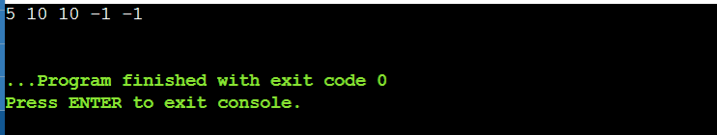
QUES-4)
SOLUTION
#include <iostream>
#include <vector>
#include <stack>
using namespace std;
vector<int> dailyTemperatures(vector<int>& temperatures) {
int n = temperatures.size();
vector<int> answer(n, 0);
stack<int> st; // stack to store indices
for (int i = n - 1; i >= 0; --i)
{
while (!st.empty() && temperatures[st.top()] <= temperatures[i]) {
st.pop();
}
if (!st.empty()) {
answer[i] = st.top() - i;
}
st.push(i);
}
return answer;
}
int main() {
vector<int> temperatures = {73, 74, 75, 71, 69, 72, 76, 73};
vector<int> result = dailyTemperatures(temperatures);
cout << "Days until warmer temperature: ";
for (int days : result) {
cout << days << " ";
}
cout << endl;
return 0;
}
OUTPUT
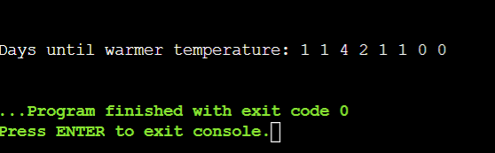
ASSIGNMENT3 QUEUE
QUES-1)
Solution
#include <iostream>
#include <queue>
using namespace std;
void generateBinaryNumbers(int n) {
queue<string> q;
q.push("1");
for (int i = 1; i <= n; ++i) {
string current = q.front();
q.pop();
cout << current << " ";
q.push(current + "0");
q.push(current + "1");
}
}
int main() {
int n = 2;
cout << "Binary numbers from 1 to " << n << ": ";
generateBinaryNumbers(n);
cout << endl;
return 0;
}
OUTPUT
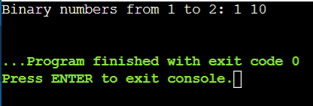
Ques-2)
Solution
#include <iostream>
#include <queue>
using namespace std;
int minIndex(queue<int>& q, int sortedIndex) {
int minIdx = -1, minVal = INT_MAX;
int size = q.size();
for (int i = 0; i < size; ++i) {
int curr = q.front();
q.pop();
if (curr <= minVal && i <= sortedIndex) {
minVal = curr;
minIdx = i;
}
q.push(curr);
}
return minIdx;
}
void moveMinToRear(queue<int>& q, int minIdx) {
int size = q.size();
int minVal;
for (int i = 0; i < size; ++i) {
int curr = q.front();
q.pop();
if (i == minIdx) {
minVal = curr;
} else {
q.push(curr);
}
}
q.push(minVal);
}
void sortQueue(queue<int>& q) {
int size = q.size();
for (int i = 0; i < size; ++i) {
int minIdx = minIndex(q, size - i - 1);
moveMinToRear(q, minIdx);
}
}
int main() {
queue<int> q;
q.push(11);
q.push(5);
q.push(4);
q.push(21);
sortQueue(q);
while (!q.empty()) {
cout << q.front() << " ";
q.pop();
}
cout << endl;
return 0;
}
OUTPUT
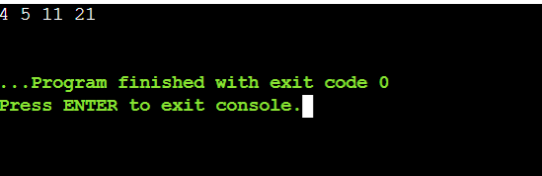
Ques-3)
Solution
#include <iostream>
#include <queue>
#include <stack>
using namespace std;
bool checkSortedPossible(queue<int>& input) {
stack<int> st;
int expected = 1;
int n = input.size();
while (!input.empty()) {
if (input.front() == expected) {
input.pop();
expected++;
} else if (!st.empty() && st.top() == expected) {
st.pop();
expected++;
} else {
st.push(input.front());
input.pop();
}
}
while (!st.empty() && st.top() == expected) {
st.pop();
expected++;
}
return expected - 1 == n;
}
int main() {
queue<int> q;
q.push(5);
q.push(1);
q.push(2);
q.push(3);
q.push(4);
if (checkSortedPossible(q))
cout << "Yes" << endl;
else
cout << "No" << endl;
return 0;
}
OUTPUT
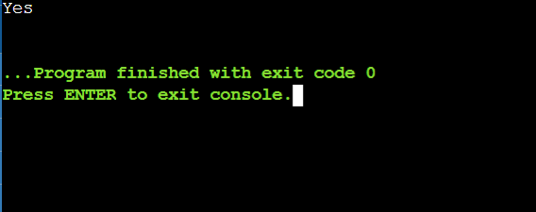
Ques-4)
Solution
#include <iostream>
#include <queue>
#include <vector>
using namespace std;
int countStudents(vector<int>& students, vector<int>& sandwiches) {
queue<int> q;
for (int s : students) q.push(s);
int i = 0, count = 0;
while (!q.empty()) {
if (q.front() == sandwiches[i]) {
q.pop();
i++;
count = 0;
} else {
int temp = q.front();
q.pop();
q.push(temp);
count++;
}
if (count == q.size()) break;
}
return q.size();
}
int main() {
vector<int> students = {1, 1, 0, 0};
vector<int> sandwiches = {0, 1, 0, 1};
cout << countStudents(students, sandwiches) << endl;
return 0;
}
OUTPUT
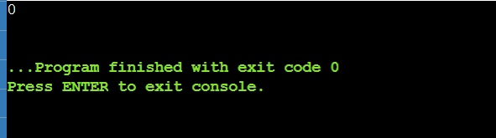
ADSSIGNMENT4 SINGLE LINKED LIST
Ques-1)
Solution->
#include <iostream>
using namespace std;
struct ListNode {
int val;
ListNode* next;
ListNode(int x) : val(x), next(nullptr) {}
};
ListNode* getIntersectionNode(ListNode* headA, ListNode* headB) {
for (ListNode* a = headA; a != nullptr; a = a->next) {
for (ListNode* b = headB; b != nullptr; b = b->next) {
if (a == b) {
return a;
}
}
}
return nullptr;
}
void printList(ListNode* head) {
while (head) {
cout << head->val << " -> ";
head = head->next;
}
cout << "NULL" << endl;
}
int main() {
ListNode* intersect = new ListNode(8);
intersect->next = new ListNode(10);
ListNode* headA = new ListNode(3);
headA->next = new ListNode(7);
headA->next->next = intersect;
ListNode* headB = new ListNode(99);
headB->next = new ListNode(1);
headB->next->next = intersect;
cout << "List A: ";
printList(headA);
cout << "List B: ";
printList(headB);

ListNode* result = getIntersectionNode(headA, headB);
if (result) {
cout << "Intersection at node with value: " << result->val << endl;
} else {
cout << "No intersection found." << endl;
}
return 0;
}
OUTPUT
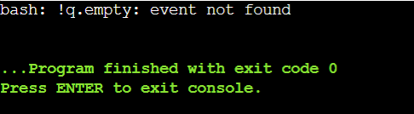
Ques-2)
Solution
#include <iostream>
using namespace std;
struct ListNode {
int val;
ListNode* next;
ListNode(int x) : val(x), next(nullptr) {}
};
ListNode* reverseKGroup(ListNode* head, int k) {
if (!head || k <= 1) {
return head;
}
int count = 0;
ListNode* temp = head;
while (temp) {
count++;
temp = temp->next;
}
ListNode* dummy = new ListNode(0);
dummy->next = head;
ListNode* prev = dummy;
ListNode* curr = head;
for (int i = 0; i < count / k; ++i)
ListNode* next_start = curr;
for (int j = 0; j < k; ++j) {
next_start = next_start->next;
}
ListNode* prev_k = next_start;
ListNode* curr_k = curr; ListNode* next_k = nullptr;

for (int j = 0; j < k; ++j) {
next_k = curr_k->next;
curr_k->next = prev_k;
prev_k = curr_k;
curr_k = next_k;
}
prev->next = prev_k;
prev = curr;
curr = next_start;
}
ListNode* new_head = dummy->next;
delete dummy;
return new_head;
}
void printList(ListNode* head) {
while (head) {
cout << head->val << " -> ";
head = head->next;
}
cout << "NULL" << endl;
}
int main() {
ListNode* head = new ListNode(1);
head->next = new ListNode(2);
head->next->next = new ListNode(3);
head->next->next->next = new ListNode(4);
head->next->next->next->next = new ListNode(5);
head->next->next->next->next->next = new ListNode(6);
head->next->next->next->next->next->next = new ListNode(7);
head->next->next->next->next->next->next->next = new ListNode(8);
int k = 3;
cout << "Original List (K=" << k << "): ";
printList(head);
ListNode* new_head = reverseKGroup(head, k);
cout << "Reversed List: ";
printList(new_head);
return 0;
}
Output
Ques-3)
Solution
#include <iostream>
using namespace std;
struct ListNode {
int val;
ListNode* next;
ListNode(int x) : val(x), next(nullptr) {}
};
void removeLoop(ListNode* head) {
if (head == nullptr || head->next == nullptr) {
return;
}
ListNode* slow = head;
ListNode* fast = head;
while (fast != nullptr && fast->next != nullptr) {
slow = slow->next;
fast = fast->next->next;
if (slow == fast) {
break;
}
}
if (slow != fast) {
return;
}
slow = head;
if (slow == fast) {
while (fast->next != slow) {
fast = fast->next;
}
} else {
while (slow->next != fast->next) {
slow = slow->next;
fast = fast->next;
}
}
fast->next = nullptr;
}
void printList(ListNode* head) {
int count = 0;
while (head && count < 10) {
cout << head->val << " -> ";
head = head->next;
count++;
}
cout << "NULL" << endl;
}
int main() {
ListNode* head = new ListNode(1);
head->next = new ListNode(2);
head->next->next = new ListNode(3);
head->next->next->next = new ListNode(4);
head->next->next->next->next = new ListNode(5);
ListNode* loop_start = head->next->next;
head->next->next->next->next->next = loop_start;
removeLoop(head);
cout << "List after removing loop: ";
printList(head); // Output: 1 -> 2 -> 3 -> 4 -> 5 -> NULL;
return 0;
}
Output
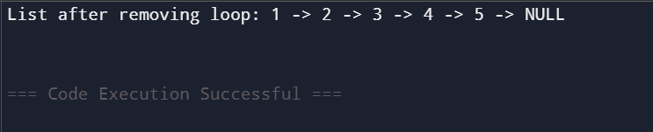
Ques4)
Solution
#include <iostream>
using namespace std;
struct ListNode {
int val;
ListNode* next;
ListNode(int x) : val(x), next(nullptr) {}
};
ListNode* rotateListLeft(ListNode* head, int k) {
if (head == nullptr || k == 0) {
return head;
}
int length = 1;
ListNode* tail = head;
while (tail->next != nullptr) {
tail = tail->next;
length++;
}
k = k % length;
if (k == 0) {
return head;
}
ListNode* new_tail = head;
for (int i = 0; i < k - 1; ++i) {
new_tail = new_tail->next;
}
ListNode* new_head = new_tail->next;
tail->next = head;
new_tail->next = nullptr;

return new_head;
}
void printList(ListNode* head) {
while (head) {
cout << head->val << " -> ";
head = head->next;
}
cout << "NULL" << endl;
}
int main() {
ListNode* head = new ListNode(1);
head->next = new ListNode(2);
head->next->next = new ListNode(3);
head->next->next->next = new ListNode(4);
head->next->next->next->next = new ListNode(5);
int k = 2;
cout << "Original List (K=" << k << "): ";
printList(head);
ListNode* new_head = rotateListLeft(head, k);
cout << "Rotated List: ";
printList(new_head);
return 0;
}
OUTPUT
