Assignment-7 Data Structures
  - TOPICSorting
Ques-1)
Solution
#include <iostream>
using namespace std;
void selectionSort(int arr[], int n) {
for (int i = 0; i < n-1; i++) {
int minIndex = i;
for (int j = i+1; j < n; j++) {
if (arr[j] < arr[minIndex]) {
minIndex = j;
}
}
int temp = arr[minIndex];
arr[minIndex] = arr[i];
arr[i] = temp;
}
}
int main() {
int arr[] = {64, 25, 12, 22, 11};
int n = sizeof(arr)/sizeof(arr[0]);
selectionSort(arr, n);
cout << "Sorted array: ";
for (int i = 0; i < n; i++)
cout << arr[i] << " ";
return 0;
}
Output
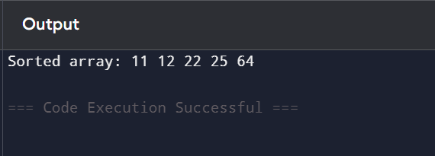
Ques-2)
Solution
#include <iostream>
using namespace std;
void insertionSort(int arr[], int n) {
for (int i = 1; i < n; i++) {
int key = arr[i];
int j = i - 1;
// Move elements greater than key
while (j >= 0 && arr[j] > key) {
arr[j + 1] = arr[j];
j--;
}
arr[j + 1] = key;
}
}
int main() {
int arr[] = {12, 11, 13, 5, 6};
int n = sizeof(arr)/sizeof(arr[0]);
insertionSort(arr, n);
cout << "Sorted array: ";
for (int i = 0; i < n; i++)
cout << arr[i] << " ";
return 0;
}
Output

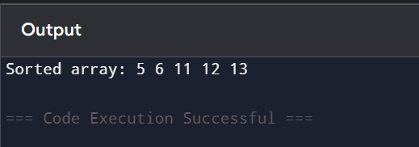
Ques-3)
Solution
#include <iostream>
using namespace std;

void bubbleSort(int arr[], int n) {
for (int i = 0; i < n-1; i++) {
for (int j = 0; j < n-i-1; j++) {
if (arr[j] > arr[j+1]) {

int temp = arr[j];
arr[j] = arr[j+1];
arr[j+1] = temp;
}
}
}
}

int main() {
int arr[] = {64, 34, 25, 12, 22, 11, 90};
int n = sizeof(arr)/sizeof(arr[0]);
bubbleSort(arr, n);
cout << "Sorted array: ";
for (int i = 0; i < n; i++)
cout << arr[i] << " ";
return 0;
}
Output
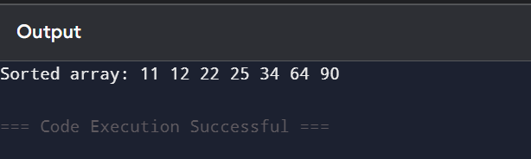
Ques-4)
Solution
#include <iostream>
using namespace std;
void merge(int arr[], int l, int m, int r) {
int n1 = m - l + 1;
int n2 = r - m;
int L[n1], R[n2];
for (int i = 0; i < n1; i++) L[i] = arr[l + i];
for (int j = 0; j < n2; j++) R[j] = arr[m + 1 + j];
int i = 0, j = 0, k = l;
while (i < n1 && j < n2) {
if (L[i] <= R[j]) arr[k++] = L[i++];
else arr[k++] = R[j++];
}
while (i < n1) arr[k++] = L[i++];
while (j < n2) arr[k++] = R[j++];
}
void mergeSort(int arr[], int l, int r) {
if (l < r) {
int m = l + (r - l) / 2;
mergeSort(arr, l, m);
mergeSort(arr, m + 1, r);
merge(arr, l, m, r);
}
}
int main() {
Output int arr[] = {38, 27, 43, 3, 9, 82, 10};
int n = sizeof(arr)/sizeof(arr[0]);
mergeSort(arr, 0, n - 1);
for (int i = 0; i < n; i++) cout << arr[i] << " ";
return 0;
}
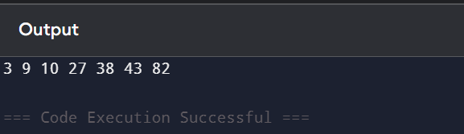
Ques-5)
Solution
#include <iostream>
using namespace std;

int partition(int arr[], int low, int high) {
int pivot = arr[high];
int i = low - 1;
for (int j = low; j < high; j++) {
if (arr[j] <= pivot) {
i++;
swap(arr[i], arr[j]);
}
}
swap(arr[i + 1], arr[high]);
return i + 1;
}

void quickSort(int arr[], int low, int high) {
if (low < high) {
int pi = partition(arr, low, high);
quickSort(arr, low, pi - 1);
quickSort(arr, pi + 1, high);
}
}

int main() {
int arr[] = {10, 7, 8, 9, 1, 5};
int n = sizeof(arr)/sizeof(arr[0]);
quickSort(arr, 0, n - 1);
for (int i = 0; i < n; i++) cout << arr[i] << " ";
return 0;
}
Output
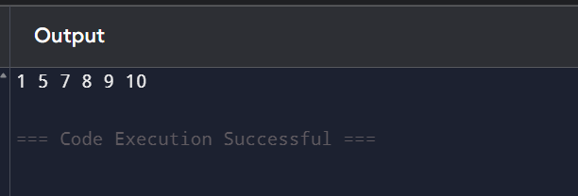
Ques-2)
Solution
#include <iostream>
using namespace std;
void improvedSelectionSort(int arr[], int n) {
int left = 0, right = n - 1;
while (left < right) {
int minIndex = left, maxIndex = left;
for (int i = left; i <= right; i++) {
if (arr[i] < arr[minIndex]) minIndex = i;
if (arr[i] > arr[maxIndex]) maxIndex = i;
}
swap(arr[left], arr[minIndex]);
if (maxIndex == left) maxIndex = minIndex;
swap(arr[right], arr[maxIndex]);

left++;
right--;
}
}
int main() {
int arr[] = {64, 25, 12, 22, 11, 90, 45};
int n = sizeof(arr)/sizeof(arr[0]);
improvedSelectionSort(arr, n);
for (int i = 0; i < n; i++) cout << arr[i] << " ";
return 0;
}
Output
