1. Objective

Develop a scalable, brandable, one-page website template using Next.js. This template will be used across a family of motorsport-related websites, with each site sharing a consistent layout and structure but customized per brand through a configuration object.

The content will come from a JSON API, but I want to work on the design component first and getting that right.

2. Websites in Scope

The following domains will use this template:

motorrace.com.au (Main organisation site)

wakefield300.com.au (Single event site - existing)

sydney300.com.au (Single event site – existing – but really outdated!)

supertt.com.au (Race category site)

clubmanchampionship.com.au (Race category site – nothing exists yet)

2.1 Design Influence

Do not copy the following sites directly. They are provided to illustrate the visual style, layout structure, and navigation patterns that are desirable:

<https://gt4australia.com.au/>

<https://www.intercontinentalgtchallenge.com/>

<https://www.gt-world-challenge.com/>

<https://www.gt-world-challenge-europe.com/>

<https://www.crowdstrike24hoursofspa.com/>

<https://www.gt-world-challenge-asia.com/>

<https://www.gt-world-challenge-america.com/>

<https://www.gt-world-challenge-australia.com/>

<https://www.gt2europeanseries.com/>

<https://japancup.co/>

<https://www.gt4europeanseries.com/>

<https://ffsagt.gt4series.com/>

<https://www.gt4-america.com/>

<https://www.gt4series.com/>

<https://www.gtamerica.us/>

<https://www.tcamerica.us/>

<https://www.ffsatourisme.fr/>

<https://www.grcupseries.com/>

<https://www.fiamotorsportgames.com/>

Font style preference: Exo 2 (or visually similar, freely available font).  
Example of button style reference: <https://trophytour.com.au/> (this is a site that I did and played around with).   
  
These are concepts that I played with. As you can see in the first image, the logo is too small to read, hence the reason for it to be transparent. If you need higher-res images from below, let me know and I can send them to you. But basically, the colour needs to run across the top of the menu (from the right) to the left, then come down and fade away? (It’s a little easier to see on the red version).

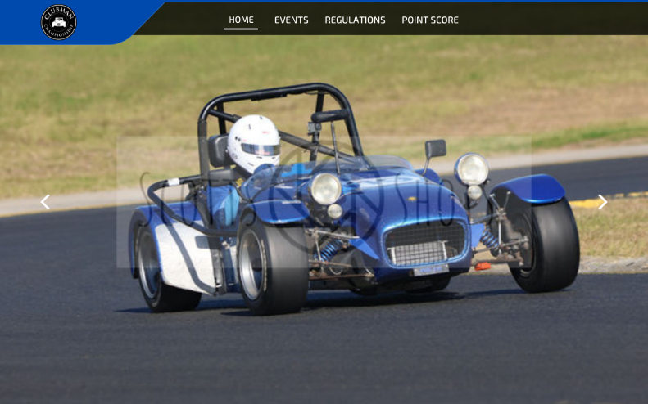 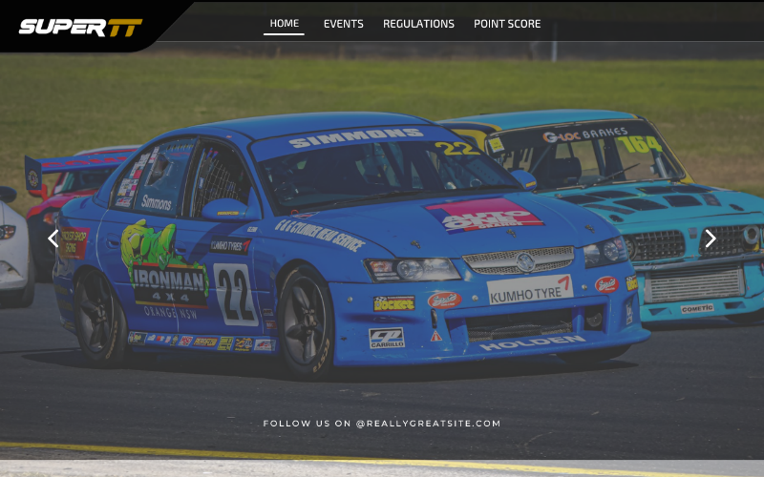

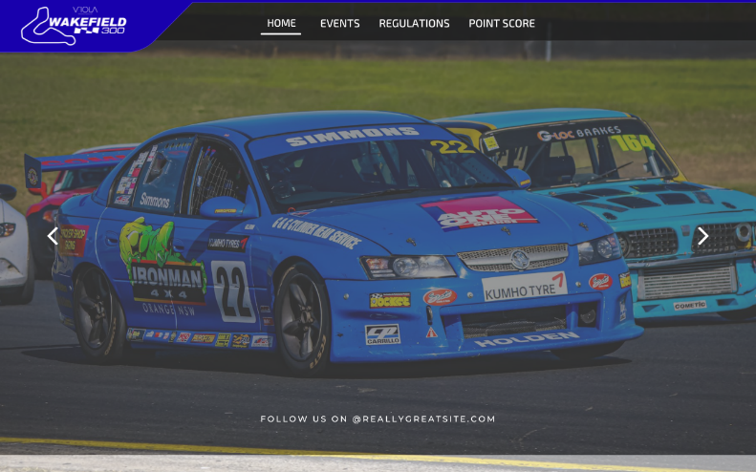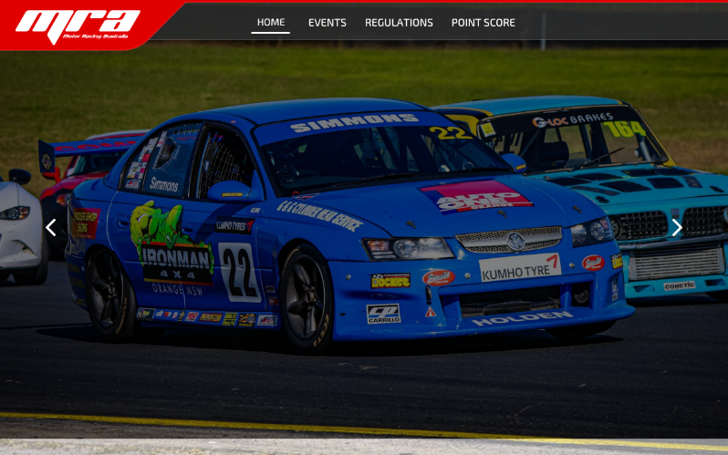

This is the concept… the best I can draw – I’m really sorry!!   
  
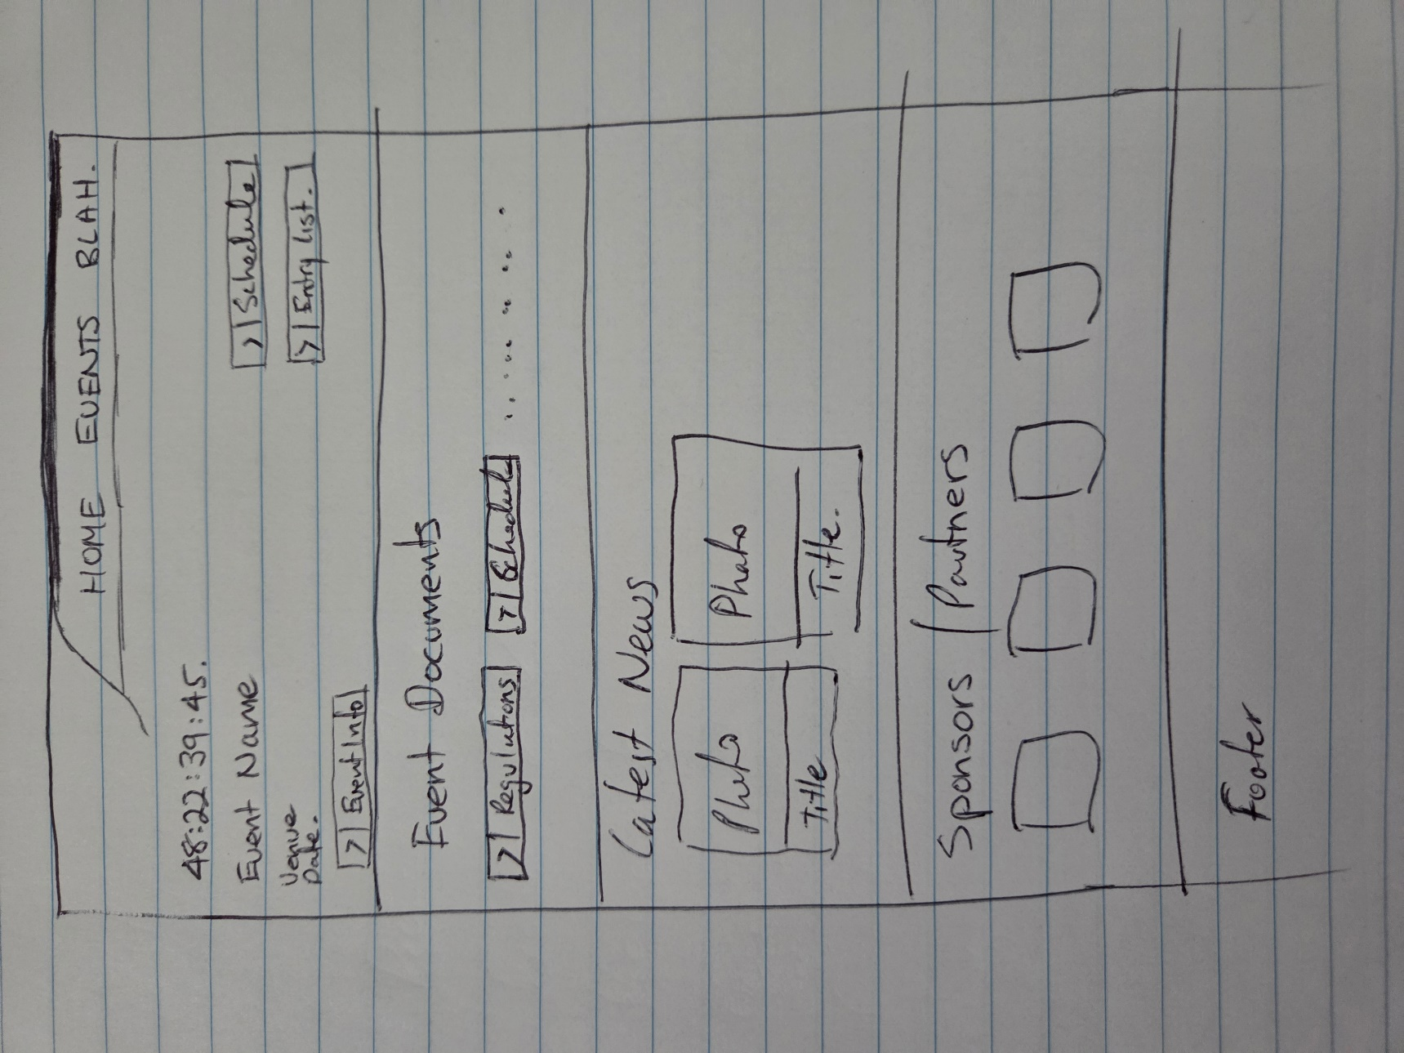

**3. Page Structure**

The layout is a single scrollable page with anchor-based navigation and six defined sections:

**Header / Menu**

Left-aligned logo with transparent background

Right-aligned menu items (text only for now)

Customisable menu background colour

SVG curve underneath header that starts high on the right and fades out near the left edge of the logo

Support for top-right action buttons (e.g. “Enter Now”)

**Hero / Event Overview**

Full-width background image (set via config)

Text overlay: event name, venue, date

Countdown timer (hardcoded for now, e.g. "23 days remaining")

Buttons styled to match trophytour.com.au

Example: “Schedule”, “Entry List”, “Event Info”

**Event Documents**

Section below hero

Title: “Event Documents”

2–4 buttons using same button styling as hero

Each button links to a downloadable file or external URL

**Latest News**

Section title: “Latest News”

Grid of 4 tiles on desktop, responsive to 2 or 1 on smaller screens

Each tile contains:

Image

Headline

Date

No click-through required for now

Content to be pulled from config

**Sponsors / Partners**

Section title: “Sponsors | Partners”

Horizontally scrollable carousel or auto-rotating layout

Logos displayed at consistent size

Optional click-through URL per sponsor

**Footer**

Logo and/or short brand text

Social media icons

Simple links (no routing required)

Footer background and text colours set via config

**4. Theming / Configuration**

Each site must load values from a JSON config to enable unique branding. Example:

{

"siteTitle": "Wakefield 300",

"primaryColor": "#E60000",

"menuBackground": "#FFFFFF",

"textColor": "#000000",

"logoImage": "/logos/wakefield300.png",

"menu": [

{ "label": "Home", "url": "/" },

{ "label": "Entry List", "url": "/entry-list/?id=1234" },

{ "label": "Event Schedule", "url": "/event-schedule/?id=1234" }

],

"hero": {

"background": "https://trophytour.com.au/assets/img/oneraceway.jpg",

"eventDate": "2025-08-16T10:00:00+10:00",

"eventInfo": "/event-info/?id=1234",

"buttons": [

{ "label": "Spectator Information", "url": "/spectator-info/?id=1234" },

{ "label": "Enter now!", "url": "/entry-form/?id=1234" },

{ "label": "Schedule", "url": "/event-schedule/?id=1234" }

]

},

"eventDocuments": [

{ "label": "Supplementary Regulations", "url": "/docs/supp-regs.pdf" },

{ "label": "Further Regs", "url": "/docs/further-regulations.pdf" },

{ "label": "Garage Allocations", "url": "/docs/garageallocations.pdf" },

{ "label": "Carport Allocations", "url": "/docs/carportallocations.pdf" }

],

"newsItems": [

{

"title": "News Item #1",

"date": "2025-07-15",

"image": "/news/entries.jpg",

"url": "/news/item-1"

},

{

"title": "News Item #2",

"date": "2025-07-15",

"image": "/news/entries.jpg",

"url": "/news/item-2"

},

{

"title": "News Item #3",

"date": "2025-07-15",

"image": "/news/entries.jpg",

"url": "/news/item-3"

},

{

"title": "News Item #4",

"date": "2025-07-15",

"image": "/news/entries.jpg",

"url": "/news/item-4"

}

],

"sponsors": [

{

"name": "Company A",

"logo": "/sponsors/a.png",

"url": "#"

},

{

"name": "Company B",

"logo": "/sponsors/b.png",

"url": "#"

}

]

}

5. Technical Requirements

| Component | Requirement |
| --- | --- |
| Framework | Next.js |
| Styling | TailwindCSS?? |
| Font | Exo 2 (Google Fonts or fallback) |
| Images | Stored in /public/ folder ?? |
| Countdown | Static content, formatted from date in config |

6. Deliverables

One-page responsive layout using Next.js

Theming system based on config JSON

Sections implemented: Header, Hero, Event Docs, News, Sponsors, Footer

Example implementations for 2 sites: motorrace.com.au, wakefield300.com.au

Folder structure for /public/images, /configs/, etc.

No CMS, backend, or API integration required in Phase 1