William Bellows and Madison Mehalko Week 9 Group Project

# Task List:

1. Find appropriate GitHub project, 1 hour.
2. Create Gantt Chart, 1 hour, depends on selected GitHub project
3. Create critical path analysis, 1 hour, depends on selected GitHub project
4. Calculate float/slack times, 1 hour, depends on critical path analysis
5. Supplement API code, 1 hour, depends on Gantt Chart and float/slack times
6. Include F reading, 2 hours, depends on Gantt Chart and float/slack times
7. Change color of text background dependent on weather, 2 hours, depends on Gantt Chart and float/slack times

# Task Diagram:

|  |  |  |  |
| --- | --- | --- | --- |
| Number | Task Name | Length [Hours] | Predecessor |
| 1 | Find appropriate GitHub project | 1 |  |
| 2 | Create Gannt Chart | 1 | 1 |
| 3 | Create Critical path analysis | 1 | 1 |
| 4 | Calculate float/slack times | 1 | 3 |
| 5 | Supplement API code | 1 | 2, 4 |
| 6 | Include F reading | 2 | 2, 4 |
| 7 | Change color of text bg dependent on weather | 2 | 2, 4 |

# Initial Gantt Chart Plan:

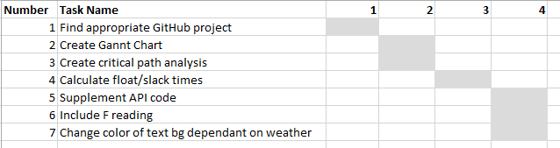

# Critical Path Analysis:

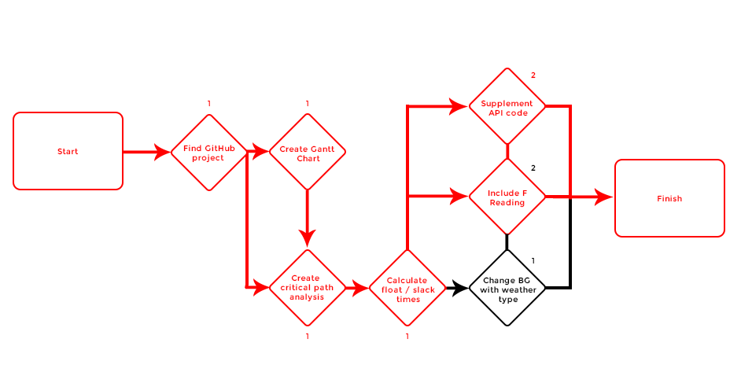

**Critical Path 1: (total 6 hours)** Find Github Project, Create Gantt Chart, Create critical path analysis, calculate float/slack times, supplement API code.

**Critical Path 2: (total 6 hours)** Find Github Project, Create Gantt Chart, Create critical path analysis, calculate float/slack times, Include F reading.

**Non-Critical Path 1: (total 5 hours)** Find Github Project, Create Gantt Chart, Create critical path analysis, calculate float/slack times, Change BG with weather type.

**Float/Slack Time:** 1 hour.