Please paste a screenshot of a successful program run, and copy-and-paste the source code from your .java file(s), here.

Your team member names must be a comment on the first line of each Java file.

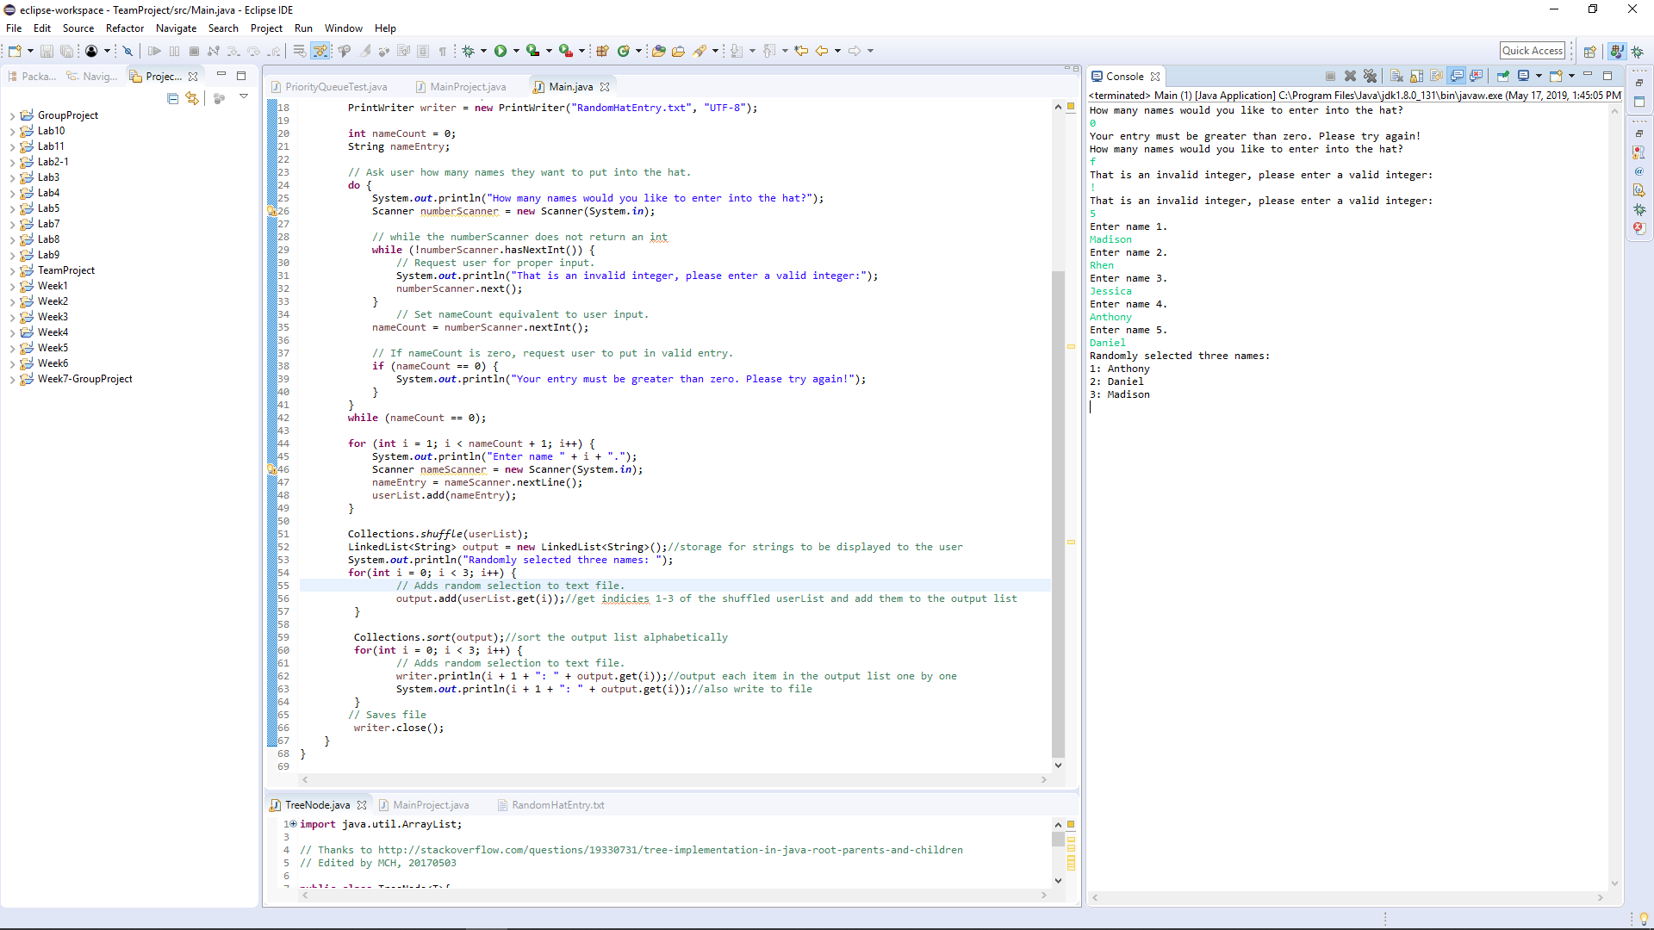

**import** java.io.FileNotFoundException;

**import** java.io.PrintWriter;

**import** java.io.UnsupportedEncodingException;

**import** java.util.Collections;

**import** java.util.LinkedList;

**import** java.util.Scanner;

/* The purpose of this program is to pull three random names from a list of

* names inputed by the user.

*

* Madison Mehalk & Rhen Niles 05/19/2019*/

**public** **class** Main {

**public** **static** **void** main(String[] args) **throws** FileNotFoundException, UnsupportedEncodingException {

// Create and initialize the list and scanner object.

LinkedList<String> userList = **new** LinkedList<>();

// Printer for file input.

PrintWriter writer = **new** PrintWriter("RandomHatEntry.txt", "UTF-8");

**int** nameCount = 0;

String nameEntry;

// Ask user how many names they want to put into the hat.

**do** {

System.***out***.println("How many names would you like to enter into the hat?");

Scanner numberScanner = **new** Scanner(System.***in***);

// while the numberScanner does not return an int

**while** (!numberScanner.hasNextInt()) {

// Request user for proper input.

System.***out***.println("That is an invalid integer, please enter a valid integer:");

numberScanner.next();

}

// Set nameCount equivalent to user input.

nameCount = numberScanner.nextInt();

// If nameCount is zero, request user to put in valid entry.

**if** (nameCount == 0) {

System.***out***.println("Your entry must be greater than zero. Please try again!");

}

}

**while** (nameCount == 0);

**for** (**int** i = 1; i < nameCount + 1; i++) {

System.***out***.println("Enter name " + i + ".");

Scanner nameScanner = **new** Scanner(System.***in***);

nameEntry = nameScanner.nextLine();

userList.add(nameEntry);

}

Collections.*shuffle*(userList);

LinkedList<String> output = **new** LinkedList<String>();//storage for strings to be displayed to the user

System.***out***.println("Randomly selected three names: ");

**for**(**int** i = 0; i < 3; i++) {

// Adds random selection to text file.

output.add(userList.get(i));//get indicies 1-3 of the shuffled userList and add them to the output list

}

Collections.*sort*(output);//sort the output list alphabetically

**for**(**int** i = 0; i < 3; i++) {

// Adds random selection to text file.

writer.println(i + 1 + ": " + output.get(i));//output each item in the output list one by one

System.***out***.println(i + 1 + ": " + output.get(i));//also write to file

}

// Saves file

writer.close();

}

}