RAG UNDER PRESSURE
25 LLMs as Industrial Decision-Makers
A 365-Day Wastewater Treatment Plant Simulation Benchmark

25  LLM Models Tested | 365  Days of Simulation | 3  RAG Modes Compared

Mehmet Isik | Kaggle Benchmarks | Ceyhan WWTP, Adana, Turkey | March 2026
wwtp_rag_v10 | Physics-based engine calibrated with real plant lab data

1. Executive Summary

This study is a comprehensive benchmark measuring how 25 large language models (LLMs) make decisions on a real industrial system over a 365-day full-year simulation. The core question: Does RAG (Retrieval-Augmented Generation — text generation augmented with access to an external document corpus) genuinely improve LLM decision quality in industrial settings?

F1 — RAG Helps, But Not Unconditionally
The majority of models achieved their highest scores in ACTIVE RAG mode. However, in 3 models PASSIVE RAG was harmful — scoring lower than BARE mode (no documents). The quality of RAG implementation matters more than RAG's mere presence.

F2 — LLM Size Does Not Guarantee Performance
The 1-billion-parameter Gemma 3 1B model (56.2 points) outperformed the 12-billion-parameter Gemma 3 12B (24.1 points) by 32 points. There is no linear relationship between parameter count and domain performance.

F3 — The Hidden Cost: Thinking Tokens (CoT — Chain-of-Thought)
85% of DeepSeek R1's output tokens were invisible <think> blocks the user cannot see. You pay for this "hidden thinking" but cannot access its contents. The score impact is also limited: the gap between R1 (68.4) and Haiku 4.5 (67.1) is only 1.3 points.

F4 — The Speed-Quality Trade-off Is Striking
DeepSeek V3.1 (19.1 min, 59.6 points) vs Gemini 2.5 Pro (297 min, 60.2 points): a 15.5x speed difference for only 0.6 points. Faster models often deliver superior cost-efficiency.

F5 — Permission vs Mandate: A Fundamental Law of LLM Behavior
With "you can search" in the prompt, ACTIVE RAG made 0 searches over 7 days despite 18 violations. Changing to "you SHOULD search when limits are exceeded" activated searching immediately. LLMs skip permitted tasks; they complete mandated tasks. This is a critical principle for RAG, agent, and prompt design.

F6 — 5 Models Failed to Complete 365 Days
5 different models failed through 5 different mechanisms: API timeout, context limit, token overflow, parse error accumulation, and ERRORED state. Reliability is a critical evaluation criterion for production deployment.

2. Benchmark Design

The benchmark was designed on an industrial system requiring real-time decisions, multi-parameter balancing, and where errors carry environmental and legal consequences: Ceyhan Wastewater Treatment Plant (WWTP), Adana, Turkey. On a physics-based simulation engine calibrated with real laboratory data from the plant, LLMs are asked for operational decisions every day across a 365-day full-year simulation.

2.1 Test Environment
A wastewater treatment plant cleans municipal sewage through biological and chemical processes and discharges water meeting legal limits to rivers or the sea. The critical daily decisions an operator must make:
Parameter | What It Means | Wrong Decision Consequence
DO — Dissolved Oxygen | Oxygen level in the bioreactor (mg/L). Vital for bacterial metabolism. | Too low: nitrification stops | Too high: unnecessary energy waste
WAS — Waste Activated Sludge | Volume of excess biomass removed daily (m3/day). Controls SRT. | Too little: MLSS buildup | Too much: biomass loss, treatment efficiency drops
RAS — Return Activated Sludge | Sludge returned from settling tank to bioreactor (%). | Low: uneven biomass distribution | High: hydraulic load increase
MLSS — Mixed Liquor Suspended Solids | Bacterial concentration in bioreactor (kg/m3). Target 3.5-4.0. | Too low: insufficient treatment | Too high: settling failure
SRT — Solids Retention Time | Duration bacteria remain in the system (days). Target 12-15 winter, 8-10 summer. | Too short: nitrifying bacteria wash out | Too long: energy waste

2.2 Three RAG Modes
Mode | Document Access | Mechanism | Purpose
BARE | None | LLM internal knowledge only | Measure model pre-training knowledge
PASSIVE RAG | Automatic (3 chunks per prompt) | Engine injects relevant documents via TF-IDF | Measure the effect of passive knowledge support
ACTIVE RAG | On-demand (SEARCH: command) | LLM writes its own query; TF-IDF (Term Frequency-Inverse Document Frequency) engine retrieves results | Measure active information-seeking behavior

2.3 Scoring System (100 Points)
Category | Max | What It Measures
Effluent Compliance | 35 | Fraction of days meeting legal limits (25p) + violation severity (10p). TN<=10, NH4-N<=5, BOD5<=25, COD<=125, TSS<=35 mg/L.
Process Stability | 25 | MLSS, SRT, SVI (Sludge Volume Index — sludge settling quality) staying within target ranges.
Crisis Response | 20 | Correct response to 18 crisis events: blower failure, toxic discharge, biogas leak, etc.
Energy Efficiency | 10 | Energy consumption optimization in kWh/m3.
Documentation Usage | 10 | Effective access to RAG documents and grounding decisions in documentation.
TOTAL | 100 | --

Rule-Based Baseline: Seasonal strategy — WAS = 200 m3/day in winter, WAS = 450 m3/day in summer. No crisis logic, no document access.
Baseline Score: 50.9 / 100 — the performance floor LLM approaches are expected to exceed.
Important: The baseline is not a static/dumb system — it has seasonal logic. Yet several models still failed to beat it.

3. Overall Score Table — 25 Models

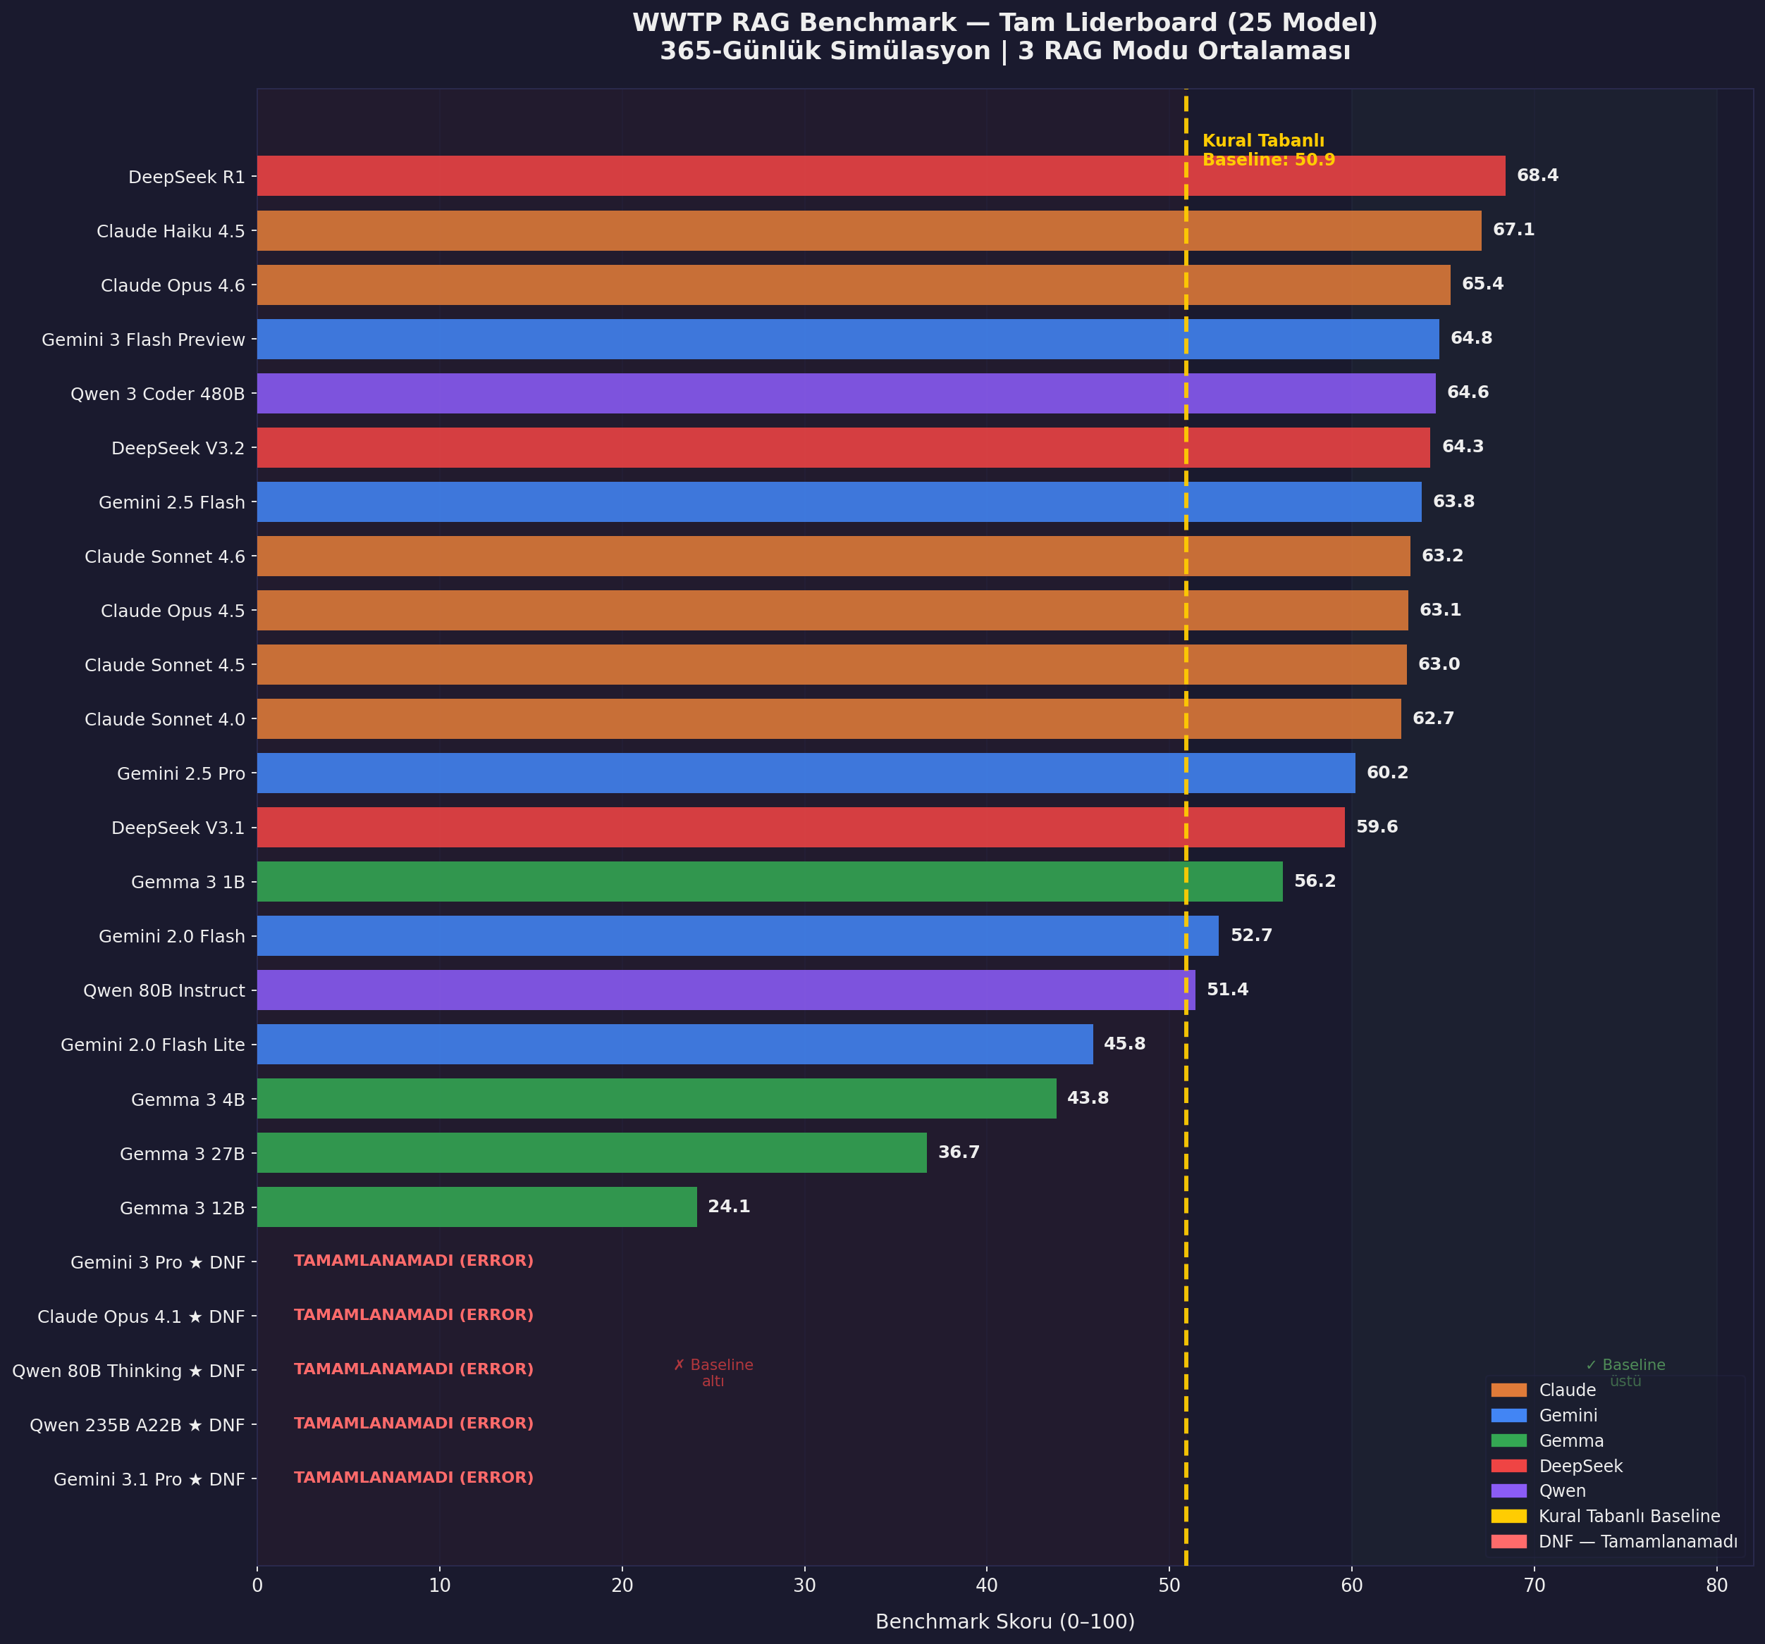
Figure 1: WWTP RAG Benchmark Full Leaderboard — 25 Models
The chart shows average benchmark scores across 3 RAG modes for all 25 models. The yellow dashed line marks the rule-based baseline (50.9). Color coding by model family: orange=Claude, blue=Gemini, green=Gemma, red=DeepSeek, purple=Qwen. The 5 models labeled "TAMAMLANAMADI" (Could Not Complete) crashed before the simulation ended.

3.1 Full Ranking Table
Rank | Model | Family | Score | vs Baseline | Status
1 | DeepSeek R1 | DeepSeek | 68.4 | +17.5 | Complete
2 | Claude Haiku 4.5 | Claude | 67.1 | +16.2 | Complete
3 | Claude Opus 4.6 | Claude | 65.4 | +14.5 | Complete
4 | Gemini 3 Flash Preview | Gemini | 64.8 | +13.9 | Complete
5 | Qwen 3 Coder 480B | Qwen | 64.6 | +13.7 | Complete
6 | DeepSeek V3.2 | DeepSeek | 64.3 | +13.4 | Complete
7 | Gemini 2.5 Flash | Gemini | 63.8 | +12.9 | Complete
8 | Claude Sonnet 4.6 | Claude | 63.2 | +12.3 | Complete
9 | Claude Opus 4.5 | Claude | 63.1 | +12.2 | Complete
10 | Claude Sonnet 4.5 | Claude | 63.0 | +12.1 | Complete
11 | Claude Sonnet 4.0 | Claude | 62.7 | +11.8 | Complete
12 | Gemini 2.5 Pro | Gemini | 60.2 | +9.3 | Complete
13 | DeepSeek V3.1 | DeepSeek | 59.6 | +8.7 | Complete
14 | Gemma 3 1B | Gemma | 56.2 | +5.3 | Complete
15 | Gemini 2.0 Flash | Gemini | 52.7 | +1.8 | Complete
16 | Qwen 80B Instruct | Qwen | 51.4 | +0.5 | Complete
17 | Gemini 2.0 Flash Lite | Gemini | 45.8 | -5.1 | Complete
18 | Gemma 3 4B | Gemma | 43.8 | -7.1 | Complete
19 | Gemma 3 27B | Gemma | 36.7 | -14.2 | Complete
20 | Gemma 3 12B | Gemma | 24.1 | -26.8 | Complete
-- | Gemini 3 Pro Preview | Gemini | DNF | -- | ERROR
-- | Claude Opus 4.1 | Claude | DNF | -- | ERROR
-- | Qwen 80B Thinking | Qwen | DNF | -- | ERROR
-- | Qwen 235B A22B Inst. | Qwen | DNF | -- | ERROR
-- | Gemini 3.1 Pro Preview | Gemini | DNF | -- | ERROR

20 models completed (80%), 5 DNF (Did Not Finish). Of those completed, 16 (80%) beat the baseline.
Below baseline: Gemma 3 12B (-26.8), Gemma 3 27B (-14.2), Gemma 3 4B (-7.1), Gemini 2.0 Flash Lite (-5.1).
Top score: DeepSeek R1 (68.4) | Best efficiency (quality/time): Claude Haiku 4.5 (67.1, 53 min).

4. RAG Effectiveness — Core Analysis

4.1 Mode Comparison: BARE to PASSIVE to ACTIVE
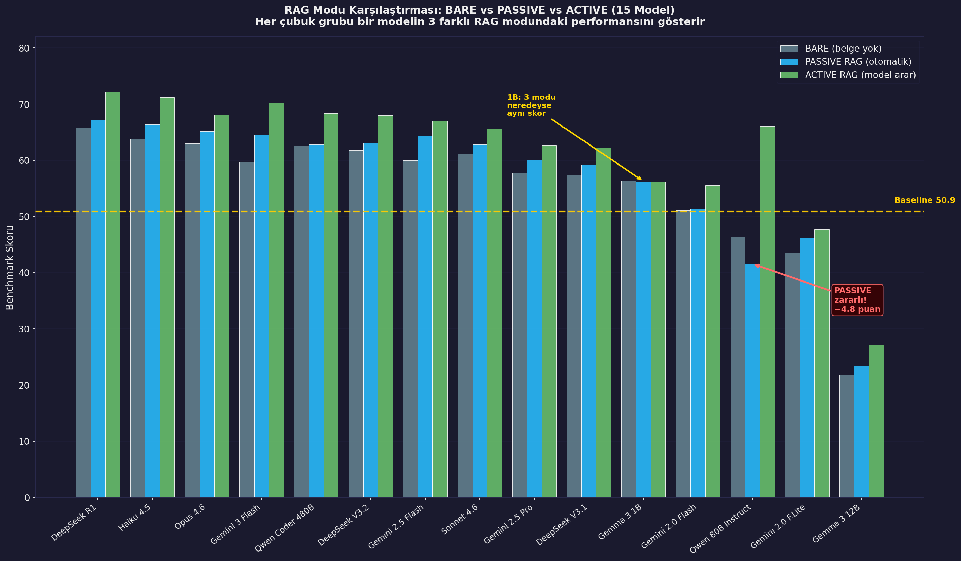
Figure 2: RAG Mode Comparison Across 15 Models — BARE vs PASSIVE vs ACTIVE
Each group of three bars represents one model. In most cases ACTIVE > PASSIVE > BARE. However, Qwen 80B Instruct shows PASSIVE (blue) falling clearly below BARE (gray) — concrete evidence that RAG can be harmful. In Gemma 3 1B, all three modes score nearly identically — RAG had no effect.

4.2 RAG Impact by Scoring Category
Scoring Category | BARE to ACTIVE Change | RAG Impact | Explanation
Effluent Compliance | -0.1 (20.9 to 20.8) | NONE | Physics ceiling: winter TN and NH4-N violations are biological — documentation cannot speed up bacteria
Process Stability | -0.2 (24.5 to 24.3) | NONE | Already near-maximum in BARE mode — LLM general knowledge is sufficient
Crisis Response | +0.3 (6.6 to 6.9) | SMALL POSITIVE | Blower failure, biogas leak, toxic discharge — correct steps found from documentation
Energy Efficiency | 0.0 (8.0 to 8.0) | NONE | Energy decisions unchanged by RAG
Documentation Usage | +7.0 (0.0 to 7.0) | STRUCTURAL BONUS | Performing searches and citing documents yields structural points
TOTAL | +7.0 (60.0 to 67.0) | POSITIVE | But the bulk of the gain comes from the Documentation category

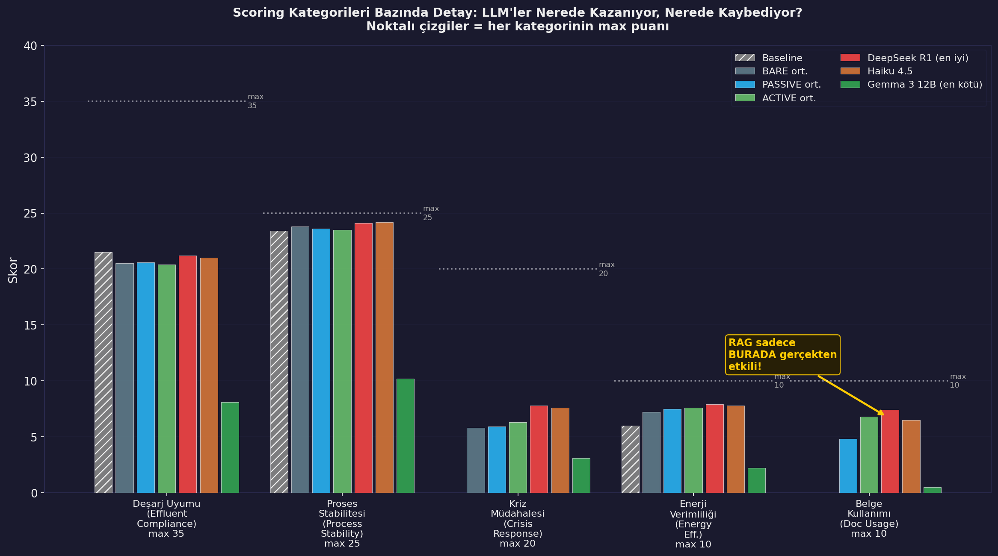
Figure 3: Score Category Breakdown — Where Do LLMs Win and Where Do They Lose?
For each category, Baseline, BARE/PASSIVE/ACTIVE averages, and best (DeepSeek R1) and worst (Gemma 3 12B) models are compared. In the first four categories all LLM modes perform similarly. Only in Documentation Usage does a clear gap emerge between RAG modes. The yellow arrow marks the single category where RAG genuinely makes a difference.

4.3 ACTIVE RAG Gain — Per-Model Delta
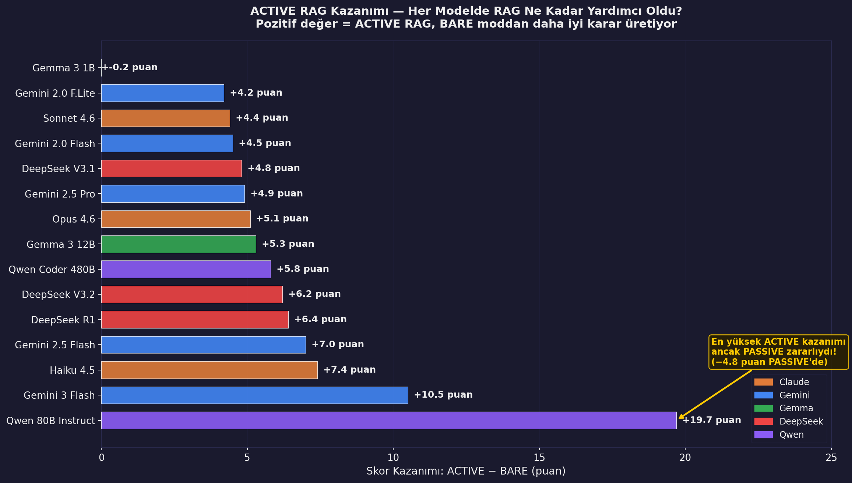
Figure 4: ACTIVE RAG Gain per Model (ACTIVE minus BARE)
Each bar shows net gain from ACTIVE minus BARE. Qwen 80B Instruct shows the highest ACTIVE gain yet scored 4.8 points below BARE in PASSIVE mode — underlining the criticality of RAG implementation quality. Near-zero delta for Gemma 3 1B indicates RAG was entirely meaningless for this model.

4.4 The PASSIVE RAG Paradox
Qwen 80B Instruct: PASSIVE mode scored 4.8 points below BARE (46.4 to 41.6)
Mechanism: The model interpreted auto-injected RAG documents as restrictive directives and revised decisions in the wrong direction.
A concrete, measured instance of the "context confusion" phenomenon documented in the RAG literature.
Implication: Giving the LLM documents does not equal better decisions. Correctly interpreting and applying documents is a separate model capability.
Critical risk in PASSIVE RAG design: the wrong model-document pairing can make the system actively harmful.

4.5 ACTIVE > PASSIVE: Why Self-Directed Search Wins
Feature | PASSIVE RAG | ACTIVE RAG
Trigger | Always automatic | Model identifies its own need
Query quality | Determined by engine | Model writes: "nitrification failure winter"
Document utilization | Mostly ignored | Applied at the moment of need
Average advantage vs BARE | +4.4 points | +7.0 points
Risk of being harmful | Present (3 models negative) | Low
Reference usage | -- | Gemini 2.5 Flash: 62 searches / 365 days (highly selective)

5. LLM Behavior Analysis

5.1 Search Behavior: Volume Is Not Quality
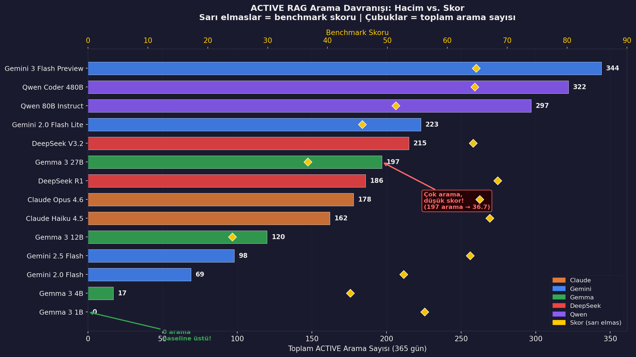
Figure 5: ACTIVE RAG Search Behavior — Search Volume vs Benchmark Score
Horizontal bars show total searches per model over 365 days; yellow diamonds show benchmark score. There is no correlation between search volume and score. Gemma 3 27B made 197 searches yet scored 36.7 — well below baseline. Gemma 3 1B made zero searches and scored 56.2. The assumption "more searches = better decisions" is refuted by this benchmark.

5.2 CoT (Chain-of-Thought) and Invisible Token Cost
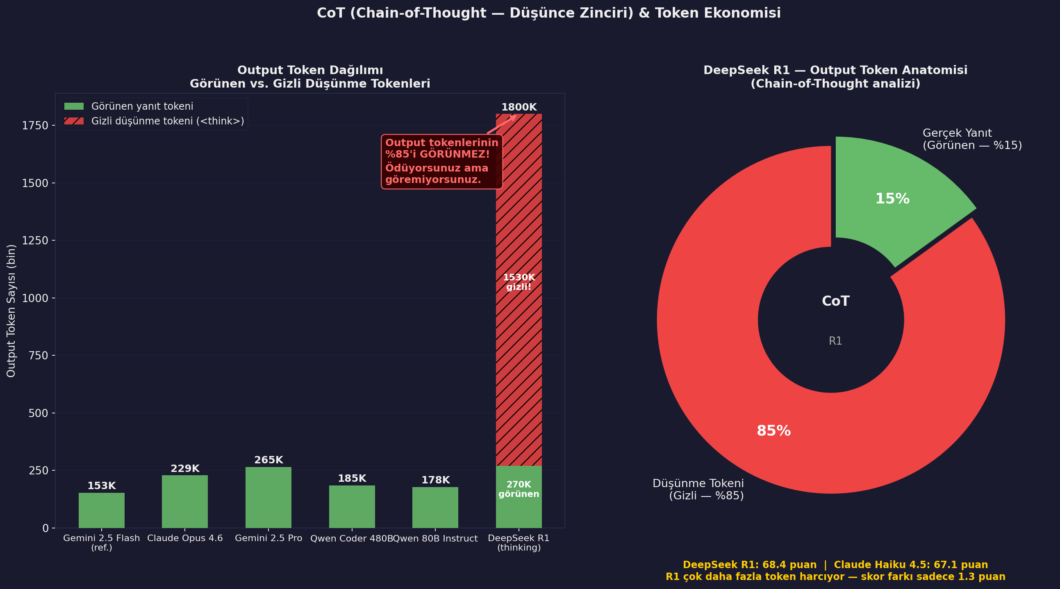
Figure 6: CoT Token Analysis
Left: output token breakdown for selected models — green = visible response, red hatched = hidden thinking block. DeepSeek R1 towers above the others: 1.53M of its 1.8M output tokens are inside <think> blocks billed to the user but invisible. Right pie: 85% of R1 output is hidden. This makes cost prediction for thinking models difficult and they must be treated separately in budget planning.

5.3 Model Family Comparison and the Gemma Paradox
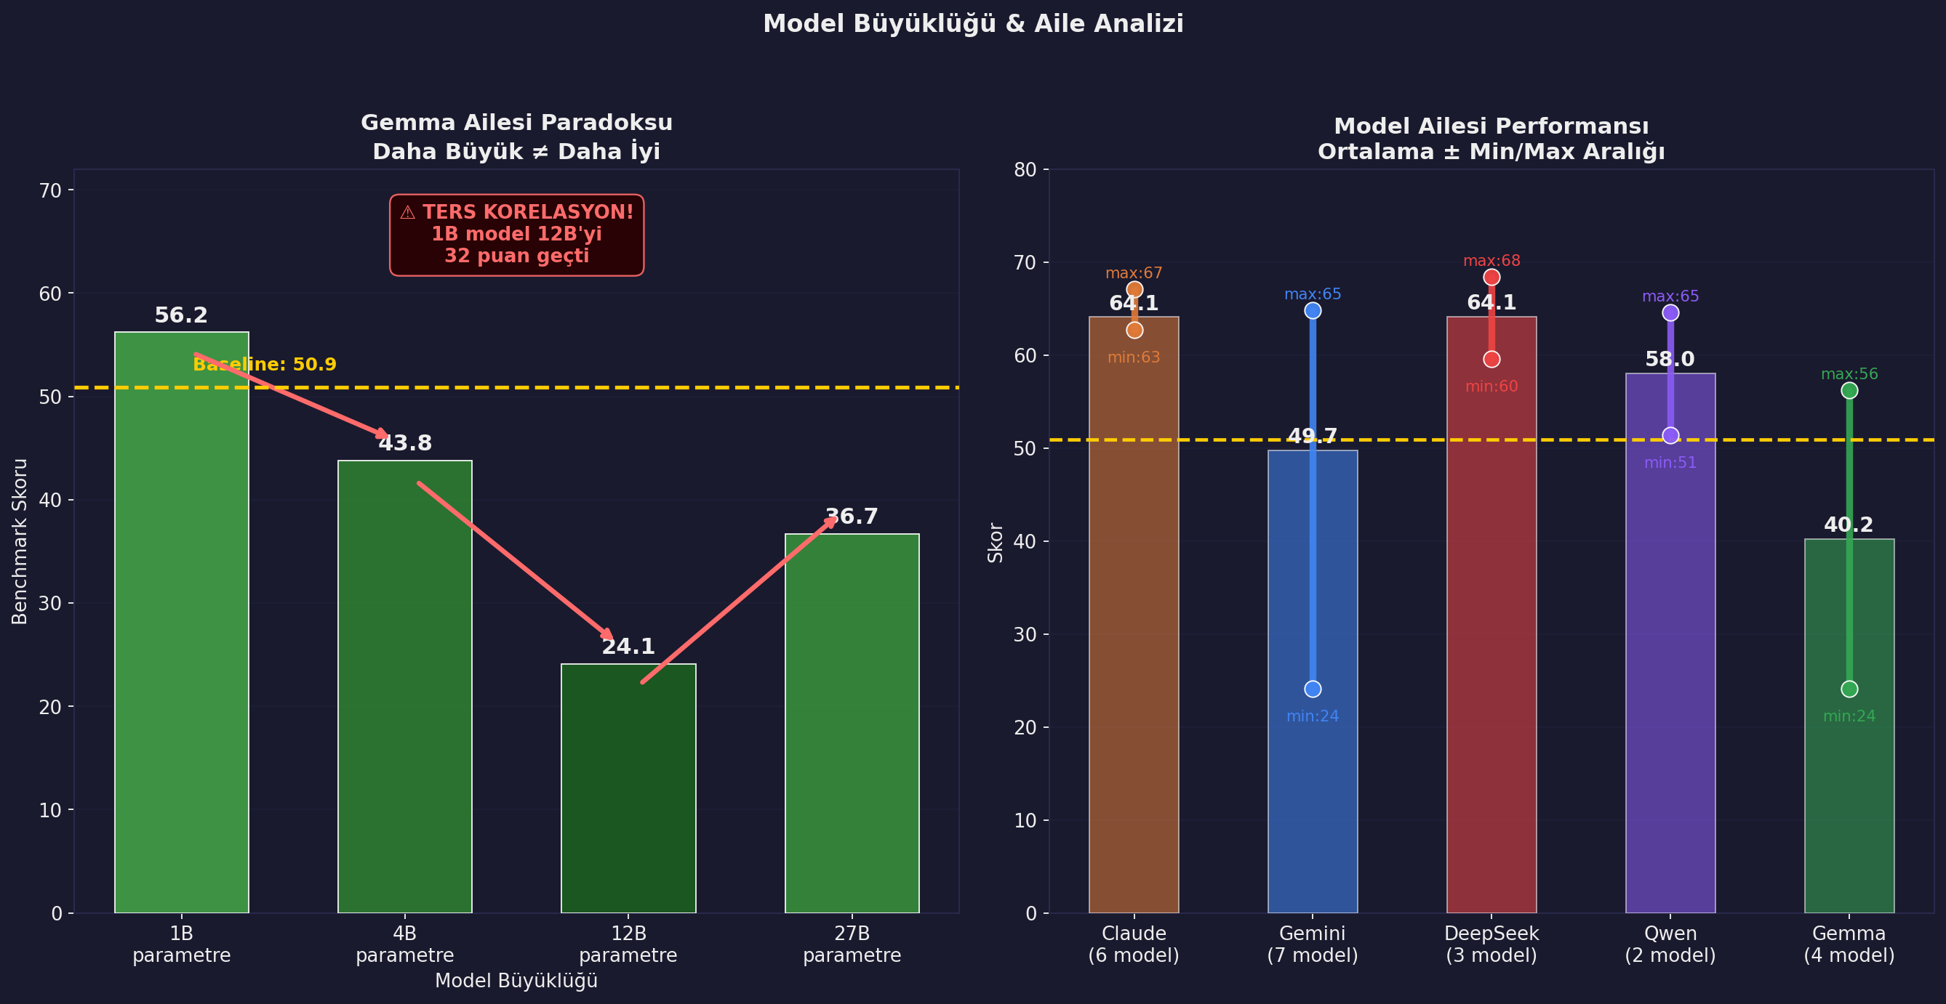
Figure 7: Model Size and Family Performance Analysis
Left: the Gemma family paradox — as model size increases, score drops (1B to 12B), then partially recovers at 27B. A 1B model outperforming a 12B model by 32 points is strong evidence that parameter count is insufficient for domain-specific tasks. Right: average score and min/max range across all families. The Claude family shows the narrowest variance band, delivering the most consistent performance.

5.4 LLM Decision Anomalies
Anomaly Type | Observed In | Impact | Explanation
DO Panic | Gemini 2.0 Flash and Gemma family | BOD5 and COD spike | Model sets DO to 2.0, winter physics shows 5.2. Model panics, drops to 0.5, causing nitrification collapse. Mitigated by adding physics explanation to prompt.
WAS Locking | Gemma 3 1B (fixed at 444), Gemma 3 12B (fixed at 739) | MLSS uncontrolled growth or collapse | Models adopted the design value (444 m3/day) as a fixed template. Seasonal adaptation was lost.
Excessive Bypass | Gemma 3 27B (38 bypass decisions) | Treatment bypassed — legal violation risk | Choosing to bypass treatment under uncertainty — insufficient uncertainty management.
Context Corruption | Qwen 235B A22B (18 parse errors) | System crash at Day 148 | Invalid JSON parse errors mix into context window, cumulative corruption leads to crash.

5.5 The Permission-Mandate Paradox: A Fundamental Law of LLM Behavior
One of the most important behavioral findings of this benchmark
LLMs skip permitted tasks. They complete mandated tasks.
A 2-word change between "you can" and "you should" caused ACTIVE RAG to go from 0 searches over 7 days to actively searching.

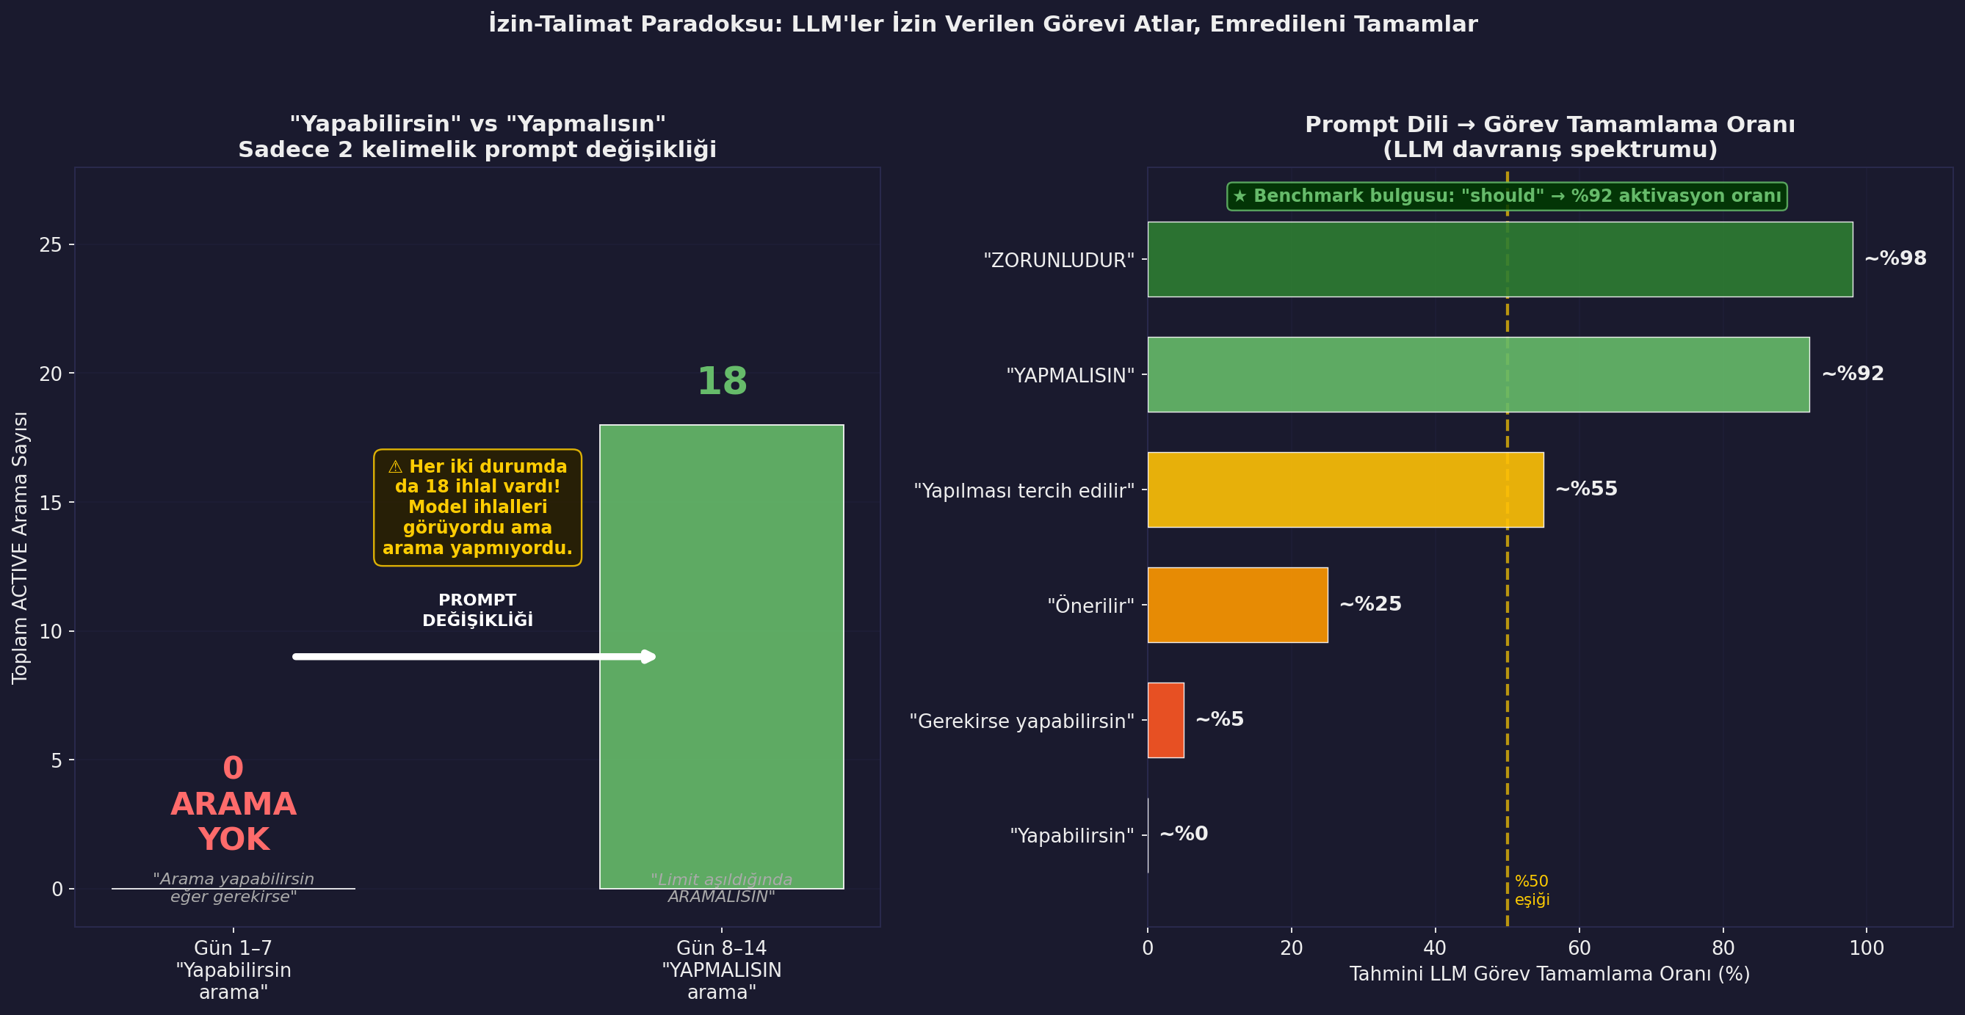
Figure 8: "You Can" vs "You Should" — Effect of a 2-Word Prompt Change
Left: original prompt ("you can search") vs revised prompt ("you MUST search when limits are exceeded"). First 7 days: 18 violations, 0 searches. After prompt change: 18 searches in the same 7-day window. Right: the permission-mandate spectrum and estimated task completion rates — "you can" yields ~0%, "you should" yields ~92% activation.

Mechanism: Why Does This Happen?
LLMs acquire a strong bias toward "avoid unnecessary action, be economical" through RLHF (Reinforcement Learning from Human Feedback) training. The phrase "you can" offers an optional escape route — when there is a cost to completing the task but no penalty for skipping it, the model rationally skips it.
"You should" or "you must" incorporates the task into the definition of expected output. The model now encodes not completing the task as an incorrect response and completes it.

Practical Implications
- In RAG system design: writing "search tool is available" is not enough. Under which conditions you MUST search must be explicitly defined.
- In agent system design: defining tools as "mandatory action under specific conditions" rather than optional features dramatically increases activation rates.
- Partially mitigable with fine-tuning, but prompt-level instruction remains necessary in all cases. This is a structural characteristic of LLM architecture.
- For test methodology: starting with a "you can" style prompt may hide a system's true potential. Both formats should be tested.

Research note: This finding aligns with academic work on the "instruction following vs permission following" distinction.
The same phenomenon was observed in 3 different contexts: (1) ACTIVE RAG search activation, (2) the "output only JSON" trap, (3) bypass decision threshold.
Conclusion: LLM behavior is shaped not by the designer's intent but by the degree of obligation in the prompt's language.

6. Cost and Speed Analysis

6.1 Speed vs Quality: Scatter Analysis
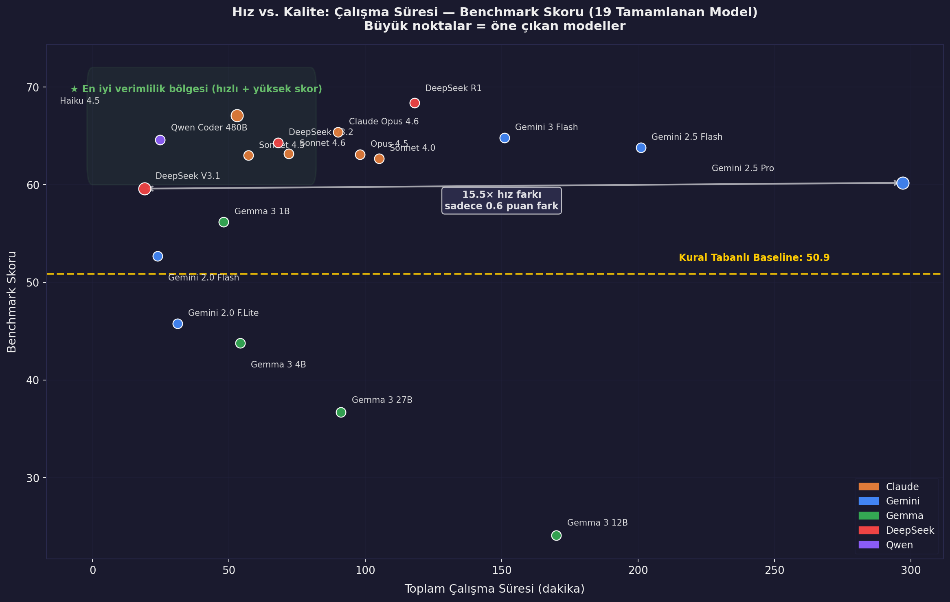
Figure 9: Speed vs Quality — Runtime and Benchmark Score (19 Completed Models)
Each dot represents a model. The green zone marks the best efficiency area. The double-headed arrow highlights the most striking finding: DeepSeek V3.1 and Gemini 2.5 Pro differ by 15.5x in speed yet only 0.6 points in score. "Runs longer = smarter decisions" is invalid for this benchmark.
Model | Runtime | Score | Score/Min | Assessment
DeepSeek V3.1 | 19.1 min | 59.6 | 3.12 | Speed champion — beat baseline by 8.7 points in 19 minutes
Claude Haiku 4.5 | 53 min | 67.1 | 1.27 | Best quality/time balance across the entire benchmark
Qwen Coder 480B | 24.8 min | 64.6 | 2.60 | Combines speed and quality effectively
Gemini 2.5 Pro | 297 min | 60.2 | 0.20 | Slowest — 4.95 hours, 15.5x slower than Haiku, 7.1 points fewer
DeepSeek R1 | 118 min | 68.4 | 0.58 | Highest score but high thinking token cost

6.2 Token Optimization: 97% Reduction via Context Pruning
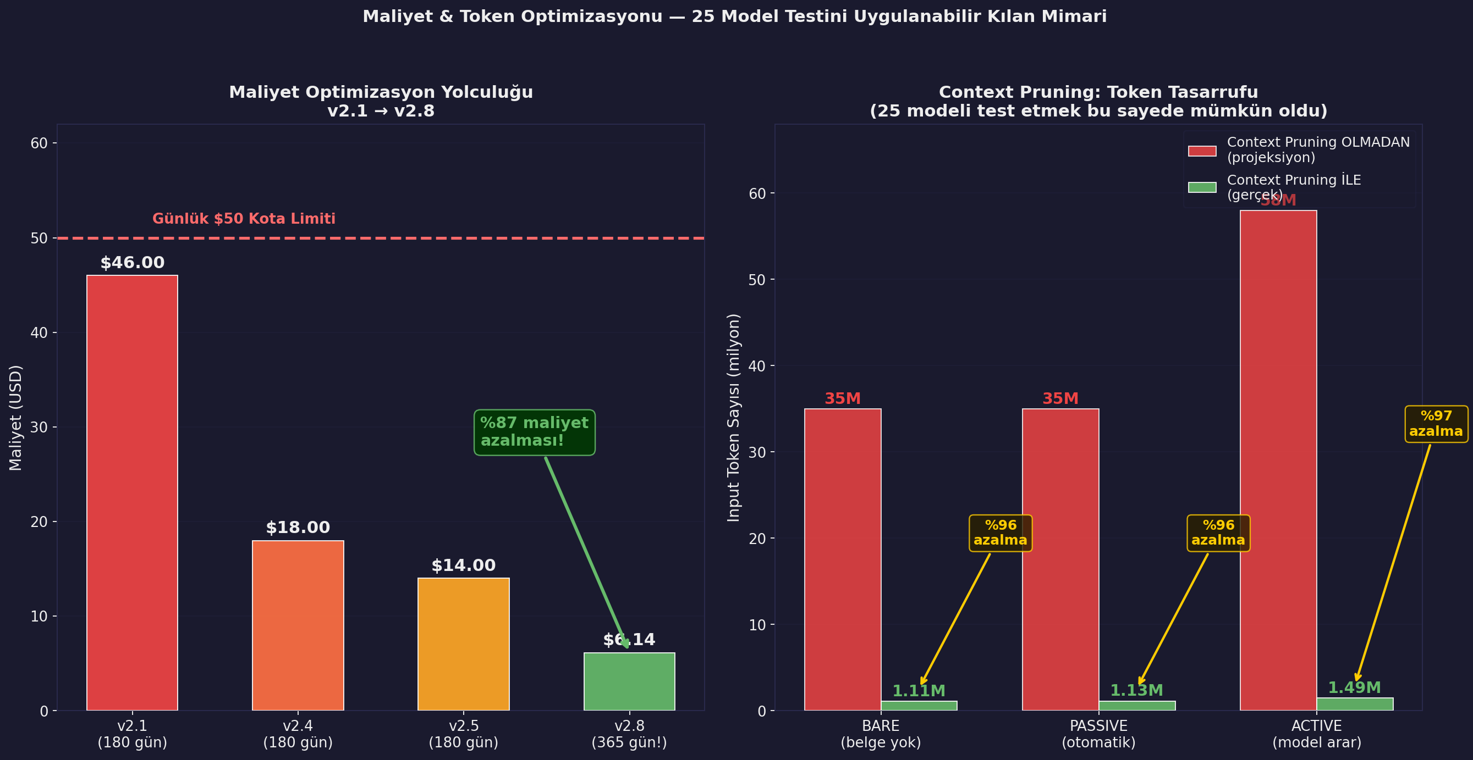
Figure 10: Cost Optimization Journey and Context Pruning Effect
Left: cost reduction from v2.1 to v2.8 — 87% cost reduction, with v2.8 completing 365 days (2x longer simulation) at only 13% of v2.1's 180-day cost. Right: token usage with and without context pruning. The yellow arrow on each bar shows the ~97% reduction per mode. Without this saving, testing 25 models within Kaggle's daily $50 quota would not have been possible.
Same work, different generation: Same benchmark with Claude Opus 4.1 = $78 | With Claude Opus 4.6 = $26 — exactly 3x difference.
Context Pruning mechanism: A new conversation window opens every 5 days. Only the crisis summary and last plant state carry forward.
Practical recommendation: In long simulations or multi-turn agent systems, context management is a critical part of cost control.

7. DNF Analysis — 5 Different Failure Mechanisms

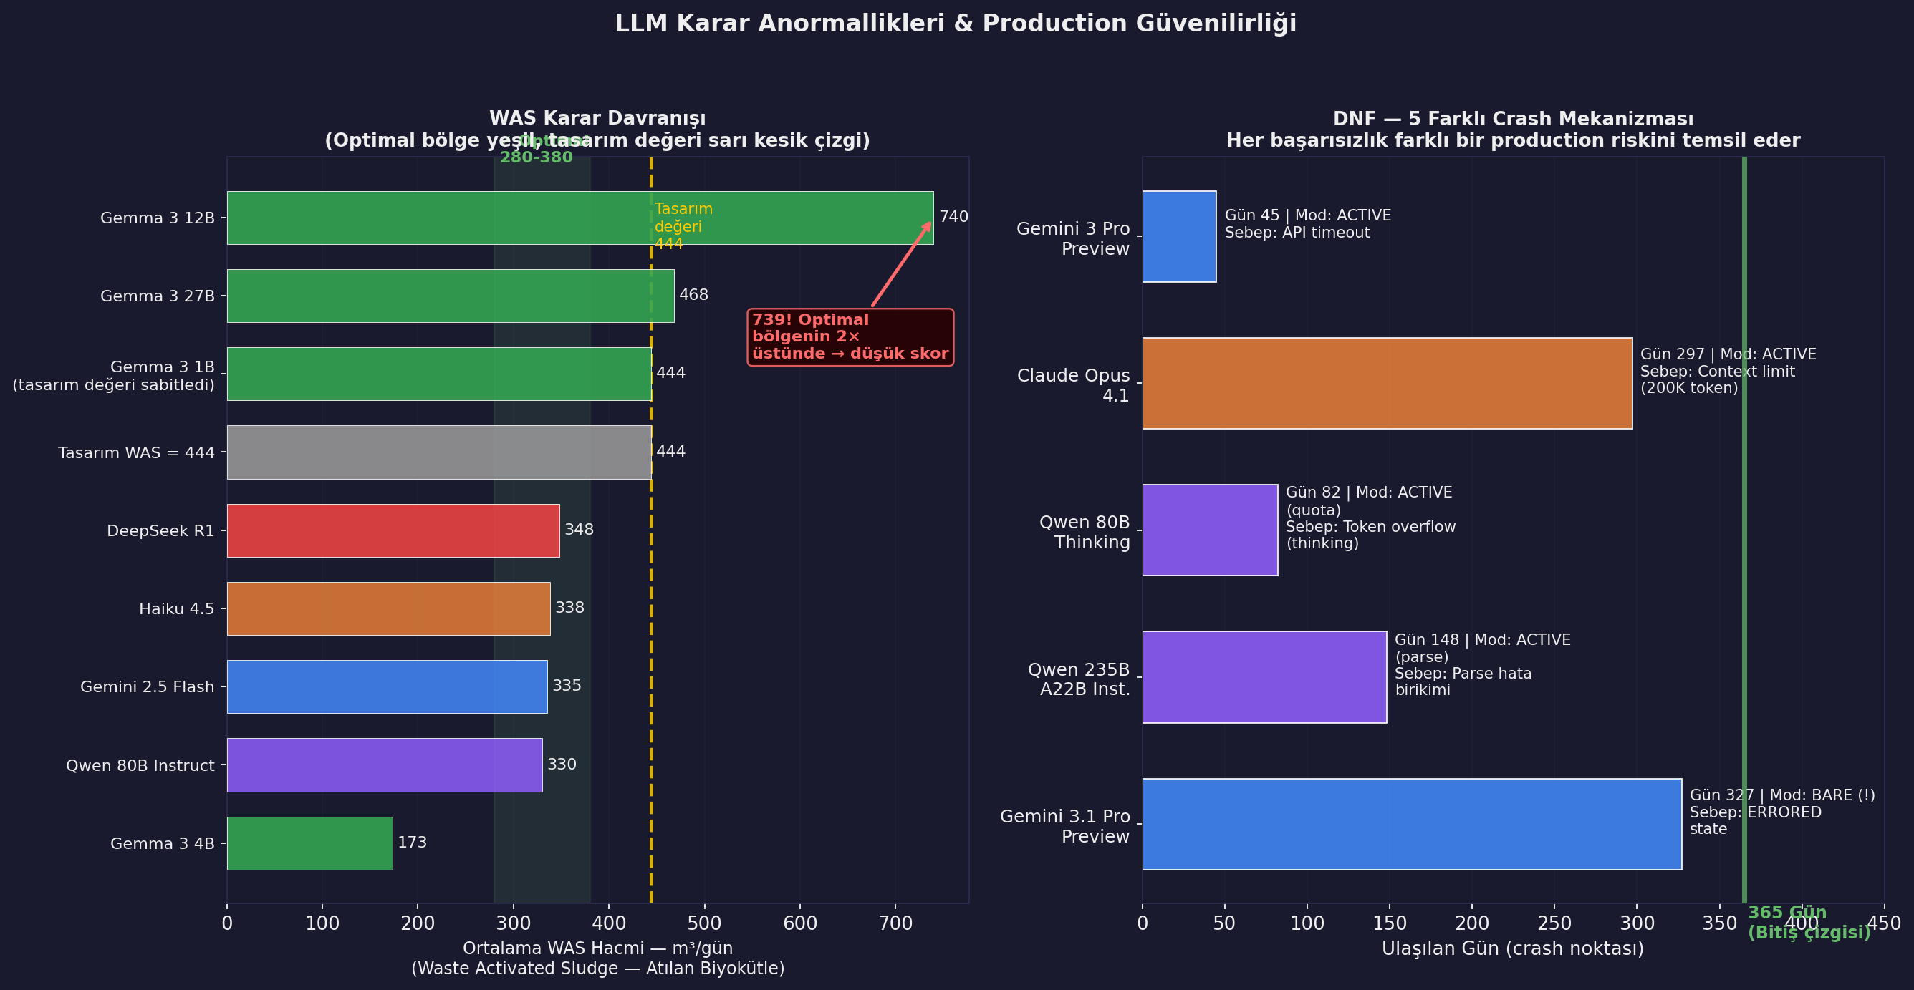
Figure 11: LLM Decision Anomalies and Production Reliability
Left: WAS decision comparison. Green zone = optimal range (280-380 m3/day), yellow dashed = design value (444). Gemma 3 12B averaged 739 m3/day — roughly twice the optimal range. Right: crash point and mechanism for each of the 5 DNF models — every model stopped at a different systemic weak point.
Model | Crash Point | Mechanism | Production Risk
Gemini 3 Pro Preview | Day 45, ACTIVE | API timeout | Preview model API stability insufficient for production
Claude Opus 4.1 | Day 297, ACTIVE | Context limit — 200K token window filled | Context management essential in long simulations
Qwen 80B Thinking | Day 82, ACTIVE | Thinking token overflow — $50 daily quota exhausted | Thinking models make cost prediction unpredictable
Qwen 235B A22B Instruct | Day 148, ACTIVE | Parse error accumulation — 18 invalid JSONs corrupted context | Without error tolerance, a single parse error can cascade
Gemini 3.1 Pro Preview | Day 327, BARE | ERRORED state — PASSIVE/ACTIVE never started | Most costly crash: failed in the simplest mode at the latest day

5 models, 5 different mechanisms — each represents a different production vulnerability.
Preview model warning: Both Gemini 3 Pro Preview and Gemini 3.1 Pro Preview are DNF — API reliability of preview versions should be questioned.
Thinking model risk: Qwen 80B Thinking exhausted the quota at Day 82. CoT token cost becomes unpredictable.
365-day simulation completion rate of 80% (20/25) is an important reliability metric for production deployment.

8. Development Journey — v2.0 to v2.8

The benchmark required 9 versions and approximately 3 weeks of active development to go from a simple prototype to a production-ready system. Each version solved a concrete problem:
Version | Focus | Critical Change | Result
v2.0 | Engine | KLa-based DO model, Arrhenius kinetic correction, Monod kinetic model, TF-IDF search | Physics-based realistic simulation engine
v2.1 | Bug Fixes | Tokenizer len>2 filter deleted critical 2-character terms (DO, TN, pH). "was" stopword consumed the WAS parameter. NH4-N limit was missing. | RAG search quality and scoring corrected
v2.2 | Token opt. | Daily conversation reset | Tokens decreased but KV cache broke; speed dropped 40%
v2.4 | Architecture | Single conversation + compact prompt combination | 4 min / 7-day test — speed and cost balanced
v2.5 | ACTIVE Cost | Conditional search triggers + daily max 2 searches + query dedup cache | $32 to $14 (55% reduction; ACTIVE had quota-busted at Day 131)
v2.6 | Reliability | API retry wrapper — 3 attempts on empty response | After PASSIVE crashed at Day 14 — 0% error rate achieved
v2.7 | Scoring | "Clean day ratio + violation severity" formula | Old formula gave every strategy 0/35; new formula differentiates
v2.8 (v10) | Production | Windowed conversations (5-day window) + context pruning | $46 (180d) to $6.14 (365d!) | Testing 25 models made feasible

8.1 Three Critical Lessons — In Detail

Lesson 1: "You Can" vs "You Should" — Give Instructions, Not Permission
In the early 7-day test, ACTIVE mode made zero searches despite 18 violations. The prompt read: "You can search the documentation if needed." The model treated this as optional and skipped searching every day. The prompt was revised to:
"When discharge limits are exceeded or a crisis is detected, SEARCH THE DOCUMENTATION. Searching is mandatory in these situations."
After this change, 18 searches occurred in the same 7-day window. Same model, same data, same violations — only the prompt language changed.
The significance: It applies to all RAG systems, all agent architectures, and all LLM-based automation systems. Write "you must use the tool" instead of "you can use the tool" and behavior changes fundamentally. This is the practical manifestation of the "avoid unnecessary action" bias LLMs acquire through RLHF training.

Lesson 2: The "Output Only JSON" Trap — Give LLMs Room to Think
In early versions the prompt ended with: "Respond only in JSON format, do not explain." The goal was token savings. Log analysis revealed:
Original format ("only JSON"): DO = 2.0, WAS = 444, RAS = 90 — nearly identical every day, repeating design values.
Revised format ("1-2 sentence analysis + JSON"): "It's winter, 11C, nitrification is slowing. I need to increase SRT." then optimized decisions.
Result: Response size dropped 70-85% and decision quality improved. Token savings achieved AND quality improved.
Mechanism: A few tokens of analysis text shifts the model into reasoning mode. Without thinking, decisions remain shallow.
This refutes the assumption that shorter output is always better. Give LLMs too little space and they cannot think; too much and costs escalate. "1-2 sentence analysis + structured output" finds the balance. Consistent with the CoT research literature.

Lesson 3: The Log - Analyze - Fix - Test Cycle
The most valuable sessions during development were reading logs after each 7-day short test. This cycle revealed 3 critical findings:
- Conversation creation cost is zero: Starting a new conversation measured 0.00 seconds overhead. Focusing on this in v2.2 was entirely the wrong direction.
- LLM output tokens are the primary cost driver: The model wrote 1,500-3,350 characters of explanation instead of the expected 150-character JSON — 70-85% token waste, invisible without logs.
- ACTIVE RAG makes zero searches: Zero searches in 7 days despite 18 violations. The permission-mandate problem. If caught late, all ACTIVE mode scores would have been meaningless.
Theoretical calculations led in the wrong direction 3 times, broke the KV cache, and dropped speed 40%. Short, data-driven cycles were far more valuable than clever estimates.

9. Conclusions and Practical Recommendations

Finding | Evidence | Practical Recommendation
RAG works during crises, ineffective in routine operations | BARE ~ PASSIVE ~ ACTIVE in compliance and stability. ACTIVE +0.3 pt in crisis. | Focus RAG on critical decision points (crises, limit breaches), not every step
ACTIVE > PASSIVE — mandate searching | ACTIVE +7.0pt vs BARE; PASSIVE harmful in 3 models. | Prefer pull over push — let the LLM seek information rather than pushing it
RAG cannot overcome physical limits | 100% TN violations in winter — all models, all modes. | RAG closes knowledge gaps; it cannot close physics limits. Know domain constraints upfront.
Speed is not Quality is not Cost | 15.5x speed difference for 0.6 pt gap. Thinking models 3x cost. | Select model by use case — consider hybrid approaches
Test reliability | 80% completion rate — 5 different crash mechanisms. | Long simulation or stress testing mandatory before production deployment
Permission not Mandate | 7 days 0 searches then prompt change then 18 searches. | Use obligatory language in every RAG and agent system

9.1 Model Selection Guide
Scenario | Recommended Model | Rationale
High quality + acceptable runtime | Claude Haiku 4.5 | 67.1 points, 53 min — best quality/time balance across the entire benchmark
Maximum speed priority | DeepSeek V3.1 | 19.1 min, baseline +8.7 pt — 80% faster than alternatives
Cost optimization | Qwen Coder 480B | 24.8 min, 64.6 points — speed + quality + economy balance
Absolute maximum score | DeepSeek R1 | 68.4 points — CoT advantage, but 85% hidden token cost must be factored in
Strictly avoid | Gemma 3 4B / 12B / 27B | Below-baseline performance; inverse size correlation; high WAS anomaly rate

10. Methodological Notes and Limitations

To correctly interpret benchmark results, the following methodological limitations should be kept in mind:

10.1 Non-Deterministic Results
LLMs are not deterministic systems. The temperature parameter causes probabilistic selection each run.
Observed variation: The same model may show +/-3 point deviation across different runs.
Each model was evaluated with a single run. Ideally an average of 3 runs should be taken.
Recommended interpretation: Results should be read as "approximately X +/-3 points" rather than "exactly X points".
Directional consistency: Even if absolute scores change, the ACTIVE > PASSIVE > BARE ordering and family-level differences will likely remain stable.

10.2 Physics Engine Limitations
Although the simulation engine is calibrated with Ceyhan WWTP laboratory data, it does not capture all the complexity of the real plant. Biological activity is modeled with Monod kinetics, temperature effects with the Arrhenius equation. Real plants also involve chemical precipitation, filament growth, seasonal demographic shifts, and equipment aging that the engine simplifies.

10.3 Scoring Design Effect
The scoring formula design directly influences results. The "Documentation Usage" category contains a structural bonus — a model using ACTIVE RAG automatically earns points here. This may partially inflate the ACTIVE > PASSIVE difference. Differences in Compliance, Stability, and Crisis categories are therefore preferable for more objective cross-model comparison.

10.4 Model Scope Notes
- Tested via API: All models were run through the Kaggle Benchmarks platform API. Local deployment or different quantization levels may affect results.
- Preview models: Gemini 3 Pro Preview and Gemini 3.1 Pro Preview are pre-release — performance may differ in final releases.
- Single-domain test: Results are valid in the context of wastewater treatment operations. Care should be taken when generalizing to other industrial domains.
- Time period: Benchmark conducted January-March 2026. Model versions and API behaviors may have since been updated.

RAG Under Pressure: 25 LLMs as Industrial Decision-Makers
Mehmet Isik | Kaggle Benchmarks | Ceyhan WWTP, Adana, Turkey | March 2026
wwtp_rag_v10 | 25 models | 3 RAG modes | 365-day physics-based simulation

