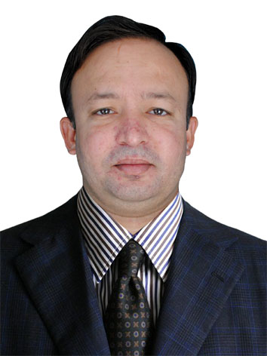
Add: Thardeep Microfinance Foundation
Banglow # A-14, Housing Scheme, Phase 1,
Park View Main, Qasimabad, Hyderabad E-mail: jeetander.dharmani@gmail.com
Cell : +92 3313710488
Office: +92 222 2670447
LinkedIn: Jeetander Brahman

Jeetander Brahman

Objectives:

- Seeking a platform where I can explore myself and contribute towards social change, sustainable development, growth, and poverty reduction of human being.

Academic Qualification:

Degree | Year | % Age | Institution
MBA | 2009 | 69 | University of Sindh
BBA | 2008 | 72 | University of Sindh
HSC | 2005 | 76 | BISE Mirpurkhas
SSC | 2003 | 76 | BISE Hyderabad

Computer Qualification:

Course | Institution
06 months short course | Banhan beli computer center
Short Course in Computer Hardware | Prime Computer Center Hyderabad

Other Skills:

- Fluent in English and Regional Language
- Excellent negotiation and communication skill

Experience:

- Senior Finance & Taxation Officer
At Thardeep Microfinance Foundation Head Office, Hyderabad
(July 01, 2019 to Present).

- Programme Officer Finance
Thardeep Microfinance Foundation Head Office, Mithi
(July 01, 2016 to June 30, 2019)
“Thardeep Microfinance Foundation-TMF” (a company set up under Section 42 of the Companies Ordinance, 1984, now referred to as a company act 2017).
- Assistant Accounts Officer
TRDP (Thardeep Rural Development Programme)
Head Office, Mithi
(March 09, 2011 to June 30, 2016)
- Five (05) years and three months consecutive working experience in a highly reputed and recognized an NGO called TRDP-MFP (Thardeep Rural Development Program-Micro Finance Program) at Mithi.

JOB RESPOSIBILITIES:

- Taxation (Income Tax & Sales Tax)
- Compliance of Tax matters regarding payments.
Withholding of income tax and sales tax and submit tax to bank and prepare monthly tax report of FBR (Federal Board of Revenue) and SRB (Sindh Revenue Board).
- Compile of tax payable ledger timely.
- Maintain FIS Online, Maintain Manual Ledger, Maintain Bank Accounts.
- To make cash & cheque Payments and compile whole record.
- To keep maintain Petty Cash and make daily close cash file/voucher.
- To check and maintain Bank Position/Funds daily.
- To update and make Bank Payments & Bank Receipts
- Compile and analyze financial information to prepare entries to accounts, such as general ledger accounts, and document business transactions.
- Establish, maintain, and coordinate the implementation of accounting and account ting control procedures.
- Analyze and review budgets and expenditures.
- Monitor and review accounting and related system reports for accuracy and completeness.
- Also read TOR’s of agreements regarding payments or etc.
- Also keep regards & update for any courier (Administration).
- Welcome, keep interest and accomplish any other task given.

- Internship
(June 13, 2007 to July 29, 2007)
- I have completed summer internship program in NBP Mithi branch.

Appreciations:

- I have been awarded many times with verbal appreciations by my office management and senior officers.

Personal Information:

Father Name : Vad viyas
CNIC No : 44303-2944407-3
Date of Birth : 17 March, 1988
Domicile : Distt: Tharparkar
Language: English, Urdu and Sindhi

