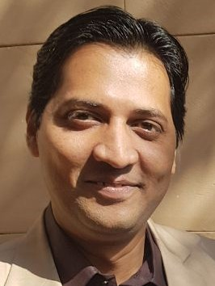
Abid Hussain
House No. R-35 Block No.9, KAECHS, Karachi, Pakistan.

Contact No. +92 3219200318

e-mail: abid.hrm@gmail.com, abid_hr@hotmail.com

PROFESSIONAL SUMMARY

Dynamic and motivated HR professional with 15+ years of experience in creating and implementing programs to improve business operations. Adept at building recruiting, selection and retention business strategies. Able to perform organizational diagnostics and provide recommendations for improvement. Strong relationship-building and effective collaboration with management and co-workers.

CAREER HISTORY

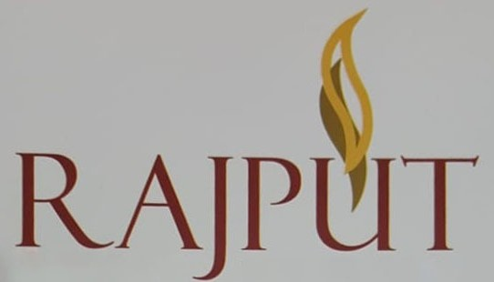

[Nov 2019 to till date] Rajput Builder & Developers

Manager HR |Reporting to the CEO|

- Develops HR policies and SOPs
- Manages recruitment process.
- Manages monthly attendance and payroll
- Manages Health Insurance of employees
- Manages security for all sites
- Grievance handling.
- Coordinates ERP and technical trainings for staff


[Jan 2019 - Oct 2019] Success Human Capital Solutions

HR Consultant

- Head Hunting Services
- Strategic HR Consultation
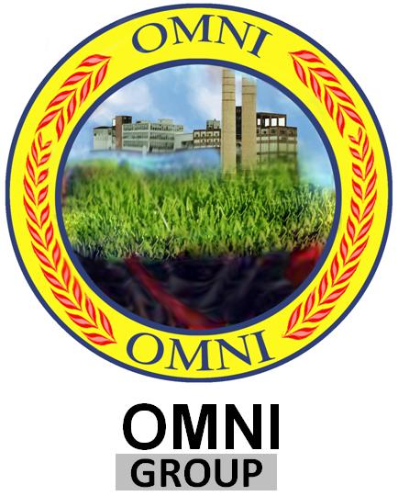

[April 2012 - Jan 2019] OMNI Group of Companies

Omni group is one of the growing group in Pakistan. It was established in 1999 as an industrial, agricultural & service oriented group. The group has diversified interests. It includes manufacturing industry with emphasis on Sugar, Rice, Various grades of ethanol, Polypropylene Bags, Automotive, and service oriented industries of construction, real estate and traveling.

HR Business Partner |Reporting to the Group Head HR / GCOO|

Job Profile:

Manages a broad range of HR functions including strategizing HR systems and practices for over 8000 employees of over 20 sites. Responsible for developing and implementing policies & procedures in line with the business needs. Also responsible for staffing, compensation administration, learning & development, performance management, succession management, counseling on management development issues. Implemented MS Dynamics ERP for HR at group level. I was also the member of HR Committee (HRC) and participated in Management Committee (MANCOM)

Major Responsibilities:

Employment
- Manpower planning & budgeting
- Job Analysis & Design, Profile for all ladders
- Employment policies & procedures

Organizational Development
- KPI based Job Universe for all positions
- Succession Planning
- Career Planning
- Development of Group Grade Structure

Learning Strategy
- Development of strategy and plans for implementation of Learning & Development
- Ascertains the overall training needs through comprehensive TNA exercise
- Monitor and evaluates training programs

HR Policy Development
- Prepares comprehensive analysis of various HR policies for put up in HRC / MANCOM
- Finalizes HR policies in line with laws and regulations, business needs and best market practices.

Performance Management
- Assists in developing of performance based reward system
- Conducts performance appraisal exercise for all staff.
- Finalizes increment & promotion sheets as per approved budget.

Compensation & benefits
- Provides direction and advice to payroll team to ensure the efficient and effective delivery of payroll services.
- Ensures the payroll are process timely and error free
- Ensures timely settlements of outgoing employees
- Review loan cases and ensures these are in line with PF rules.
- Rationalization of salaries.
- Negotiates and finalizes Group Health & Life Insurance for the Group.
- Regularly meets internal customers in person & listens to their issues/ queries/ Grievances/ feedback.

Achievements:
- Developed HR department from infancy stage
- Developed and implemented various HR policies & procedures
- Restructuring of Cane, Surveillance and Corporate Farms
- Implemented MS Dynamics ERP at Group Level
- Initiated Employee Self Service Portal (ESS)
- Developed Job Universe for all ladders


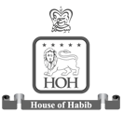

[April 2009 - March 2012] THAL ENGINEERING (a company of House of Habib)

Thal Engineering (Division of Thal Limited, a company of House of Habib) was established in 1996 starting with Auto Air conditioners and subsequently added Wiring Harness, Heater Blower and AC Controls to its product line. It is one of the largest automotive parts manufacturers in Pakistan and is a major supplier of parts to all major automobile manufacturers in Pakistan.

Deputy Manager HR (Reporting to the Head of HR)

Job Profile:

- Managed a broad range of HR functions including strategizing HR systems and practices for over 1000 employees of 2 divisions.
- Monitoring key HR performance pointers and identify causes of HR problems and develop recommendations for improvement of organization's HR policies and practices as necessary.
- Facilitating TNAs and maintaining training calendars and nominations to cope with training needs
- Ensure excellent communication within the organization by putting in place communication vehicles to keep employees informed on matters that concern them and also on need basis.
- Liaison with ISO-TS 16949 coordinator for compliance of employees training and other HR related requirements.
- Coordinating with Internal & External audit and updating SOP.
- Carrying out Job Satisfaction Surveys.
- To prepare Annual Objective and process implementation.
- Generate reports on HR Dashboard / SAP Reports e.g. Employee Strength / Training Hours / Turnover / Joining & leaving of Executive / JTM etc for decision making.

Achievements:

- Achieved Best Performance Award for the Year 2010-11
- Facilitate in restructuring HR department by developing HR Vision and Strategies
- Initiated Online Leave Request Management (OLRM) – A step ahead of paperless environment
- Developed Organizational Charts and JDs for all levels
- Assist Group Director HR in conducting Job Evaluation Exercise through HAY methodology
- Developed and revised HR Policies & Procedures

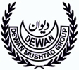
[March 2004 - March 2009] DEWAN MUSHTAQ GROUP

This well-known and respected Group comprises of more than 22 companies operates in the automotive, Sugar, Textile, Fibre, Cement, Oil & Gas and General Trading sectors with more than 15,000+ employees.

Assistant Manager Group HR (Reporting to the Group Director HR)

Job Profile:
Worked as HR Generalist and also the Power User of SAP HR Module and worked on the implementation of Organizational Management, Personnel Management, Time Management and Payroll Modules of HR.

Main Responsibilities:
- Ensure proper implementation of Compensation policies and benefit packages.
- Ensure timely submission of Appraisal forms for making increment sheets subject to approved management guidelines / budget and issue increment & promotion letters.
- Management of employee Health and Life insurance at group level, ensure that all concerned employees are covered and updating renewals and coordination in benefit structuring / premium payment, lodge claims with insurance companies and manage the entire process in an efficient manner, for speedy and timely settlements.
- Manage recruitment & selection process through liaising with universities, head hunters, different publications and other related sources, while putting in place necessary selection tools.
- Prepare and issue acceptance letters to selected candidates, obtain all relevant certificates / degrees, testimonials, experience certificates and other documents as well as follow-up for references.
- Ensure that probationer’s progress review forms are returned, duly filled by concerned line managers in order to ensure timely confirmation of employees in the company’s service.
- Responsible for the accurate and timely processing of full & final settlement cases.
- Process OPD bills / LFA / Loan applications as per employee’s entitlement, maintain and update LFA and Loan record & OPD balance and prepare monthly / yearly statement for finance for timely payment.
- HR Power User for SAP implementation.
- Provide information, advice and interpretation to staff in entitlements, benefits and policies in a manner that not only meets their requirements but also maintains the integrity of policies.
- Maintain records and compile statistical reports concerning personnel-related data such as hires, transfers, performance appraisals, employee turnover, absenteeism rates, and headcount report with accuracy of data source.
- Generate Executive reports for decision making in other areas of HRD.

Achievements:
- Implemented SAP Human Resource Management modules.
- Design formats as per approved policies.
- Successfully coordinated and processed 360 degree appraisals.
- Analyzed and revised grading and salary structure.
- Developed Organizational Charts and JDs for all levels in different companies.


[August 2003 - March 2004] GALLUP / Business Research Bureau (BRB)

Marketing Assistant

Job Profile:
- Prepare presentations.
- Prepare Survey Questionnaires.
- Maintain filing system.

QUALIFICATION

Masters in Business Administration (Human Resource Management)
PAF KIET Karachi

Bachelor in Science (Computer Science)
University of Sindh Jamshoro Karachi

Intermediate
Govt. National College Karachi
DIPLOMA / CERTIFICATE COURSES / WORKSHOPS

- 3 months Diploma in “Human Resources with ERP” from Skill Development Council.
- Succession Management from Octara
- Psychometric Testing & Analysis from E 3 Global
- Psychometric Testing & Behavioral Interviewing Skills from Pakistan Society for Training & Development (PSTD)
- Speak For Yourself from Corporate Trainings & PR
- Strategic Time Management from Time Lenders.
- ACT Training (Attitude, Communication & Teamwork) from NAVITUS
- Six Sigma Green Belt Course.
- Self Development Courses.

INTERNAL TRAININGS

In-House SAP Training from Siemens Consultants for following HR modules:
- Organizational Management
- Personnel Management
- Time Management
- Payroll

COMPUTER SKILLS

- ERP, Microsoft Office, MS Access, MS Outlook, MS Visio, Inpage etc.

PERSONAL

Date of Birth : 23rd September 1981
N.I.C. # : 42301-1023850-3
Marital Status : Married with 2 kids
REFERENCE

Will be furnished on request

