Uzair Jamal
Mobile: 0334-3095288
0317-2877964
Email: uzair.jamal@ymail.com ___________________________________________________________________________

Dear Sir/Madam,

I have attached my resume for your reference; I take this opportunity to offer my candidature for a suitable post in your organization.

To secure a position in a professionally managed progressive organization which will give me an opportunity to utilize my strong leadership, communication and administrative management skills and to reward myself with successful career growth? I am therefore respectfully requesting a personal interview.
I feel confident that a frank, in person discussion will determine if a compatible environment exists for a future relationship.

I trust my academic background and professional experience with companies would meet your requirement. I have a very good communication & interpersonal skills and I am a good team player with proactive and assertive personality, I assure you that I will deliver the best if I get a chance to serve your esteemed organization .while assuring you of my dedicated efforts , I wait a positive response at your earliest convenience.

Sincerely,

Uzair Jamal

URRICULUM 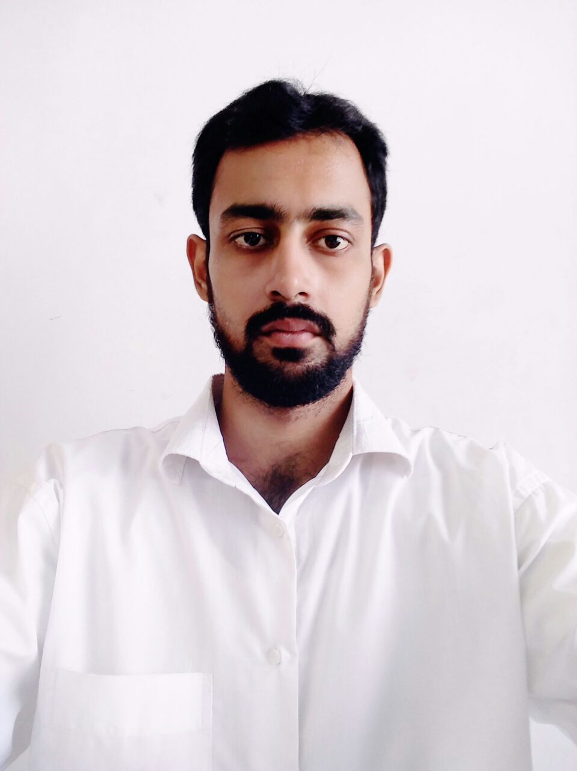
ITAE

Objective

To grow in a more challenging, career oriented position in a professional organization that fosters learning and where my abilities and education and experience could add value

Organizational Ability

- Strong attention and ability to help other to improve their performance in difficult tasks
- Give assignments to team staff according to their potential for maximum results
- Communicate with superior management for better organizational growth
- +

Professional Experience

- CSD Ministry Of Defense as Maintenance Supervisor, Karachi Pakistan. ( Oct 2017 to Till)
( Solar System, Access Control, Fire Alarm Addressable/Convectional Panel, CCTV IP/Analog, Fiber OTDR Testing, Low Voltage Panel Termination, Work Throw Gate, FM 200, Attend Machine, Nurse Call System, Public Address System IP/Analog Maintenance and Installation)
- MA tech as a Service Engineer, Karachi Pakistan. ( Oct 2016 to Nov 2017)
- Anwar Al-Tammah Jeddah(KSA) Employed as Electronics Engineer as an Engineer(Feb2014 To june2016)
- Panasonic’s Authorized Dealer (UBM) as Assistant Engineer(May2012 To Jan2014)

Scholastics

Degree | Institution | Year
B Tech hons (Electronics) | Preston University Karachi | 2017
B Tech (Electronics) | Preston University Karachi | 2014
D.A.E (Electronics) | Jinnah Polytechnic Institute | 2012
SSC (Science) | Dehli Govt Boys Secondary School | 2008

Technical Skills

Course's | Institution | Year
Electrician | YMCA Polytechnic Institute | 2010
Automotive | YMCA Polytechnic Institute | 2011

Computer Skills

Course's | Institution | Year
AutoCAD | Expert Institute Karachi | 2011
Graphics Design | Expert Institute Karachi | 2010

Personal Information

Name : Uzair Jamal
Father’s Name : Tariq Jamal
Email : uzair.jamal@ymail.com
Contact No. : 0334-3095288/ 0317-2877964
Driving License (KSA) :2363145794
Nationality : Pakistani
Religion : Islam
N.I.C. No. : 42101-7682306-9
Marital Status : Single
Date of birth : 19 May, 1992

Achievements/Activities/Skills

- Voluntarily participated in Departmental Activities
- Hardworking
- Proficient in MS Office Suite, AutoCAD
- Microsoft Windows XP, Vista, 7, and 8
- Sound Communication & Interpersonal Skills
- Initiatives Abilities
- Reading Books, Exercise, outing, games, cognizant of current affairs

Languages

- English (Expert)
- Urdu (Native)
- Arabic (Expert)
- Chinese (Normal)

Mission to serve

I am very keen to do something different for the support of Power Distribution & contribute my share for betterment of its services to the valuable consumer

References

Reference will be furnished on request

