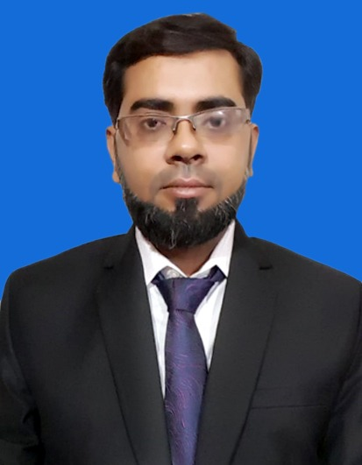
HAFIZ MUHAMMAD OMER IQBAL

Postal Address: E-7 Anjuman Apartment
Shamsi Society Malir Halt, Karachi. Pakistan.

Cell # +923132593684
+923452217838
E-mail # hmomer143@gmail.com

OBJECTIVE

- Significantly contribute to the success of a progressive organization for a long period where I can synergies my qualification. Expand knowledge, qualitative exposure and experience for organization & personal development.

QUALIFICATION
Qualifications | Year | Board | Division
B-Tech Pass (Mechanical) | 2012 | N.I.C.E | 2.98 GPA
D.A.E (Mechanical) | 2007 | P.S.I.T (Karachi) | 1st
Matriculation (Science) | 2004 | Karachi | 2nd

Experence

Techies Engineering Services (2 Years) – Jan 2017 -
Electrical and Data Networking Systems, CCTV, Civil & Mechanical Contractor

Sales & Service Engineer.
- Responsibilities
  - Supervision of Mechanical & Electrical Works
  - Supervision of Electrical and Data Cabling Works
  - Piping Works including Installation Valves, Fittings, Insulation and other miscellaneous works.
  - Prepare Bill of Quantity
  - Measurements / As built drawings
  - Management of Labor and Skilled worker and Managing resources

LOTTE (Pakistan PTA Limited) (Years) MARCH 2009 TO 2013
Mechanical Technician (Apprenticeship)
- Responsibilities:
  - Centrifugal & P.D Pumps, multi stage centrifugal & reciprocating compressors overhauling in workshop & plant area.
  - Working Experience in Utility Plant.
  - Miscellaneous workshop rotary and plant stationary equipment’s.
  - Mechanical seals refurbishment.
  - Gear boxes (increaser and reducer).
  - Centrifuges and rotary vacuum filter.
- Perform & manage pressure vessel inspection, Heat Exchanger, Relief valves, Relief stream inspection, Anodizing of titanium, Snuffer test, Endoscopies and all NDT work i.e. DPT, MPI, UT (scan & thickness), Positive material inspection.

Bosicor Pakistan Ltd; November 2007 to March 2009

Position: As a Field Operator
- Responsibilities: Filling of Oil Tankers, Checking for Quality Control and Decanting them.

COMPUTER SKILLS

- MS Office (Word, Excel, Power Point)
- Auto CAD
- MS Front Page 2003(HTML)
- Android App Development

HSE

- Compliance for the use of Personal Protective Equipment’s.
- Audit of safety Equipment’s.
- Practical training for the use of firefighting equipment’s.
- Have used safety gadgets in case of toxic gas release (Escape sets, BA sets)
- Strictly follow Permit to work system
- Use of Extox meter.

PERSONAL INFORMATION

Father’s Name : Muhammad Iqbal Shamsi (Late)
Date of Birth : 16-01-1986
N.I.C. No. : 42201-2510004-7
Nationality : Pakistani
Domicile : Karachi (Sindh)
Permanent Address : E-7 Anjuman Apartment Shamsi Society Malir Halt, Karachi, Pakistan
Residence # : +92-21-34599842

