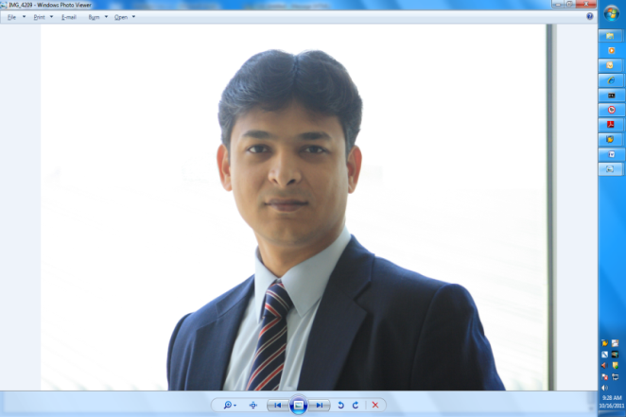

**Hammad Ahmed**

⯁+923352418844⯁hammad.ahmedsiddique@hotmail.com

# Summary

17 plus years of Finance, Ops & Hr experience in Multinational groups in UAE & Pakistan, Diversity of exposure in risk and credit management is my vantage point over other Companies growth in terms of sales & product management professionals. Having worked in areas of product development, budgets, revenue, profitability, market management, customer service, alternate channel development, digitalization, transformation (processes and procedure), business strategy, communication, and technology, not only adds to my repertoire but also gives me the foresight for future readiness.

Professional& Technical skills

|  |  |
| --- | --- |
| * Financial Planning & Analysis(FP&A) * Credit Control * Contract Negotiations * Sap, Oracle & Quick books | * Metrics & KPIs * Cost Improvement Assessments * Data Trending, Reports and Documentation * Sales & Business Development |

Professional Experience

## NPL 2019 Jan – Till date

## *Finance & Hr Manager*

* Preparing Financial Pack (Cash flow, Financials and Balances Sheet).
* Monitor and control transactional accounting.
* Credit Control.
* Lead finance team to deliver their best [output](https://en.wikipedia.org/wiki/Output_(economics)) with [efficiency](https://en.wikipedia.org/wiki/Efficiency_(economics)).
* Taxation.
* Deal with Audit, Legal departments and Insurance.
* Hr (Policies, implementation, Hiring and others)

## KARACHI, PAKISTAN 2018 July – 2018 Dec

## *ADVISORY*

* Conduct Business Process Review to evaluate current processes and identifies ways to make them more effectual.
* Perform Gap Analysis to determine where the business is—and where it wants to be.
* Identify Risk and suggest the controls.
* Suggest Performance Improvement by measuring the output of a particular [business process](https://en.wikipedia.org/wiki/Business_process), then modifying them to increase the [output](https://en.wikipedia.org/wiki/Output_(economics)) and [efficiency](https://en.wikipedia.org/wiki/Efficiency_(economics)).
* Internal Audit.

## ABME. – ABU DHABI, UAE 2015 – 2018

***Finance & Commercial Manager (FP&A)***

* Prepared feasibilities and analysis to assist Owner in making strategic ‘go or no-go’ decisions in relation to new investments and existing business Conduct energy audits of various buildings and assemble audit reports for the clients.
* Prepared business unit financial budget including cash flows, income statement and balance sheet.
* Challenged the assumptions of operations and commercial department to arrive at an ‘achievable yet challenging’ business unit budget.
* Met with existing & new clients and review business contracts to understand and portray the financials accordingly.
* Managed and present Business project related data required for the proposal.
* Lead the management and accounting of business efficiency upgrade projects in the entire client enterprise portfolio.

## dubai, uae 2010 – 2015

***Financial Analyst (FP&A), Credit Controller & Corp Accountant***

* Month ended dashboards and reports for senior management presenting performance, achievement of KPIs, and future focus areas.
* Utilized Financial Analysis to create risk assessment and provide optimal strategies for business needs.
* Preparation of group reporting pack, business unit financial budget including cash flows, income statements and balance sheets.
* Reviewed Credit outstanding report, take necessary actions to emphasis on collection follow up, reviewed and set the target for bill collectors and approved the credit after initial cross checked by the team.
* Reviewed and adjust the KPIs of credit on month end dashboards.
* Reviewed the SOPs of Credit and update accordingly with business new requirements.
* Attended meeting with legal department and treasury on complicated issues.
* Managed Risk/Reward - balanced business development needs with sound business management practices.
* Trained and coached new associates as needed.

## dubai, uae 2002 – 2009

***Operation Manager***

* Reporting of branch financial results to senior management & Preparation and review of budget and forecasts.
* Managed the accounts team to ensure all day to day transactions & Liaising with the internal auditors for the year-end audit and inventory counts for the branch.
* Inventory Management, Pricing and Cost Management and Compliance with overall SOPs.
* Attended annual meeting with the ‘Principal’ (Yamaha & Suzuki) to exchange views on market and raise key commercial and operational concerns.
* Assisted Group Marketing & Branch Sales Team.
* Performed all aspects of newly open branch business setup tasks associated with design and launch; including space planning, and provide design guidance to internal Business Unit or Program partners. Managed design challenges and solutions for best layout that’s sustainable, green & cost efficient in terms of financial feasibility.

education

## UNIVERSITY of karachi – Pakistan. July 2005

## Masters of Economics

## Icap Foundation tuition – Pakistan. March 1999

## Finance & Business

## UNIVERSITY of karachi – Pakistan. December 1998

## Bachelors of Commerce

Certifications

## certified accounting technician – from ACCA. June 2001

Award

## BEST EMPLOYEE OF THE MONTH –from TOYOTA. July 2011

## BEST EMPLOYEE OF THE YEAR GLOBAL –from YAMAHA IN JAPAN Oct 2003

## 

Languages

## Arabic : Read Fully, Understand and Speak Moderately

English : Fluent in reading, understanding and writing.

Urdu : Native