X`

DEPUTY MANAGER ACCOUNTS

|  |  |
| --- | --- |
| Phone.jpg | **:**  +92 331 2011020 |
| 2.png | **:**  +92 321 2523579 |
| emIl.jpg | **:** hafiz.azhar@hotmail.com |
| Skype_2.jpg | **:** hafiz.azhar123 |

**AZHAR ANWAR**

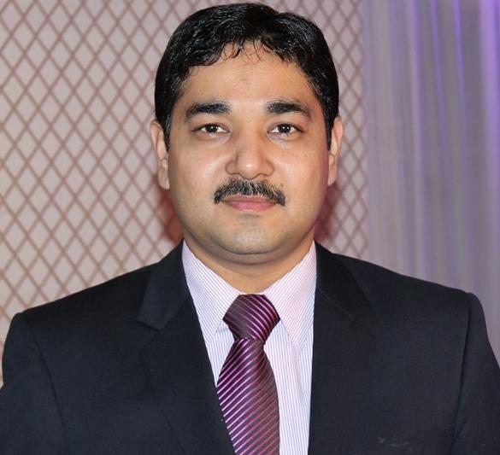

### Contact

House No # 4/229 Liaquatabd No # 4. Near Erum Bakers, Karachi, Pakistan

|  |  |
| --- | --- |
| **Objective:** | A dynamic and committed Cost & Management Accountant who believes in making positive contributions to the organization through acting as a Change Agent. |

|  |  |
| --- | --- |
| **Objective:** | An accounts & finance professional having 11 years of professional experience in accounts and  finance, during my professional career I have worked in areas like, Finance, Accounting and Payroll Management.  Objective is to work in an exciting and professional environment of the organization with personal  development and growth possibilities and to achieve company’s goal through professional ethics,  sincere commitment and hard work. |

### Professional Career Summary

|  |  |  |
| --- | --- | --- |
| **Professional Certification :** | M.COM (In process) | |
| **Education :** | B.COM | |
| **Work Experience :** | **Duration** | **Organization & Designation** |
| Jun-18 to date | Nue Multiplex & Square & Co. as a DM Accounts |
| Jul-17 - Ap-18  Jan 17 – Jun 17 | GEMS (Pvt) Ltd. As a Deputy Manager Accounts  Herbion Pakistan (Pvt.) Ltd. as Accounts Executive |
| Jan 11 - Dec 16 | Herbion Pakistan (Pvt.) Ltd. as Accounts Officer |
| Feb 08 - Dec 10 | Herbion Pakistan (Pvt.) Ltd. as Assistant Accountant |
| Jun 06 - Jul 07 | Pak Global Enterprises. as Office Assistant |
|  |  |

### Work Experience

**Nue Multiplex & Entertainment Square Co. (Pvt) Ltd. www.nueplex.com**

Deputy Manager Accounts June 2018 to date

* Preparation of weekly accounts payable reports related to all vendors.
* Aging analysis of payable and plan payments according to available funds.
* Receiving, Checking and Recording suppliers’ bills in SD / FI modules of SAP.
* Recoding of monthly expenses related to utilities, traveling, logistics, and promotions.
* Reconciliation with suppliers regarding payment and bills.
* Letters to suppliers regarding details of payment with cheques.
* Preparing monthly bank reconciliation statements & related correspondence with all banks.
* Follow up all receivable.
* Maintaining record of Petty Cash / Cash in Hand.
* Checking and verifying company’s payroll and calculation of tax related to payroll.
* Disbursement of payroll through S2B (Straight to Bank) Standard Chartered bank

**GEMS www.gem-intl.com**

Deputy Manager Accounts July 2017 to April 2018

* Manage cash flow planning.
* Preparation of weekly accounts payable reports related to all vendors.
* Aging analysis of payable and plan payments according to available funds.
* Supervising accounts team for daily task of accounting activities
* Maintaining daily cash position
* Budgeted cash position
* Follow up all receivable.
* Finalize all type of employee problem regarding Final Settlement, Leave Encashment, Bonus and Gratuity etc.
* Checking and verifying company’s payroll and calculation of tax related to payroll.
* Disbursement of payroll through S2B (Straight to Bank) Standard Chartered bank

**Herbion Pakistan (Pvt) Ltd. www.herbion.com**

Accounts Executive Jan 2017 to Jun 2017

* Preparation of weekly accounts payable reports related to all vendors.
* Aging analysis of Payable and plan payments according to available funds
* Manage cash flow planning.
* Receiving, Checking and Recording suppliers’ bills in SD / FI modules of SAP.
* Recoding of monthly expenses related to utilities, traveling, logistics, and promotions.
* Prepare ageing analysis for weekly management meeting.
* Preparing monthly bank reconciliation statements & related correspondence with all banks.
* Checking and verifying company’s payroll and calculation and tax related to payroll.
* Maintain provident fund record ERP, PF investment plan
* Maintaining record of Petty Cash / Cash in Hand.
* Assisting the Manager Accounts in day-to-day routine task

**Herbion Pakistan (Pvt.) Ltd. www.herbion.com**

Accounts Officer Jan 2011 to Dec 2016

* Maintain the company’s payroll for 800 employees and process it accordingly.
* Receiving, checking and Recording suppliers’ bills in SD / FI modules of SAP.
* Maintaining record of Petty Cash / Cash in Hand.
* Prepare aging analysis for weekly management meeting.
* Recoding of monthly expenses related to utilities, traveling, logistics, and promotions.
* Establish / maintain employees’ records, ensure that employee changes are entered correctly and on timely basis.
* Maintain provident Fund record on ERP, PF investment plan.
* Handling day to day accounting activities.

**Herbion Pakistan (Pvt) Ltd. www.macter.com**

Assistant Accountant Feb 2008 to Dec 2010

* Reconciliation with suppliers regarding payment and bills.
* Preparation of daily bank position & bank reconciliation.

Prepared Recording and maintaining insurance policies pertaining to Fixed Assets, Health & Life insurance etc. & resultantly following up claims if any.

* Receiving, Checking and Recording suppliers’ bills in ERP software.
* Maintaining record of Petty Cash / Cash in Hand.
* Letters to suppliers regarding details of payment with cheques.

**Pak Global Enterprises.**

Office Assistant Jan 2006 to Jul 2007

* Perform daily office routine works like filling, computer related work, bank related work

### Professional Certification & Academic Education

|  |  |  |  |  |
| --- | --- | --- | --- | --- |
| **Sr.** | **Certification / Degree** | Institution / University | **Specialization / Major** | **Passing Year** |
| 1 | M.Com | University of Karachi | Finance | In Prcess |
| 2 | B.Com | University of Karachi | Commerce | 2014 |
| 3 | Hifz-Ul-Quran | Barkati Foundation | Islamic Education | 2011 |
| 4 | I.Com | Jinnah Government College | Commerce | 2007 |
| 5 | SSC | Muslim Children Paradise School | Computer Science | 2005 |
|  |  |  |  |  |

### Computer Skills and Other Abilities

|  |  |  |  |
| --- | --- | --- | --- |
| **Sr.** | **Skills & Abilities** | **Proficiency Level** | **Last Used / Practiced** |
| 1  2  3 | Odoo (ERP Solution)  Ms – Office  SAP Business One (ERP Solution | Excellent  Excellent  Excellent | Currently Using  Currently Using  April 2018 |
| 4 | SAP ECC 6.0 (ERP Solution) | Excellent | June 2017 |
|  |  |  |  |
|  |  |  |  |

### Achievements & Awards

|  |  |  |
| --- | --- | --- |
| **Sr.** | **Description of Activities** | Year |
| 1  2 | Participated as power user in successful implementation of Odoo in 5-months  Participated as power user in successful implementation of FI Module of SAP in 3-months | 2019  2014 |
|  |  |  |

### Personal Information

|  |  |
| --- | --- |
| Father’s Name : | Muhammad Anwar Shaikh (Late) |
| Date of Birth : | 30th January 1989 |
| Marital Status : | Married |
| Religion : | Islam |
| Language Competency : | English, Urdu |
| Countries Visited : | Saudi Arab, UAE, Nepal |

### References

|  |  |  |  |  |
| --- | --- | --- | --- | --- |
| **Sr.** | **Name** | Organization | Designation | **Contact No.** |
| 1 | Naveed Sultan | Nue Multiplex & Entertainment. | CFO | +92 321 3898656 |
| 2 | Imran Khan | Herbion Pakistan (Pvt) Ltd. | Senior Manager Accounts | +92 321 2070904 |
| 3 | Afsha Javed | Sanofi-Aventis Pakistan Ltd. | Assistant Manager HR | +92 343 2605987 |
| 4 | Muhammad Faisal | Scilife Pharma (Pvt.) Ltd. | Project Manager | +92 333 2303391 |
|  |  |  |  |  |