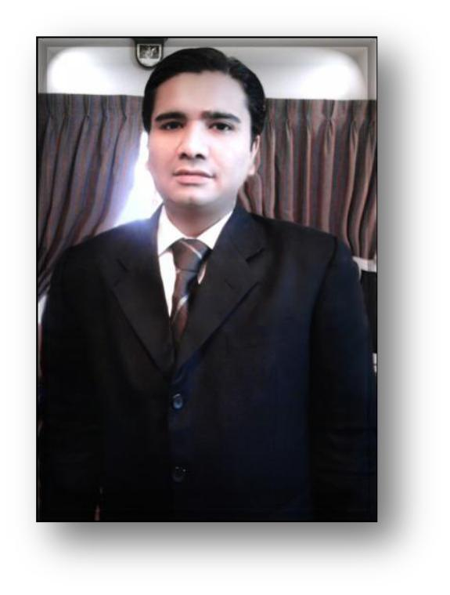 **MANSOOR MUMTAZ**

Address A -15 Block A KDA Officer Society near Stadium,

Road Karachi

Phone Number:  +92-21-34969028

Mobile Number: - +92345-3441936

Email Address: [**mansoor.mumtaz3@gmail.com**](mailto:mansoor_mumtaz4@hotmail.com)

**OBJECTIVE**

To obtain a position in HR Field with a large corporation committed to employee education and growth.

***Educational Background***

https://lh6.googleusercontent.com/56x8EZ-riJk1ryQz0y8N3hDLW9o3H5rqyJ-8Ijt31r6-5N2UZngCn4Lwai2wBrBv7XV4cBbFEAAQuKLro4VphKDrWf4ghO-k9xl3gNb7OnRxPjmFyW3910LlLvpKYATBRCElukNJXtiUasUDYw

* *Obtain Associate MPHIL in Human Resources Management from the DHIMS University of Management Institute, in the year 2008.*
* *Obtain Master of Business Administration Degree from DHIMS University in the year 2005.*
* *Obtain Associate Bachelor Degree In Computer Engineering from Sir Syed University in 1st Division from 2001.*
* *Obtain Intermediate from DJ College in the year 1997.*
* *Obtain Metric from Happy Home School in 1994.*

***Professional Experience***

https://lh6.googleusercontent.com/56x8EZ-riJk1ryQz0y8N3hDLW9o3H5rqyJ-8Ijt31r6-5N2UZngCn4Lwai2wBrBv7XV4cBbFEAAQuKLro4VphKDrWf4ghO-k9xl3gNb7OnRxPjmFyW3910LlLvpKYATBRCElukNJXtiUasUDYw

**5 years working Experience in Osmani & Co.**

**HR Manager**

* Assisted a 40 member consulting team in the administration of the OSMANI Co Type

Indicator to assess employee’s personality types and how they correlate with job performance.

* Work as Manager of the Human Resource Department with extended understanding in maximizing the performance with various methods of progressive human developments.
* Differentiate generalist practice for various considered human resources developments and employee relations with employment proceedings.
* Offer expanded experience regarding compensation through executive development.
* Developed and conducted training classes
* Responsible for the continuing education, training, and certification of new experienced employees.
* Create Long term and Short Term Strategies as per company Policy
* Developed Training Development Form for an Employee's Personnel, Recruit and Selection Form, & Performance Appraisal Form for Daily work routine performance.
* Prepared presentation and manuals.
* Taught employees new and more efficient ways to perform their jobs.
* Travelled to more than 20 branch offices and manufacturing plants.
* Presented over 40 training courses.
* Trained new employees on company equipment and how to use software programs.
* Prepared training materials.
* Monitored, evaluated and counseled staff of 42 employees.
* Designed and implemented employee incentive programs to increase productivity and customer satisfaction, Reduced union grievances by 40% while maintaining a streamlined, profitable department.
* Managed operation including forecasting, inventory control, purchasing and quality insurance. Maximized revenues through efficient staffing, labor cost controls, and promotions.
* Computed yearly, quarterly and monthly benefits and payrolls totals for clients.
* Coordinated orientations and exit interview for part-time and temporary employees.
* **12 years’ experience in Karim Housing Pvt. Limited as a Senior H.R. & Admin Manager**
* Working in Job descriptions, recruitment and selection, Payroll System, Promotions, Performance Appraisal and Profile Managements and H.R Policies. Supervising day to day operations of the administrative department and staff members. Hiring, training, and evaluating employees, taking corrective action when necessary. Developing, reviewing, and improving administrative systems, policies, and procedures.  Ensuring the office is stocked with necessary supplies and all equipment is working and properly maintained. Planning, scheduling, and promoting office events, including meetings. Conference interviews, orientations, and training sessions, Collecting, organizing and storing information using computers and filing systems. Overseeing special projects and tracking progress towards company goals. Building new and expanding existing skills by engaging in educational opportunities
* **5 years experience in Pizza Hut International Chan as a H.R. Manager.**
* Working in Job descriptions, recruitment and selection, Payroll System, Promotions, Performance Appraisal and Profile Managements and H.R Policies, Training and Development, Training New Staff and Hiring and Firing and Motivating.
* **4 years experience in KDA Government Employee in Secretariat Department as an Assistant H.R. Director & Administration**
* Working in Job descriptions, recruitment and selection, Payroll System, Promotions, Performance Appraisal and Profile Managements and H.R Policies, Training and Development, Training New Staff and Hiring and Firing and Motivating, Son Quota, Jobs Applications, Jobs Description, Job Analysis and Job Specification. Maintaining file record systems of employees,
* Completed a training program on Affirmative Action Hiring Procedures, union Regulations, EEOC Compliances, and labor laws
* **TRAINING AND DEVELOPMENT:**
* Designed an HRD invention to improve employee performance at a local chain Conducted an in-depth analysis of the problem by performing a Needs Assessment using Organizational / Task/Person Analysis.
* Provided recommendations to the organization by the use of a designed training program.
* **5 years working experience as Network engineer in S.H International.**

**Additional Skills.**

* Seminars: Train the Trainer, Core Management, Progressive Disciplining, Preventing Sexual Harassment, Managing Diversity.
* Language Skills: Fluent in English.
* Computer Skills: Proficient in MS Office 2000, Lexis-Nexis and other research databases.
* Computer Skills
* Networks CCNA CCNP, CCIE, Training Course, Windows, Microsoft Word, Word Perfect, Excel, Power Point, Page Maker, Linux Administration, LAN, WAN, Routers, Switches.
* **Extra Activities**
* IELTS from British Council from 6.5 Bands
* **Personal**

Father Name                          Mumtaz Ali

Marital Status                         Single