**SUMAIR KHAN  
Flat # 428, EK1 Building, Al Qusais, Dubai, UAE  
Email:** **sumair.khan007@gmail.com** **Mobile Number: 052-2496735**

**OBJECTIVE:**

A position in a results-oriented organization that seeks an ambitious and career conscious individual, where acquired education will be utilized towards continuous growth and advancement while being resourceful, innovative and competitive.

**EDUCATIONAL BACKGROUND:**

University of South Asia, Lahore MBA (Marketing) 2014 3.2 CGPA  
University of South Asia, Lahore BBA (Finance) 2012 3.1 CGPA  
Government College, Model Town Intermediate (Commerce) 2008 B Grade   
United Public School, Islamabad Matriculation (Science) 2006 B Grade

**WORK EXPERIENCE:**

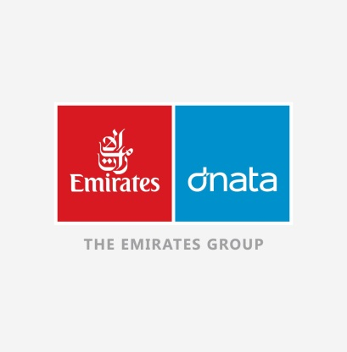

**DNATA (EMIRATES GROUP) – (5th January 2015 – Present)  
Customer Service Professional**

* Experience of working in both airports of Dubai i.e. Dubai International Airport (DXB) and Dubai Al Maktoum Airport (DWC).
* Coordination with teams of different airlines (For e.g. Indigo Airline, SpiceJet, Air Blue, Mahan Air, Ural Airline, Azur Airline, Condor Airline etc) in handling their passengers at both check-in and boarding.
* To provide a consistent quality service to the customers to all passengers at any designated area (check-in, gates, transfer desk and FMU) that is consistent with Dnata’s high service standards.
* Display excellent customer service skills, team work and understanding to achieve customer satisfaction in all areas.
* Strive as part of a dedicated team to avoid complaints and earn compliments.
* Ensure excellent discipline and grooming standards are displayed at all times while on duty.
* Always adhere to the set service standards and procedures so that the passengers are handled in a friendly and efficient manner.
* Report any irregularity or service shortfall to the senior management on duty to enable service recovery and appropriate corrective action to be taken.
* Ensure that the handling requirements of the various categories of passengers have been met and that special services and facilities are provided to meet any special services requirements by the customers.

**CERTIFICATIONS AND ACHIEVEMENTS :**

* Proficiency in Navitaire Departure Control System (DCS) of check-in and boarding.
* Proficiency in DMACS Departure Control System (DCS) of check-in and boarding.
* Proficiency in GoNow Departure Control System (DCS) of check-in and boarding.
* Acquired Dangerous Goods Regulation certificate (Category 9) accredited by IATA.
* Acquired certificate in credit card fraud and online scamming.
* Acquired certificate for the completion of course based on IATA area 1, 2 and 3.
* Extensive knowledge of IATA Airport and Airline codes.
* Extensive knowledge of geographical locations.
* Attended several workshops on effective communication and Behavior Management held in University of South Asia, Lahore.
* Participated in the Debate and Declamation competition, held in United Public School.
* Conducted market research for Coca Cola to identify loyal customers as part of marketing management.
* Conducted sales report for Toyota Motors to identify growth in the market as part of sales management.

**SKILLS AND COMPETENCIES :**

* Advanced level knowledge of Microsoft Word, Microsoft Excel and Microsoft PowerPoint.
* Excellent communication skills in English and Urdu
* Basic understanding of Hindi, Pashto and Punjabi.
* A good debater and an eloquent speaker.

**INTERESTS AND HOBBIES :**

* Keen interest in Gadgets and technological related news and latest development.
* Enjoy playing different genre of video games and learn about latest development in gaming industry.
* Make and plan annual trips to different countries to experience new cultures.
* Plan and execute adventure based sports like skydiving, parasailing, paragliding, rafting, and go karting.
* Online volunteer work for NASA in their search for extra terrestrial intelligent (SETI) life forms in collaboration with University of California, Berkeley.
* Online volunteer work for NASA to generate accurate 3D model of our Milky Way Galaxy in collaboration with Rensselaer Polytechnic Institute.