1. First choice for brand: yes
2. Second choice for model: yes
3. Third choice for price: yes
4. Fourth choice for type: yes
5. Fifth choice for priority: no
6. Sixth choice for seller: yes

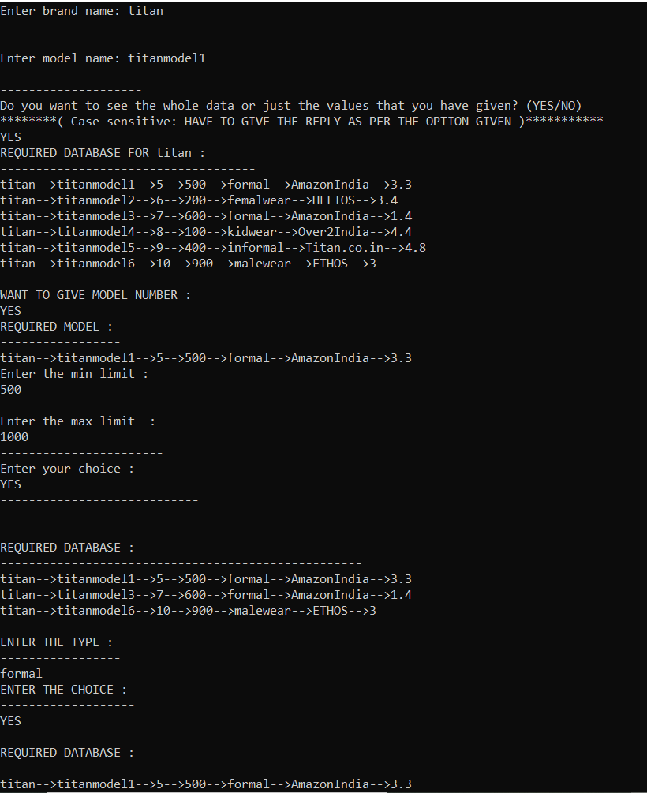

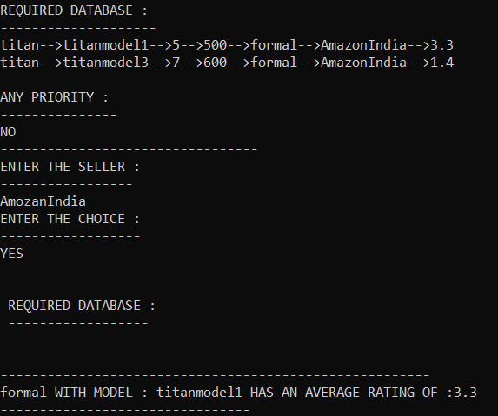

1. First choice for brand: no
2. Second choice for model: no
3. Third choice for price: no
4. Fourth choice for type: no
5. Fifth choice for priority: no
6. Sixth choice for seller: no

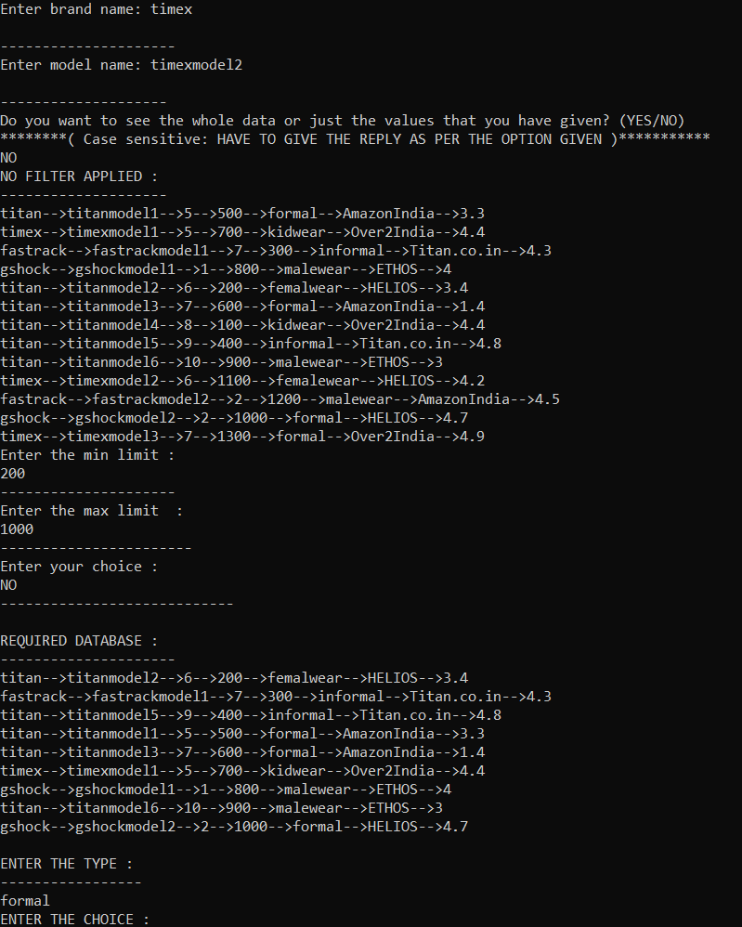

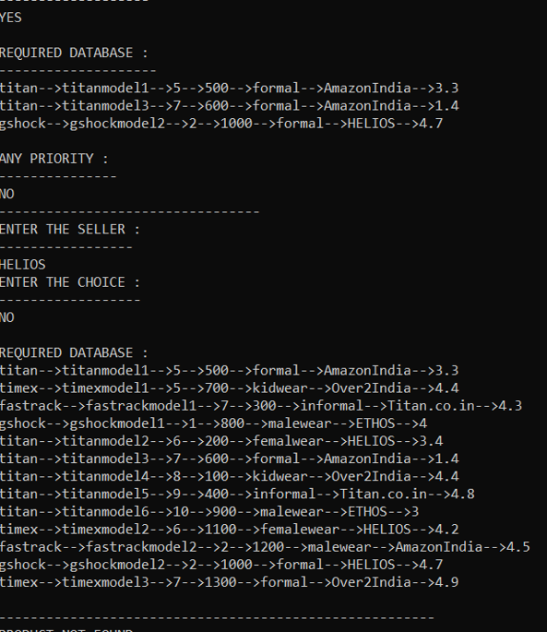

1. First choice for brand: no
2. Second choice for model: no
3. Third choice for price: no
4. Fourth choice for type: no
5. Fifth choice for priority: no
6. Sixth choice for seller: no

