Arsen Markiv

Melisew Mengsitie

Syed Quadri

CS 315 – Modern Database Management

Professor Rachel Adler

April 2019

**Student Database Final Project**

**Creating Tables:**

1. create table Student

(StudentID int,

firstName varchar(20),

lastName varchar(20),

Seniority varchar(20),

FieldOfStudy varchar(50),

PRIMARY KEY(StudentID)

);

1. create table Enrollment

(StudentID int,

CourseID varchar(15),

Section int,

Semester varchar(15),

PRIMARY KEY(StudentID, CourseID, Section)

);

1. create table Section

(CourseID varchar(15),

Section int,

StartDate varchar(15),

EndDate varchar(15),

Capacity int,

PRIMARY KEY(CourseID, Section)

);

1. create table Course

(CourseID varchar(15),

courseName varchar(50),

Cost decimal(20,2),

PRIMARY KEY(CourseID)

);

1. create table Grades

(StudentID int,

CourseID varchar(15),

Semester varchar(20),

Grade varchar(2),

PRIMARY KEY(StudentID, CourseID)

);

**Tables after the values imported from CSV file:**

**Student Table:**

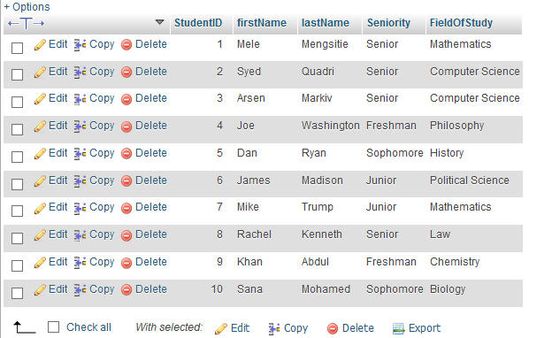

**Enrollment Table:**

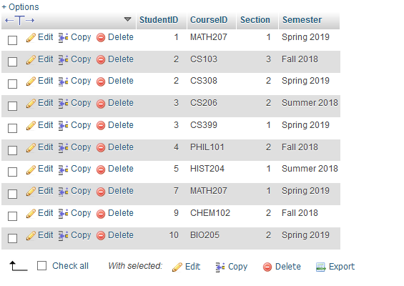

**Section Table:**

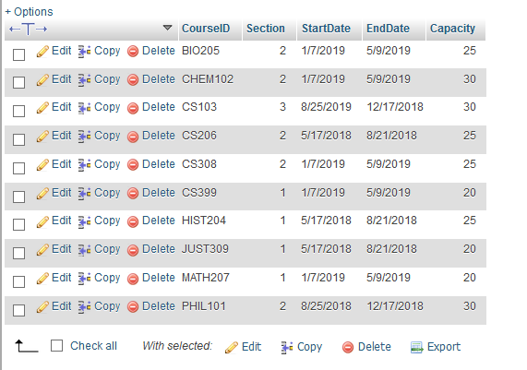

**Course Table:**

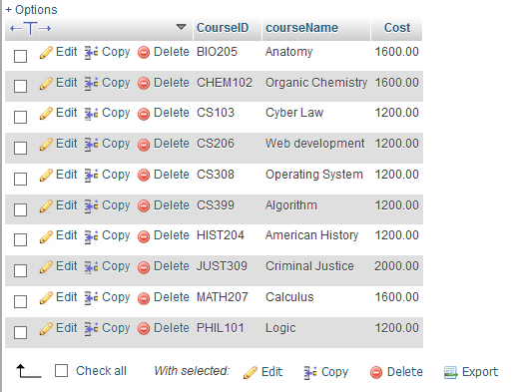

**Grades Table:**

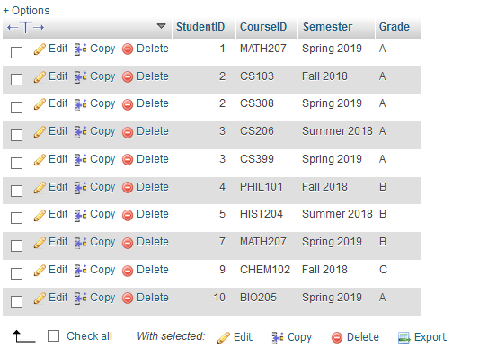

**Creating a JOIN**

**We did it in Java program as well**

String sql = "SELECT firstName, lastName, CourseID, Grade FROM Student s RIGHT JOIN Grades g ON s.StudentID=g.StudentID";  
ResultSet file = stmt.executeQuery(sql);

**Creating VIEW – we did to retrieved it in java program too:**

CREATE VIEW V_Senior_Students AS

SELECT firstName, lastName, FieldOfStudy FROM Student WHERE Seniority='Senior' ORDER BY firstName ASC;

SELECT * FROM V_Senior_Students;

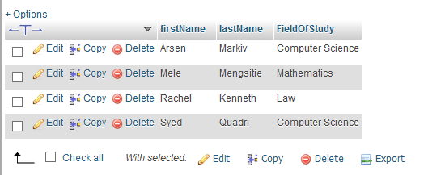

**The screen shots from the Java Program**

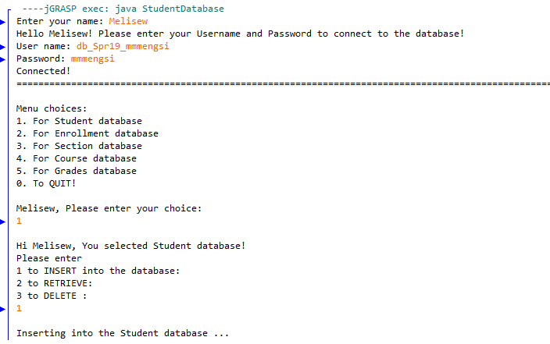

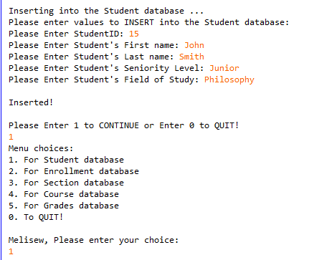

After inserted: John smith is added

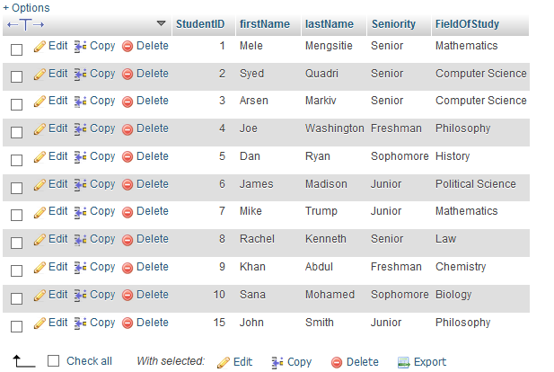

**VIEW on java:**

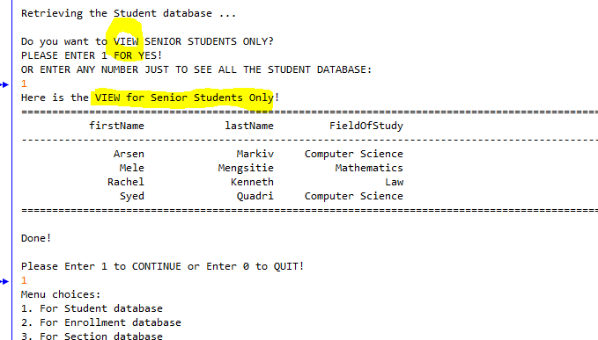

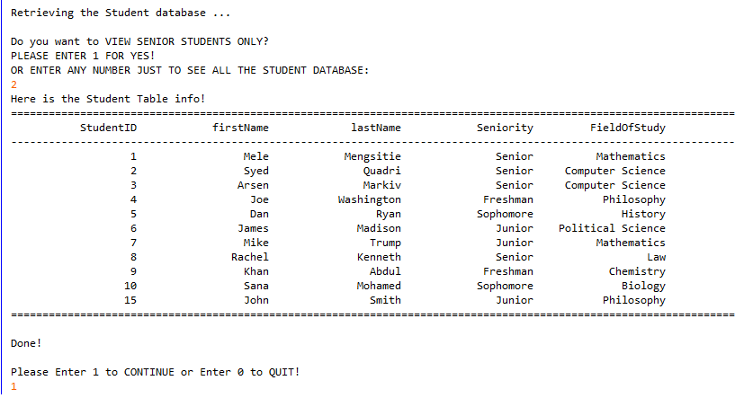

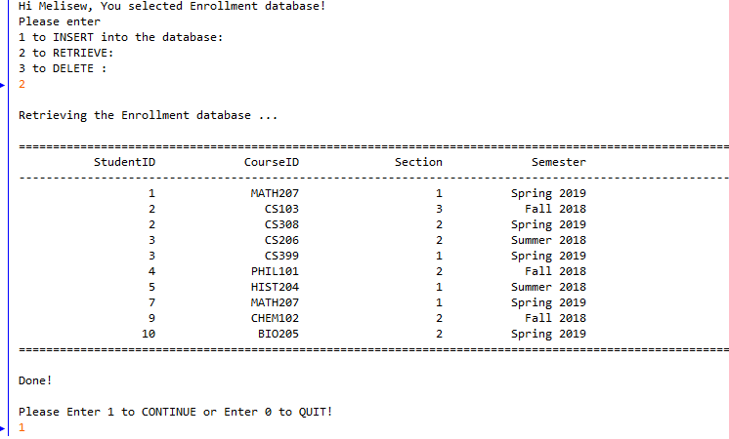

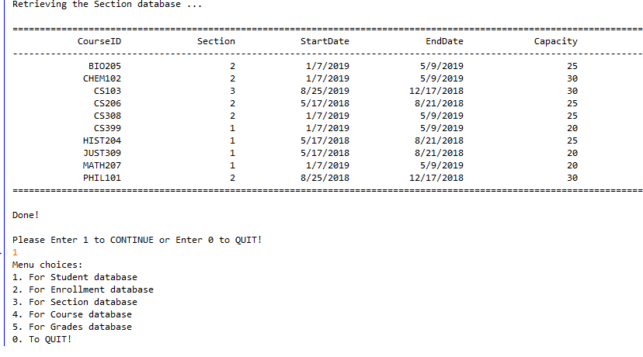

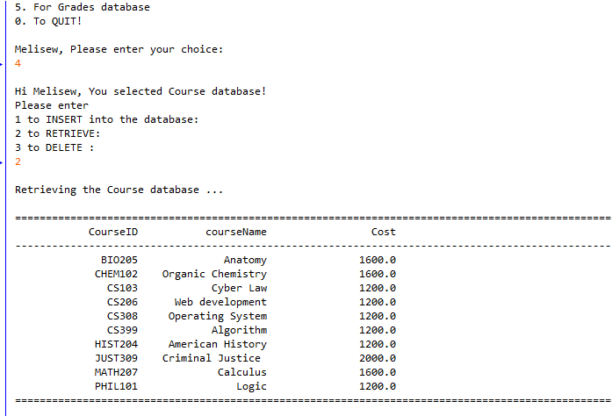

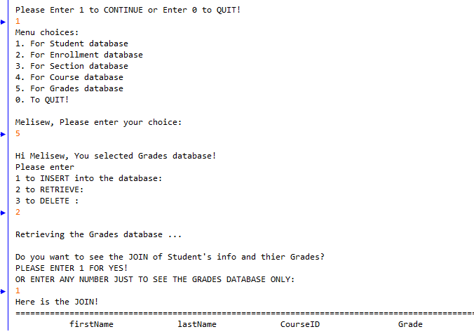

The JOIN:

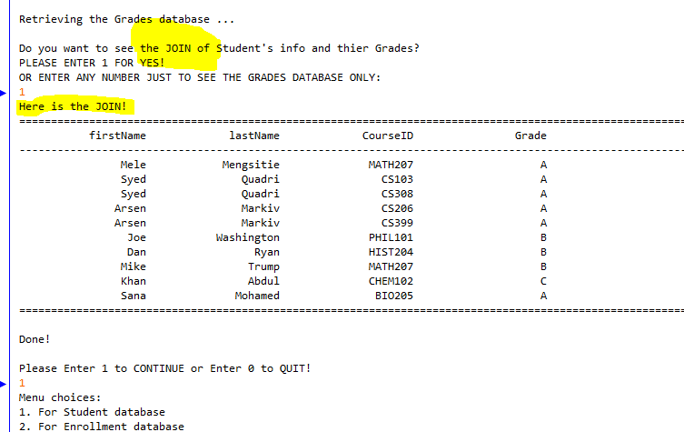

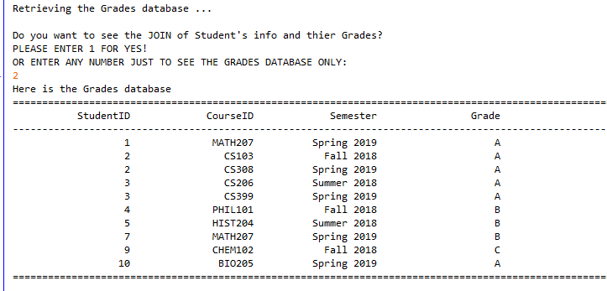

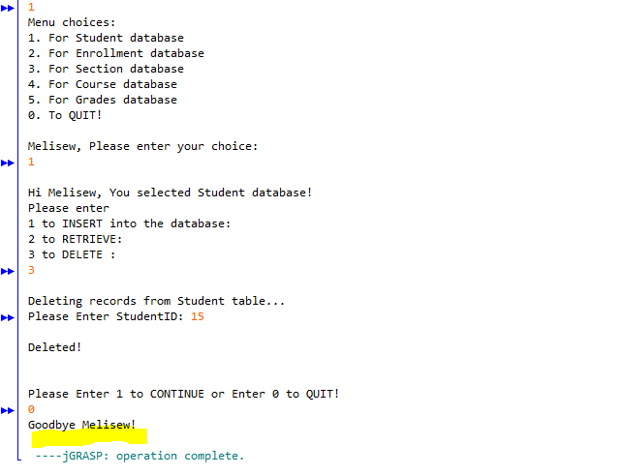

John Smith who has StudentID = 15 has deleted

Here is after deleted:

