# Name memansi subgroup 2c35

# Assignment 2

Ques1 ) Implement the Binary search algorithm regarded as a fast search algorithm with run-time complexity of Ο(log n) in comparison to the Linear Search.

Sol: #include<iostream>

using namespace std;

int main(){

    int arr[10];

    for(int i=0;i<7;i++){

        cout<<"enter element "<<i+1<<endl;

        cin>>arr[i];

    }

    int target;

    cout<<"enter target"<<endl;

    cin>>target;

    int l=0;

    int r=6;

    bool found=false;

    while(l<=r){

    int mid=(l+r)/2;

    if(arr[mid]==target){

        cout<<"target found at index"<<mid<<endl;

        found=true;

        break;

    }

    else if(arr[mid]>target){

        r=mid-1;

    }

    else {

        l=mid+1;

}

    }

if(!found){

    cout<<"not found";

}

      return 0;

}

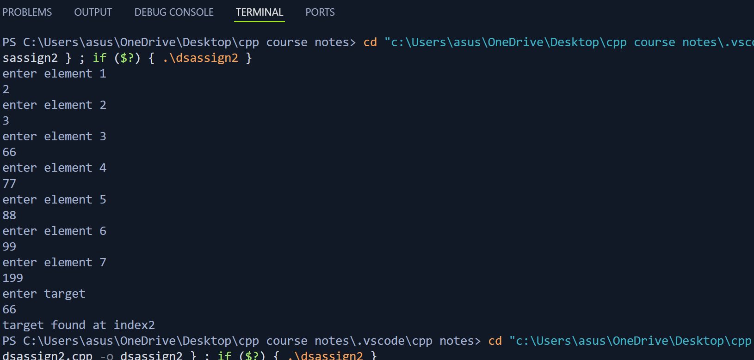

Ques 2) Bubble Sort is the simplest sorting algorithm that works by repeatedly swapping the adjacent elements if they are in wrong order. Code the Bubble sort with the following elements:

#include<iostream>

using namespace std;

int main(){

    int arr[7]={64,34,25,12,22,11,90};

    for(int i=0; i<7; i++){

        for(int j=0; j<7-i-1; j++){

            if(arr[j]>arr[j+1]){

                int temp=arr[j];

                arr[j]=arr[j+1];

                arr[j+1]=temp;

            }

        }

    }

    for(int i=0; i<7; i++){

        cout<<arr[i]<<endl;

    }

    return 0;

}

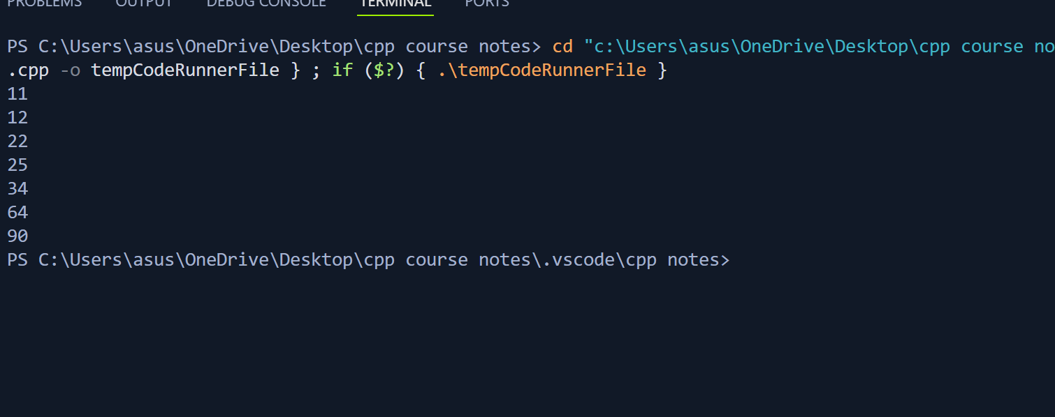

Ques3 Design the Logic to Find a Missing Number in a Sorted Array.

#include<iostream>

using namespace std;

int main(){

    int arr[5]={1,2,3,5,6};

    int sum =0;

    int n=6;

    int sum2=n*(n+1)/2;

    for(int i=0; i<5;i++){

        sum=sum+arr[i];

    }

    int missing =sum2-sum;

    cout<<"mising is "<<missing;

    return 0;

}

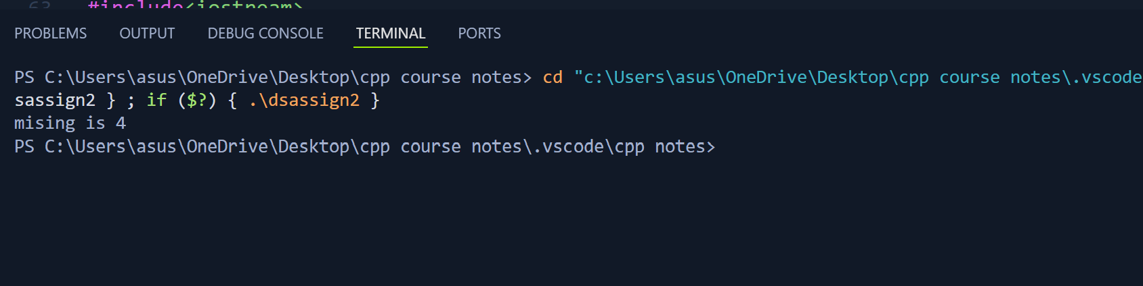

4) String Related Programs (a) Write a program to concatenate one string to another string. (b) Write a program to reverse a string. (c) Write a program to delete all the vowels from the string. (d) Write a program to sort the strings in alphabetical order. (e) Write a program to convert a character from uppercase to lowercase.

Sol a:

#include<iostream>

#include<cstring>

using namespace std;

int main(){

    char str1[100];

    char str2[100];

    cout<<"enter str1";

    gets(str1);

    cout<<"enter str2";

    gets(str2);

    strcat(str1,str2);

    puts(str1);

    return 0;

}

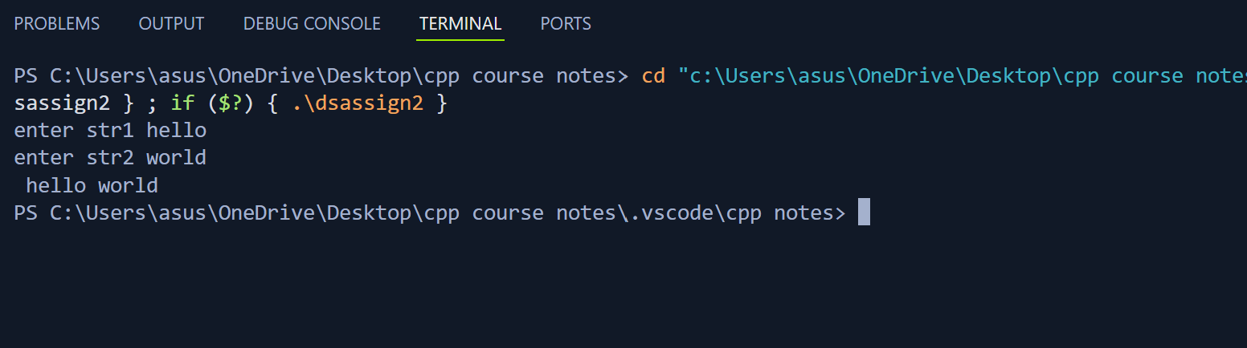

Sol b:

#include<iostream>

#include<cstring>

using namespace std;

int main(){

char str[6]="hello";

for(int i=5; i>=0; i--){

    cout<<str[i];

}

return 0;

}

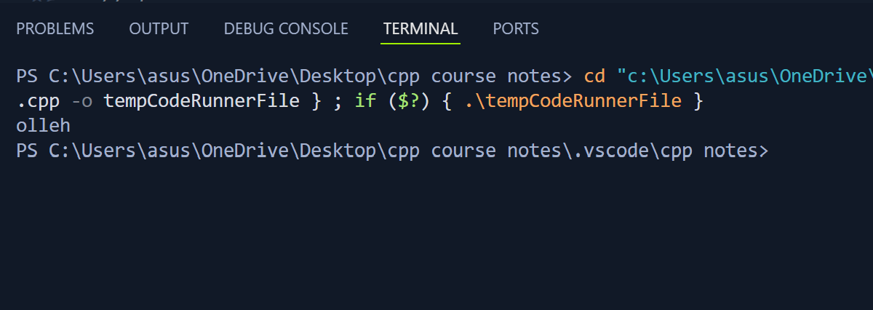

Sol c:

#include<iostream>

#include<cstring>

using namespace std;

int main(){

char str[6]="hello";

for(int i=0; i<6; i++){

   if(str[i]=='a'||str[i]=='e'||str[i]=='i'||str[i]=='0'||str[i]=='u'){

    continue;

   }

   cout<<str[i];

}

return 0;

}

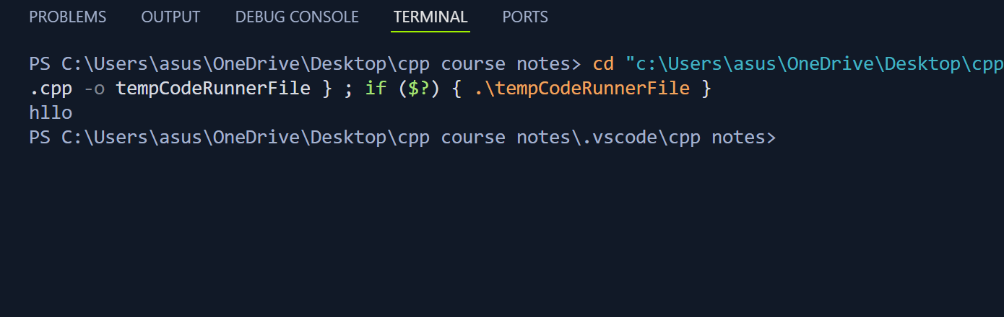

Sol d

#include<iostream>

#include<cstring>

using namespace std;

int main(){

    char str[6]="hello";

for(int i=0; i<6; i++){

    for(int j=0; j<6-i-1;j++){

        if(str[j]>str[j+1]){

            int temp =str[j];

        str[j]=str[j+1];

    str[j+1]=temp;

      }

    }

}

for(int i=0; i<6; i++){

    cout<<str[i];

}

 return 0;

}

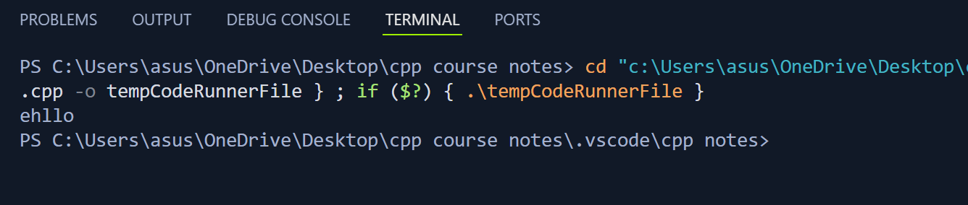

Sol e:

#include<iostream>

#include<cstring>

using namespace std;

int main(){

char str[6]="hElLo";

puts(str);

for(int i=0; i<6;i++){

    if(str[i]>='A'&&str[i]<='Z'){

        str[i]=str[i]+32;

    }

   cout<<str[i];

}

return 0;

}

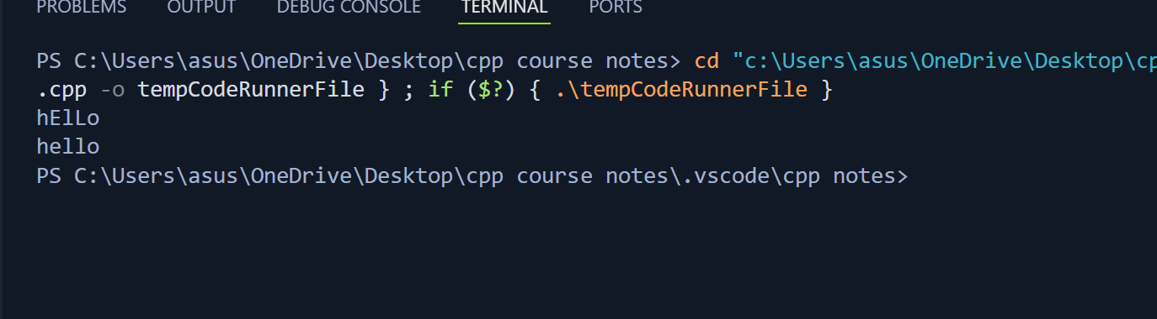

Ques 5; and ques 6 have not done in lab and class yet

Will do in next assignment

Ques 7: Let A[1 …. n] be an array of n real numbers. A pair (A[i], A[j ]) is said to be an inversion if these numbers are out of order, i.e., i < j but A[i]>A[j ]. Write a program to count the number of inversions in an array.

Sol: #include<iostream>

using namespace std;

int main(){

    int arr[10];

    cout<<"enter array"<<endl;

    for(int i=0;i<10; i++){

        cin>>arr[i];

    }

    int count=0;

    for(int i=0; i<9; i++){

        for(int j=i+1; j<10;j++){

            if(arr[i]>arr[j]){

                count++;

            }

        }

    }

    cout<<"count: "<<count;

    return 0;

}

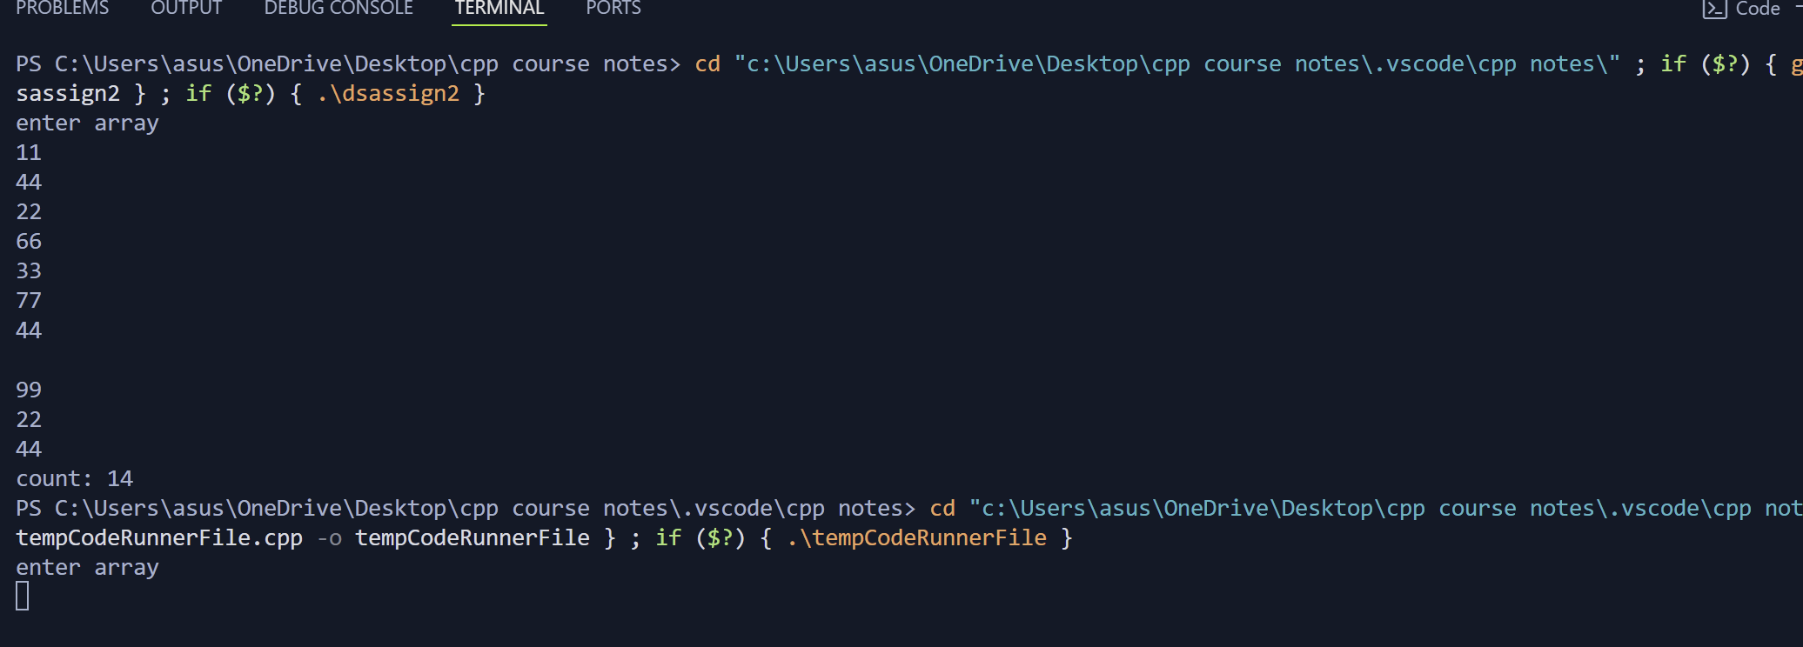

Ques 8: Write a program to count the total number of distinct elements in an array of length n.  
  
sol

#include<iostream>

using namespace std;

int main(){

int arr[10]={1,3,5,7,9,5,8,3,2,9};

int count =0;

    for(int i=0; i<10;i++){

        bool isunique=true;

    for(int j=0; j<10; j++){

        if(i!=j&&arr[i]==arr[j]){

           isunique =false;

        }

    }

    if(isunique==true){

        count++;

    }

}

cout<<count;

return 0;

}

