Chem 5312 Homework 7. Due Monday March 22, 8:30 am. Late assignments receive zero credit.

Problem 1. Impedance spectroscopy

a) Make an Excel spread sheet that allows you to calculate the real and imaginary parts of the impedance versus frequency for the equivalent circuit below (But use different values for the two resistors R (i.e. call then Rc and Rct) and the two CPE elements)

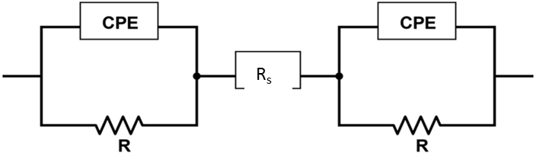

Make sure that you can exactly reproduce some of the EIS spectra that are in your notes that I calculated with my spreadsheet.

a1) Calculate the impedance versus frequency (use ω = 2πf) for the equivalent circuit with:

Rs = 2 Ω, Rc = 10 Ω, Rct = 20 Ω, Qc = 0.0002 “F”, φc = 0.8, Qct = 0.02 “F” and φct = 0.7. The values of ω should run from 100,000 Hz to 0.01 Hz. They should be equally spaced in log(ω).

a2) – plot the Nyquist diagram for your calculation (publication quality graph)

a3) – plot the real part of the impedance versus frequency (Bode plot). Make sure the frequency axis is plotted as a logarithmic axis.

a4) – plot the negative imaginary part of the impedance versus frequency (Bode plot). Make sure the frequency axis is plotted as a logarithmic axis.

b) Read the paper by Ma et el. provided with this homework. Look carefully at Figures 2 and 3. Understand clearly the experimental protocol that was followed. (Read the experimental section carefully).

b1) Using a constant value for Rc, the contact resistance, and your spreadsheet, make a series of Nyquist plots that approximate well the Nyquist plots for the 2.8 – 4.3V cycling for 2% VC in Figure 3. (2nd left-most panel in the top row). Note: typically the values of Q change very little during cycling, only the R’s change. Make sure you understand how the spectrum changes from one hump for the fresh cell to two humps for the later cycles.

Hint: Look at the experimental part to determine the range over which the frequency (in this case it was f, not ω that varied from 100000Hz to 0.01 Hz) varied. Your calculated spectra must show the same features as the experimental spectra over the same frequency range.

b2) Make a graph of the Rct that you extract versus the cycle count.

b3) You have to realize that the same cells were used for all the experiments in this particular panel in Figure 3. What should the authors have done at the end of the 40 cycles to be able to interpret their results better?

Problem 2. dV/dQ analysis

You will find three data files attached to this homework. There is a positive reference curve, a negative reference curve and some full cell data. **PLEASE NOTE THAT YOU ALL DO NOT HAVE THE SAME FILES to discourage direct collaboration.**

Your goal will be to develop excellent fits to the experimental dV/dQ vs Q and dQ/dV vs V data. Please then plot graphs (to be handed in) that show the full cell voltage versus capacity, the negative voltage versus capacity and the positive voltage versus capacity. Based on your last graph please report the following:

1. What fraction of graphite could be safely removed from this cell to have it still operate effectively to the upper cutoff voltage used for the full cell?
2. If you removed that fraction of the graphite, by what fraction would you expect the stack energy of the cell to increase? Make reasonable assumptions.

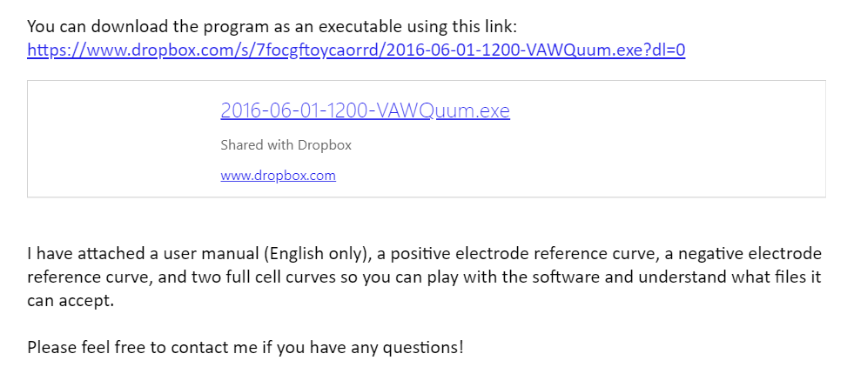

There is a user manual attached to this e-mail. Please read the users manual first.