FINAL REPORT

GhostWriter
Team 21
Lucas Bruder
Matt Mercedes
Jake Stephens

May 6th, 2016

Abstract

In our Embedded System Design class, our team designed and built a 2 dimensional plotter that improves on other plotters by providing users with the options of plotting images on any sized workspace, ranging from a small desk to a 4’x8’ sheet of plywood. We were able to take in a SVG (Scalable Vector Graphics) file, parse it to obtain the paths and curves in the file, and convert it to string lengths for our plotter. The plotter string lengths were sent over to a microcontroller that was responsible for controlling the length of wire for four stepper motors.
Our project was able to reproduce SVG files with reasonable accuracy. Rectangles were occasionally rounded and circles were occasionally ovals, but most of the drawings provided could be reproduced with recognition. Some sources of inaccuracies include the extra wire on the spool causing a bigger diameter, the springs on the tool piece, and the stepper motor wires getting in the way of the drawing tool.
We believe with a few modifications, our system can reproduce images with a high level of accuracy. Some of these modifications include wireless communication, wireless power for the motors, and an improved parsing algorithm to account of accumulated wire on the spool. Overall, our project in our opinion was a success and we learned a great amount about developing and implementing an embedded system from start to finish.

Table of Contents

Project Description . . . . . . . . . . . . . . . . . . . . . . . . . . . . . 3
Requirements . . . . . . . . . . . . . . . . . . . . . . . . . . . . . 4
Architecture . . . . . . . . . . . . . . . . . . . . . . . . . . . . . . . . . 5
Design Trade-offs . . . . . . . . . . . . . . . . . . . . . . . . . . . . . . . . . 6
System Overview . . . . . . . . . . . . . . . . . . . . . . . . . . . . . . . . . 8
Description . . . . . . . . . . . . . . . . . . . . . . . . . . . . . 8
Depiction . . . . . . . . . . . . . . . . . . . . . . . . . . 8
Project Management . . . . . . . . . . . . . . . . . . . . . . . . . . 9
Evaluation . . . . . . . . . . . . . . . . . . . . . . . . . . . . . . . . . . . 14
Conclusions . . . . . . . . . . . . . . . . . . . . . . . . . . . . . . . . . . . 14
Related Work . . . . . . . . . . . . . . . . . . . . . . . . . . . . . . . . . . 15
References . . . . . . . . . . . . . . . . . . . . . . . . . . . . . . . . . . . . 16

Project Description

Our project, called GhostWriter, is an electromechanical system to generate written content by use of existing drawing tools. The goal of our project is to create a system capable of outputting physical drawings from a given digital input. This system would allow a user to submit an image file to our system, and have a machine reproduce the image onto paper with a user provided drawing utensil such as a pen, pencil, or marker. It will also be able to draw on surfaces of different dimensions, allowing the user to reproduce drawings on anything from a sheet of plywood to a small table.

Requirements

Explicit Requirements

- System shall be able to recreate pictures and write out text via a provided drawing utensil

- System shall be able to adapt to different drawing surfaces and sizes, so as to produce an accurate reproduction given the space provided

Stretch Goals

- System should be able to communicate wirelessly between motors and microcontroller.
- System should be able to analyze input based on a camera.

- System should be able to analyze and respond to human input, such as playing the game Tic-Tac-Toe

- System should be able to draw on vertical surfaces

- System should have a mobile or web application that allows transfer or upload of drawing date and notify user of system status

Coolness Requirements

- Recreate an image in a reasonable amount of time for a bystander to stay and witness

- Have a slim form factor that allows for travel between surfaces and locations

Architecture

As detailed in Figure 1, a user interacts with the system by sending a file to a processing platform. The platform will then convert the file to a format understood by the motor controllers to draw. The motor controllers will command the motors to draw on the drawing medium (paper, whiteboard, chalk, etc.). When the motors are done drawing, the processing platform will notify the user it’s done and the user can now get their drawing, a perfectly drawn smiley face.

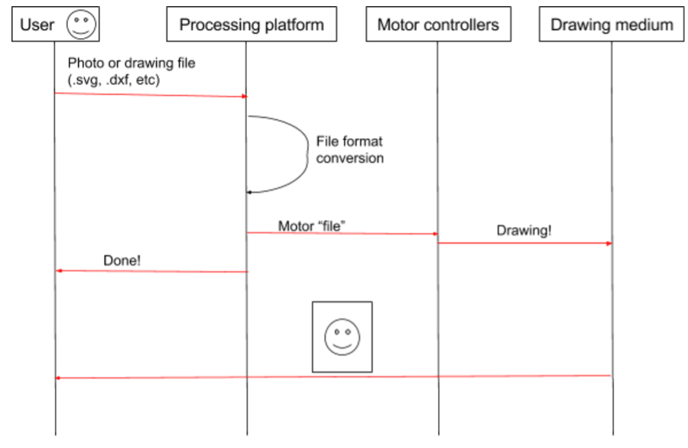

Figure 1: User Interaction Diagram

Design Trade-offs

Frame

Choice 1

The majority of x-y plotters use a standard square frame as depicted in Figure 2. The benefits of this frame include simplicity, ruggedness, and ease of use. Each motor is only responsible for one axis and that greatly simplifies reliability and trajectory control. However, the frame is a fixed size and is big and heavy. If one wanted to increase the size of their workspace, they would have to buy several new components including extruded aluminum, belts, and several other key components to the operation of the plotter.

Choice 2
Our second choice for frame design is a design similar to the ZarPlotter^{[1]}; We have sketched out a picture of what the frame looks like in Figure 3. This design features four motors in each corner (pictured in black) with strings running to a tool in the workspace responsible for drawing. This design is more complicated, could be more prone to reliability issues, and complicates the trajectory control. However, this design can be used on any surface whether it be horizontal or vertical and can also be used on workspaces with different areas. Also, when drawing, it looks much cooler for a bystander.

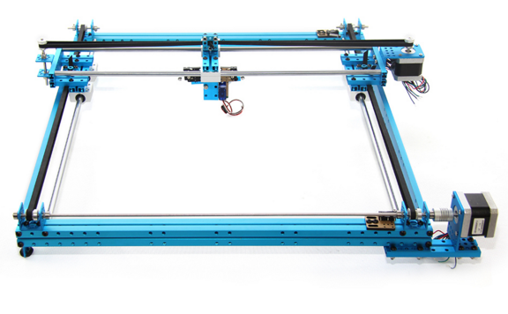

Figure 2: Standard XY plotter

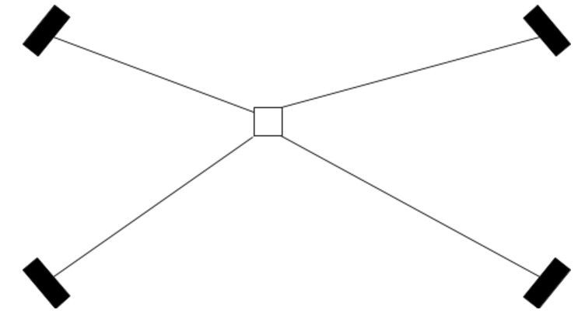

Figure 3: ‘X’ style plotter

Decision

Since one of our design and coolness requirements is being able to use the product on a workspace of any size, we have decided to go with choice 2 for the frame. However, if this frame layout is too complicated, our backup plan is choice 1, which utilizes many of the same components found in choice 2.

Processing Platform

There are various processing platforms available that would have enough power for what we need. We decided to narrow it down to two processing platforms to choose between.

Choice 1

Our first choice of processing platform is the Raspberry Pi. There are several different models to choose from ranging from $5 to $30, single core to quad core. There is a huge community support and finding example code and libraries would be extremely easy.

Choice 2

Our second choice for a suitable processing platform is the Beaglebone Black with a price point at around $50. The capabilities of the Beaglebone Black are much less than the capabilities of the Raspberry Pi with a lower clock speed and lower amount of GPIO pins.

Decision

Because of the bigger user support, more options, and cheaper price point, we have decided to use a Raspberry Pi as our main processing platform.

Other Decisions

There are a few other design decisions that need to be made including stepper motors, stepper motor drivers, microprocessor, and method of attachment. These design decisions will be evaluated more in depth as the semester progresses and additional information becomes available.

System Overview

Description

Overall System Design

Our overall system depiction is pictured in Figure 4. The Raspberry Pi will be the main processing unit, performing the translation from one file format to a format that the microcontroller can understand. Once this new format is computed, it will send the data through I2C to the main microcontroller which parses the received data and is responsible for controlling the four separate stepper motor drivers, which in turn control the stepper motors.

Stepper Motor Driver Subsystem

Our stepper motor driver subsystem is depicted in Figure 5. We will most likely be using the A4988 chip, but the interface for a stepper motor is pretty standard across motor controllers. In the top right of the figure, you can see that V_{mot} is attached to the motor power supply. This power supply must be able to handle relatively high amperage, since stepper motors can draw at or more than 2 amps. Next, there are ports 2B, 2A, 1A, and 1B, which lead to the stepper motor itself. These lines are responsible for switching the motor phases on and off to ensure the motor steps the correct number of times, and they must be hooked up in specific motor to ensure it functions properly. V_{dd} is a line used to determine what voltage logic level to use. Most importantly, we have the step and direction line. The step line is pulsed to let the controller take a step, and the direction line is usually set high for one direction and set low to go the opposite direction.

Depiction

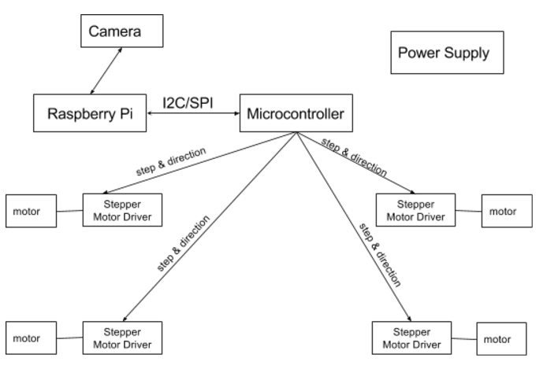
Figure 4: Main Interaction Diagram

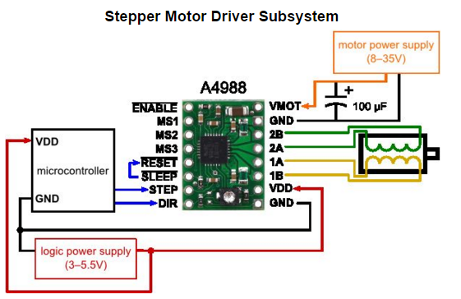
Figure 5: A4988 Stepper Motor Driver

Project Management

Schedule

- We plan to have a group meetings three times a week
- Meetings are scheduled after class on Mondays and Wednesdays from 1:00pm to 2:00pm
- Additional meeting on Saturday from 2:00pm to 5:00pm
- Original schedule is outlined in Figure 6

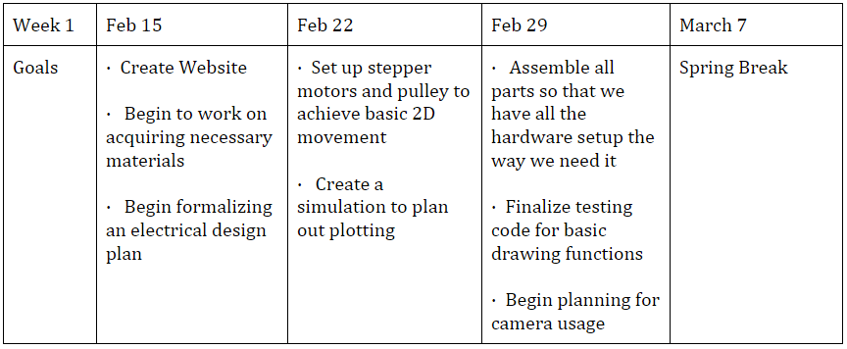

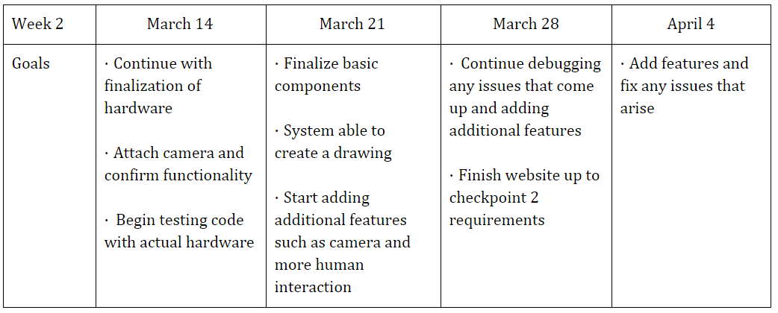

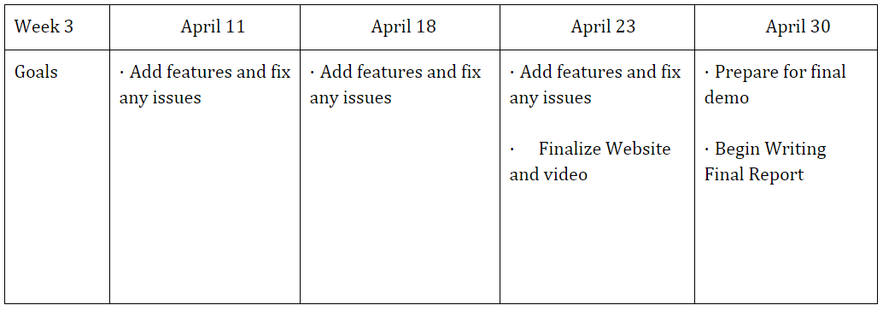
Figure 6: Schedule

Responsibilities

Jake Stephens

Will be responsible for working on designing the circuit composing the drawing hand that holds the tool to impress the design onto the drawing surface and implementing the ability to raise and lower the drawing utensil on command.

Matt Mercedes

Responsible for writing the code that takes a digital image format and translating it into a set of instructions for the stepper motors to follow. Will also be responsible for both creating and maintaining an updated version of our website that depicts our project’s progress.

Lucas Bruder

Will be responsible for assembling the four motors and accompanying pulley systems along with their respective drivers. Will also be the main person for maintaining the overall hardware design of our project.

Budget

Raspberry Pi $30

Microcontroller $5

Stepper Motor Drivers (4) $20

Stepper Motors (4) $80

Physical Equipment (pulleys, string, PCB, etc) $250

4’ x 8’ Plywood $15

Small Digital Camera $30

5v power supply (10A minimum) $30

Total $460

Risk Management

We plan to mitigate any issues that may occur by working in parallel on the various subsystems. If any issues occur on one particular subsystem, it won’t slow down the work of other parts of our project. In addition, by building the least amount of hardware first, we plan to focus on getting a minimum working hardware project first, so we can focus on software improvements and hardware improvements later.

Evaluation

We believe our system performed quite well given the timeline we had to develop the system. We fell short on a few of our goals, which included getting the camera to work and wireless communication to the motors, but the project was able to accomplish our explicit requirements of plotting an image and adapting to different workspace areas.
The accuracy of our plotter was occasionally an issue. Images recreated by the plotter were absolutely recognizable, but straight lines were sometimes curved and circles were occasionally ovals. We noticed the accuracy of the images depended largely on the part of the workspace the drawing tool was in; if the tool was towards the middle of the workspace, the drawings were made with much higher accuracy verses when the drawing tool was towards the edge of the workspace.
The stepper motor wires dragging on the drawing workspace were also a source of inaccuracy. The stepper wires occasionally would get caught on the paracord dragging the tool around or would get caught on the drawing tool, which would get in the way of the drawing tool.

Conclusion

This project provided an awesome learning experience for all members involved on the team with plenty of lessons learned. As seen by the differences in our original schedule and revised schedule, there was a good amount of work that was pushed back for various reasons, which limited some of the things we wanted to develop for a coolness factor. We believe if we followed our schedule tightly, we could have presented a better project, but there were multiple technical issues that we ran into during the build that slowed development which included 3d printing difficulties, ordering the wrong stepper motors, and I2C communication issues. However, we were able to follow our risk management strategy to ensure the completion of our project.
There are several changes we would make if we were to do this project again. First off, making this project wireless would eliminate issues caused by the stepper motor wires. If made wireless, each motor would have a separate PCB with a wireless transceiver and battery attached, eliminating all wires except for the paracord responsible for pulling the tool around. Furthermore, our parsing algorithm could be improved to include DXF and other types of drawing files.
If we were to start a company based on the progress we’ve made so far, there are several steps that would need to be taken. First off, making this system wireless would be a must. If the wires were eliminated, the drawings would come out much better and the project could be expanded to a workspace of any size. If made wireless, LiPo batteries could be used to power each motor individually, providing over 1-2 hours of drawing time before needing to be recharged. In a perfect world, our parsing algorithm could account for the wire accumulation on the spool, which would provide a higher level of drawing accuracy. Furthermore, our microcontrollers could be ran much faster, completing drawings in a faster and cooler manner than we are currently doing.

Related Work

DryPlt

DryPlt^{[2]} mostly focused on integrating with common whiteboards. DryPlt tried to use several different techniques to locate the position of the pen on the whiteboard. However, it was never confirmed if it successfully implemented the ability to recreate images on a white board. Additionally, there is no input from the physical world during, or after the recreating of a given image.

XY Plotter

The XY Plotter^{[3]} only has basic fixed-size drawing functionality. One cannot change the size of the area that will be drawn on and is restricted to the given layout of the plotter. In addition, there is no input from the physical word or feedback provided to the system. There is also no ability for the plotter to continue from a previously left off position or respond to potential interruptions during the drawing process.

ZarScribe

The ZarScribe^{[4]} is fixed in place and is unable to change the size of the area that it is working on. Additionally, there is no input or feedback from its surroundings just like many of the other plotters. Also, the controller of this plotter is big and clunky and must be wired up to all the other parts of the system. It is also very new and thus does not have much documentation so there is no info on how it actually works or what systems are in place to allow it to recreate a given image. In addition, since it is very new it is not currently available in the consumer market for purchase, nor is there a date for when it will become available.

Basic Plotters

Basic plotters do not have many features and are fixed to printing the images they are given with no further input. They commonly function as simple printers and thus do not provide too much functionality beyond basic reproduction functions.

References

[1] http://www.zarplotter.com/
[2] https://www.ece.cmu.edu/~ece549/spring15/team15/website

[3] http://www.makeblock.cc/xy-plotter-robot-kit/

[4] http://www.zarplotter.com/

