JasperReports is an open source Java reporting tool that can write to a variety of targets, such as: screen, a printer, into PDF, HTML, Microsoft Excel, RTF, ODT, Comma-separated values or XML files.
It can be used in Java-enabled applications, including Java EE or web applications, to generate dynamic content. It reads its instructions from an XML or .jasper file.
JasperReports is part of the Lisog open source stack initiative.
To be able to create reports you need to have the iReport studio which will enable you to create very sophisticated layouts containing charts, images, subreports, crosstabs and much more. You will also be able to access your data through JDBC, TableModels, JavaBeans, XML, Hibernate, CSV, and custom sources. Then publish your reports as PDF, RTF, XML, XLS, CSV, HTML, XHTML, text, DOCX, or OpenOffice.
The jasper reports studio uses the jasper reports library which is as per their site: “The JasperReports Library is the world's most popular open source reporting engine. It is entirely written in Java and it is able to use data coming from any kind of data source and produce pixel-perfect documents that can be viewed, printed or exported in a variety of document formats including HTML, PDF, Excel, OpenOffice and Word.”
Now let us configure 2 types of reports and call them from our java web application:
- a global reporting
- a parameter based report (our parameter here is the username)
First we run the report wizard to connect to our database and select the fields and the grouping that should be applied in our reports.

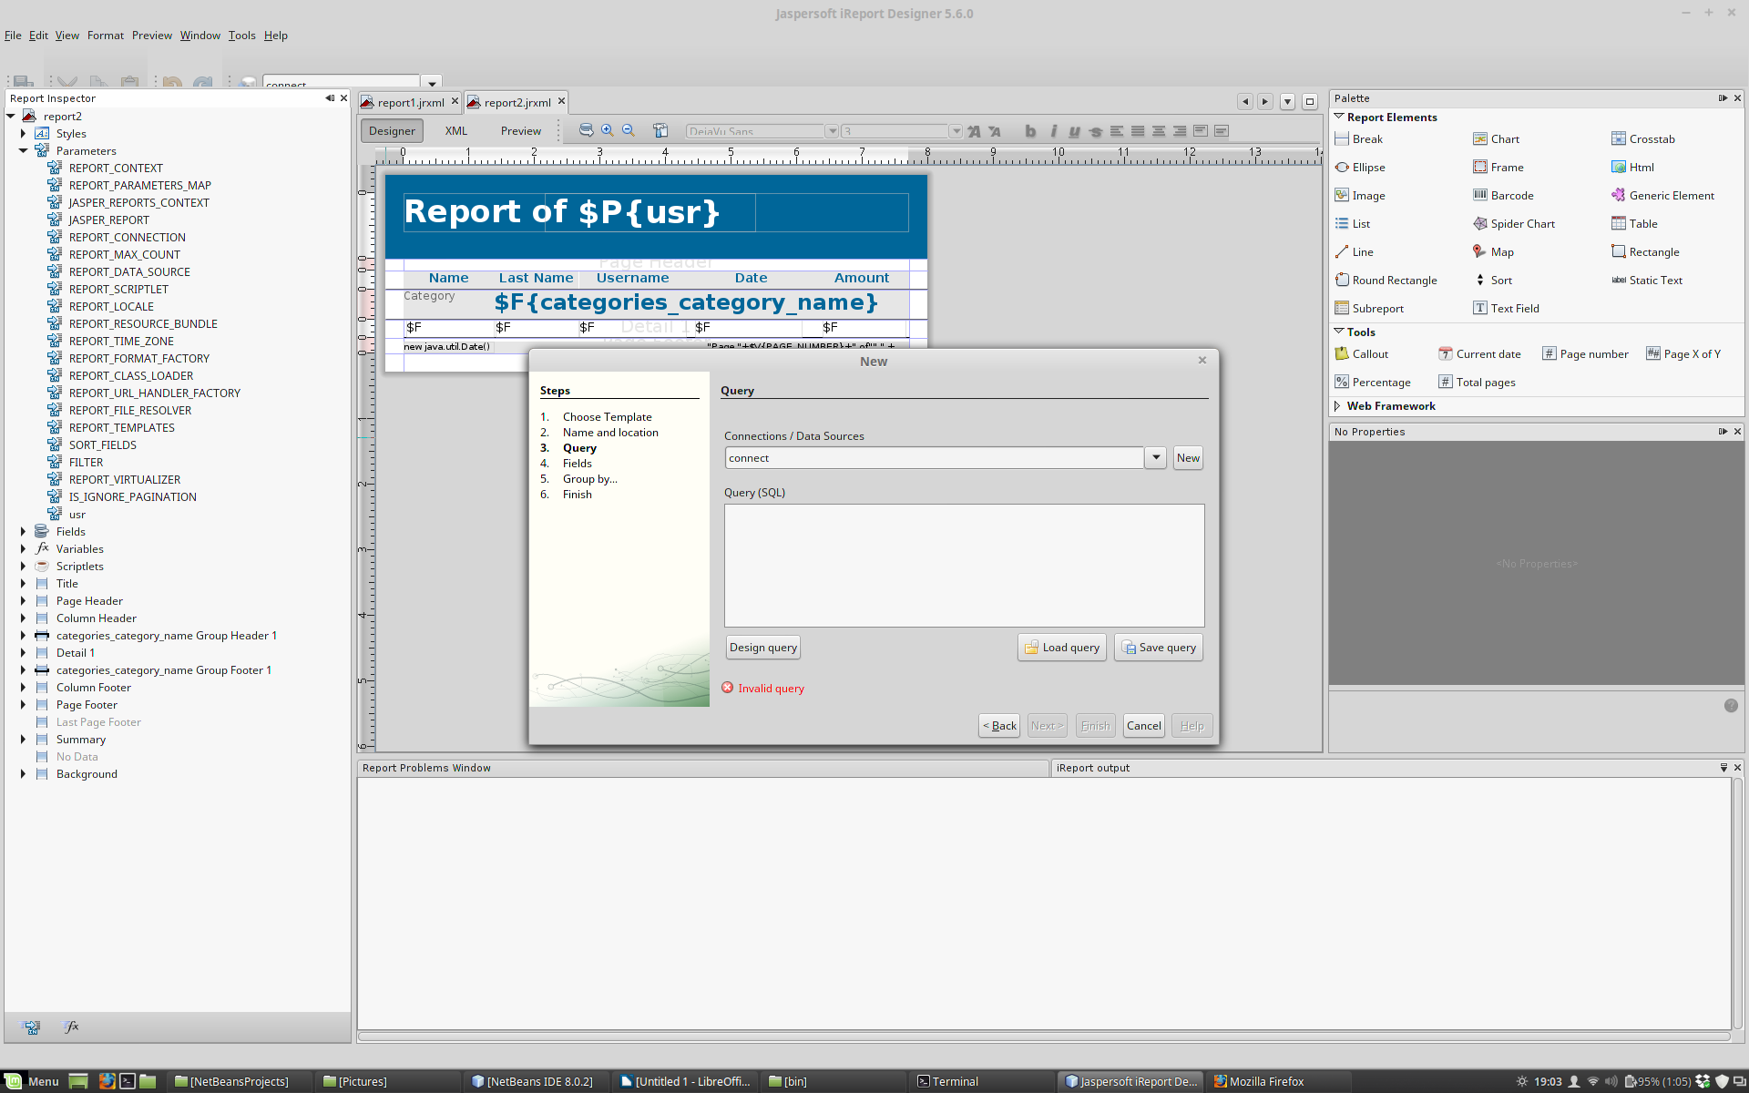
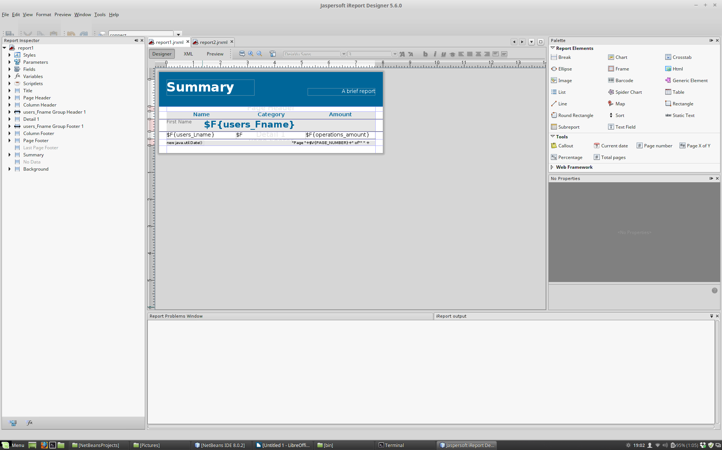
A no parameter report is as easy as 1 2 3 you just follow the on screen windows to create your report.

The parameter based report is a normal report where u can add a parameter (left panel right click on parameters add parameter)
Drag the parameter to the report it will have the syntax like $P{xxx}.
Add the parameter to the report query as a condition.
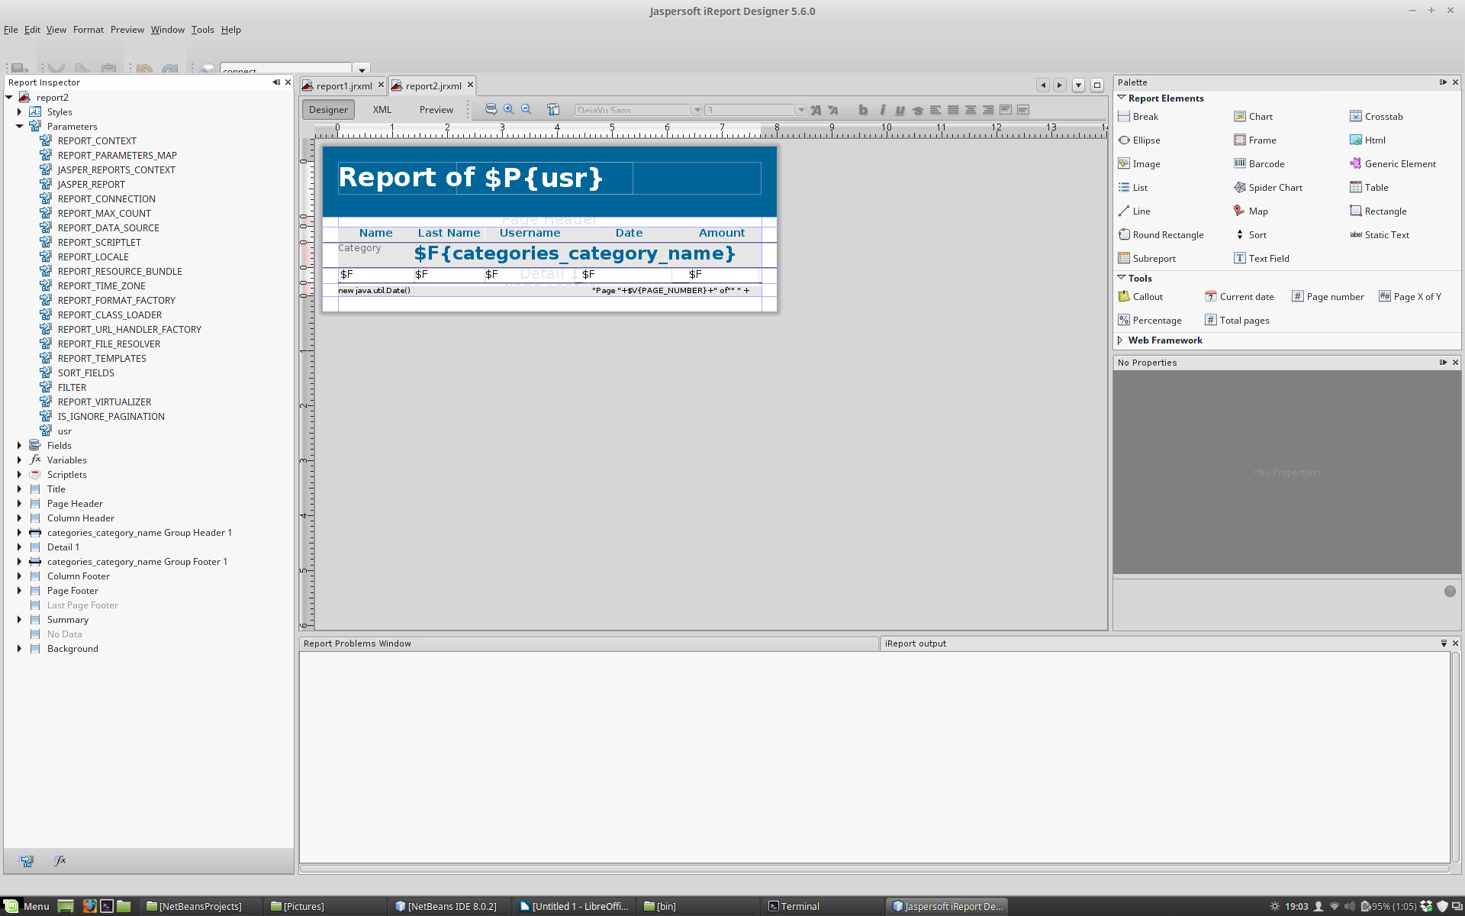

Now we create the calling java class which has 3 objectives:
- create the database connection
- fill the reporting
- export the report to the desired format
The next pictures show how this process works, database connection, filling the reports and exporting them. The first step is common however to differenciate a full report and a parameter based one we create separate methods that will each call its own report.
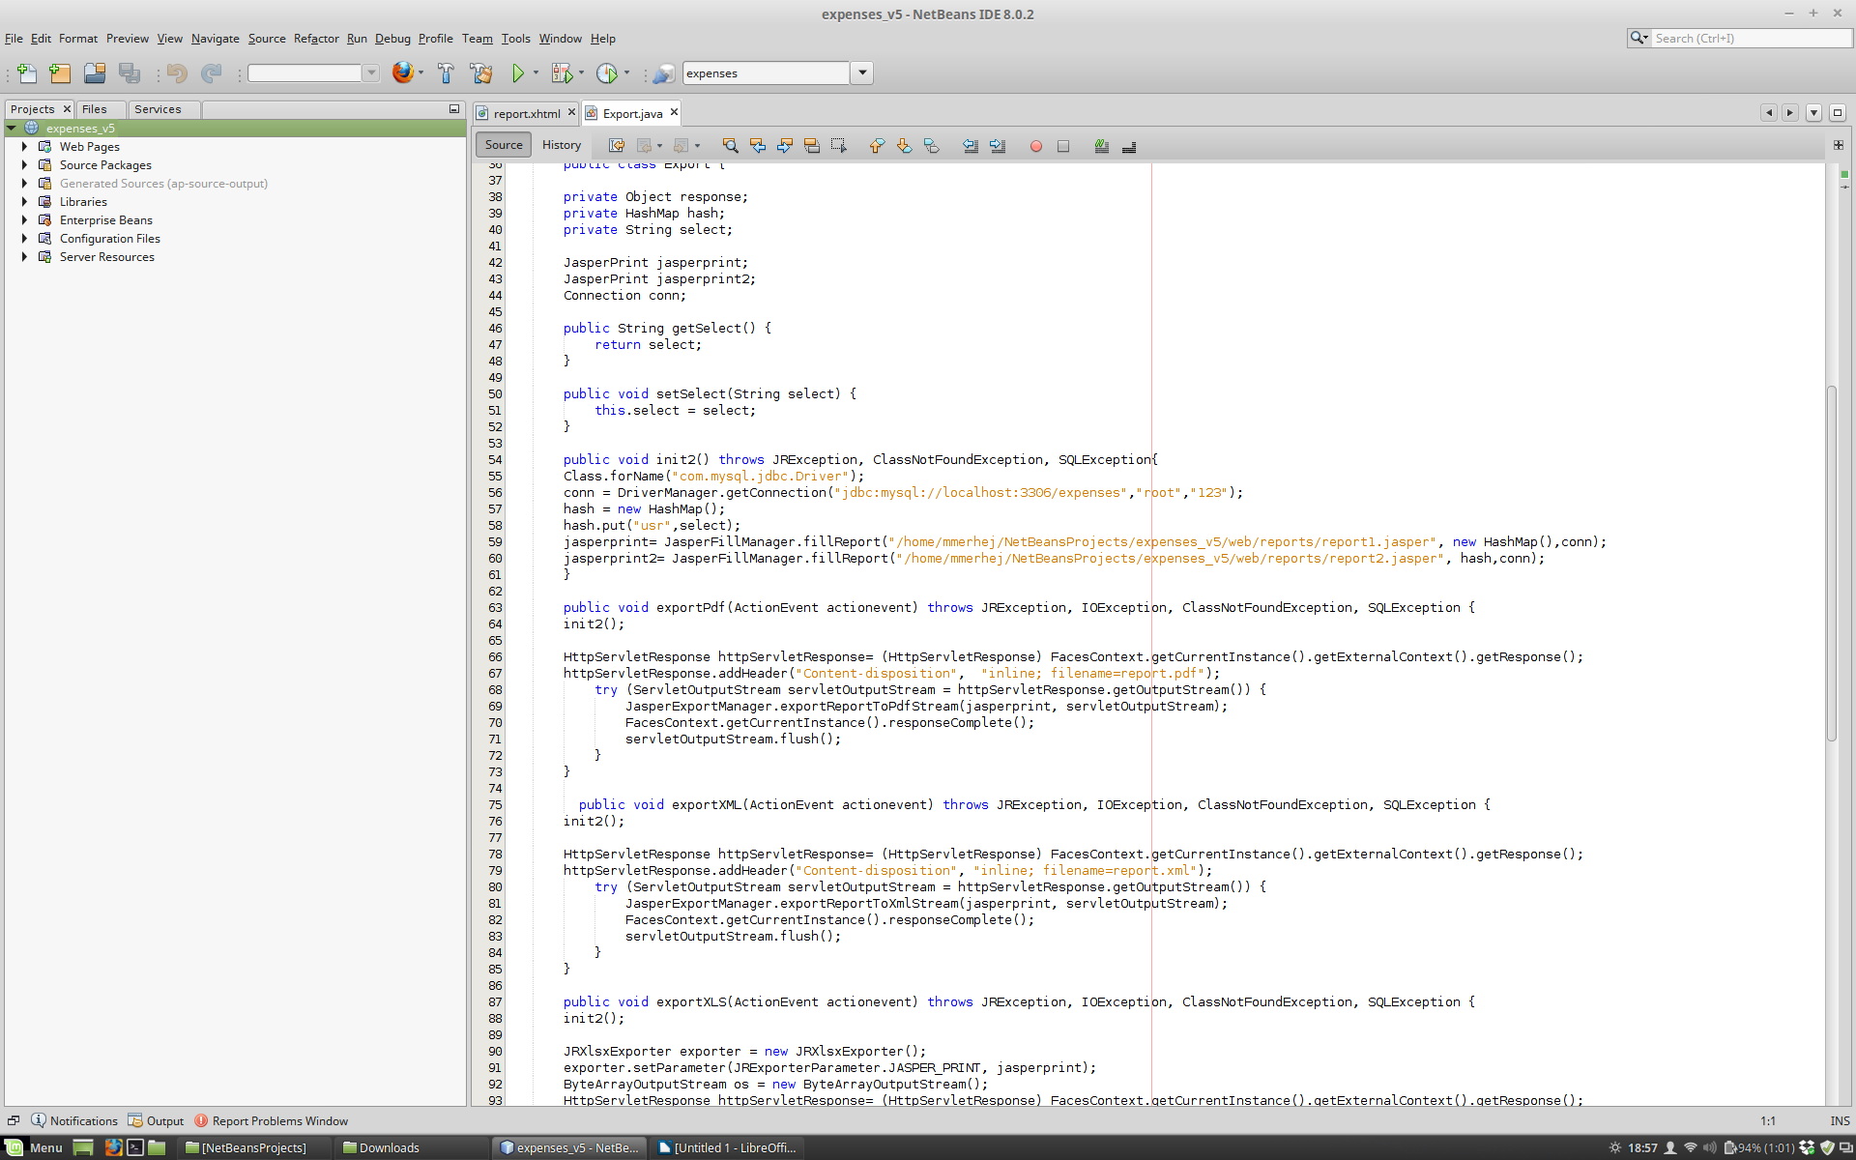
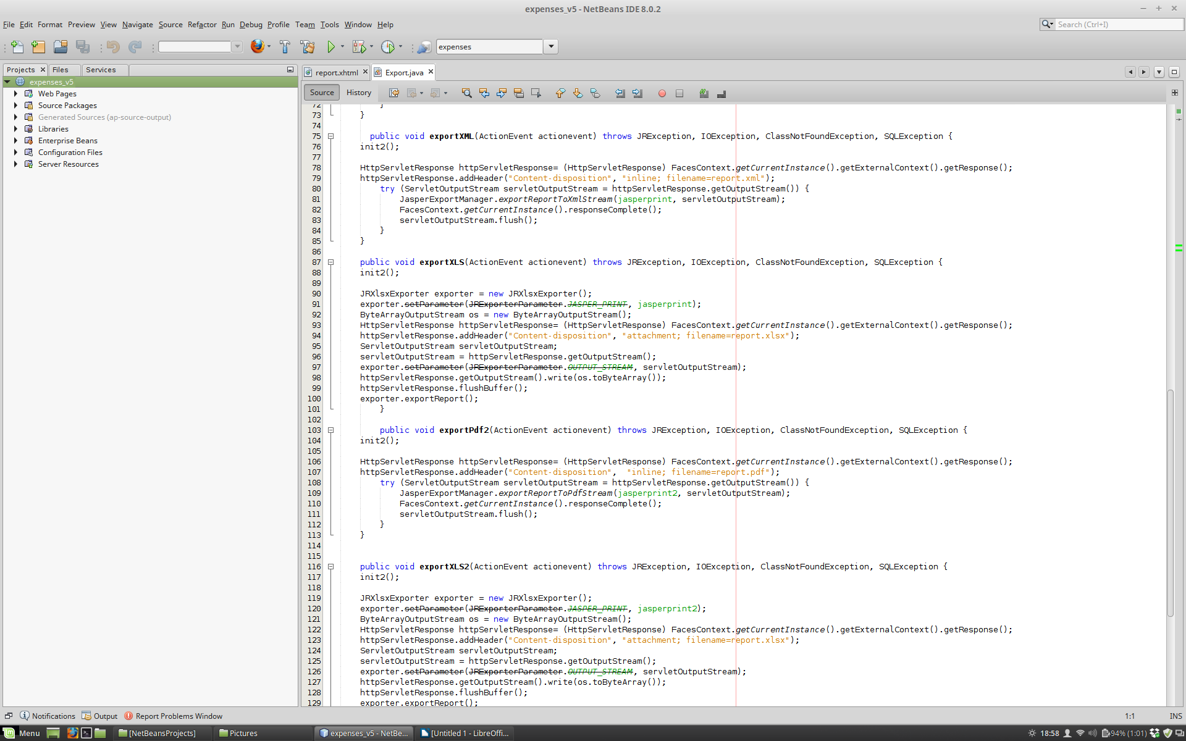

We create the buttons that will each call its assigned method
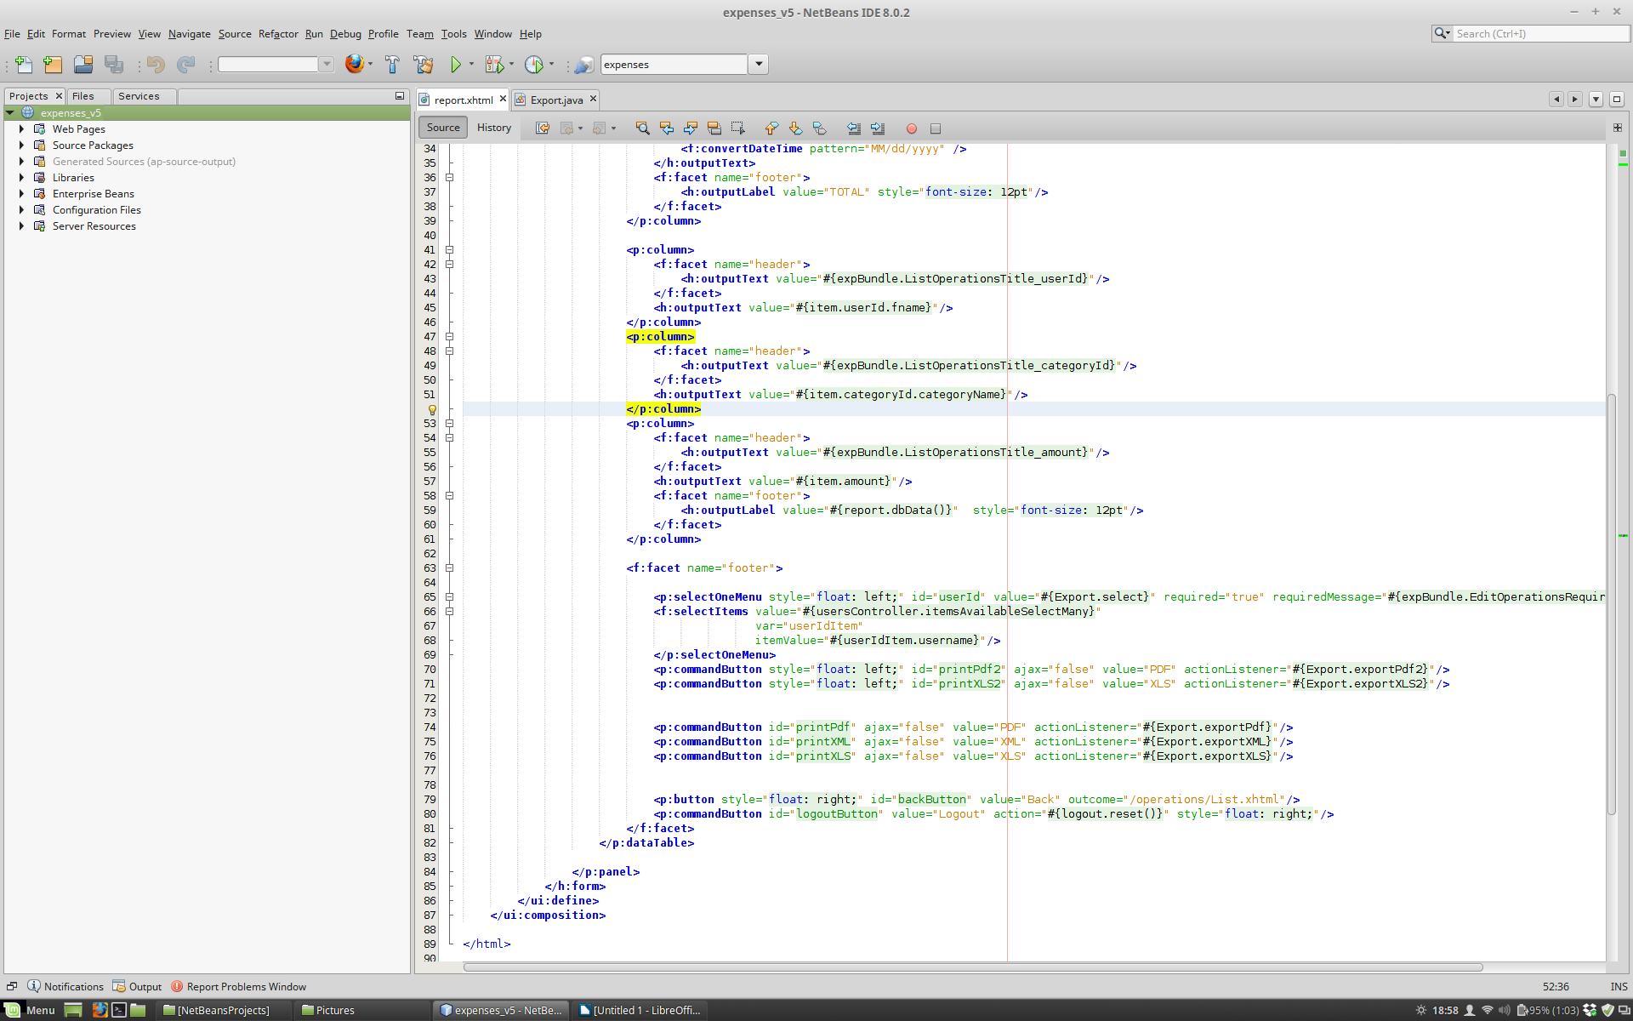
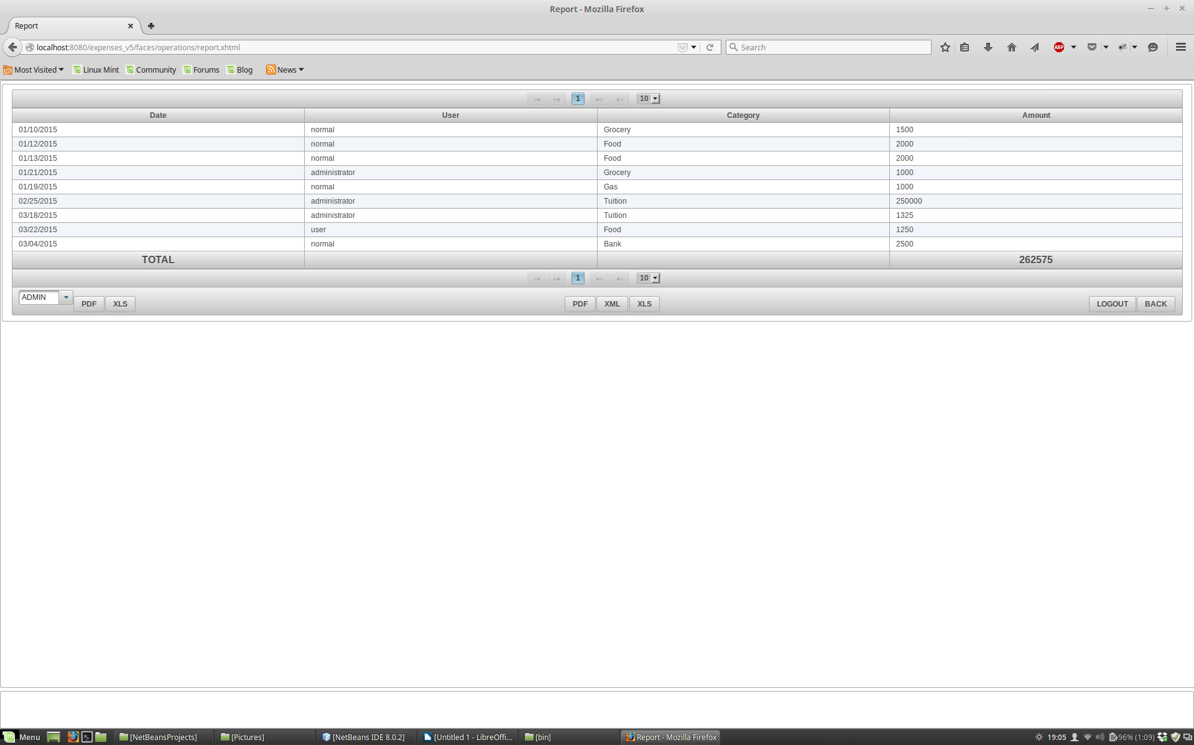
And below is the end result for an exported PDF report.
