Technical Report
Conv2D and Max Pooling Layers:
The convolutional layer is positioned first when building the model. The convolutional layer is a fundamental aspect of a CNN (Goodfellow et al., 2016). The Convolutional layer is used to detect spatial features from data and is especially used for images. Throughout a convolution, the goal is to extract specific patterns such as edges, curves, or textures that make up the image. The process consists of applying a filter over the input which will perform multiplication over the matrix and sum up the results to produce something called a feature map (Brownlee, 2019). The feature map holds the patterns used to distinguish between healthy and very mild demented patients. For our project we are using a 2-Dimensional model (Conv2d). Conv2D is a layer of the CNN that specializes in 2-Dimensional data such as images. In our convolutional layers, we have applied a couple of parameters. To begin, we have applied 64 filters to slide over the image and look for patterns mentioned above. Next, we have specified a window size of (3,3). Essentially each filter will scan over pixels in a 3x3 “window” at a time. Within our convolutional layer we are using ReLU activation, which will be discussed further in the report. Next, we have the max pooling layers (MaxPooling2D). The function MaxPooling2D is used to reduce the spatial dimensions of image while retaining the most significant features (Goodfellow et al., 2016). MaxPooling2D does this by taking the maximum value from the output that comes from the convolutional filters . In our model, we have set this function to have a pool size of (2,2). Fundamentally, this small 2 x 2 grid will run over the output from the convolutional layer and pick the largest values. Therefore, the model retains the most significant features while reducing the image.

ReLU Nonlinearity:
ReLU is significant to our model by introducing nonlinearity in a simplistic manner. ReLU will change all negative features to value 0 while positive features will be unchanged. Essentially, the activation function will allow all positive values to pass through the convolutional layer unchanged while setting all negative values to zero. Therefore, the model will be able to maintain complexity and learn significant patterns well (GeeksforGeeks, 2024).

Convolutional Neural Network:
The deep learning model chosen for our project is a Convolutional Neural Network (CNN). The scope of our project encompasses computer vision, and CNN models are widely used in this field. They are mainly designed to extract features from grid-like datasets. This is useful for data that contains images such as our MRI data set. A CNN is composed of multiple layers such as the input layer, convolutional layer, pooling layer, and dense layers. Below, we take a look at how each layer works (Goodfellow et al., 2016).

Flatten, Dropout, and Dense Layers:
The CNN model needs to implement the flatten layer so the output of the previous layers (convolutional and pooling layers) can be processed for prediction. The previous layers are in a 2-dimensional format which is not accepted for a dense layer (fully connected layer). The format needs to be a 1-dimensional vector. This is where the flatten layer makes this conversion. Next, before adding the final dense layer we included a dropout layer in the model. The dropout layer’s role is to prevent overfitting. Without dropout different neurons can extract very similar features from the input data because the weights of the features are the same. This can lead to overfitting because if the same features are being extracted from the training data it gives them higher significance for the model. Therefore, dropout shuts down some of these neurons by zeroing their values out. By zeroing out the neuron values we are training our model on a sample of neurons rather than the entire network. This results in our model learning the hidden features better and not overfitting. Lastly, our model implements two dense layers. Dense layers are also known as fully connected layers. They are fully connected layers because every neuron in the dense layer will connect to every neuron in the previous layers. The neurons in the dense layers will each make different combinations with the neurons in the previous layers to find different patterns to make a prediction. This creates a highly interconnected network. The last dense layer in our model only has one neuron for binary classification (GeeksforGeeks, 2024). This layer will convert our features into an output score using an activation function called sigmoid. The sigmoid function will output a probability in between zero and one.

Early Stopping
To prevent overfitting in our CNN model, we implemented early stopping. Overfitting can occur when a neural network learns the training data too well, capturing noise and patterns that do not generalize to new unseen data. Early stopping addresses this by monitoring the model’s performance on a validation dataset and halting training when the validation loss no longer improves. In our model, the EarlyStopping callback in Keras was configured to monitor the validation loss (val_loss) with a patience of three epochs. This means that if the validation loss did not improve for three consecutive epochs, training would stop automatically. Additionally, the restore_best_weights=True parameter ensured that the model retained the weights corresponding to the epoch with the lowest validation loss, effectively capturing the network. By using early stopping, our CNN model was able to avoid over-optimization on the training data and improve generalization to the test dataset. During Training, the network could halt before completing all ten epochs if validation performance plateaued (GeeksforGeeks, 2024).

Model Evaluation Metrics
The performance of the CNN model was evaluated on the test set using multiple metrics, including accuracy, precision, recall, F1-score, and a confusion matrix. The overall test accuracy achieved by the model was 89.01%, indicating that the model correctly classified the majority of MRI images. Class-specific metrics provide more insight into model performance. For healthy patients, the precision was 0.9121, recall was 0.8715, and F1-score was 0.8913. For patients with very mild dementia, the precision was 0.8686, recall was 0.9100, and F1-score was 0.8888. These metrics indicate that the model performs slightly better at correctly identifying very mild demented patients than healthy cases, though overall performance is relatively balanced across classes. Our confusion Matrix supports these observations. Out of 1,440 healthy images 1,255 were correctly classified, while 185 were misclassified as mild dementia. Similarly, out of 1,344 mild dementia images 1,223 were correctly classified, and 121 were misclassified as healthy.
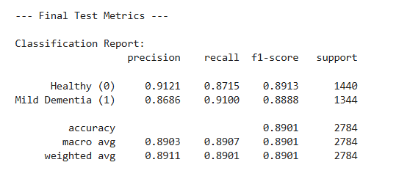
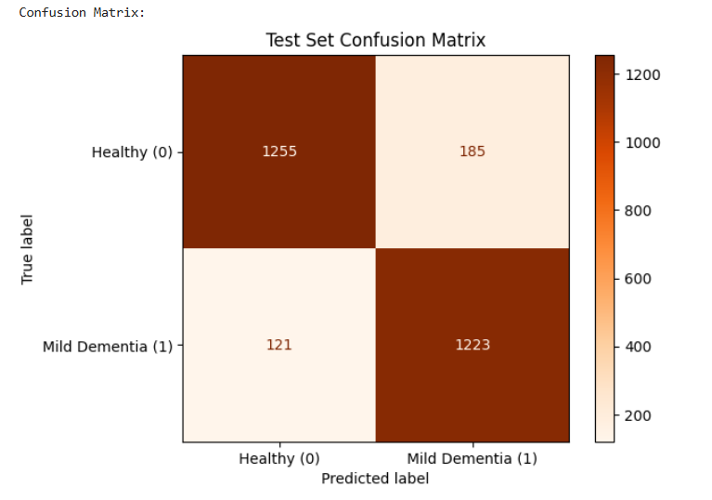

The flatten layer takes the output from the convolutional and pooling layers and converts it into a 1-dimensional vector that the dense layer can use to process and make predictions. The dense layer needs a 1-dimensional vector for single matrix multiplication. If the dense layer receives an input greater than a 1-dimensional vector the shape will not match. Therefore, the model will not be able to multiple the input and dense layer weights through matrix multiplication.

Binary Cross entropy, ADAM, Accuracy
We compiled our model for evaluation and for improvement using Binary Cross-Entropy, the optimizer Adam, and the metric accuracy. Binary Cross-Entropy is a loss function used for binary classification. Loss is the model’s error in making predictions. The lower the loss score, the better the model is. There is a mathematical equation to calculate this loss using Binary Cross-Entropy. This loss function measures the distance between predicted probabilities and the true labels. The closer the probability is to the true label the lower the loss score is (GeeksforGeeks, 2024). Next, we used the optimizer Adapt Moment Estimation (ADAM). ADAM adjusts the weights of features to decrease loss for the model, which can improve evaluation metrics. ADAM combines momentum and Root Mean Square Propagation (RSMprop) to learn faster and smoothly. Momentum will adjust the weights to smooth the gradient, which will move toward correct classification between dementia and healthy patients. RSMprop will adjust the step size of certain weights that cause huge fluctuations in the gradient which can confuse the model (GeeksforGeeks, 2020). Lastly, we can see the accuracy of our model, which is the percentage of correctly classified patients.

TensorFlow
TensorFlow is an open-source Python Library for Machine Learning. We used TensorFlow to prepare our MRI images for the Convolutional Neural Network. This library handled automatic labeling by inferring the folder structure we provided for access to the datasets (GeeksforGeeks, 2017). Also, TensorFlow standardized all of our images to be the same size, used a grayscale color channel to lower computational costs, and processed multiple images at one time using the batch_size parameter. Lastly, we used the Shuffle parameter for our training images to ensure the images are randomly mixed before each epoch to help the model learn. This process was repeated for the validation and testing folders. However, the shuffle parameter was set to false for these folders to ensure a consistent repeatable evaluation.

Conclusion
In this project, we applied a Convolutional Neural Network (CNN) to classify MRI images of healthy and very mild dementia patients. Using Tensorflow, we preprocessed the images, applied convolutional and max-pooling layers to extract key spatial features, and leveraged dense layers with dropouts for reliable prediction. ReLU activations introduced nonlinearity, and early stopping helped prevent overfitting, ensuring the model generalized well to unseen data. Our evaluation metrics show that the model we created performs well on the training and testing data. The CNN achieved an overall test accuracy of 89% with balanced precision and recall across both classes, indicating effective classification performance.

References
Chen, C., Isa, & Liu, X. (2024). A review of convolutional neural network based methods for medical image classification. Computers in Biology and Medicine, 185, 109507–109507. https://doi.org/10.1016/j.compbiomed.2024.109507
GeeksforGeeks. (2017, August 4). Introduction to TensorFlow. GeeksforGeeks. https://www.geeksforgeeks.org/python/introduction-to-tensorflow/
GeeksforGeeks. (2019, June 26). Keras.Conv2D Class. GeeksforGeeks. https://www.geeksforgeeks.org/machine-learning/keras-conv2d-class/
GeeksforGeeks. (2020, October 22). What is Adam Optimizer? GeeksforGeeks. https://www.geeksforgeeks.org/deep-learning/adam-optimizer/
GeeksforGeeks. (2023, March 20). Apply a 2D Max Pooling in PyTorch. GeeksforGeeks. https://www.geeksforgeeks.org/computer-vision/apply-a-2d-max-pooling-in-pytorch/
GeeksforGeeks. (2024a, April 18). Using Early Stopping to Reduce Overfitting in Neural Networks. GeeksforGeeks. https://www.geeksforgeeks.org/deep-learning/using-early-stopping-to-reduce-overfitting-in-neural-networks/
GeeksforGeeks. (2024b, May 27). Binary Cross Entropy/Log Loss for Binary Classification. GeeksforGeeks. https://www.geeksforgeeks.org/deep-learning/binary-cross-entropy-log-loss-for-binary-classification/
GeeksforGeeks. (2024c, May 27). What is Fully Connected Layer in Deep Learning? GeeksforGeeks. https://www.geeksforgeeks.org/deep-learning/what-is-fully-connected-layer-in-deep-learning/
GeeksforGeeks. (2024d, September 30). ReLU Activation Function in Deep Learning. GeeksforGeeks. https://www.geeksforgeeks.org/deep-learning/relu-activation-function-in-deep-learning/
Goodfellow, I., Bengio, Y., & Courville, A. (2016). Deep Learning. The MIT Press. https://www.deeplearningbook.org/
Gurucharan, M. (2020, December 7). Basic CNN Architecture: Explaining 5 Layers of Convolutional Neural Network. UpGrad Blog. https://www.upgrad.com/blog/basic-cnn-architecture/
Jason Brownlee. (2019, April 16). How Do Convolutional Layers Work in Deep Learning Neural Networks? Machine Learning Mastery. https://machinelearningmastery.com/convolutional-layers-for-deep-learning-neural-networks/
Keita, Z. (2023, November 14). An Introduction to Convolutional Neural Networks (CNNs). Datacamp. https://www.datacamp.com/tutorial/introduction-to-convolutional-neural-networks-cnns
LearnOpenCV. (2023, January 18). Understanding Convolutional Neural Networks: A Complete Guide. Learnopencv.com. https://learnopencv.com/understanding-convolutional-neural-networks-cnn/
Malviya, N. (2023, August 3). Convolution & Pooling Layers - Nikita Malviya - Medium. Medium. https://medium.com/@nikitamalviya/convolution-pooling-f8e797898cf9
Versloot, C. (2020). What are Max Pooling, Average Pooling, Global Max Pooling and Global Average Pooling? | MachineCurve.com. Machinecurve.com. https://machinecurve.com/index.php/2020/01/30/what-are-max-pooling-average-pooling-global-max-pooling-and-global-average-pooling

