I will be following the steps in this link: <https://packaging.python.org/en/latest/tutorials/packaging-projects/>

I am running them on Anaconda command prompt as follows:

I created the suggested folders hierarchy:

1. Setting a new virtual environment: 
2. Activate the new environment:



1. Make sure to update pip (if needed):



1. I installed jupyter notebook to create/edit the Python file, I know this might not be the best practice, your suggestions is very welcomed.



1. Creating /Editing the .py files
2. Creating/Editing the other files : setup.cfg, pyproject.toml, README.md, and LICENSE.

1. Build the package:

1. run this command from the same directory where pyproject.toml is located:

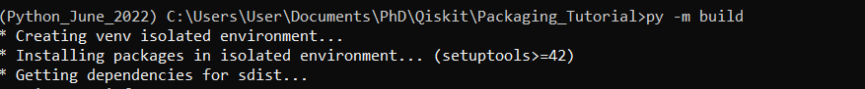

1. A picture containing application

   Description automatically generated