Political Violence in Post-Election Bangladesh:Trends, Intensity, and Conflict Configuration, January–June 2026
A Quantitative Policy Brief, September 2026 by M. Mezbah Uddin Khan | Primary source: Human Rights Support Society (HRSS)

Executive Summary
Bangladesh held its national parliamentary election since the political shift in August 2024 on 12 February 2026. A new government was put into place on 17 February. This short report looks at the recorded violence during the six months after the transition started. The period under study was from January to June 2026. It uses quarterly and half-yearly reports from the Human Rights Support Society (HRSS). During those six months the data from HRSS shows 830 cases of violence. There were 56 deaths and 5,246 injuries. This is a rise of 57% in cases and 27% in injuries compared to the time in 2025. There was also a drop of 29% in deaths. The pattern of the months shows that the number of incidents and the level of violence did not go together. February, which included the election had the number of incidents 346.. The death rate was low 2.9 deaths for every 100 incidents. March had a third as many incidents, 113 but the highest death rate in the whole period 15.9 for every 100 incidents. The injury rate was also high. The main finding from the report is that fewer incidents do not mean danger to people. A second finding is about the type of conflict. About 93% of the political violence was connected to problems inside the BNP or fights between the BNP and other parties. Feuds within the BNP and conflicts between the BNP and Jamaat-e-Islami together made up two-thirds of all incidents. The report ends with suggestions based on these two findings. It suggests monitoring that pays attention to how intense the violence's not just how often. It also recommends ways to manage conflicts at the party level. These are specifically for disputes within the BNP and, between the BNP and other parties.

Introduction

Bangladesh held its national parliamentary election on 12 February 2026. This was the competitive election since the August 2024 uprising that ended the Awami League government.

The Bangladesh Nationalist Party or BNP won the election and the referendum that was held at the time. A BNP‑led government headed by Tarique Rahman was sworn in on 17 February 2026 ending two decades of being out of power.This period, which covers the stretch of campaigning the election itself and the first months of the new government offers a clear window for looking at political violence. Unlike the diffuse post‑transition period of 2024–2025 the months of January to June 2026 are anchored by a dateable electoral event. That makes it possible to ask a question than simply "did violence rise or fall."

The question this brief asks is: how did the scale, intensity and organizational pattern of violence in Bangladesh change during the first six months of 2026? Of treating political violence as one undifferentiated trend the brief separates three distinct empirical questions. First trend: did incident counts rise or fall from month to month? Second intensity: did fewer incidents also mean severe violence? Configuration: what share of violence was intra‑party, versus inter‑party? Collapsing them into one number would hide the pattern that the data reveal.

Data and Methodology

The dataset spans six months January to June 2026. It is made up of HRSS monthly monitoring reports and the HRSS yearly report for January to June 2026. These reports are covered by The Daily Star, The Business Standard and Bangla Tribune. The March report was also obtained directly from HRSSs website (hrssbd.org). Five of the six incident, death and injury numbers from February to June are reported directly by HRSS in a separate monthly release. There is no HRSS report for January 2026 by itself. The January number used here which is 151 incidents, 8 deaths and 1,233 injuries is found by subtracting the February and March figures from HRSSs January to March quarterly total. That total is 610 incidents, 36 deaths and 4,078 injuries. This calculation is not an estimate. All the numbers involved including the total and the two monthly numbers are reported directly by HRSS. So the January number is worked out mathematically. To check the six monthly numbers put together add up exactly to 830 incidents, 56 deaths and 5,246 injuries. This matches HRSSs half-year total that they published separately. This is a sign that the numbers are correct. Two indicators are used throughout the analysis. One is deaths per 100 incidents, which shows how deadly the incidents are. The other is injuries per incident, which is used as a measure of how much harm's done in each conflict. The way the conflicts are set up is looked at using HRSSs party-conflict categories. These include things like BNP internal, BNP–Jamaat-e-Islami BNP–Awami League. These categories are reported at the half-year level for all six months. They are also reported at the level for four months. February, March, May and June. These are the months when HRSSs monthly reports included a breakdown of categories. January and April do not have this level of detail so they are left blank of being guessed. As in similar studies having six monthly observations is a small sample. The statistics and the correlation shown here are for showing what is happening. They are not meant to be used for statistical analysis. All the work was done in R. The full code is, in Appendix B.

3. Findings

3.1 Trend
The number of incidents dropped quickly. In a steady way over the time period after an initial rise around the election: 151 incidents in January then a high of 346 in February (the month of the election) followed by 113 in March 98 in April 64 in May and 58 in June. A drop of about six times from the February high to the June low. If seen alone this pattern would suggest a return to normal after the election. The data on the severity of the incidents make that idea much harder to believe.
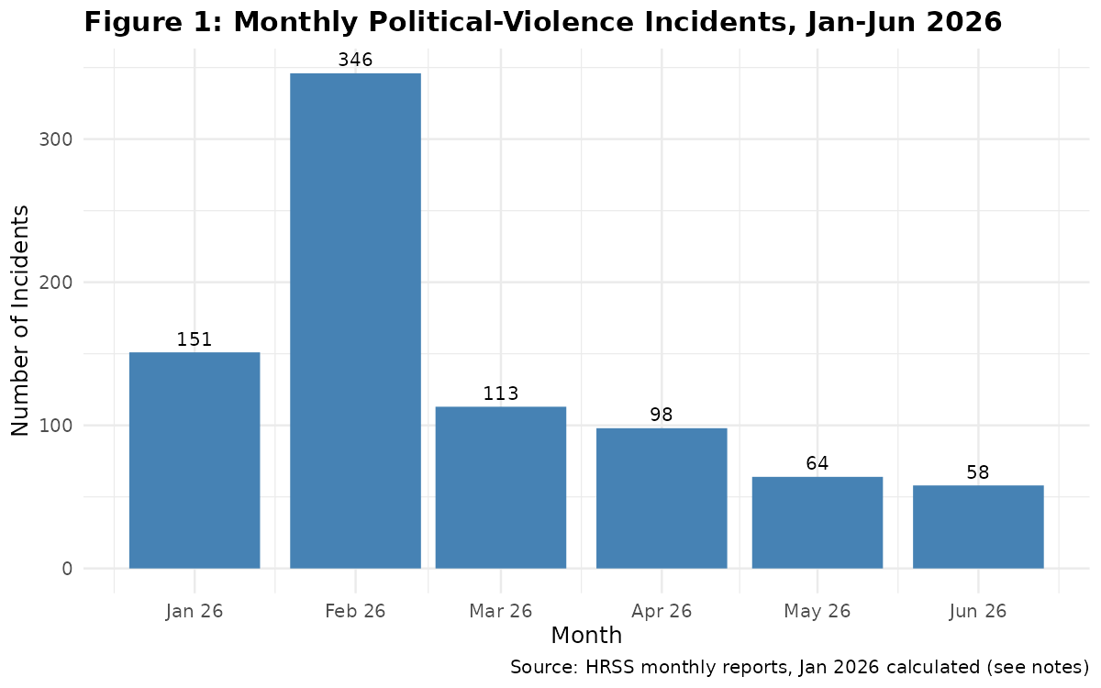
Figure 1. Monthly political-violence incidents, January–June 2026. January is calculated; February–June are directly reported by HRSS.

3.2 Intensity
The number of deaths and injuries did not follow the number of incidents. February even though it had the incidents in the whole time (346) had the lowest death rate of the period (2.89 deaths per 100 incidents) and a moderate rate of injuries. March, which had than one third of Februarys number of incidents (113) had the highest death rate of the six months (15.93 per 100 incidents) and the second-highest rate of injuries (8.07 per incident). Almost as many deaths (18) as February (10) even though there were far fewer incidents. June also shows a situation: the number of incidents kept going down (58, the lowest of the period) while the death rate went up to 15.52 per 100 incidents the second-highest in the series.
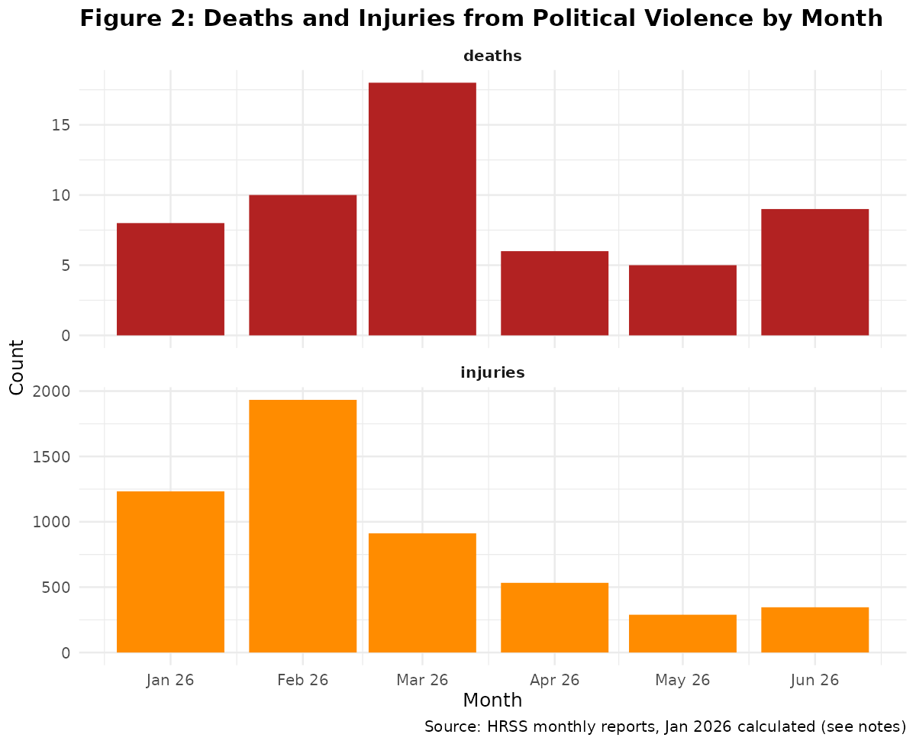
Figure 2. Deaths and injuries from political violence by month.
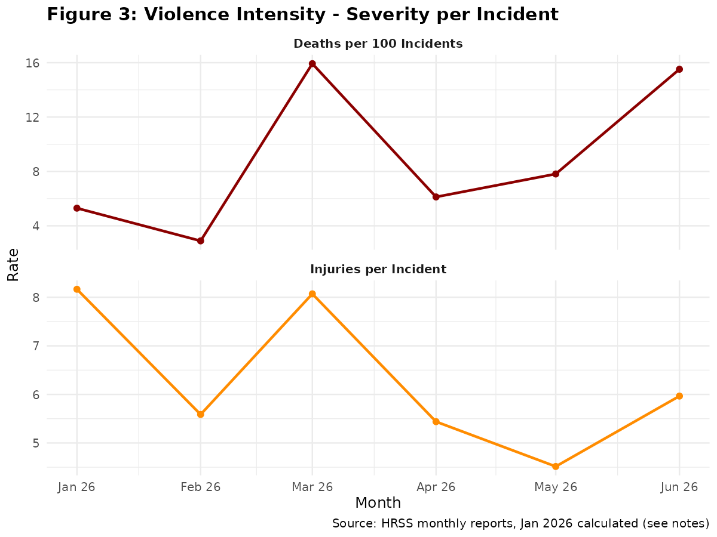
Figure 3. Deaths per 100 incidents and injuries per incident, by month — violence intensity, distinct from frequency.

An initial Pearson correlation across the six months supports this difference: the link between incidents and deaths is weak (r = 0.16). The link between incidents and injuries is much stronger (r = 0.96). This means that the number of injuries changed in line with how many clashes there were but the number of deaths did not. A small number of clashes with high death rates mostly, in March and June caused the deaths without depending on how many clashes happened that month. With six months of data this correlation is not strong statistically but it lines up with the pattern seen in Figures 2 and 3.

3.3 Conflict Configuration
Political violence during this time was mostly connected to the BNP either because of fights within the party or because of clashes between the BNP and other political groups. According to HRSS’s records out of 830 documented incidents in six months about 93 percent were tied to internal BNP conflicts or to fights between the BNP and other parties. At the category level the common type of violence involved clashes between the BNP and Jamaat-e-Islami. 290 Incidents, which made up 34.9 percent of all recorded events. This was a little more than the number of incidents involving internal conflict within the BNP itself. 273 Cases or 32.9 percent. Together these two categories alone make up two-thirds of all violence reported in this period. The BNP also clashed with unnamed parties in 97 cases (11.7 percent). Meanwhile clashes between the BNP and the Awami League. Even though the Awami League was banned in May 2025. Has long been one of the main political forces in Bangladesh. Only accounted for 77 incidents (9.3 percent). Clashes between the BNP and the NCP well as those, between the Awami League and the NCP were much less frequent. 4.0 Percent and 0.4 percent respectively.
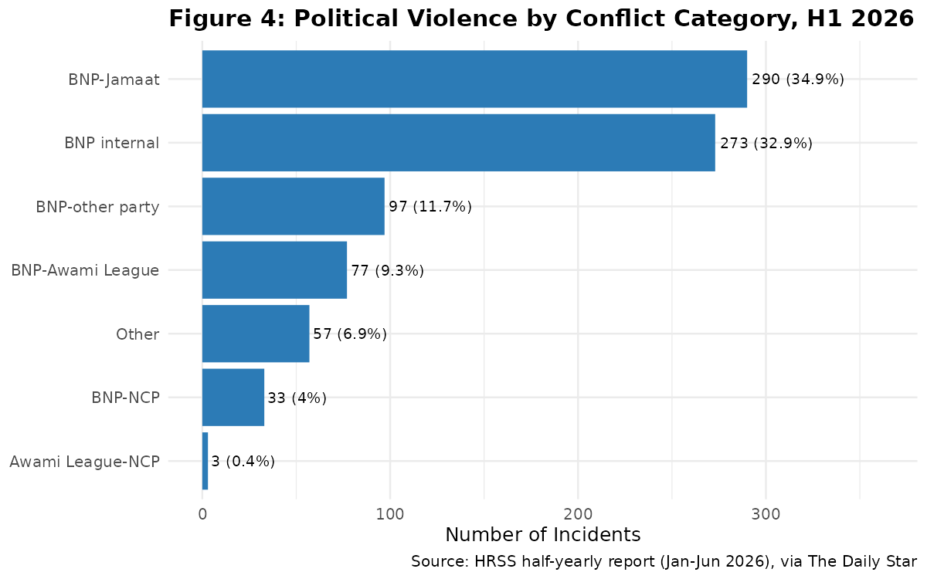
Figure 4. Political violence by conflict category, H1 2026 (directly reported by HRSS).

Where monthly category data are available the composition of incidents shifts over time. In February BNP–Jamaat clashes alone (191 incidents) accounted for over half of that month’s total and for 998 of its 1,933 injuries. This is consistent with electoral-period competition between the two parties for the voter base. By March intra-BNP conflict became the single category (45 of 113 incidents with 9 of the month’s 18 deaths). By June intra-BNP conflict again led (21 of 58 incidents 3 of 9 deaths) while BNP–Awami League clashes contributed a share of injuries (115 of June’s 346). This pattern reflects a shift from electoral inter-party competition around the February vote toward more sustained intra-party and multi-front local competition once the new government was in office. However the four months, with category data—February, March, May and June—are not a complete monthly series. January and April cannot be similarly decomposed.

4. Policy Implications

The drop in how violence happens does not mean the danger is going down. That’s what Section 3.2 shows. Just because there are incidents, like in March doesn’t mean people are safer. In fact March had fights but the highest death rate of the whole period. That means the violence that did happen was more deadly. More planned or more brutal. So fewer but more dangerous clashes can hurt people than many small fights. If officials only look at how many incidents happen they might miss the threat. They could end up doing little during months like March or June when violence is less common but much more deadly.

Section 3.3 gives another point. Most of the violence about two-thirds happen either inside the BNP or between the BNP and Jamaat-e-Islami. So the best place to act is not in peace talks between all parties. The real focus should be on managing conflict around the governing party. Since the BNP is now in power any system to handle disputes must have authority. Not just depend on party leaders. That’s the part. It’s harder than mediation between a ruling party and an opposition group. You need rules and bodies that can hold leaders accountable no matter what. That’s a challenge and one that’s different, from what we usually see.

5. Recommendations

1. Intensity-sensitive warning monitoring: The Election Commission and law enforcement should track deaths per incident and injuries per incident in addition to raw incident counts because Section 3.2 shows that these figures can move in opposite directions. A monitoring dashboard that uses incident counts would have missed the spike in lethality seen in March.

2. Targeted intra-BNP and BNP-adjacent conflict management: Because BNP-internal and BNP–Jamaat clashes together account for two-thirds of the violence the Police Reform Commissions suggestions for politically independent policing become very important for disputes that involve the governing partys own activists. In cases local police might feel the strongest pressure not to step in.

3. Standardized monthly category reporting: HRSSs monthly reports did not always separate party-conflict categories each month. The data were available for February, March, May and June. Missing for January and April in the sources we found. If this breakdown were standardized each month the type of configuration analysis shown in Section 3.3 could be carried out without missing data.

4. Independent verification and cross-checking: Because this brief relies on one monitor, ongoing parallel tracking by Odhikar, ASK and Transparency International Bangladesh still provides a useful check on HRSSs figures. This is true only if differences, in definitions and methods are reported openly of being combined into one single number.

6. Limitations
- Primary source: This report uses HRSS as the only source for numbers. HRSS gets its numbers from 15 to 16 media outlets plus its own research. This means the numbers show events that were covered by the media not all cases of violence.
- Calculated January figure: The number for January 2026 was found by subtracting from a total that was reported for three months. It was not reported directly for January. The six months add up correctly with another total that was reported for six months. This is a check for accuracy. There was no separate report from HRSS for January to confirm the number.
- Incomplete monthly category data: Breakdowns of party-conflict are available for four of the six months (Feb, Mar, May, Jun). January and April do not have category details based on the sources found. Because of this the comparison within the year in Section 3.3 is not complete.
- Small sample size: There are six monthly numbers. The statistics and the correlation in Section 3.2 are examples, not strong enough to make firm conclusions. No strong claims should be made from them.
- Party attribution: The party-conflict categories from HRSS show the affiliations that were reported or believed locally. They do not show responsibility from an organization.
- Observational design: This report is descriptive. It shows patterns in reported violence during a six-month time, around a national election. It does not and cannot say that the election or any government action caused these patterns.

7. Conclusion

Between January and June 2026 recorded political violence in Bangladesh dropped sharply in the number of incidents after the February election. However this drop did not mean that the danger to people’s lives also went down. In March and June although the number of incidents was relatively low the death rates were the highest in that period. At the time most of this political violence – about two-thirds according to HRSS – happened inside the BNP or between the BNP and other parties not between the BNP and Awami League as people usually think. Together these findings show that both monitoring and policy actions should look at how intense political violence is as well as how many incidents occur. Also efforts to manage conflict would be most effective if they focus on disputes inside and, around the governing party.

Tables

Table 1. Descriptive Statistics (N = 6 months, Jan–Jun 2026)
Variable | Mean | Median | Min | Max | SD
Incidents | 138.33 | 105.50 | 58 | 346 | 107.27
Deaths | 9.33 | 8.50 | 5 | 18 | 4.63
Injuries | 874.33 | 722.50 | 289 | 1,933 | 630.73
Deaths / 100 incidents | 8.93 | 6.97 | 2.89 | 15.93 | 5.50
Injuries / incident | 6.29 | 5.78 | 4.52 | 8.17 | 1.49
N=6; treat as indicative, not a basis for inference. See Appendix B for R code.

Table 2. Monthly Dataset with Data Provenance
Month | Incidents | Deaths | Injuries | Deaths/100 | Injuries/incident | Data status
Jan 2026 | 151 | 8 | 1,233 | 5.30 | 8.17 | Calculated*
Feb 2026 | 346 | 10 | 1,933 | 2.89 | 5.59 | Directly reported
Mar 2026 | 113 | 18 | 912 | 15.93 | 8.07 | Directly reported
Apr 2026 | 98 | 6 | 533 | 6.12 | 5.44 | Directly reported
May 2026 | 64 | 5 | 289 | 7.81 | 4.52 | Directly reported
Jun 2026 | 58 | 9 | 346 | 15.52 | 5.97 | Directly reported
Total (H1 2026) | 830 | 56 | 5,246 | 6.75 | 6.32 | Reconciles exactly to HRSS half-yearly report
*January is calculated (Q1 total minus directly-reported Feb & Mar); see Section 2. All other months directly reported by HRSS.

Table 3. Year-on-Year Comparison (H1 2025 vs. H1 2026)
Indicator | H1 2025 | H1 2026 | % change
Incidents | 529 | 830 | +56.9%
Deaths | 79 | 56 | −29.1%
Injuries | 4,124 | 5,246 | +27.2%
Source: HRSS half-yearly report, as reported by The Daily Star.

Table 4. Political Violence by Conflict Category, H1 2026
Category | Incidents (H1 2026) | Share of total
BNP–Jamaat-e-Islami | 290 | 34.9%
BNP internal (intra-party) | 273 | 32.9%
BNP–other party | 97 | 11.7%
BNP–Awami League | 77 | 9.3%
Other / unclassified | 57 | 6.9%
BNP–NCP | 33 | 4.0%
Awami League–NCP | 3 | 0.4%
Total | 830 | 100%
Source: HRSS half-yearly report (Jan–Jun 2026), as reported by The Daily Star.

References
Human Rights Support Society (HRSS). (2026). Human Rights Situation Report of Bangladesh (March 2026). hrssbd.org, 3 April 2026. https://hrssbd.org/report_details/72
The Daily Star. (2026, March 5). Feb 2026 marked by violence centring election; 10 killed, 1,933 hurt: HRSS. https://epfs.thedailystar.net/TDS/2026/03/04/Bangladesh/MAI/5_03/e3e441e7967f0bcf_03.pdf
Bangla Tribune. (2026, April 4). মার্চে রাজনৈতিক সহিংসতায় নিহত ১৮, আহত ৯১২: এইচআরএসএস [March political violence: 18 killed, 912 injured: HRSS]. https://www.banglatribune.com/others/940437/%E0%A6%AE%E0%A6%BE%E0%A6%B0%E0%A7%8D%E0%A6%9A%E0%A7%87-%E0%A6%B0%E0%A6%BE%E0%A6%9C%E0%A6%A8%E0%A7%88%E0%A6%A4%E0%A6%BF%E0%A6%95-%E0%A6%B8%E0%A6%B9%E0%A6%BF%E0%A6%82%E0%A6%B8%E0%A6%A4%E0%A6%BE%E0%A7%9F-%E0%A6%A8%E0%A6%BF%E0%A6%B9%E0%A6%A4-%E0%A7%A7%E0%A7%AE-%E0%A6%86%E0%A6%B9%E0%A6%A4-%E0%A7%AF%E0%A7%A7%E0%A7%A8
Bangla Barta BD. (2026, May 5). এপ্রিল মাসে ৭৫ সাংবাদিক হয়রানির শিকার: এইচআরএসএস [75 journalists harassed in April: HRSS]. https://www.banglabartabd.com/national/news/15467
The Business Standard. (2026, June 5). Political violence kills 5, mob attacks claim 31 lives in May: HRSS. https://www.tbsnews.net/bangladesh/political-violence-kills-5-mob-attacks-claim-31-lives-may-hrss-1455066
The Business Standard. (2026, July 2). Political violence kills 9, injures 346 in June: HRSS. https://www.tbsnews.net/bangladesh/crime/political-violence-kills-9-injures-346-june-hrss-1478376
The Daily Star. (2026, April 12). 39 die in custody in first 3 months of 2026: HRSS report. [Source for Jan–Mar 2026 quarterly total: 610 incidents, 36 deaths, 4,078 injuries.] https://www.thedailystar.net/news/crime-justice/news/39-die-custody-first-3-months-2026-hrss-report-4149566
The Daily Star. (2026, July 16). Rights violations, abuses surge in first half of 2026. [Source for H1 2026 total (830/56/5,246), H1 2025 comparison, and party-conflict category breakdown.] https://www.thedailystar.net/news/bangladesh/rights/news/rights-violations-abuses-surge-first-half-2026-4225171
Daily New Nation. (2026, July 15). 56 killed in political violence in six months. https://dailynewnation.com/news/842513
ALBD.org. (2026, July 6). Bangladesh in Crisis: BNP Government's Catastrophic Failure on Human Rights in June 2026. [Corroborating source for June HRSS figures.] https://www.albd.org/articles/news/41748/Bangladesh-in-Crisis:-BNP-Government%E2%80%99s-Catastrophic-Failure-on-Human-Rights-in-June-2026

Appendix A: Data Provenance Note
Every incident, death and injury figure in this brief was verified against least one HRSS news report before it was included. Five of six months from February to June are reported directly by HRSS in a monthly release. The March figures were also checked directly against HRSSs report page at hrssbd.org/report_details/72. The January figure was calculated as described in Section 2 and Table 2. This brief replaces a draft that used a fake monthly series for September 2024 to August 2026. The figures, in that draft did not match HRSS reporting so they have been discarded instead of being corrected in place.

Appendix B: Complete Reproducible R Code
The R script below creates the monthly data set. It also checks the numbers against the half-year total reported by HRSS. It includes Tables 1 to 4. It shows the correlation. It has Figures 1 to 4. All of these match exactly what is, in this brief.
R Script: Political Violence in Bangladesh, Jan–Jun 2026

# =============================================================================
# Project: Political Violence in Bangladesh, January-June 2026
# All incidents/deaths/injuries figures below are drawn from Human Rights
# Support Society (HRSS) monthly/quarterly/half-yearly reports as covered by
# The Daily Star, The Business Standard, and Bangla Tribune, or fetched
# directly from hrssbd.org. January 2026 is CALCULATED (Q1 total minus the
# directly-reported February and March figures) because no standalone HRSS
# January 2026 monthly report could be located; this is flagged explicitly
# and the six months reconcile exactly to the independently reported
# half-year total (830 / 56 / 5,246), which cross-validates the calculation.
# =============================================================================

library(tidyverse)
library(lubridate)
library(scales)

# -----------------------------------------------------------------------------
# 1. Data
# -----------------------------------------------------------------------------
months_data <- tibble::tribble(
~month_label, ~incidents, ~deaths, ~injuries, ~source_type,
"Jan 2026", 151, 8, 1233, "Calculated (Q1 total minus Feb & Mar)",
"Feb 2026", 346, 10, 1933, "Directly reported (HRSS via Daily Star, 5 Mar 2026)",
"Mar 2026", 113, 18, 912, "Directly reported (HRSS primary report, 3 Apr 2026)",
"Apr 2026", 98, 6, 533, "Directly reported (HRSS monthly report, 5 May 2026)",
"May 2026", 64, 5, 289, "Directly reported (HRSS via TBS, 5 Jun 2026)",
"Jun 2026", 58, 9, 346, "Directly reported (HRSS via TBS, 2 Jul 2026)"
)

df <- months_data %>%
mutate(
date_obj = my(month_label),
death_rate = (deaths / incidents) * 100,
injury_rate = injuries / incidents
) %>%
arrange(date_obj)

write_csv(df, "./output/monthly_dataset_verified.csv")

cat("\n== Reconciliation check against HRSS half-yearly report ==\n")
cat("Sum incidents:", sum(df$incidents), "(HRSS half-yearly report: 830)\n")
cat("Sum deaths: ", sum(df$deaths), "(HRSS half-yearly report: 56)\n")
cat("Sum injuries: ", sum(df$injuries), "(HRSS half-yearly report: 5,246)\n")

# -----------------------------------------------------------------------------
# 2. Party-conflict configuration (H1 2026 aggregate, directly reported)
# -----------------------------------------------------------------------------
composition_h1 <- tibble::tribble(
~category, ~incidents,
"BNP internal", 273,
"BNP-Jamaat", 290,
"BNP-Awami League", 77,
"BNP-NCP", 33,
"Awami League-NCP", 3,
"BNP-other party", 97,
"Other", 57
) %>%
mutate(share_pct = round(incidents / sum(incidents) * 100, 1))

write_csv(composition_h1, "./output/table_composition_h1.csv")
cat("\n== H1 2026 conflict configuration (directly reported) ==\n")
print(composition_h1)
cat("Sum check:", sum(composition_h1$incidents), "(expect 830)\n")

# Monthly party breakdown - ONLY for months where HRSS reported it (Feb, Mar, May, Jun)
# Jan and Apr breakdowns were not available in any located source and are
# left out rather than estimated.
monthly_composition <- tibble::tribble(
~month_label, ~category, ~incidents, ~deaths, ~injuries,
"Feb 2026", "BNP internal", 95, 8, 599,
"Feb 2026", "BNP-Jamaat", 191, 1, 998,
"Mar 2026", "BNP internal", 45, 9, 501,
"Mar 2026", "BNP-Jamaat", 16, 5, 109,
"Mar 2026", "BNP-Awami League", 22, 2, 156,
"Mar 2026", "BNP-NCP", 2, 0, 11,
"Mar 2026", "BNP-other party",21, 0, 39,
"Mar 2026", "Other", 7, 2, 96,
"May 2026", "BNP internal", 18, 0, 114,
"May 2026", "BNP-Jamaat", 10, 1, 49,
"May 2026", "BNP-Awami League", 14, 2, 72,
"Jun 2026", "BNP internal", 21, 3, 146,
"Jun 2026", "BNP-Jamaat", 8, 2, 36,
"Jun 2026", "BNP-Awami League", 14, 2, 115,
"Jun 2026", "BNP-NCP", 5, 0, 18,
"Jun 2026", "BNP-other party",5, 0, 9,
"Jun 2026", "Other", 5, 2, 22
)
write_csv(monthly_composition, "./output/monthly_composition_partial.csv")

# -----------------------------------------------------------------------------
# 3. Descriptive statistics (N = 6 -- explicitly noted as a small sample)
# -----------------------------------------------------------------------------
desc_vars <- c("incidents", "deaths", "injuries", "death_rate", "injury_rate")
desc_table <- df %>%
select(all_of(desc_vars)) %>%
summarise(across(everything(), list(
Mean = ~mean(.x), Median = ~median(.x), Min = ~min(.x), Max = ~max(.x), SD = ~sd(.x)
))) %>%
pivot_longer(everything(), names_to = c("Variable", ".value"), names_sep = "_(?=[^_]+$)") %>%
mutate(across(where(is.numeric), ~round(.x, 2)))

cat("\n== Table 1: Descriptive statistics (N = 6 months) ==\n")
print(desc_table, n = Inf)
write_csv(desc_table, "./output/table1_descriptive_stats.csv")

# -----------------------------------------------------------------------------
# 4. Year-on-year comparison (H1 2026 vs H1 2025, directly reported by HRSS)
# -----------------------------------------------------------------------------
yoy <- tibble::tribble(
~Indicator, ~`H1 2025`, ~`H1 2026`, ~`Pct change`,
"Incidents", 529, 830, round((830-529)/529*100,1),
"Deaths", 79, 56, round((56-79)/79*100,1),
"Injuries", 4124,5246, round((5246-4124)/4124*100,1)
)
cat("\n== Table 2: Year-on-year comparison ==\n")
print(yoy)
write_csv(yoy, "./output/table2_yoy_comparison.csv")

# -----------------------------------------------------------------------------
# 5. Exploratory correlation (association only, N=6 -- indicative, not robust)
# -----------------------------------------------------------------------------
cor_inc_deaths <- cor(df$incidents, df$deaths)
cor_inc_injuries <- cor(df$incidents, df$injuries)
cat(sprintf("\nIncidents vs deaths: r = %.3f (N=6, indicative only)\n", cor_inc_deaths))
cat(sprintf("Incidents vs injuries: r = %.3f (N=6, indicative only)\n", cor_inc_injuries))

# -----------------------------------------------------------------------------
# 6. Figures
# -----------------------------------------------------------------------------
theme_brief <- theme_minimal(base_size = 12) +
theme(plot.title = element_text(face = "bold"), legend.position = "bottom")

src_caption <- "Source: HRSS monthly reports, Jan 2026 calculated (see notes)"

# FIGURE 1: monthly incidents
fig1 <- ggplot(df, aes(x = date_obj, y = incidents)) +
geom_col(fill = "steelblue") +
geom_text(aes(label = incidents), vjust = -0.5, size = 3.5) +
scale_x_date(date_breaks = "1 month", date_labels = "%b %y") +
labs(title = "Figure 1: Monthly Political-Violence Incidents, Jan-Jun 2026",
x = "Month", y = "Number of Incidents", caption = src_caption) +
theme_brief
ggsave("./figures/figure1_monthly_incidents.png", fig1, width = 8, height = 5, dpi = 150)

# FIGURE 2: deaths and injuries by month (separate panels)
df_long <- df %>% select(date_obj, deaths, injuries) %>%
pivot_longer(c(deaths, injuries), names_to = "metric", values_to = "count") %>%
mutate(metric = factor(metric, levels = c("deaths","injuries")))
fig2 <- ggplot(df_long, aes(x = date_obj, y = count, fill = metric)) +
geom_col() +
facet_wrap(~metric, scales = "free_y", ncol = 1) +
scale_x_date(date_breaks = "1 month", date_labels = "%b %y") +
scale_fill_manual(values = c(deaths = "firebrick", injuries = "darkorange")) +
labs(title = "Figure 2: Deaths and Injuries from Political Violence by Month",
x = "Month", y = "Count", caption = src_caption) +
theme_brief + theme(legend.position = "none", strip.text = element_text(face="bold"))
ggsave("./figures/figure2_deaths_injuries.png", fig2, width = 8, height = 6.5, dpi = 150)

# FIGURE 3: severity rates
df_rates <- df %>% select(date_obj, death_rate, injury_rate) %>%
pivot_longer(c(death_rate, injury_rate), names_to = "rate_type", values_to = "value")
fig3 <- ggplot(df_rates, aes(x = date_obj, y = value, color = rate_type)) +
geom_line(linewidth = 1) + geom_point(size = 2) +
facet_wrap(~rate_type, scales = "free_y", ncol = 1,
labeller = as_labeller(c(death_rate="Deaths per 100 Incidents", injury_rate="Injuries per Incident"))) +
scale_x_date(date_breaks = "1 month", date_labels = "%b %y") +
scale_color_manual(values = c(death_rate="darkred", injury_rate="darkorange")) +
labs(title = "Figure 3: Violence Intensity - Severity per Incident",
x = "Month", y = "Rate", caption = src_caption) +
theme_brief + theme(legend.position="none", strip.text = element_text(face="bold"))
ggsave("./figures/figure3_severity_rates.png", fig3, width = 8, height = 6, dpi = 150)

# FIGURE 4: H1 2026 conflict configuration (directly reported aggregate)
comp_plot <- composition_h1 %>% mutate(category = fct_reorder(category, incidents))
fig4 <- ggplot(comp_plot, aes(x = category, y = incidents)) +
geom_col(fill = "#2c7bb6") +
geom_text(aes(label = paste0(incidents, " (", share_pct, "%)")), hjust = -0.05, size = 3.3) +
coord_flip(clip = "off") +
expand_limits(y = max(comp_plot$incidents) * 1.25) +
labs(title = "Figure 4: Political Violence by Conflict Category, H1 2026",
x = NULL, y = "Number of Incidents",
caption = "Source: HRSS half-yearly report (Jan-Jun 2026), via The Daily Star") +
theme_brief + theme(legend.position = "none")
ggsave("./figures/figure4_composition.png", fig4, width = 8, height = 5, dpi = 150)

cat("\nAll figures and tables written.\n")

